UNITED STATES
SECURITIES AND EXCHANGE COMMISSION
Washington, D.C. 20549
SCHEDULE 14A INFORMATION

Proxy Statement Pursuant to Section 14(a) of the
Securities Exchange Act of 1934
(Amendment No. )
Filed by the Registrant ☒ |  |  | Filed by a Party other than the Registrant ☐

Check the appropriate box:
☐ |  |  | Preliminary Proxy Statement
☐ |  |  | Confidential, for Use of the Commission Only (as permitted by Rule 14a-6(e)(2))
☐ |  |  | Definitive Proxy Statement
☒ |  |  | Definitive Additional Materials
☐ |  |  | Soliciting Material Pursuant to §240.14a-12
Pliant Therapeutics, Inc.
(Name of Registrant as Specified in its Charter)
Not Applicable
(Name of Person(s) Filing Proxy Statement, if other than the Registrant)

Payment of Filing Fee (Check the appropriate box):
☒ |  |  | No fee required.
☐ |  |  | Fee computed on table in exhibit required by Item 25(b) per Exchange Act Rules 14a-6(i)(1) and 0-11.
☐ |  |  | Fee paid previously with preliminary materials.

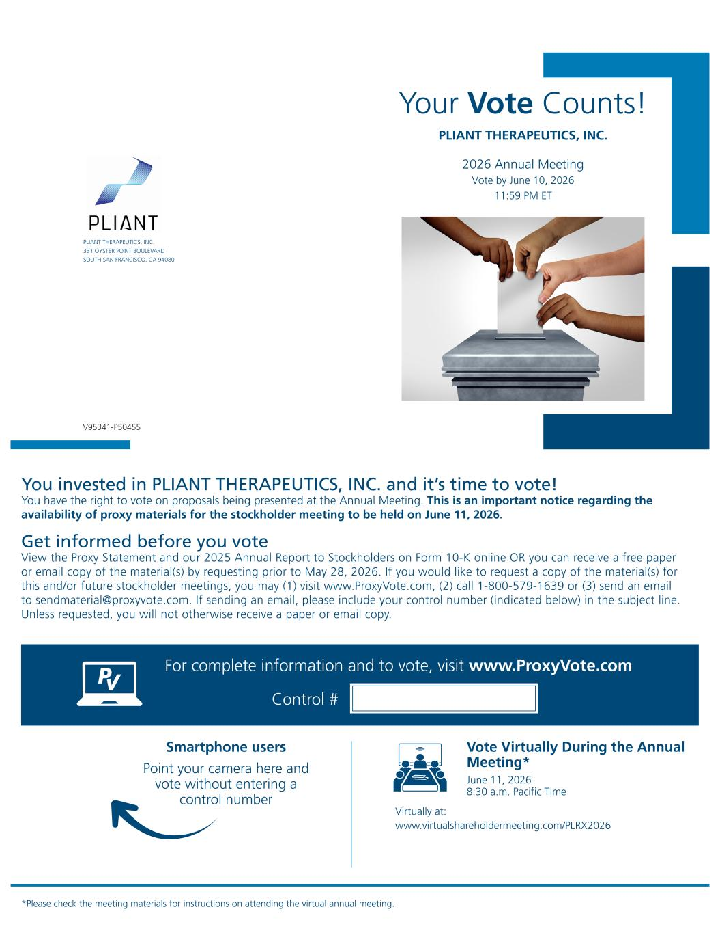
Your Vote Counts! Smartphone users Point your camera here and vote without entering a control number For complete information and to vote, visit www.ProxyVote.com Control # V95341-P50455 *Please check the meeting materials for instructions on attending the virtual annual meeting. PLIANT THERAPEUTICS, INC. 331 OYSTER POINT BOULEVARD SOUTH SAN FRANCISCO, CA 94080 PLIANT THERAPEUTICS, INC. 2026 Annual Meeting Vote by June 10, 2026 11:59 PM ET You invested in PLIANT THERAPEUTICS, INC. and it’s time to vote! You have the right to vote on proposals being presented at the Annual Meeting. This is an important notice regarding the availability of proxy materials for the stockholder meeting to be held on June 11, 2026. Get informed before you vote View the Proxy Statement and our 2025 Annual Report to Stockholders on Form 10-K online OR you can receive a free paper or email copy of the material(s) by requesting prior to May 28, 2026. If you would like to request a copy of the material(s) for this and/or future stockholder meetings, you may (1) visit www.ProxyVote.com, (2) call 1-800-579-1639 or (3) send an email to sendmaterial@proxyvote.com. If sending an email, please include your control number (indicated below) in the subject line. Unless requested, you will not otherwise receive a paper or email copy. Vote Virtually During the Annual Meeting* June 11, 2026 8:30 a.m. Pacific Time Virtually at: www.virtualshareholdermeeting.com/PLRX2026

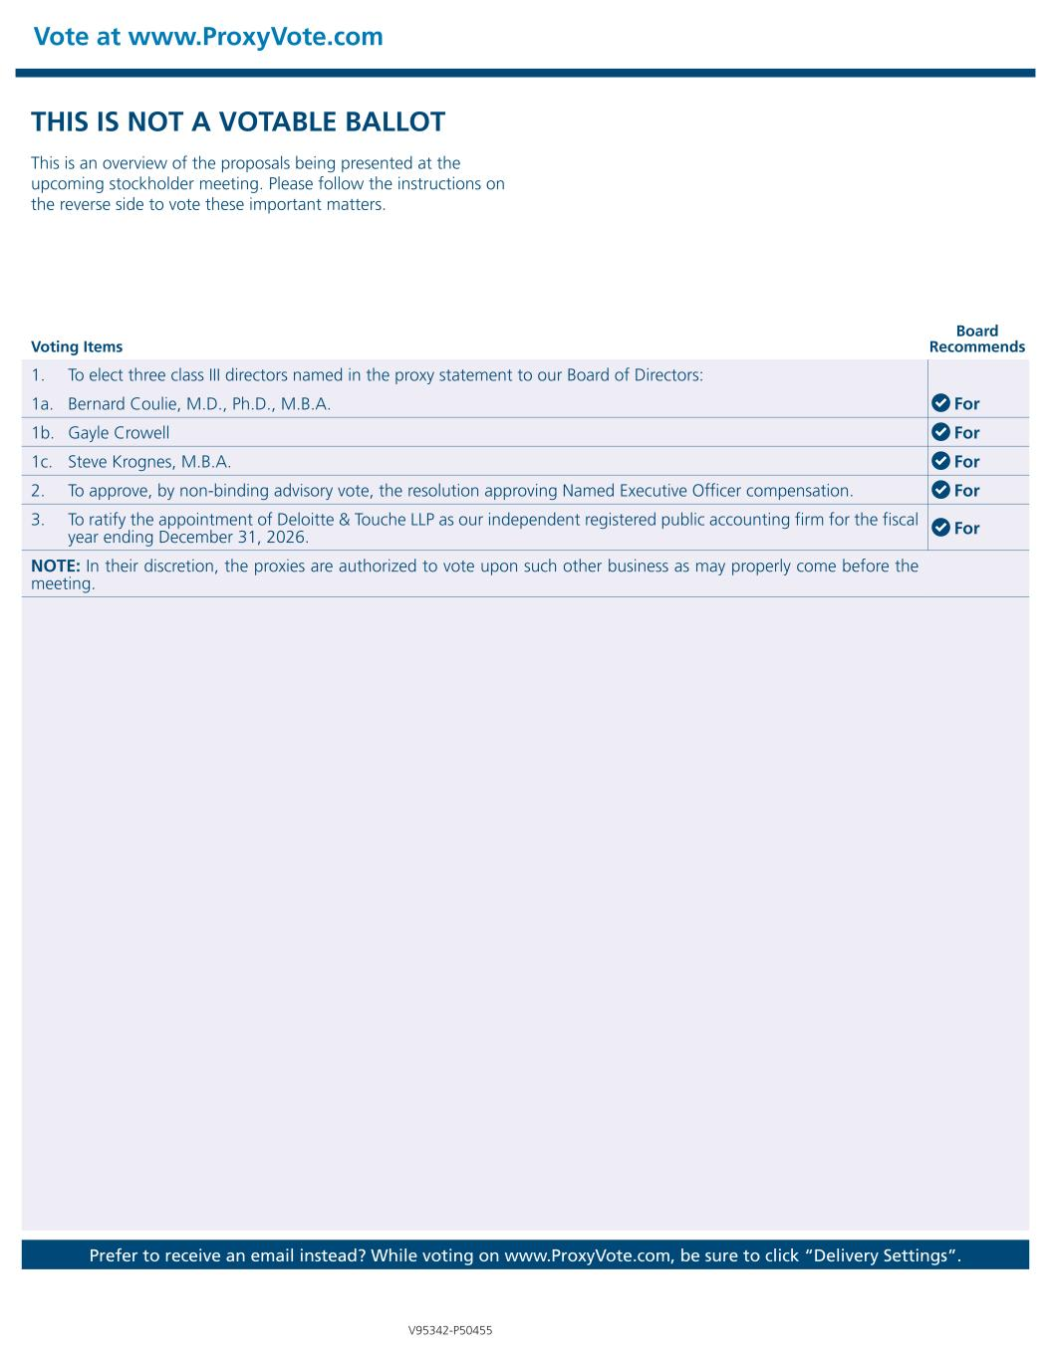
Vote at www.ProxyVote.com Prefer to receive an email instead? While voting on www.ProxyVote.com, be sure to click “Delivery Settings”. Voting Items Board Recommends V95342-P50455 THIS IS NOT A VOTABLE BALLOT This is an overview of the proposals being presented at the upcoming stockholder meeting. Please follow the instructions on the reverse side to vote these important matters. 1. To elect three class III directors named in the proxy statement to our Board of Directors: 1a. Bernard Coulie, M.D., Ph.D., M.B.A. For 1b. Gayle Crowell For 1c. Steve Krognes, M.B.A. For 2. To approve, by non-binding advisory vote, the resolution approving Named Executive Officer compensation. For 3. To ratify the appointment of Deloitte & Touche LLP as our independent registered public accounting firm for the fiscal year ending December 31, 2026. For NOTE: In their discretion, the proxies are authorized to vote upon such other business as may properly come before the meeting.

