Table of Contents

UNITED STATES

SECURITIES AND EXCHANGE COMMISSION

Washington, D.C. 20549

_____________________________________________

FORM 10-K

_____________________________________________

(Mark One)

x

ANNUAL REPORT PURSUANT TO SECTION 13 OR 15(d) OF THE SECURITIES EXCHANGE ACT OF 1934

For the fiscal year ended December 31, 2022

OR

☐

TRANSITION REPORT PURSUANT TO SECTION 13 OR 15(d) OF THE SECURITIES EXCHANGE ACT OF 1934 FOR THE TRANSITION PERIOD FROM

TO

Commission File Number 001-39303

_____________________________________________

PLIANT THERAPEUTICS, INC.

(Exact Name of Registrant as Specified in Its Charter)

_____________________________________________

Delaware

47-4272481

(State or Other Jurisdiction of

Incorporation or Organization)

(I.R.S. Employer

Identification No.)

260 Littlefield Avenue

South San Francisco , CA

94080

(Address of Principal Executive Offices)

(Zip Code)

Registrant’s telephone number, including area code: (650) 481-6770

_____________________________________________

Securities registered pursuant to Section 12(b) of the Act:

Title of Each Class | Trading Symbol(s) | Name of Each Exchange on which Registered
Common Stock, par value $0.0001 per share | PLRX | The Nasdaq Stock Market LLC

Securities registered pursuant to Section 12(g) of the Act: None

Indicate by check mark if the Registrant is a well-known seasoned issuer, as defined in Rule 405 of the Securities Act. Yes ☐ No x Indicate by check mark if the Registrant is not required to file reports pursuant to Section 13 or 15(d) of the Act. Yes ☐ No x

Indicate by check mark whether the Registrant: (1) has filed all reports required to be filed by Section 13 or 15(d) of the Securities Exchange Act of 1934 during the preceding 12 months (or for such shorter period that the Registrant was required to file such reports), and (2) has been subject to such filing requirements for the past 90 days. Yes x No ☐

Indicate by check mark whether the Registrant has submitted electronically every Interactive Data File required to be submitted pursuant to Rule 405 of Regulation S-T (§232.405 of this chapter) during the preceding 12 months (or for such shorter period that the Registrant was required to submit such files). Yes x No ☐

Indicate by check mark whether the registrant is a large accelerated filer, an accelerated filer, a non-accelerated filer, a smaller reporting company, or an emerging growth company. See the definitions of “large accelerated filer,” “accelerated filer,” “smaller reporting company,” and “emerging growth company” in Rule 12b-2 of the Exchange Act.

Large accelerated filer | ☐ | Accelerated filer | ☐
Non-accelerated filer | x | Smaller reporting company | x
Emerging growth company | ☐

If an emerging growth company, indicate by check mark if the registrant has elected not to use the extended transition period for complying with any new or revised financial accounting standards provided pursuant to Section 13(a) of the Exchange Act. ☐

Indicate by check mark whether the registrant has filed a report on and attestation to its management’s assessment of the effectiveness of its internal control over financial reporting under Section 404(b) of the Sarbanes-Oxley Act (15 U.S.C. 7262(b)) by the registered public accounting firm that prepared or issued its audit report. ☐
If securities are registered pursuant to Section 12(b) of the Act, indicate by check mark whether financial statements of the registrant included in the filing reflect the correction of an error to previously issued financial statements. ☐

Indicate by check mark whether any of those error corrections are restatements that required a recovery analysis of incentive-based compensation received by any of the registrant’s executive officers during the relevant recovery period pursuant to §240.10D-1(b). ☐

Indicate by check mark whether the Registrant is a shell company (as defined in Rule 12b-2 of the Exchange Act). Yes ☐ No x

The aggregate market value of the voting and non-voting common equity held by non-affiliates of the Registrant, based on the closing price of the shares of common stock on The NASDAQ Stock Market on June 30, 2022, was $281,511,770.

The number of shares of Registrant’s Common Stock outstanding as of March 5, 2023 was 58,939,667.

DOCUMENTS INCORPORATED BY REFERENCE

Portions of the registrant’s definitive Proxy Statement for the 2023 Annual Meeting of Stockholders to be filed with the U.S. Securities and Exchange Commission pursuant to Regulation 14A not later than 120 days after the end of the fiscal year covered by this Annual Report on Form 10-K are incorporated by reference in Part III, Items 10-14 of this Annual Report on Form 10-K

Table of Contents
 |  |  |  |  |  |  |  |  |  |  |  |  |  |  |  |  |  |  |  |  |  | Table of Contents
 |  |  |  |  |  |  |  |  |  |  |  |  |  |  |  |  |  |  |  |  |  |  |  |  |  |  |  | Page
 |  |  |  |  |  |  | Special Note Regarding Forward-Looking Statements |  |  |  |  |  |  |  |  |  |  |  |  |  |  |  |  |  |  |  |  | 1
 |  |  |  |  |  |  | Summary of Risks Associated With Our Business |  |  |  |  |  |  |  |  |  |  |  |  |  |  |  |  |  |  |  |  | 3
 | PART I
 | Item 1. |  |  |  |  |  | Business |  |  |  |  |  |  |  |  |  |  |  |  |  |  |  |  |  |  |  |  | 5
 | Item 1A. |  |  |  |  |  | Risk Factors |  |  |  |  |  |  |  |  |  |  |  |  |  |  |  |  |  |  |  |  | 42
 | Item 1B. |  |  |  |  |  | Unresolved Staff Comments |  |  |  |  |  |  |  |  |  |  |  |  |  |  |  |  |  |  |  |  | 74
 | Item 2. |  |  |  |  |  | Properties |  |  |  |  |  |  |  |  |  |  |  |  |  |  |  |  |  |  |  |  | 74
 | Item 3. |  |  |  |  |  | Legal Proceedings |  |  |  |  |  |  |  |  |  |  |  |  |  |  |  |  |  |  |  |  | 74
 | Item 4. |  |  |  |  |  | Mine Safety Disclosures |  |  |  |  |  |  |  |  |  |  |  |  |  |  |  |  |  |  |  |  | 74
 | PART II
 | Item 5. |  |  |  |  |  | Market for Registrant’s Common Equity, Related Stockholder Matters and Issuer Purchases of Equity Securities |  |  |  |  |  |  |  |  |  |  |  |  |  |  |  |  |  |  |  |  | 75
 | Item 6. |  |  |  |  |  | Reserved |  |  |  |  |  |  |  |  |  |  |  |  |  |  |  |  |  |  |  |  | 75
 | Item 7. |  |  |  |  |  | Management’s Discussion and Analysis of Financial Condition and Results of Operations |  |  |  |  |  |  |  |  |  |  |  |  |  |  |  |  |  |  |  |  | 75
 | Item 7A. |  |  |  |  |  | Quantitative and Qualitative Disclosures About Market Risk |  |  |  |  |  |  |  |  |  |  |  |  |  |  |  |  |  |  |  |  | 85
 | Item 8. |  |  |  |  |  | Financial Statements and Supplementary Data |  |  |  |  |  |  |  |  |  |  |  |  |  |  |  |  |  |  |  |  | 86
 | Item 9. |  |  |  |  |  | Changes in and Disagreements With Accountants on Accounting and Financial Disclosure |  |  |  |  |  |  |  |  |  |  |  |  |  |  |  |  |  |  |  |  | 113
 | Item 9A. |  |  |  |  |  | Controls and Procedures |  |  |  |  |  |  |  |  |  |  |  |  |  |  |  |  |  |  |  |  | 113
 | Item 9B. |  |  |  |  |  | Other Information |  |  |  |  |  |  |  |  |  |  |  |  |  |  |  |  |  |  |  |  | 114
 | PART III
 | Item 10. |  |  |  |  |  | Directors, Executive Officers and Corporate Governance |  |  |  |  |  |  |  |  |  |  |  |  |  |  |  |  |  |  |  |  | 115
 | Item 11. |  |  |  |  |  | Executive Compensation |  |  |  |  |  |  |  |  |  |  |  |  |  |  |  |  |  |  |  |  | 115
 | Item 12. |  |  |  |  |  | Security Ownership of Certain Beneficial Owners and Management and Related Stockholder Matters |  |  |  |  |  |  |  |  |  |  |  |  |  |  |  |  |  |  |  |  | 115
 | Item 13. |  |  |  |  |  | Certain Relationships and Related Transactions, and Director Independence |  |  |  |  |  |  |  |  |  |  |  |  |  |  |  |  |  |  |  |  | 115
 | Item 14. |  |  |  |  |  | Principal Accounting Fees and Services |  |  |  |  |  |  |  |  |  |  |  |  |  |  |  |  |  |  |  |  | 115
 | PART IV
 | Item 15. |  |  |  |  |  | Exhibits, Financial Statement Schedules |  |  |  |  |  |  |  |  |  |  |  |  |  |  |  |  |  |  |  |  | 116
 | Item 16 |  |  |  |  |  | Form 10-K Summary |  |  |  |  |  |  |  |  |  |  |  |  |  |  |  |  |  |  |  |  | 118

i

Table of Contents

SPECIAL NOTE REGARDING FORWARD-LOOKING STATEMENTS

This Annual Report on Form 10-K, or this Report, contains forward-looking statements that involve risks, uncertainties, and assumptions that, if they never materialize or prove incorrect, could cause our results to differ materially from those expressed or implied by such forward-looking statements. The statements contained in this Report that are not purely historical are forward-looking statements within the meaning of Section 27A of the Securities Act of 1933, as amended, or the Securities Act, and Section 21E of the Securities Exchange Act of 1934, as amended, or the Exchange Act. Forward-looking statements are often identified by the use of words such as, but not limited to, “anticipate,” “believe,” “could,” “estimate,” “expect,” “intend,” “may,” “plan,” “potential,” “predict,” “project,” “should,” “will,” “would” or the negative of those terms, and similar expressions that convey uncertainty of future events or outcomes. Any statements contained herein that are not statements of historical facts may be deemed to be forward-looking statements. Forward-looking statements in this Report include, but are not limited to, statements about:

- Our estimates regarding expenses, future revenue, capital requirements and needs for additional financing;

- The success, cost and timing of our product development activities and clinical trials of our lead product candidate, bexotegrast (PLN-74809), as well as PLN-1474 and our other product candidates;

- Our estimates regarding the impact of the COVID-19 pandemic on our business and operations, and our ability to manage such impacts;

- Our or our current or future collaborators plans to initiate, recruit and enroll patients in, and conduct our clinical trials at the pace that we project;

- Our plans and strategy to obtain and maintain regulatory approvals of our product candidates;

- Our plans and strategy to obtain funding for our operations, including funding necessary to complete further development and, upon successful development, if approved, commercialize any of our product candidates;

- The potential benefit of orphan drug and fast track designations for bexotegrast;

- Our ability to compete with companies currently marketing or engaged in the development of treatments for fibrosis;

- Our plans and strategy regarding obtaining and maintaining intellectual property protection for our product candidates and the duration of such protection;

- Our plans and strategy regarding the manufacture of our product candidates for clinical trials and for commercial use, if approved;

- Our dependence on current and future collaborators for developing, obtaining regulatory approval for and commercializing product candidates in the collaboration;

- Our receipt and timing of any milestone payments or royalties under any current or future research collaboration or license agreements or arrangements;

- Our plans and strategy regarding the commercialization of any products that are approved for marketing and our ability to establish adequate pricing in the U.S. and international markets;

- The size and growth potential of the markets for our product candidates, and our ability to serve those markets, either alone or in combination with others;

- Our ability to attract and retain qualified employees and key personnel; and

- Our expectations regarding government and third-party payor coverage and reimbursement.

These statements are based on the beliefs and assumptions of our management, which are in turn based on information currently available to management. Such forward-looking statements are subject to risks, uncertainties and other important factors that could cause actual results and the timing of certain events to differ materially from future results and timing expressed or implied by such forward-looking statements. Factors that could cause or contribute to such differences include, but are not limited to, those discussed in the section entitled “Risk Factors” included under Part I, Item 1A in this Report. Furthermore, such forward-looking statements speak only as of the date of this Report. Except as

1

Table of Contents

required by law, we undertake no obligation to update any forward-looking statements to reflect events or circumstances after the date of such statements.

2

Table of Contents

SUMMARY OF RISKS ASSOCIATED WITH OUR BUSINESS

Our business involves significant risks, some of which are summarized below. The summary risk factors listed below should be read together with the text of the full risk factors discussed in "Part I, Item 1A. Risk Factors" in this Report. You should carefully consider the risks described below, as well as the other information in this Report, including our financial statements and the related notes and “Management’s Discussion and Analysis of Financial Condition and Results of Operations” as well as in other documents that we file with the Securities and Exchange Commission, or the SEC. The occurrence of any of the events or developments described in this Report could have a material adverse effect on our business, financial condition, results of operations, growth prospects and stock price. In such an event, the market price of our common stock could decline. Additional risks and uncertainties not presently known to us or that we currently deem immaterial may also impair our business operations and the market price of our common stock.

Risks Related to Our Financial Position and Need for Additional Capital

- We have incurred significant net losses since inception, and we expect to continue to incur significant net losses for the foreseeable future.

- We will require substantial additional capital to finance our operations. If we are unable to raise such capital when needed, or on acceptable terms, we may be forced to delay, reduce and/or eliminate one or more of our research and drug development programs, future commercialization efforts or other operations.

Risks Related to Research and Development and the Biopharmaceutical Industry

- We have a limited operating history, which may make it difficult to evaluate our prospects and likelihood of success.

- Our business is highly dependent on the success of our lead product candidate, bexotegrast, as well as PLN-1474 and any other product candidates that we advance into the clinic. All of our product candidates will require significant additional preclinical and clinical development before we may be able to seek regulatory approval for and launch a product commercially.

- Our approach to drug discovery and development in the area of fibrotic diseases is unproven and may not result in marketable products.

- Clinical development involves a lengthy, complex, and expensive process, with an uncertain outcome to support either a marketing authorization or positive pricing and reimbursement decisions.

- We may incur additional costs or experience delays in completing, or ultimately be unable to complete, the development and commercialization of bexotegrast or any other product candidates.
- We may fail to obtain and maintain certain regulatory exclusivities and orphan designations in some jurisdictions and therefore fail to secure orphan exclusivity or other exclusivity extensions in those jurisdictions.

- Our ongoing and future clinical trials may reveal significant adverse events or unexpected drug-drug interactions not seen in our preclinical studies and may result in a safety profile that could delay or prevent regulatory approval or market acceptance of any of our product candidates.

- If we encounter difficulties enrolling patients in our clinical trials, our clinical development activities could be delayed or otherwise adversely affected.

- We face substantial competition, which may result in others discovering, developing, or commercializing products before or more successfully than us.

Risks Related to Our Intellectual Property

3

Table of Contents

- Our success depends in part on our ability to obtain patent term extensions and to protect our intellectual property. It is difficult and costly to protect our proprietary rights and technology, and we may not be able to ensure their protection.

- Our collaborators may assert ownership or commercial rights to inventions they develop from research we support, or that we develop from our use of the tissue samples or other biological materials which they provide to us, or otherwise arising from the collaboration.

Risks Related to Our Reliance on Third Parties

- We have entered into a collaboration agreement, as amended, with Novartis Institutes for Biomedical Research, Inc., or Novartis, for the development of PLN-1474 and may in the future seek to enter into collaborations with third parties for the development and commercialization of other product candidates. If we fail to enter into such collaborations, or if our collaborations are not successful, we may be unable to continue development of such product candidates, we would not receive any contemplated milestone payments or royalties, and we could fail to capitalize on the market potential of such product candidates.

- We rely on third parties to conduct certain aspects of our preclinical studies and clinical trials and for tissue samples and other materials required for our research and development activities.

- We rely on single-source third party suppliers located in foreign jurisdictions, including China, to manufacture our drug candidates. An interruption in this supply, caused by a business interruption or geopolitical events, could materially disrupt our research and development activities.

Risks Related to Managing Our Business and Operations

- The ongoing COVID-19 pandemic could adversely impact our business, including our preclinical studies and clinical trials.

- Our loss of key management personnel, or our failure to recruit additional highly skilled personnel, will impair our ability to develop current product candidates or identify and develop new product candidates, could result in loss of markets or market share and could make us less competitive.

4

Table of Contents

PART I

Item 1. Business

Overview

We are a clinical stage biopharmaceutical company focused on discovering and developing novel therapies for the treatment of fibrosis and related diseases. Our initial focus is on treating fibrosis by inhibiting integrin-mediated activation of TGF-β. We have applied our deep understanding of fibrosis biology, along with our medicinal chemistry and translational medicine expertise to develop a set of proprietary tools designed to discover and de-risk product candidates quickly and efficiently. Our wholly-owned lead product candidate, bexotegrast (PLN-74809), is an oral, small molecule, dual selective inhibitor of αvß6 and αvß1 integrins that we are developing for the treatment of idiopathic pulmonary fibrosis, or IPF, and primary sclerosing cholangitis, or PSC. We are currently conducting three Phase 2a trials in our lead indications: two in IPF and one in PSC. We announced positive interim data from our Phase 2a INTEGRIS-IPF trial in July 2022 and January 2023. We expect to release final data from the INTEGRIS-IPF trial in the second quarter of 2023. We expect to release interim data from our Phase 2a trial in PSC in the third quarter of 2023.

We have also developed a second clinical stage product candidate, PLN-1474, an oral, small molecule selective inhibitor of αvß1 for the treatment of liver fibrosis associated with nonalcoholic steatohepatitis, or NASH. PLN-1474 is Phase 2-ready, having shown an excellent safety and pharmacokinetic profile in Phase 1 trials. PLN-1474 was licensed to Novartis in 2019. As part of a broad strategic realignment, Novartis has discontinued clinical development in NASH and, as a result, discontinued development of PLN-1474. In February 2023, Novartis returned global rights to PLN-1474 to Pliant.

In January 2023, we received FDA clearance of investigational new drug application, or IND, for our third clinical program, PLN-101095, a dual inhibitor of integrins αvß8 and αvß1 for the treatment of solid tumors that are resistant to immune checkpoint inhibitors. We expect to initiate a Phase 1 trial of PLN-101095 in the second quarter of 2023.

In addition to our clinical programs, we are currently advancing a preclinical integrin-based program targeting muscular dystrophies.

Our Pipeline
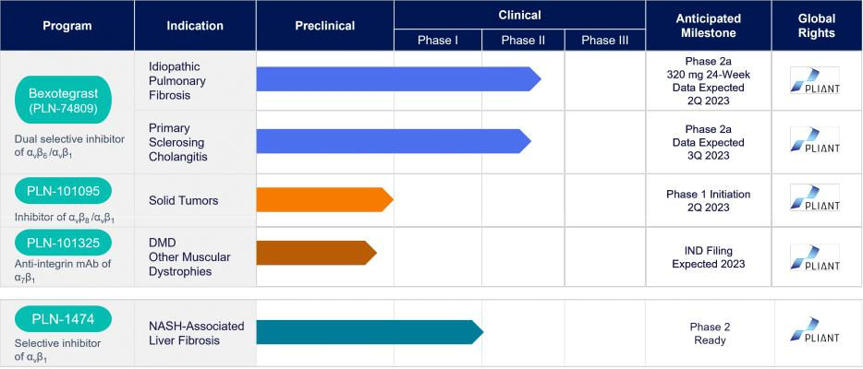

Our Lead Candidate - Bexotegrast

Our lead wholly-owned product candidate, bexotegrast, is an oral, small molecule, dual-selective inhibitor of αvß6 and αvß1 that we are advancing in IPF and PSC. While expressed at very low levels in normal tissues, αvß6 and αvß1 are upregulated in the pulmonary tissues of IPF patients, and in the liver tissues of PSC patients. They both serve as activators of TGF-β, leading to increased collagen production and fibrosis in these tissues. By blocking TGF-β activation by both αvß6 and αvß1, we believe bexotegrast may slow and potentially halt the progression of fibrosis in these patient populations. Bexotegrast has been granted orphan drug designation by the United States Food and Drug Administration, or

5

Table of Contents

FDA and the European Medicines Agency, or EMA, for both IPF and PSC. In addition, bexotegrast has been granted Fast Track designation by the FDA for IPF and PSC.

Bexotegrast for Treatment of IPF

IPF is the most common and severe form of progressive pulmonary fibrosis, affecting approximately 140,000 patients in the United States and over 3 million patients around the world. While the underlying cause of IPF is unknown, the course of the disease is well documented, with progressive scarring that destroys the structure and function of the lungs over time. The average life expectancy for patients with confirmed IPF is between three and five years. There are currently two FDA-approved therapies for IPF. Both have shown modest slowing of disease progression. However, both therapies have raised significant safety and tolerability concerns.

Bexotegrast is an oral small-molecule that selectively inhibits both αvß6 and αvß1 integrins that we are developing as a potential therapy for IPF and PSC. We have determined that TGF-β activation in fibrosis associated with IPF and PSC involves both αvß6 and αvß1 integrins. It has been shown that expression of both αvß6 on epithelial cells and αvß1 on fibroblasts can lead to excessive activation of TGF-β in fibrosis. Epithelial tissue includes any tissue that lines the surfaces of the body such as alveoli, bile ducts, urinary tract, skin, and gastrointestinal tract. Each of these tissues contains multiple cell types including epithelial cells and fibroblasts. An important secondary effect of the TGF-β cascade is that it promotes upregulation of αvß1 on epithelial cells. The increased expression of these integrins on the cell surface contributes in turn to further TGF-β activation in a TGF-β-driven positive feed-forward loop.

In July 2022, we announced positive interim data from the 40 mg, 80 mg and 160 mg dose groups of INTEGRIS-IPF, a multinational, randomized, double-blind, placebo-controlled Phase 2a clinical trial of bexotegrast in patients with IPF. The trial met its primary and secondary endpoints demonstrating that bexotegrast was well tolerated over a 12-week treatment period and displayed a favorable pharmacokinetic profile. The trial’s exploratory efficacy endpoints assessing changes in forced vital capacity, or FVC, and Quantitative Lung Fibrosis, or QLF, imaging, demonstrated a dose-dependent treatment effect on FVC and QLF versus placebo over 12 weeks in bexotegrast treated patients. Bexotegrast was well tolerated over 12 weeks of treatment with no drug related serious adverse events, or SAEs, and no treatment discontinuations due to adverse events

In January 2023, we announced additional positive 12-week interim data from the 320 mg dose group of INTEGRIS-IPF. The 320 mg group met its primary and secondary endpoints demonstrating that bexotegrast was well tolerated over a 12-week treatment period and displayed a favorable pharmacokinetic profile. Bexotegrast at 320 mg demonstrated a statistically significant mean increase in FVC from baseline at all timepoints, surpassing all lower dose groups, and showed a strong treatment effect on FVC percent predicted, or FVCpp, QLF and profibrotic biomarkers versus placebo at 12 weeks. Bexotegrast was well tolerated over 12 weeks of treatment at 320 mg with no drug-related severe or serious adverse events.
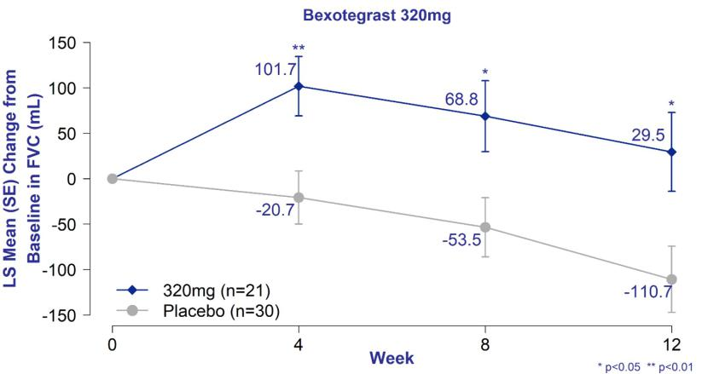

Change in FVC from Baseline of Bexotegrast 320 mg Over 12 Weeks in INTEGRIS-IPF; Mixed Model Repeat Measures Analysis – Modified Intent to Treat Population

6

Table of Contents
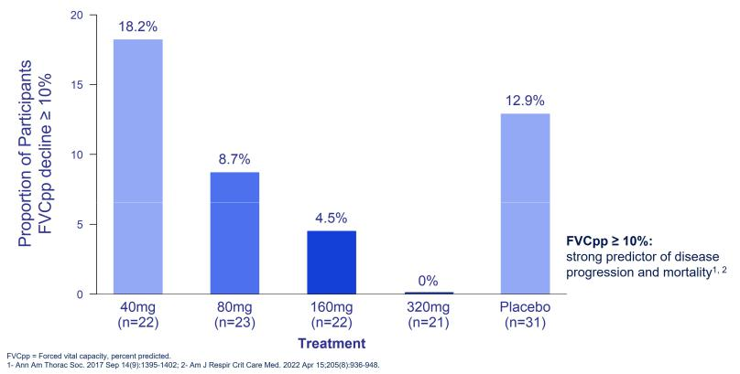

Proportion of Participants with FVCpp Decline ≥10% - Intent to Treat Population
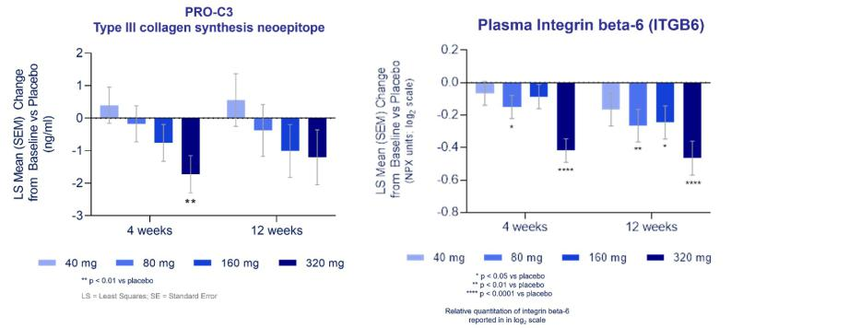

Circulating PRO-C3 and Integrin beta-6 Biomarker Levels–

Change from Baseline at 4- and 12-Weeks vs Placebo

Bexotegrast for Treatment of Primary Sclerosing Cholangitis

PSC is a progressive liver disorder affecting approximately 30,000 to 45,000 patients in the United States. The disease is characterized by fibrosis originating in the bile ducts that ultimately results in bile flow obstruction or cholestasis, causing liver damage and progressive fibrosis of the liver. Patients have a median survival of 10 to 12 years without intervention and carry high lifetime risk of developing gastrointestinal malignancies. There are currently no FDA-approved therapies for PSC.

We are currently conducting a Phase 2a trial of bexotegrast in PSC. The trial is a 12-week randomized, double-blind, placebo-controlled trial enrolling approximately 84 PSC patients across four treatment groups consisting of three bexotegrast doses (40 mg, 80 mg and 160 mg) and one placebo group that will evaluate safety, tolerability and PK. We also plan to evaluate exploratory efficacy endpoints including fibrosis biomarkers such as Pro-C3 and ELF, as well as ALP and liver imaging. We expect to announce data from this trial in the third quarter of 2023.

PLN-1474 for Treatment of Liver Fibrosis Associated with NASH

NASH is highly prevalent, affecting approximately 16.5 million adults in the United States, including approximately 3.3 million with stage F3/F4 fibrosis. The stage of fibrosis is the strongest predictor of liver-related morbidity and all-cause mortality in NASH. Patients with F3 and F4 fibrosis carry liver-related mortality risk that is 17 times and 42 times greater, respectively, than NASH patients without fibrosis. Therefore, we believe that treating F3/F4

7

Table of Contents

liver fibrosis will have an impact on liver-related morbidity and all-cause mortality in NASH. There are currently no approved therapies for NASH and the candidates in development to date have shown only modest antifibrotic effects in published clinical trials.

We have developed a second clinical stage product candidate, PLN-1474, which is an oral, small molecule, selective inhibitor of TGF-β activation by the integrin αvß1 in development for treatment of advanced liver fibrosis associated with NASH. αvß1 serves as an activator of TGF-β and its expression has been shown to be upregulated in hepatic stellate cells in late-stage NASH-associated liver fibrosis.

PLN-1474 has completed a first-in-human, randomized, double-blind, placebo-controlled Phase 1 dose escalation trial that enrolled 84 healthy volunteers across single ascending dose and multiple ascending dose groups. Results showed that PLN-1474 was rapidly absorbed and well tolerated with no dose- or treatment-limiting toxicities observed with adverse events that were mostly mild with no severe or serious adverse events observed.

In October 2019, we entered into a collaboration and license agreement with Novartis in which Novartis licensed global rights to PLN-1474. Pursuant to the terms of the agreement, we received an upfront $50.0 million license fee and a $25.0 million contingent payment upon first-patient first-dose in the Phase 1 clinical trial of PLN-1474. As part of a broad strategic realignment, Novartis has discontinued clinical development in NASH and, as a result, discontinued development of PLN-1474. In February 2023, Novartis returned global rights to PLN-1474 to Pliant. Please refer to Note 8 to our financial statements appearing elsewhere in this Annual Report for further information about the license and collaboration.

PLN-101095 for Treatment of Solid Tumors That are Resistant to Immune Checkpoint Inhibitors

In December 2022, we filed an IND for our third clinical program, PLN-101095 an oral, dual inhibitor of αvß8 and αvß1 integrins for the treatment of solid tumors with a suboptimal response to immune checkpoint inhibitors, or ICIs. In January 2023 we received clearance from the FDA to begin clinical trials. As TGF-β biology has been elucidated, it has become increasingly understood in the scientific literature that TGF-β plays an important anti-inflammatory role in the tumor micro-environment, preventing T-cell infiltration and inhibiting release of various cytokines. This mechanism is becoming increasingly recognized as a potential cause of the resistance to checkpoint inhibitors such as anti-PD-1 therapies seen in many tumors. We are targeting the TGF-β activating integrins αvβ8 and αvβ1, which are upregulated in certain tumors, with the goal of sensitizing tumors to checkpoint inhibitors. We plan to initiate Phase 1 first-in-human study evaluating PLN-101095 in patients with solid tumors with a suboptimal response to immune checkpoint inhibitors, or ICIs, in the second quarter of 2023.

PLN-101325 for Treatment of Muscular Dystrophies

In addition to our clinical programs, we are developing a preclinical allosteric agonistic monoclonal antibody against α7β1 for treatment of muscular dystrophies, including Duchenne Muscular Dystrophy, or DMD. The α7β1 integrin is upregulated on muscle cells in several muscular dystrophy indications, partially compensating for the lack of dystrophin and helping to anchor muscle cells to the extracellular matrix. The program utilizes an allosteric agonistic antibody to activate the target in order to augment the naturally occurring compensatory mechanism. Because the antibody is not mutation specific, it could potentially be effective as a single therapy or in combination with other treatment modalities across multiple muscular dystrophy indications. Our muscular dystrophy candidate is currently undergoing IND enabling studies with submission of an IND expected in 2023.

Our Team

We have assembled an executive team with highly relevant experience in fibrosis, small molecule drug discovery and clinical development. Bernard Coulie, M.D., Ph.D., our President and Chief Executive Officer, has over 20 years of experience in drug development, previously serving as Chief Executive Officer and Chief Medical Officer of ActoGeniX, as well as holding senior roles at Johnson & Johnson. Éric Lefebvre, M.D., our Chief Medical Officer, brings deep experience in clinical development in liver disease. He previously served as head of clinical research and development for the NASH program at Allergan. Prior to Allergan, Dr. Lefebvre led HIV and HCV development at Janssen and later served as Chief Medical Officer at Tobira. Our science builds on the research of world-renowned researchers Dean Sheppard, M.D., Rik Derynck, Ph.D., Bill DeGrado, Ph.D. and Hal Chapman, M.D., all from the University of California, San Francisco, who bring broad experience in fibrosis biology and small molecule chemistry among other related disciplines.

8

Table of Contents

Our Strategy

Our goal is to become a world-leading fibrosis company, developing and commercializing disease- modifying therapies across a spectrum of fibrotic diseases. To achieve this, we are focused on the following key strategies:

- Rapidly advance bexotegrast through clinical development and commercialization in IPF and PSC. We are developing our lead oral, small molecule inhibitor of αvß6 and αvß1 as a novel therapy for IPF and PSC, each an area of high unmet medical need. Both IPF and PSC are orphan indications that we believe we can commercialize on our own in key geographies using targeted sales forces.

- Selectively evaluate additional partnerships in indications and geographies where we believe partners can add significant commercial and/or development capabilities. Fibrotic diseases represent a broad set of disease indications to pursue. Our focus is to commercialize our assets in orphan fibrosis indications and to selectively work with partners in larger indications and in geographies outside of North America. Furthermore, we will evaluate and potentially choose to partner our unpartnered product candidates in indications outside of fibrosis.

- Explore opportunities for our pipeline assets in additional fibrotic indications. We are evaluating the potential benefit of our product candidates outside of their lead indications. Our product candidates have shown anti-fibrotic activity in multiple animal models as well as human tissue in indications outside of IPF, PSC and NASH. We will continue to evaluate additional indications to maximize the potential of our pipeline.

- Leverage our industry leading tools and capabilities to advance our mission of becoming a leading fibrosis company. Since our founding, we have endeavored to advance the understanding of fibrosis biology, uncover new targets and advance novel product candidates. Currently, our proprietary capabilities include a target expression atlas, an expansive library of over 10,000 integrin binding molecules, an integrin screening assay platform, a live fibrotic human tissue program, a PET-ligand imaging program and biomarker assays. We continue to expand our integrin inhibitor library and develop tools such as additional PET-ligands as well as novel disease biomarkers. In addition, we have a library of over 70,000 compounds for non-integrin targets. We intend to leverage these tools and capabilities in a target- and modality-agnostic manner to expand our pipeline with a mission to become a world-leading fibrosis company.

Competition

The biotechnology and biopharmaceutical industries are characterized by rapidly advancing technologies, strong competition and an emphasis on proprietary products. While we believe that our technology, knowledge, experience and scientific personnel provide us with competitive advantages, we face substantial competition from many different sources, including larger pharmaceutical companies with greater resources. Smaller specialty biotechnology and biopharmaceutical companies, academic research institutions, governmental agencies, as well as public and private institutions are also potential sources of competitive products and technologies, including through collaborative arrangements with large and established biopharmaceutical companies. We also face competition in recruiting and retaining qualified scientific and management personnel, establishing clinical trial sites and enrolling patients for clinical trials, and acquiring technologies complementary to, or necessary for, our programs. We believe that the key competitive factors affecting the success of any of our product candidates will include efficacy, safety profile, convenience, method of administration, cost, level of promotional activity and intellectual property protection.

There are a number of biopharmaceutical and biotechnology companies that are currently pursuing the development of products for the treatment of fibrosis. Companies that we are aware of that are targeting the treatment of various fibrosis indications through inhibiting various parts of the TGF-β pathway include companies with significant financial resources such as AbbVie

Inc., AstraZeneca plc, Bristol Myers Squibb Co., Corbus Pharmaceutical, DiCE Therapeutics, Inc., FibroGen, Inc., Merck & Co., Inc., Morphic Therapeutics, Inc., Novartis AG, Scholar Rock and Takeda Pharmaceutical Company.

Boehringer Ingelheim's PDE4B inhibitor (BI 1015550), FibroGen Inc.'s monoclonal antibody against connective tissue growth factor (pamrevlumab) and United Therapeutics' prostacyclin vasodilator (treprostinil) are the most advanced development candidates for the treatment of IPF. Roche Holding AG recently discontinued its Phase 3 trial of recombinant human pentraxin-2 monoclonal antibody.

9

Table of Contents

Although our novel approach is unique from most other existing or investigational therapies across the disease areas where we are focusing our development, we will need to compete with currently approved therapies, and potentially those in currently in development if they are approved. We are aware of several marketed and investigational products in our leading disease areas, including but not limited to:

- IPF: There are currently two approved products for the treatment of IPF; Esbriet, marketed by Roche Holding AG, and Ofev, marketed by Boehringer Ingelheim GmbH. Companies currently developing product candidates in IPF include Boehringer Ingelheim Pharmaceuticals, Inc., FibroGen Inc., Galecto Biotech, Inc., Amgen Inc., Bristol Myers Squibb Co., United Therapeutics Corporation, Vicore Pharma Holding, CSL Behring, and Endeavor BioMedicines, Inc.

- PSC: There are currently no approved therapies for the treatment of PSC. Companies currently developing product candidates in PSC include Dr. Falk Pharma GmbH, Mirum Pharmaceuticals, Inc., Chemomab Therapeutics Ltd., HighTide Therapeutics Inc., and Escient Pharmaceuticals, Inc.

- NASH: There are currently no FDA-approved therapies for the treatment of NASH. There are a number of companies developing product candidates for the treatment of NASH including 89bio, Inc., AbbVie Inc., Akero Therapeutics, Inc., Amgen Inc., AstraZeneca plc, Boehringer Ingelheim, Bristol Myers Squibb Co., Cascade Pharmaceuticals, Inc., Cirius Therapeutics, Inc., Dr. Falk Pharma GmbH, Eli Lilly & Company, Enanta Pharmaceuticals, Inc., Gannex Pharma Co., Ltd., Galectin Therapeutics Inc., Gilead Sciences, Inc., Genfit SA, Genentech, Inc., GlaxoSmithKline plc, Intercept Pharmaceuticals, Inc., Inventiva Pharma, Ionis Pharmaceuticals, Inc., Johnson & Johnson, Madrigal Pharmaceuticals, Inc., Merck & Co., Inc., Metacrine, Inc., NGM Biopharmaceuticals, Inc., NorthSea Therapeutics B.V., Novo Nordisk, Pfizer Inc., Roche Holding AG, Regeneron Pharmaceuticals, Inc., Sanofi S.A., Takeda Pharmaceutical Company, Terns Pharmaceuticals, Inc., Viking Therapeutics, Inc. and Zydus Therapeutics Inc. Most of the drugs currently in development for NASH are focused on decreasing liver fat or improving liver inflammation as opposed to direct liver anti-fibrotic approaches.

The availability of reimbursement from government and other third-party payors will also significantly affect the pricing and competitiveness of our product candidates, if approved for marketing. Our competitors also may obtain FDA or other regulatory approval for their products more rapidly than we do, which could result in our competitors establishing a strong market position before we are able to enter the market.

Intellectual Property

Overview

We strive to protect and enhance the proprietary technology, inventions, and improvements that are commercially important to the development of our business, including seeking, maintaining, and defending patent rights, whether developed internally or licensed from third parties. We also rely on trade secrets relating to our proprietary technology platform and on know-how, continuing technological innovation and in-licensing opportunities to develop, strengthen, and maintain our proprietary position in the field of fibrosis that may be important for the development of our business. We additionally may rely on regulatory protection afforded through data exclusivity, market exclusivity, and patent term extensions, where available.

Our commercial success may depend in part on our ability to: obtain and maintain patent and other proprietary protection for commercially important technology, inventions and know-how related to our business; defend and enforce our patents; preserve the confidentiality of our trade secrets; and operate without infringing the valid enforceable patents and proprietary rights of third parties. Our ability to stop third parties from making, using, selling, offering to sell, or importing our products may depend on the extent to which we have rights under valid and enforceable licenses, patents, or trade secrets that cover these activities. In some cases, enforcement of these rights may depend on third party licensors. With respect to both licensed and company-owned intellectual property, we cannot be sure that patents will be granted with respect to any of our pending patent applications or with respect to any patent applications filed by us in the future, nor can we be sure that any of our existing patents or any patents that may be granted to us in the future will be commercially useful in protecting our commercial products and methods of manufacturing the same.

10

Table of Contents

As of March 5, 2023, we own, co-own or license over 250 pending patent applications worldwide in over 26 patent families, including United States and corresponding foreign patent applications. As of March 5, 2023, nine U.S. patents and four foreign patents have been issued or allowed. Our patents and any patents that may issue from our pending patent applications are generally expected to expire between the years 2037 to 2044, subject to possible patent term adjustment and/or extension. Our policy is to file patent applications to protect technology, inventions and improvements to inventions that are commercially important to the development of our business. We seek United States and foreign patent protection for a variety of technologies, including, research compounds and methods, candidate compounds and antibodies for modulating the activity of integrins, methods for treating diseases of interest, and methods for manufacturing our products. We also intend to seek patent protection or rely upon trade secret rights to protect other technologies that may be used to discover and validate targets and that may be used to identify and develop novel products. We seek protection, in part, through confidentiality and proprietary information agreements. We are a party to various other license agreements that give us rights to use specific technologies in our research and development.

Company Owned IP

We own multiple families of patent applications that are directed to small-molecule compositions capable of modulating integrins and methods for treating or preventing diseases associated with integrins. Certain applications in these families relate to our bexotegrast and PLN-1474 small-molecule product candidates, backup compounds and structural analogs, various unit dosages, dosing regimens, and routes of administration. We are also pursuing innovative ways to modulate integrin function using antibodies and have 36 pending patent applications to that technology in the United States and foreign jurisdictions. Patents that may issue from these company owned applications are generally expected to expire between the years 2040 to 2043, subject to possible patent term adjustment and/or extension.

Trademark Protection

We have two registered U.S. trademarks for use in connection with our products. We may pursue additional registrations for future products in markets of interest. Trade Secret Protection

We may rely, in some circumstances, on trade secrets to protect our technology. We seek to protect our proprietary technology and processes, in part, by entering into confidentiality agreements with our employees, consultants, scientific advisors, and contractors. We also seek to preserve the integrity and confidentiality of our data and trade secrets by maintaining physical security of our premises and physical and electronic security of our information technology systems.

In addition to the above, we have established expertise and development capabilities focused in the areas of preclinical research and development, manufacturing and manufacturing process development, quality control, quality assurance, regulatory affairs, and clinical trial design and implementation. We believe that our focus and expertise will help us develop products based on our proprietary intellectual property.

License Agreements

Novartis Collaboration and License Agreement

In October 2019, we entered into a collaboration and license agreement, or the Novartis Agreement, with Novartis Institutes for Biomedical Research, Inc., or Novartis, for the research, development, and commercialization of PLN-1474. Pursuant to the terms of the Novartis Agreement, the PLN-1474 IND was transferred to Novartis in the first quarter of 2021 following completion of our first-in-human Phase 1 clinical trial. Upon transfer of the IND, Novartis assumed responsibility for all future development, manufacturing, and commercialization and we earned research and development services revenues in performing certain activities outlined in the Novartis Agreement. All such services were substantially complete as of December 31, 2022.

In addition, the Novartis Agreement provided for an early research program for up to three additional integrin targets, or the Research Targets. The research term, as amended in 2022, concludes in the first quarter of 2023. During the research term, we collaborate with Novartis to biologically validate certain potential Research Targets and identify and synthesize potential research compounds for each Research Target in accordance with the applicable research plan. In the second quarter of 2022 we validated one of the Research Targets and began synthesizing potential research compounds.

11

Table of Contents

As part of a broad strategic realignment, Novartis has discontinued clinical development in NASH and, as a result, discontinued development of PLN-1474. In February 2023, Novartis issued a termination notice for the collaboration and license agreement, and returned global rights to Pliant for PLN-1474 as well as the early research targets and associated compounds.

Please refer to Note 8 to our financial statements appearing elsewhere in this Annual Report for further information about the license and collaboration.

Manufacturing

Our product candidates, bexotegrast and PLN-1474, are small molecule inhibitors amenable to standard formulation technologies. We have confirmed the utility of the synthetic process and manufactured multi-kilogram quantities sufficient to provide drug product for our clinical trials. The manufacturing process of the drug substance for such product candidates is robust and accessed from readily available starting materials. The synthetic route is amenable to large-scale production and does not require unusual equipment or handling during the manufacturing process.

We do not own or operate facilities for clinical drug manufacturing, storage, distribution, or quality testing. All of our clinical manufacturing is outsourced to third-party manufacturers. Our agreements with third-party manufacturers include confidentiality and intellectual property provisions as well as routine quality audits. We also rely on internal personnel with extensive cGMP manufacturing experience in order to ensure effective technology transfer and to manage the manufacturing and development processes conducted by third-party manufacturers.

We have established an adequate supply of the drug substance for bexotegrast from our Asian contract manufacturing organizations, or CMOs, to satisfy both our clinical and preclinical requirements and have evaluated additional suppliers in North America and Europe to mitigate supply chain risk and maximize flexibility.

As our development programs expand and we build new process efficiencies, we expect to continually evaluate this strategy with the objective of satisfying demand for our clinical trials and, if approved, the manufacture, sale, and distribution of commercial products.

Government Regulation

The FDA and comparable regulatory authorities in state and local jurisdictions and in other countries impose substantial and burdensome requirements upon companies involved in the clinical development, manufacture, marketing, and distribution of drugs, such as those we are developing. These agencies and other federal, state, and local entities regulate, among other things, the research and development, testing, manufacture, quality control, safety, effectiveness, labeling, storage, record keeping, approval, advertising and promotion, distribution, post-approval monitoring and reporting, sampling and export and import of our product candidates.

U.S. government regulation of drug products

In the United States, the FDA regulates drugs under the Federal Food, Drug, and Cosmetic Act, or FDCA, and its implementing regulations. The FDA also regulates biological products under the FDCA and the Public Health Service Act, or PHSA. If we advance clinical development of a biological product candidate in the future, these development activities will be subject to additional regulatory requirements specific to biological products. The process of obtaining regulatory approvals and the subsequent compliance with applicable federal, state, local and foreign statutes and regulations requires the expenditure of substantial time and financial resources. Failure to comply with the applicable U.S. requirements at any time during the product development process, approval process or after approval, may subject an applicant to a variety of administrative or judicial sanctions, such as the FDA’s refusal to approve pending New Drug Applications, or NDAs, withdrawal of an approval, imposition of a clinical hold, issuance of warning letters, product recalls, product seizures, total or partial suspension of production or distribution, injunctions, fines, refusals of government contracts, restitution, disgorgement or civil or criminal penalties.

The process required by the FDA before a drug may be marketed in the United States generally involves the following:

- Completion of preclinical laboratory tests, animal studies and formulation studies in compliance with the FDA’s good laboratory practice, or GLP, regulations;

- Submission to the FDA of an investigational new drug application, or IND, which must become effective before human clinical trials may begin;

12

Table of Contents

- Approval by an independent institutional review board, or IRB, at each clinical site before each trial may be initiated;

- Performance of adequate and well-controlled human clinical trials in accordance with good clinical practice, or GCP, requirements to establish the safety and efficacy of the proposed drug product for each indication;

- Submission to the FDA of an NDA;

- Satisfactory completion of an FDA advisory committee review, if applicable;

- Satisfactory completion of an FDA inspection of the manufacturing facility or facilities at which the product is produced to assess compliance with current good manufacturing practice, or cGMP, requirements and to assure that the facilities, methods and controls are adequate to preserve the drug’s identity, strength, quality and purity;

- Satisfactory completion of FDA audits of clinical trial sites to assure compliance with GCPs and the integrity of the clinical data;

- Payment of user fees and securing FDA approval of the NDA; and

- Compliance with any post-approval requirements, including the potential requirement to implement a Risk Evaluation and Mitigation Strategy, or REMS, and the potential requirement to conduct post-approval studies.

Preclinical studies

Preclinical studies include laboratory evaluation of product chemistry, toxicity and formulation, as well as animal studies to assess potential safety and efficacy. An IND sponsor must submit the results of the preclinical tests, together with manufacturing information, analytical data and any available clinical data or literature, among other things, to the FDA as part of an IND. Some preclinical testing may continue even after the IND is submitted. An IND automatically becomes effective 30 days after receipt by the FDA, unless before that time the FDA raises concerns or questions related to one or more proposed clinical trials and places the clinical trial on a clinical hold. In such a case, the IND sponsor and the FDA must resolve any outstanding concerns before the clinical trial can begin. As a result, submission of an IND may not result in the FDA allowing clinical trials to initiate.

Clinical trials

Clinical trials involve the administration of the investigational new drug to human subjects under the supervision of qualified investigators in accordance with GCP requirements, which include the requirement that all research subjects provide their informed consent in writing for their participation in any clinical trial. Clinical trials are conducted under protocols detailing, among other things, the objectives of the trial, the parameters to be used in monitoring safety, and the effectiveness criteria to be evaluated. A protocol for each clinical trial and any subsequent protocol amendments must be submitted to the FDA as part of the IND. In addition, an IRB at each institution participating in the clinical trial must review and approve the plan for any clinical trial before it initiates at that institution. Information about certain clinical trials must be submitted within specific timeframes to the National Institutes of Health, or NIH, for public dissemination on their www.clinicaltrials.gov website.

Human clinical trials are typically conducted in three sequential phases, which may overlap or be combined:

- Phase 1: The drug is initially introduced into healthy human subjects or patients with the target disease or condition and tested for safety, dosage tolerance, absorption, metabolism, distribution, excretion and, if possible, to gain an early indication of its effectiveness.

- Phase 2: The drug is administered to a limited patient population to identify possible adverse effects and safety risks, to preliminarily evaluate the efficacy of the product for specific targeted diseases and to determine dosage tolerance and optimal dosage.

- Phase 3: The drug is administered to an expanded patient population, generally at geographically dispersed clinical trial sites, in well-controlled clinical trials to generate enough data to statistically

13

Table of Contents

evaluate the efficacy and safety of the product for approval, to establish the overall risk-benefit profile of the product, and to provide adequate information for the labeling of the product.

Progress reports detailing the results of the clinical trials must be submitted at least annually to the FDA and more frequently if serious adverse events occur. Phase 1, Phase 2 and Phase 3 trials may not be completed successfully within any specified period, or at all. Furthermore, the FDA or the sponsor may suspend or terminate a clinical trial at any time on various grounds, including a finding that the research subjects are being exposed to an unacceptable health risk. Similarly, an IRB can suspend or terminate approval of a clinical trial at its institution if the clinical trial is not being conducted in accordance with the IRB’s requirements or if the drug has been associated with unexpected serious harm to patients.

Marketing approval

Assuming successful completion of the required clinical testing, the results of the preclinical and clinical studies, together with detailed information relating to the product’s chemistry, manufacture, controls, and proposed labeling, among other things, are submitted to the FDA as part of an NDA requesting approval to market the product for one or more indications. In most cases, the submission of an NDA is subject to a substantial application user fee. Under the Prescription Drug User Fee Act, or PDUFA, guidelines that are currently in effect, the FDA has a goal of ten months from the date of “filing” of a standard NDA, for a new molecular entity to review and act on the submission. This review typically takes twelve months from the date the NDA is submitted to FDA because the FDA has approximately two months to make a “filing” decision.

In addition, under the Pediatric Research Equity Act of 2003, or PREA, as amended and reauthorized, certain NDAs or supplements to an NDA must contain data that are adequate to assess the safety and effectiveness of the drug for the claimed indications in all relevant pediatric subpopulations, and to support dosing and administration for each pediatric subpopulation for which the product is safe and effective. The FDA may, on its own initiative or at the request of the applicant, grant deferrals for submission of some or all pediatric data until after approval of the product for use in adults, or full or partial waivers from the pediatric data requirements. An Agreed Initial Pediatric Study Plan requesting a waiver from the requirement to conduct clinical studies has been submitted to the FDA.

The FDA also may require submission of a risk evaluation and mitigation strategy, or REMS, plan to ensure that the benefits of the drug outweigh its risks. The REMS plan could include medication guides, physician communication plans, assessment plans, and/or elements to assure safe use, such as restricted distribution methods, patient registries, or other risk minimization tools.

The FDA conducts a preliminary review of all NDAs within the first 60 days after submission, before accepting them for filing, to determine whether they are sufficiently complete to permit substantive review. The FDA may request additional information rather than accept an NDA for filing. In this event, the application must be resubmitted with the additional information. The resubmitted application is also subject to review before the FDA accepts it for filing. Once the submission is accepted for filing, the FDA begins an in-depth substantive review. The FDA reviews an NDA to determine, among other things, whether the drug is safe and effective and whether the facility in which it is manufactured, processed, packaged or held meets standards designed to assure the product’s continued safety, quality and purity.

The FDA may refer an application for a novel drug to an advisory committee. An advisory committee is a panel of independent experts, including clinicians and other scientific experts, which reviews, evaluates and provides a recommendation as to whether the application should be approved and under what conditions. The FDA is not bound by the recommendations of an advisory committee, but it considers such recommendations carefully when making decisions.

Before approving an NDA, the FDA typically will inspect the facility or facilities where the product is manufactured. The FDA will not approve an application unless it determines that the manufacturing processes and facilities are in compliance with cGMP requirements and adequate to assure consistent production of the product within required specifications. Additionally, before approving an NDA, the FDA may inspect one or more clinical trial sites to assure compliance with GCP requirements.

After evaluating the NDA and all related information, including the advisory committee recommendation, if any, and inspection reports regarding the manufacturing facilities and clinical trial sites, the FDA may issue an approval letter, or, in some cases, a complete response letter. A complete response letter generally contains a statement of specific conditions that must be met in order to secure final approval of the NDA and may require additional clinical or preclinical testing in order for FDA to reconsider the application. Even with submission of this additional information, the FDA ultimately may decide that the application does not satisfy the regulatory criteria for approval. If and when those conditions

14

Table of Contents

have been met to the FDA’s satisfaction, the FDA will typically issue an approval letter. An approval letter authorizes commercial marketing of the drug with specific prescribing information for specific indications.

Even if the FDA approves a product, it may limit the approved indications for use of the product, require that contraindications, warnings or precautions be included in the product labeling, require that post-approval studies, including Phase 4 clinical trials, be conducted to further assess a drug’s safety after approval, require testing and surveillance programs to monitor the product after commercialization, or impose other conditions, including distribution and use restrictions or other risk management mechanisms under a REMS, which can materially affect the potential market and profitability of the product. The FDA may prevent or limit further marketing of a product based on the results of post-marketing studies or surveillance programs. After approval, some types of changes to the approved product, such as adding new indications, manufacturing changes, and additional labeling claims, are subject to further testing requirements and FDA review and approval.

Fast Track designation

The FDA is authorized to designate certain products for expedited review if they are intended to address an unmet medical need in the treatment of a serious or life-threatening disease or condition. Among these programs is Fast Track designation. In May 2014, the FDA published a final Guidance for Industry titled “Expedited Programs for Serious Conditions Drugs and Biologics,” which provides guidance on the FDA programs that are intended to facilitate and expedite development and review of new drug or biological product candidates as well as threshold criteria generally applicable to concluding that a product candidate is a candidate for these expedited development and review programs.

The FDA may designate a product for Fast Track review if it is intended, whether alone or in combination with one or more other products, for the treatment of a serious or life-threatening disease or condition, and nonclinical or clinical data demonstrate the potential to address unmet medical needs for such a disease or condition. For Fast Track products, sponsors may have greater interactions with the FDA and the FDA may initiate review of sections of a Fast Track product’s application before the application is complete. This rolling review may be available if the FDA determines, after preliminary evaluation of clinical data submitted by the sponsor, that a Fast Track product may be effective. The sponsor must also provide, and the FDA must approve, a schedule for the submission of the remaining information and the sponsor must pay applicable user fees. However, the FDA’s review clock for a Fast Track application does not begin until the last section of the application is submitted. In addition, the Fast Track designation may be withdrawn by the FDA if the FDA believes that the designation is no longer supported by data emerging in the clinical trial process.

Orphan drug designation and exclusivity

Under the Orphan Drug Act, the FDA may designate a drug product as an “orphan drug” if it is intended to treat a rare disease or condition (generally meaning that it affects fewer than 200,000 individuals in the United States, or more in cases in which there is no reasonable expectation that the cost of developing and making a drug product available in the United States for treatment of the disease or condition will be recovered from sales of the product). A company must request orphan product designation before submitting an NDA. If the request is granted, the FDA will disclose the identity of the therapeutic agent and its potential use. Orphan product designation does not convey any advantage in or shorten the duration of the regulatory review and approval process.

If a product with orphan status receives the first FDA approval for the disease or condition for which it has such designation or for a select indication or use within the rare disease or condition for which it was designated, the product generally will be receiving orphan product exclusivity. The first active moiety to be approved to treat a disease with FDA's Orphan Drug designation is entitled to a seven-year period of marketing exclusivity in the United States for that product indication, except in certain limited circumstances. If a drug or drug product designated as an orphan product ultimately receives marketing approval for an indication broader than what was designated in its orphan product application, it may not be entitled to exclusivity. Orphan exclusivity will not bar approval of another product under certain circumstances, including if a subsequent product with the same active ingredient for the same indication is shown to be clinically superior to the approved product on the basis of greater efficacy or safety, or providing a major contribution to patient care, or if the company with orphan drug exclusivity is not able to meet market demand. Further, the FDA may approve more than one product for the same orphan indication or disease as long as the products contain different active ingredients. Moreover, competitors may receive approval of different products for the indication for which the orphan product has exclusivity or obtain approval for the same product but for a different indication for which the orphan product has exclusivity.

15

Table of Contents

In addition, Congress is considering updates to the orphan drug provisions of the FDCA in response to a recent decision by the U.S. Court of Appeals for the Eleventh Circuit. Any changes to the orphan drug provisions could change our opportunities for, or likelihood of success in obtaining, orphan drug exclusivity and would materially adversely affect our business, results of operations, financial condition and prospects.

U.S. marketing exclusivity

Market exclusivity provisions under the FDCA also can delay the submission or the approval of certain applications. The FDCA provides a five-year period of non-patent marketing exclusivity within the United States to the first applicant to gain approval of an NDA for a new chemical entity. A drug is a new chemical entity if the FDA has not previously approved any other new drug containing the same active moiety, which is the molecule or ion responsible for the action of the drug substance. During the exclusivity period, the FDA may not accept for review an Abbreviated New Drug Application, or ANDA, or a 505(b)(2) NDA submitted by another company for another version of such drug where the applicant does not own or have a legal right of reference to all the data required for approval. However, an application may be submitted after four years if it contains a certification of patent invalidity or non-infringement. The FDCA also provides three years of marketing exclusivity for a NDA, 505(b)(2) NDA or supplement to an existing NDA if new clinical investigations, other than bioavailability studies, that were conducted or sponsored by the applicant are deemed by the FDA to be essential to the approval of the application, for example, new indications, dosages or strengths of an existing drug. This three-year exclusivity covers only the conditions of use associated with the new clinical investigations and does not prohibit the FDA from approving ANDAs for the original non-modified version of the drug. Five-year and three-year exclusivity will not delay the submission or approval of a full NDA. However, an applicant submitting a full NDA would be required to conduct or obtain a right of reference to all of the preclinical studies and adequate and well-controlled clinical trials necessary to demonstrate safety and effectiveness.

Pediatric exclusivity is another type of regulatory market exclusivity in the United States. Pediatric exclusivity, if granted, adds six months to existing regulatory exclusivity periods. This six-month exclusivity may be granted based on the voluntary completion of a pediatric trial in accordance with an FDA-issued “Written Request” for such a trial.

Post-approval requirements

Drugs manufactured or distributed pursuant to FDA approvals are subject to pervasive and continuing regulation by the FDA, including, among other things, requirements relating to recordkeeping, periodic reporting, product sampling and distribution, advertising and promotion and reporting of adverse experiences with the product. After approval, most changes to the approved product, such as adding new indications or other labeling claims are subject to prior FDA review and approval. There are continuing, annual user fee requirements for any marketed products and the establishments where such products are manufactured, as well as new application fees for supplemental applications with clinical data.

The FDA may impose a number of post-approval requirements as a condition of approval of an NDA. For example, the FDA may require post-marketing testing, including Phase 4 clinical trials, and surveillance to further assess and monitor the product’s safety and effectiveness after commercialization.

In addition, drug manufacturers and other entities involved in the manufacture and distribution of approved drugs are required to register their establishments with the FDA and state agencies and are subject to periodic unannounced inspections by the FDA and these state agencies for compliance with cGMP requirements. Changes to the manufacturing process are strictly regulated and often require prior FDA approval before being implemented. FDA regulations also require investigation and correction of any deviations from cGMP requirements and impose reporting and documentation requirements upon the sponsor and any third-party manufacturers that the sponsor may decide to use. Accordingly, manufacturers must continue to expend time, money, and effort in the area of production and quality control to maintain cGMP compliance.

Once an approval of a drug is granted, the FDA may withdraw the approval if compliance with regulatory requirements and standards is not maintained or if problems occur after the product reaches the market. Later discovery of previously unknown problems with a product, including adverse events of unanticipated severity or frequency, or with manufacturing processes, or failure to comply with regulatory requirements, may result in mandatory revisions to the approved labeling to add new safety information; imposition of post-market studies or clinical trials to assess new safety risks; or imposition of distribution or other restrictions under a REMS program. Other potential consequences include, among other things:

- Restrictions on the marketing or manufacturing of the product, complete withdrawal of the product from the market or product recalls;

16

Table of Contents

- Fines, warning letters or holds on post-approval clinical trials;

- Refusal of the FDA to approve pending NDAs or supplements to approved NDAs, or suspension or revocation of product approvals;

- Product seizure or detention, or refusal to permit the import or export of products; and

- Injunctions or the imposition of civil or criminal penalties.

The FDA strictly regulates marketing, labeling, advertising, and promotion of products that are placed on the market. Drugs may be promoted by a manufacturer and any third parties acting on behalf of a manufacturer only for the approved indications and in a manner consistent with the approved label for the product. The FDA and other agencies actively enforce the laws and regulations prohibiting the promotion of off-label uses, and a company that is found to have improperly promoted off-label uses may be subject to significant liability.

Other healthcare laws

Healthcare providers, physicians, and third party payors play a primary role in the recommendation and prescription of drug products for which we obtain marketing approval. Arrangements with third party payors, healthcare providers and physicians, in connection with the clinical research, sales, marketing and promotion of products, once approved, and related activities, may expose a pharmaceutical manufacturer to broadly applicable fraud and abuse and other healthcare laws and regulations. In the United States, these laws include, without limitation, state and federal anti-kickback, false claims, physician transparency, and patient data privacy and security laws and regulations, including but not limited to those described below:
- the federal Anti-Kickback Statute, or AKS, which makes it illegal for any person, including a prescription drug manufacturer (or a party acting on its behalf) to knowingly and willfully solicit, receive, offer or pay any remuneration (including any kickback, bribe, or rebate), directly or indirectly, overtly or covertly, in cash or in kind, that is intended to induce or reward, referrals including the purchase recommendation, order or prescription of a particular drug for which payment may be made under a federal healthcare program, such as the Medicare and Medicaid programs. A person or entity does not need to have actual knowledge of the statute or specific intent to violate it in order to have committed a violation. In addition, the government may assert that a claim including items or services resulting from a violation of the federal Anti-Kickback Statute constitutes a false or fraudulent claim for purposes of the federal False Claims Act, or FCA. Violations of the federal Anti-Kickback Statute are punishable by imprisonment for up to ten years and statutory fines of up to $100,000. Additional criminal fines can be imposed under federal U.S. criminal procedure laws. Civil penalties include statutory amounts of up to $100,000 (adjusted for inflation) per violation, assessments of up to three times the total payments between the parties to the arrangement, and exclusion from participation in the federal healthcare programs or suspension from future participation in Medicare and Medicaid. Further, violation of the federal Anti-Kickback Statute can also form the basis for False Claims Act liability (discussed below). Although there are a number of statutory exceptions and regulatory safe harbors to the federal Anti-Kickback Statute protecting certain common business arrangements and activities from prosecution or regulatory sanctions, the exceptions and safe harbors are drawn narrowly, and practices that involve remuneration to those who prescribe, purchase, or recommend pharmaceutical and biological products, may be subject to scrutiny if they do not fit squarely within an exception or safe harbor;

- the federal civil and criminal false claims laws, including the FCA, which can be enforced through “qui tam” or “whistleblower” actions, and civil monetary penalty laws, which impose criminal and civil penalties against individuals or entities for, among other things, knowingly presenting, or causing to be presented, claims for payment or approval from Medicare, Medicaid, or other federal health care programs that are false or fraudulent; knowingly making or causing a false statement material to a false or fraudulent claim or an obligation to pay or transmit money or property to the federal government; or knowingly concealing or knowingly and improperly avoiding or decreasing such an obligation. Similar to the federal Anti-Kickback Statute, a person or entity does not need to have actual knowledge of these statutes or specific intent to violate them in order to have committed a violation. Violations of the False Claims Act can result in civil penalties of up to more than $25,000 per false claim or statement (an amount adjusted annually for inflation) plus three times the amount of damages sustained by the government;

- the federal Health Insurance Portability and Accountability Act of 1996, or HIPAA, which created additional federal criminal statutes that prohibit knowingly and willfully executing, or attempting to execute, a scheme to defraud any healthcare benefit program or obtain, by means of false or fraudulent

17

Table of Contents

pretenses, representations, or promises, any of the money or property owned by, or under the custody or control of, any healthcare benefit program, regardless of the payor (e.g., public or private) and knowingly and willfully falsifying, concealing or covering up by any trick or device a material fact or making any materially false statements in connection with the delivery of, or payment for, healthcare benefits, items or services relating to healthcare matters;

- HIPAA, as amended by the Health Information Technology for Economic and Clinical Health Act of 2009, or HITECH, and their respective implementing regulations, which impose requirements on certain covered healthcare providers, health plans, and healthcare clearinghouses as well as their respective business associates that perform services for them that involve the creation, use, receipt, maintenance or disclosure of individually identifiable health information, relating to the privacy, security and transmission of individually identifiable health information;

- the federal Physician Payments Sunshine Act, created under Patient Protection and Affordable Care Act, as amended by the Health Care and Education Reconciliation Act of 2010, or collectively, the ACA, and its implementing regulations, which require manufacturers of drugs, devices, biological products and medical supplies for which payment is available under Medicare, Medicaid or the Children’s Health Insurance Program to report annually to the Centers for Medicare and Medicaid Services, or CMS, under the Open Payments Program, information related to payments or other transfers of value made to physicians (defined to include doctors, dentists, optometrists, podiatrists and chiropractors) , nurse practitioners, clinical nurse specialists, certified registered nurse anesthetists, anesthesiologist assistants, certified nurse-midwives, and teaching hospitals, as well as ownership and investment interests held by physicians and their immediate family members; and

- analogous state and foreign laws and regulations, such as state and foreign anti-kickback, false claims, consumer protection, transparency and disclosure laws, and unfair competition laws which may apply to pharmaceutical business practices, including but not limited to, research, distribution, sales and marketing arrangements as well as submitting claims involving healthcare items or services reimbursed by any third-party payor, including commercial insurers; state laws that require pharmaceutical companies to comply with the pharmaceutical industry’s voluntary compliance guidelines and the relevant compliance guidance promulgated by the federal government that otherwise restricts payments that may be made to healthcare providers and other potential referral sources; state laws that require drug manufacturers to file reports with states regarding pricing and marketing information, such as the tracking and reporting of gifts, compensations and other remuneration and items of value provided to healthcare professionals and entities and, in some states, the reporting of drug wholesale acquisition costs or average manufacturer prices, information related to new drug launches, and drug price increases above certain statutory thresholds; state and local laws requiring the registration of pharmaceutical sales representatives; and state and foreign laws governing the privacy and security of health information in certain circumstances, many of which differ from each other in significant ways and may not have the same effect, thus complicating compliance efforts.

Because of the breadth of these laws, it is possible that some of a pharmaceutical manufacturer’s business activities could be subject to challenge under one or more of such laws. Efforts to ensure that business arrangements comply with applicable healthcare laws involve substantial costs. It is possible that governmental and enforcement authorities will conclude that a pharmaceutical manufacturer’s business practices do not comply with current or future statutes, regulations or case law interpreting applicable fraud and abuse or other healthcare laws and regulations. If any such actions are instituted against a pharmaceutical manufacturer, and it is not successful in defending itself or asserting its rights, those actions could have a significant impact on its business, including the imposition of significant civil, criminal and administrative penalties, damages, disgorgement, imprisonment, monetary fines, possible exclusion from participation in Medicare, Medicaid and other federal healthcare programs, reporting obligations and oversight if a pharmaceutical manufacturer becomes subject to integrity and oversight agreements to resolve allegations of non-compliance, contractual damages, reputational harm, diminished profits and future earnings, and curtailment of operations, any of which could adversely affect a pharmaceutical manufacturer’s ability to operate its business and the results of operations. In addition, commercialization of any drug product outside the United States will also likely be subject to foreign equivalents of the healthcare laws mentioned above, among other foreign laws.

In the U.S., numerous federal and state laws, and regulations, including state data breach notification laws, state health information privacy laws, and federal and state consumer protection laws, govern the collection, use, disclosure, and protection of health-related and other personal information. For example, in June 2018, the State of California enacted the California Consumer Privacy Act of 2018, or the CCPA, which came into effect on January 1, 2020 and provides new data privacy rights for consumers and new operational requirements for companies, which may increase our compliance costs and potential liability. The CCPA gives California residents expanded rights to access and delete their personal

18

Table of Contents

information, opt out of certain personal information sharing, and receive detailed information about how their personal information is used. The CCPA provides for civil penalties for violations, as well as a private right of action for data breaches that is expected to increase data breach litigation. While there is currently an exception for protected health information that is subject to HIPAA and clinical trial regulations, as currently written, the CCPA impacts certain of our business activities. The CCPA could mark the beginning of a trend toward more stringent state privacy legislation in the U.S., which could increase our potential liability and adversely affect our business.

In the event we decide to conduct clinical trials or continue to enroll subjects in our ongoing or future clinical trials, we may be subject to additional privacy restrictions. The collection, use, storage, disclosure, transfer, or other processing of personal data regarding individuals in the European Economic Area, or EEA, including personal health data, is subject to the EU General Data Protection Regulation, or EU GDPR, which became effective on May 25, 2018. The EU GDPR is wide-ranging in scope and imposes numerous requirements on companies that process personal data (i.e., data relating to identified or identifiable individuals), including requirements relating to having legal bases for processing personal data, transferring such personal data outside the EEA, including to the United States, processing health and other sensitive data, obtaining consent of the individuals to whom the personal data relates, providing information to individuals regarding data processing activities, responding to individuals’ requests to exercise their rights in respect of their personal data, implementing safeguards to protect the security and confidentiality of personal data, having data processing agreements with third parties who process personal data on our behalf, providing notification of data breaches, and taking certain measures when engaging third-party processors, conducting data protection impact assessments, and record-keeping.

The EU GDPR increases substantially the penalties to which we could be subject in the event of any non-compliance and permits data protection authorities to impose large penalties for violations of the EU GDPR, including potential fines of up to €20 million or 4% of annual global revenues, whichever is greater. The EU GDPR also confers a private right of action on data subjects and consumer associations to lodge complaints with supervisory authorities, seek judicial remedies, and obtain compensation for damages resulting from violations of the EU GDPR. The EU GDPR may increase our responsibility and liability in relation to personal data that we process where such processing is subject to the EU GDPR, and we may be required to put in place additional mechanisms to ensure compliance with the EU GDPR, including as implemented by individual countries. Compliance with the EU GDPR is a rigorous and time-intensive process that may increase our cost of doing business or require us to change our business practices, and despite those efforts, there is a risk that we may be subject to fines and penalties, litigation, and reputational harm in connection with our European activities.

The EU GDPR also prohibits the transfer of personal data from the EEA to the United States and other countries that are not recognized as having “adequate” data protection laws by the European Commission unless the parties to the transfer have implemented specific safeguards to protect the transferred personal data. One of the primary safeguards allowing U.S. companies to
import personal data from the EEA had been certification to the EU-U.S. Privacy Shield framework administered by the U.S. Department of Commerce. However, the European Court of Justice issued a decision in July 2020 which invalidated the EU-U.S. Privacy Shield framework for international transfers (Schrems II) and imposed further restrictions on using the specific safeguard standard contractual clauses (SCCs) including, a requirement for companies to carry out a transfer privacy impact assessment, which among other things, assesses laws governing access to personal data in the recipient country and considers whether supplementary measures that provide privacy protections additional to those provided under the SCCs will need to be implemented to ensure an essentially equivalent level of data protection to that afforded in the EU. Following that decision, the Swiss Federal Data Protection and Information Commissioner took a similar view and considered that data transfers based on the Swiss-U.S. Privacy Shield framework are no longer lawful (despite the fact that Schrems II is not directly applicable in Switzerland (unless the Swiss based company is subject to the EU GDPR) although the Swiss-U.S. Privacy Shield has not been officially invalidated).

Further to Schrems II, the European Commission published new EU SCCs in June 2021, which place onerous obligations on the contracting parties. Therefore, until recently, there were few, if any, viable alternatives to the SCCs. However, on 7 October 2022, President Biden introduced an Executive Order to facilitate a new Trans-Atlantic Data Privacy Framework which will act as a successor to the invalidated EU-U.S. Privacy Shield. If approved by the European Commission and implemented, the agreement will facilitate the transatlantic flow of personal data and provide additional safeguards to any existing data transfer mechanisms (including SCCs) for companies transferring personal data from the EU to the U.S. However, before entities rely on the new EU-U.S. Privacy Shield, there are still legislative and regulatory steps that must be undertaken both in the U.S. and in the EU. Therefore, at present the new EU SCCs are still the primary safeguard available for personal data transfers from the EU to the U.S. As such, the current legal position may have implications for our cross-border data flows and may result in compliance costs.

In addition, further to the UK’s exit from the EU on January 31, 2020, the EU GDPR ceased to apply in the UK at the end of the transition period on December 31, 2020. However, as of January 1, 2021, the UK’s European Union (Withdrawal) Act 2018 incorporated the EU GDPR (as it existed on December 31, 2020 but subject to certain UK specific amendments) into UK law (referred to as the 'UK GDPR'). The UK GDPR and the UK Data Protection Act 2018 set out

19

Table of Contents

the UK’s data protection regime, which is independent from but aligned to the EU’s data protection regime. Non-compliance with the UK GDPR may result in monetary penalties of up to £17.5 million or 4% of worldwide revenue, whichever is higher.
As a result, we are potentially exposed to two parallel data protection regimes, each of which authorizes fines and the potential for divergent enforcement actions. The European Commission adopted the adequacy decision for the UK in June 2021, allowing a free flow of personal data from the EU to the UK where it benefits from an essentially equivalent level of protection to that guaranteed under EU data protection law. It should be noted that the UK GDPR also prohibits the transfer of personal data from the UK to other countries that are not recognized as having “adequate” data protection laws, including the U.S., in a similar manner to the EU. In addition, the UK Government has published its own form of SCCs, known as the International Data Transfer Agreement and International Data Transfer Addendum to the new EU SCCs. The UK Information Commissioner’s Office has also published its version of the transfer impact assessment and revised guidance on international transfers, although companies may choose to either use the EU style or UK style transfer impact assessment. In terms of international data transfers between the UK and US, it is understood that the UK and the US are negotiating an adequacy agreement.

Current and future healthcare reform legislation

In both the United States and certain foreign jurisdictions, there have been a number of legislative and regulatory changes to the health care system. In the United States, in March 2010, the Patient Protection and Affordable Care Act, as amended by the Health Care and Education Reconciliation Act, collectively known as the ACA, was enacted, which substantially changed the way healthcare is financed by both governmental and private payors, and significantly affected the pharmaceutical industry. The ACA, among other things, addressed a new methodology by which rebates owed by manufacturers under the Medicaid Drug Rebate Program are calculated for drugs that are inhaled, infused, instilled, implanted or injected, increased the minimum Medicaid rebates owed by manufacturers under the Medicaid Drug Rebate Program and extended the rebate program to individuals enrolled in Medicaid managed care organizations, established annual fees and taxes on manufacturers of certain branded prescription drugs, and created a new Medicare Part D coverage gap discount program, in which manufacturers must agree to offer 50% (increased to 70% pursuant to the Bipartisan Budget Act of 2018, effective as of 2019) point-of-sale discounts off negotiated prices of applicable brand drugs to eligible beneficiaries during their coverage gap period, as a condition for the manufacturer’s outpatient drugs to be covered under Medicare Part D. Under the Inflation Reduction Act of 2022, or the IRA, this coverage gap discount program will be eliminated beginning January 1, 2025. Manufacturers will then be required to pay 10% of the negotiated price of brands, biologics and biosimilar products when Medicare Part D beneficiaries are in the initial coverage phase, and 20% of the negotiated price during the catastrophic phase of Medicare Part D coverage. There have been numerous historic judicial, administrative, executive, and legislative challenges and amendments (including recent amendments that expand access to care) to certain aspects of the ACA. In June 2021, the Supreme Court dismissed a lawsuit challenging the constitutionality of certain aspects of the ACA, without ruling on the meris of the constitutionality arguments. In the future, there may be additional legislative, regulatory, executive, or judicial actions that result in healthcare reform. It remains to be seen precisely what any new reforms will provide, when or if they will be enacted, and what impact they will have on the availability and cost of healthcare items and services, including drug products.

Other legislative and regulatory changes have been proposed or adopted in the United States since the ACA was enacted, including several legislative and regulatory changes that are focused on capping or reducing healthcare costs, as well as measures that would address healthcare fraud and abuse, value-based care, drug pricing and other reforms. For example, in August 2022,

President Biden signed into law the IRA, which implements substantial changes to the Medicare program, including drug pricing reforms and changes to the Medicare Part D benefit design. Among other reforms, the Inflation Reduction Act of 2022 imposes inflation rebates on drug manufacturers for products reimbursed under Medicare Parts B and D if the prices of those products increase faster than inflation; implements changes to the Medicare Part D benefit that, beginning in 2025, will cap benefit annual out-of-pocket spending at $2,000, while imposing new discount obligations for pharmaceutical manufacturers; and, beginning in 2026, establishes a “maximum fair price” for a fixed number of high spend pharmaceutical and biological products covered under Medicare Parts B and D following a price negotiation process with the Centers for Medicare and Medicaid Services. The IRA explicitly excludes from price negotiation orphan drugs designated for only one rare disease or condition and for which the only approved indication is for such disease or condition. However, those drugs with multiple orphan designations are not explicitly excluded from drug price negotiation. It remains to be seen how the maximum fair prices or other drug pricing provisions imposed by the IRA will affect orphan drug development or the broader pharmaceutical industry.

The increasing efforts by governmental and third-party payors in the United States and abroad to cap or reduce healthcare costs may cause such organizations to limit both coverage and the level of reimbursement for newly approved products and, as a result, they may not cover or provide adequate payment for our product candidates. There has been increasing legislative, regulatory and enforcement interest in the United States with respect to specialty drug pricing practices. For example, there have been several recent U.S. Congressional inquiries and proposed and enacted federal and state legislation designed to, among other things, bring more transparency to drug pricing, reduce the cost of prescription drugs under Medicare, review the relationship between pricing and manufacturer patient programs, and reform government program reimbursement methodologies for drugs.

20

Table of Contents

At the state level, legislatures are increasingly passing legislation and implementing regulations designed to control biopharmaceutical and biologic product pricing, including price or patient reimbursement constraints, discounts, restrictions on certain product access and marketing cost disclosure and transparency measures, and, in some cases, designed to encourage importation from other countries and bulk purchasing.

These laws, regulations, and actions, and any state or federal healthcare reform measures that may be adopted in the future, could reduce coverage or reimbursement Medicare and other government programs, may result in a similar reduction in coverage or payment from private payers, and may otherwise affect the prices we may obtain for any of our product candidates for which we may obtain regulatory approval or the frequency with which any such product candidate is prescribed or used. Additionally, we expect to experience pricing pressures in connection with the sale of any future approved product candidates due to the trend toward managed healthcare, the increasing influence of health maintenance organizations, cost containment initiatives and additional legislative changes.

Legislative and regulatory proposals, and enactment of laws, at the foreign, federal, and state levels, directed at containing or lowering the cost of healthcare, will likely continue into the

future.

Rest of World Regulation

For other countries outside of the European Union and the United States, such as countries in Eastern Europe, Latin America or Asia, the requirements governing product development, the conduct of clinical trials, manufacturing, distribution, marketing approval, product licensing, pricing and reimbursement vary from country to country. Additionally, clinical trials must be conducted in accordance with GCP requirements and the applicable regulatory requirements and the ethical principles that have their origin in the Declaration of Helsinki.

If we fail to comply with applicable foreign regulatory requirements, we may be subject to, among other things, fines, suspension or withdrawal of regulatory approvals, product recalls, seizure of products, operating restrictions, and criminal prosecution.

Additionally, to the extent that any of our product candidates, once approved, are sold in a foreign country, we may be subject to applicable post-marketing requirements, including safety surveillance, anti-fraud and abuse laws and implementation of corporate compliance programs and reporting of payments or other transfers of value to healthcare professionals.

European Union clinical trials regulation and clinical data sharing

In the EU, a Clinical Trial Application, or CTA, must be submitted for each clinical trial to each country’s national competent authority, or NCA, and at least one independent Ethics Committee, or EC, much like the FDA and an IRB, respectively. Once the CTA is approved in accordance with a country’s requirements, the corresponding clinical trial may proceed. Under the current regime (the EU Clinical Trials Regulation 536/2014, which has been in effect since January 31, 2022 replacing the EU Clinical Trials Directive 2001/20/EC) all suspected unexpected serious adverse reactions to the investigated drug that occur during the clinical trial have to be reported to the NCA and ECs of the Member State where they occurred.

In addition to data privacy requirements, many jurisdictions have mandatory clinical trial information obligations on sponsors. In the EU this is under the Transparency Regulation No 1049/ 2001, EMA Policy 0043, EMA Policy 0070, as well as the Clinical Trials Regulation No 536/2014, all of which impose on sponsors the obligation to make publicly available certain information stemming from clinical studies, either proactively or in response to third party requests. In the EU, the transparency framework provides for a wide right for (EU-based at the moment) interested parties to submit an access to documents request to the EMA for information included in the marketing authorization application dossier for approved medicinal products. Only very limited information is exempted from disclosure, i.e. commercially confidential information (which is construed increasingly narrowly) and protected personal data. It is possible for competitors to access and use this data in their own research and development programs anywhere in the world, once this data is in the public domain.

On May 3, 2022, the European Commission published a proposal for a regulation on the European Health Data Space, or EHDS, which aims to further enable exchange of electronic health data both for primary use (among national EU healthcare systems for patient care) and secondary use (among private companies and regulators to enable scientific research). Whilst the regulation is currently under discussions among the EU legislators, the text is expected to be finalized by the end of 2023 and for the EHDS to become reality in 2025. This will impose new obligations, but also create opportunities, for entities engaged in health-related research to share and access health data on a scale much larger than what is foreseen under current applicable transparency provisions.

21

Table of Contents

European drug review and approval

To obtain a marketing authorization in the EEA (comprising the EU Member States, plus Norway, Iceland, and Liechtenstein), a company may submit marketing authorization applications either under a centralized procedure administered by the European Medicines Agency, or EMA, or one of the procedures administered by competent authorities in the EEA Member States (decentralized procedure, national procedure, or mutual recognition procedure). The centralized procedure is compulsory for certain medicines, including those produced by biotechnology, products designated as orphan medicinal products, advanced therapy medicinal products (gene therapy, somatic cell therapy and tissue-engineered products) and those with a new active substance indicated for the treatment of HIV, AIDS, cancer, neurodegenerative disorders, autoimmune and other immune dysfunctions, viral diseases, or diabetes. The centralized procedure is optional for those medicines which contain a new active substance, or which are a significant therapeutic, scientific, or technical innovation or whose authorization would be in the interest of public health. The centralized procedure provides for the grant of a single marketing authorization that is valid throughout the EEA. Under the centralized procedure, the maximum timeframe for the evaluation of a marketing authorization application, or MAA, by the EMA is 210 days, excluding clock stops, when additional written or oral information is to be provided by the applicant in response to questions asked by the EMA's Committee for Medicinal Products for Human Use, or CHMP. Clock stops may extend the timeframe of evaluation of a MAA considerably beyond 210 days. Where the CHMP gives a positive opinion, it provides the opinion together with supporting documentation to the European Commission, who make the final decision to grant a marketing authorization, which is issued within 67 days of receipt of the EMA’s positive opinion. Accelerated assessment might be granted by the CHMP in exceptional cases, when a medicinal product is expected to be of major public health interest, particularly from the point of view of therapeutic innovation. The timeframe for the evaluation of a MAA under the accelerated assessment procedure is 150 days, excluding clock stops, but it is possible that the CHMP may revert to the standard time limit for the centralized procedure if it determines that it is no longer appropriate to conduct an accelerated assessment. As far as pediatric marketing authorization applications are concerned, all applications for marketing authorization for new medicines have to include the results of studies as described in an agreed Pediatric Investigation Plan (PIP), unless the medicine is exempt because of a deferral or waiver.

Through the decentralized procedure, a medicinal product that has not yet been authorized in the EEA can be simultaneously authorized in several EEA Member States. The mutual recognition procedure provides for mutual recognition of national approval decisions. Under this procedure, the holder of a national marketing authorization may submit an application to other EEA Member States. Within 90 days of receiving the applications and assessment reports, each Member State involved must decide whether to recognize the approval. If a Member State does not recognize the marketing authorization, the disputed points are eventually referred to the European Commission, whose decision is binding.

To obtain a marketing authorization in Switzerland, a company must submit a marketing authorization application to Swissmedic, Switzerland’s national authorization and supervisory authority for medicinal products and medical devices. There are no international agreements on mutual recognition of authorizations in relation to medicinal products. However, marketing authorization dossiers can be submitted to Swissmedic with clinical data, irrespective of the location where a clinical trial was conducted, that were collected in accordance with globally applicable international standards such as the Good Clinical Practice, or GCP, of the International Conference on Harmonization, or ICH, which are based on the Declaration of Helsinki. Furthermore, if a medicinal product or procedure is already authorized in a country having equivalent medicinal product control, the results of tests carried out for this purpose shall be taken into account. According to Swissmedic's practice, this includes the authorization procedures of the following countries: Australia, the member states of the EU, the EFTA states in the EEA (Liechtenstein, Norway and Iceland), Japan, Canada, New Zealand, Singapore and the United States.

Now that the UK (which comprises Great Britain and Northern Ireland) has left the EU, Great Britain will no longer be covered by centralized marketing authorizations (under the Northern Irish Protocol, centralized marketing authorizations will continue to be recognized in Northern Ireland). All medicinal products with an existing centralized marketing authorization were automatically converted to Great Britain marketing authorizations on January 1, 2021. For a period of two years from January 1, 2021, the Medicines and Healthcare Products Regulatory Agency, or MHRA, the UK medicines regulator, may rely on a decision taken by the European Commission on the approval of a new marketing authorization in the centralized procedure. A separate application will, however, still be required. The MHRA has ceased to participate in the assessment of any centralized procedures since January 1, 2021. Since then, the MHRA has launched the Innovative Licensing and Access Pathway, or ILAP, a new accelerated assessment procedure for marketing authorization applications facilitating the interaction with pricing authorities and HTA bodies and aiming to enable companies to enter the UK market faster.

22

Table of Contents

European orphan drug designation and exclusivity

As in the U.S., we may apply for designation of a product candidate as an orphan drug for the treatment of a specific indication in the EEA before the application for marketing authorization is made. The criteria for designating an “orphan medicinal product” in the EEA are similar in principle to those in the United States. Under Article 3 of Regulation (EC) 141/2000, a medicinal product may be designated as an orphan medicinal product if it meets the following criteria: (1) is intended for the diagnosis, prevention or treatment of a life-threatening or chronically debilitating condition; and (2) either the prevalence of such condition must not be more than five in 10,000 persons in the EU when the application is made, or without the benefits derived from orphan status, it must be unlikely that the marketing of the medicine would generate sufficient return in the EU to justify the investment needed for its development; and (3) there exists no satisfactory method of diagnosis, prevention or treatment of such condition authorized for marketing in the EU or if such a method exists, the product will be of significant benefit to those affected by the condition, as defined in Regulation (EC) 847/2000. Sponsors of orphan drugs can enjoy economic and marketing benefits, including a reduction of fees or fee waivers and up to ten years of market exclusivity for the approved indication which can be further extended by two years under certain circumstances; namely when the pediatric studies have been conducted in accordance with an agreed PIP and other requirements are satisfied. During such period of market exclusivity, marketing authorization applications for “similar medicinal products” will not be accepted, unless another applicant can show that its product is safer, more effective or otherwise clinically superior to the orphan-designated product, the marketing authorization holder consents to the second orphan medicinal product application, or where the marketing authorization holder cannot supply enough orphan medicinal product. In the EEA, a “similar medicinal product” is a medicinal product containing a similar active substance or substances as contained in a currently authorized orphan medicinal product, and which is intended for the same therapeutic indication. The ten-year market exclusivity may be reduced to six years if, at the end of the fifth year, it is established that the product no longer meets the criteria for orphan designation, for example, if the product is sufficiently profitable not to justify the maintenance of market exclusivity.

The general pharmaceutical legislative framework, as well as the framework applicable to orphan and pediatric medicinal products in the EU, is under review. The European Commission expects to publish its position on this in March 2023. However, draft proposals by the European Commission for a new Regulation set to replace Regulation (EC) No 726/2004 and a new Directive replacing Directive 2001/83 on the Community Code relating to medicinal products for human use were recently leaked to the press on January 31, 2023. Although the final proposals are not yet known, it is expected that there will be a reduction in applicable regulatory exclusivities which will significantly affect all medicinal products that will be authorized after the legislative changes have taken effect.

Brexit and the Regulatory Framework in the United Kingdom

The UK officially left the EU on January 31, 2020. A transition period began on February 1, 2020, during which EU pharmaceutical law remained applicable to the UK. This transition period ended on December 31, 2020. Since the regulatory framework in the UK covering the quality, safety and efficacy of pharmaceutical products, clinical trials, marketing authorization, commercial sales and distribution of pharmaceutical products is derived from EU Directives and Regulations, it continues to apply presently as “retained EU law”. However, as UK legislation now has the potential to diverge from EU legislation, the future regulatory regime which applies to products and the approval of product candidates in the UK may change. It remains to be seen how Brexit will impact regulatory requirements for product candidates and products in the UK in the long-term. The MHRA published detailed guidance for industry and organizations to follow which will be updated as the UK’s regulatory position on medicinal products evolves over time.

‘Retained EU law,’ which has prevented substantial divergence to the regulation of medicines. However, some changes to the UK legislation have been necessary, including the implementation of the Northern Ireland Protocol (NIP), pursuant to which the EU pharmaceutical legal framework continues to apply in Northern Ireland (subject to periodic consent of the Northern Ireland Legislative Assembly), and only products compliant with EU law can be placed in the Northern Ireland market. This dynamic adds an extra layer of regulatory complexity for companies withing to commercialize medicinal products in Great Britain (namely, England, Wales and Scotland, as EU law continues to apply in Northern Ireland), as such companies now need to comply with separate UK regulatory legal framework. The UK government is currently trying to renegotiate certain aspects of the Northern Ireland Protocol so this is an unpredictable area for companies in the near future. The Trade and Cooperation Agreement signed between the UK and the EU allows for future deviation from the current regulatory framework and it is not known if and/or when any deviations may occur, which may have an impact on development, manufacture, marketing authorization, commercial sales and distribution of pharmaceutical products.

Coverage and reimbursement

Successful commercialization of new drug products depends in part on the extent to which coverage and reimbursement, as applicable, for those drug products will be available from government health administration authorities, private health insurers, and other organizations. Government authorities and third-party payors, such as private health insurers and health maintenance organizations, decide which drug products they will cover and pay for and establish

23

Table of Contents

reimbursement levels. The availability and extent of coverage and reimbursement by governmental and private payors is essential for most patients to be able to afford a drug product. Sales of drug products depend substantially, both domestically and abroad, on the extent to which drugs are covered and the costs of drugs products are paid for by health maintenance, managed care, pharmacy benefit and similar healthcare management organizations, or covered and reimbursed by government health administration authorities, private health coverage insurers and other third-party payors.

A primary trend in the U.S. healthcare industry and elsewhere is cost containment. Government authorities and third-party payors have attempted to control costs by limiting coverage and the amount of reimbursement for particular drug products. In many countries, the prices of drug products are subject to varying price control mechanisms as part of national health systems. In general, the prices of drug products under such systems are substantially lower than in the United States. Other countries allow companies to fix their own prices for drug products but monitor and control company profits. Accordingly, in markets outside the United States, the reimbursement for drug products may be reduced compared with the United States.
In the United States, the decisions about Medicare reimbursement for new drug products are typically made by CMS, an agency within the U.S. Department of Health and Human Services, or HHS. CMS decides whether and to what extent a new drug product will be covered and reimbursed under Medicare, and private payors tend to follow CMS coverage guidelines. However, no uniform policy of coverage and reimbursement for drug products exists among third-party payors and coverage and reimbursement levels for drug products can differ significantly from payor to payor.

The Medicare Prescription Drug, Improvement, and Modernization Act of 2003, or the MMA, established the Medicare Part D program to provide a voluntary prescription drug benefit to Medicare beneficiaries. Under Part D, Medicare beneficiaries may enroll in prescription drug plans offered by private entities that provide coverage of outpatient prescription drugs. While all Medicare drug plans must give at least a standard level of coverage set by Medicare, Part D prescription drug plan sponsors are not required to pay for all covered Part D drugs, and each Part D prescription drug plan can develop its own drug formulary that identifies which drugs it will cover and at what tier or level. However, Part D prescription drug formularies must include drugs within each therapeutic category and class of covered Part D drugs, though not necessarily all the drugs in each category or class and with some exceptions for certain classes of drugs. Any formulary used by a Part D prescription drug plan must be developed and reviewed by a pharmacy and therapeutic committee. Government payment for some of the costs of prescription drugs may increase demand for drugs for which we obtain marketing approval. Any negotiated prices for any of our products covered by a Part D prescription drug plan will likely be lower than the prices we might otherwise obtain. Additionally, beginning in 2025, manufacturers must pay additional discounts for products covered under Medicare Part D. Moreover, while the MMA Part D plan policies applies only to drug benefits for Medicare beneficiaries, private payors often follow Medicare coverage policies and payment limitations in setting their own payment rates coverage guidelines. Any reduction in payment restrictions in Part D coverage that results from the MMA may result in a similar reduction in payment restrictions from non-governmental payors.

For a drug product to receive federal reimbursement under the Medicaid or Medicare Part B programs or to be sold directly to U.S. government agencies, the manufacturer must extend discounts to entities eligible to participate in the 340B drug pricing program. The required 340B discount on a given product is calculated based on the average manufacturer price, or AMP, and Medicaid rebate amounts reported by the manufacturer. As of 2010, the ACA expanded the types of entities eligible to receive discounted 340B pricing, although under the current state of the law these newly eligible entities (with the exception of children’s hospitals) will not be eligible to receive discounted 340B pricing on orphan drugs. As 340B drug pricing is determined based on AMP and Medicaid rebate data, the revisions to the Medicaid rebate formula and AMP definition described above could cause the required 340B discount to increase. The 340B drug pricing program may be subject to future changes in light of ongoing litigation and attempts to reform the program. It is unclear how any such changes could affect our obligation to offer 340B pricing to certain entities.

These laws, and future state and federal healthcare reform measures may be adopted in the future, any of which may result in additional reductions in Medicare and other healthcare funding and otherwise affect the prices we may obtain for any product candidates for which we may obtain regulatory approval or the frequency with which any such product candidate is prescribed or used.

Outside of the United States, the pricing of pharmaceutical products and medical devices is subject to governmental control in many countries. For example, in the European Union, pricing and reimbursement schemes vary widely from country to country. Some countries provide that products may be marketed only after a reimbursement price has been agreed. Some countries may require the completion of additional studies that compare the cost effectiveness of a particular therapy to currently available therapies or so-called health technology assessments, or HTA, in order to obtain reimbursement or pricing approval. The outcome of HTA assessments is decided on a national basis and some payors may not reimburse the use of assessed products or may reduce the rate of reimbursement for such products. In December 2021, the EU adopted a new Regulation on Health Technology Assessment. The Regulation creates collaborative structures and procedures that allow Member States to carry out joint clinical assessments, effect joint clinical consultations and identify jointly emerging health technologies and will come into effect in 2025.

24

Table of Contents

Other countries may allow companies to fix their own prices for products but monitor and control product volumes and issue guidance to physicians to limit prescriptions. Efforts to control prices and utilization of pharmaceutical products and medical devices will likely continue as countries attempt to manage healthcare expenditures.

Human Capital Resources

As of December 31, 2022, we had 124 full-time employees, including 41 with Ph.D. or M.D. degrees. Of our employees, 85 were engaged in research and development activities, and 39 were engaged in general and administrative activities. None of our employees are represented by labor unions or covered by collective bargaining agreements, and we have experienced no work stoppages. We consider our relationship with our employees to be good.

We rely on skilled, experienced, and innovative employees to conduct the operations of our company and we continue to face intense competition for our personnel from our competitors and other companies throughout our industry. The biotechnology industry is very competitive and recruiting and retaining such employees is important to the continued success of our business. We are committed to building an outstanding, committed team and fostering a rewarding work environment and a culture that values scientific innovation, inclusion, collaboration, and equity. We believe that each employee brings unique perspectives and strengths, and by embracing these strengths, we can do our best work for patients. We focus on recruiting, retaining, and developing employees from a diverse range of backgrounds to conduct our research, development, and clinical activities.

As part of our measures to attract and retain a highly skilled workforce, we offer a number of benefits to our full-time employees to help support their health and financial well-being, including medical, dental and vision insurance, life insurance, 401k retirement program with a company match, flexible spending accounts, and paid holiday and vacation time. We provide our employees with competitive salaries and bonuses, opportunities for equity ownership, development opportunities that enable continued learning and growth and a robust recognition program that recognizes and celebrates their accomplishments. In addition, we regularly conduct an employee survey to gauge employee engagement and identify areas of focus.

The health and safety of our employees is a priority. In 2022, we maintained the employee benefits enhancements that were implemented in response to the COVID-19 pandemic. For example, we increased company-wide flexible work arrangements, provided weekly onsite COVID-19 testing for all employees routinely working onsite through the Omicron surge and provided at-home COVID-19 test kits to any employee who may have been exposed to COVID-19 at work. Our management has continued to assess and respond to the evolving needs of our workforce throughout the pandemic.

Corporate and Available Information

We were incorporated under the laws of the State of Delaware in June 2015. Our principal executive office is located at 260 Littlefield Avenue, South San Francisco, California 94080, and our telephone number is (650) 481-6770. Our website address is https://pliantrx.com.

We file or furnish electronically with the U.S. Securities and Exchange Commission (the “SEC”) annual reports on Form 10-K, quarterly reports on Form 10-Q, current reports on Form 8-K and amendments to those reports filed or furnished pursuant to Section 13(a) or 15(d) of the Exchange Act. We make copies of these reports available free of charge through our investor relations website as soon as reasonably practicable after we file or furnish them with the SEC. The SEC maintains an Internet site that contains reports, proxy and information statements and other information regarding our filings at www.sec.gov.

Information contained on or accessible through our websites is not incorporated into, and does not form a part of, this Annual Report or any other report or document we file with the SEC, and any references to our websites are intended to be inactive textual references only.

Item 1A. Risk Factors.

RISK FACTORS

Risks Related to Our Financial Position and Need for Additional Capital

We have incurred significant net losses since inception and we expect to continue to incur significant net losses for the foreseeable future.

We have incurred significant net losses since our inception and have financed our operations principally through equity and debt financing and our collaboration with Novartis. We continue to incur significant research and development and other expenses related to our ongoing operations. Our net loss was $123.3 million $97.3 million and

25

Table of Contents

$41.5 million for the years ended December 31, 2022, 2021 and 2020, respectively. As of December 31, 2022, we had an accumulated deficit of $338.4 million. We have devoted substantially all of our resources and efforts to research and development, and we expect that it will be at least several years, if ever, before we generate revenue from product sales. Even if we receive marketing approval for and commercialize one or more of our product candidates, we expect that we will continue to incur substantial research and development and other expenses in order to further develop and, if approved, market additional potential product candidates.

We expect to continue to incur significant losses for the foreseeable future, and we anticipate that our expenses will increase substantially if, and as, we:

- advance our lead product candidate, bexotegrast, and our other product candidates through clinical development, and, if successful, later-stage clinical trials;

- discover and develop new product candidates;

- advance our preclinical development programs into clinical development;

- further develop manufacturing processes and manufacture our product candidates;

- experience delays or interruptions to preclinical studies, clinical trials, our receipt of services from our third-party service providers on whom we rely, or our supply chain due to the COVID-19 pandemic;

- seek regulatory approvals for any product candidates that successfully complete clinical trials;

- commercialize bexotegrast, our other product candidates and any future product candidates, if approved;

- increase the amount of research and development activities to identify and develop product candidates;

- hire additional clinical development, quality control, scientific and management personnel;

- expand our operational, financial and management systems and increase personnel, including personnel to support our clinical development and manufacturing efforts;

- establish a sales, marketing, medical affairs and distribution infrastructure to commercialize any products for which we may obtain marketing approval and intend to commercialize on our own or jointly with third parties;

- maintain, expand and protect our intellectual property portfolio;

- invest in or in-license other technologies or product candidates; and

- continue to build out our organization to engage in such activities.

To become and remain profitable, we must develop and eventually commercialize products with significant market potential. This will require us to be successful in a range of challenging activities, including completing preclinical studies and clinical trials, obtaining marketing approval for product candidates, manufacturing, marketing, and selling products for which we may obtain marketing approval and satisfying any post-marketing requirements. We may never succeed in any or all of these activities and, even if we do, we may never generate revenue that is significant enough to achieve profitability. If we do achieve profitability, we may not be able to sustain or increase profitability on a quarterly or annual basis. Our failure to become and remain profitable would decrease the value of our company and could impair our ability to raise capital, maintain our research and development efforts, expand our business, or continue our operations.

We will require substantial additional capital to fund our operations. If we are unable to raise such capital when needed, or on acceptable terms, we may be forced to delay, reduce and/or eliminate one or more of our research and drug development programs, future commercialization efforts or other operations.

Developing biopharmaceutical products, including conducting preclinical studies and clinical trials, is a very time-consuming, expensive, and uncertain process that takes years to complete. Our operations have consumed substantial amounts of cash since inception. We expect our expenses to increase in connection with our ongoing activities, particularly as we conduct our planned clinical trials of bexotegrast and any future product candidates that we may develop, seek regulatory approvals for our product candidates and to launch and commercialize any products for which we receive regulatory approval. Accordingly, we will need to obtain substantial additional funding in order to maintain our continuing

26

Table of Contents

operations. If we are unable to raise capital when needed or on acceptable terms, we may be forced to delay, reduce, or eliminate one or more of our research and drug development programs or future commercialization efforts.

As of December 31, 2022, we had approximately $331.2 million in cash, cash equivalents and short-term investments. We believe that our existing capital resources, together with the proceeds from our July 2022 and January 2023 public offerings will be sufficient to meet our projected operating requirements into the second half of 2026. However, our future capital requirements and the period for which our existing resources will support our operations may vary significantly from what we expect, and we will in any event require additional capital in order to complete clinical development of any of our current programs. Our monthly spending levels will vary based on new and ongoing development and corporate activities. Because the length of time and activities associated with development of our product candidates is highly uncertain, we are unable to estimate the actual funds we will require for development, marketing, and commercialization activities. Our future funding requirements, both near and long-term, will depend on many factors, including, but not limited to:

- the initiation, progress, timing, costs and results of preclinical studies and clinical trials for our product candidates;

- the clinical development plans we establish for these product candidates;

- the timelines of our clinical trials and the overall costs to conduct and complete the clinical trials, including any increased costs due to disruptions caused by the ongoing COVID-19 pandemic or other geopolitical conditions;

- the cost and capital commitments required for developing manufacturing processes for our product candidates and manufacturing our product candidates at clinical and commercial scales;

- the number and characteristics of product candidates that we develop;

- the outcome, timing and cost of meeting regulatory requirements established by the FDA and other comparable foreign regulatory authorities;

- whether we are able to maintain our existing collaboration with Novartis and enter into additional collaboration agreements and the terms of any such agreements;

- the ability to and timing of achieving a favorable pricing and reimbursement decision by the pricing authorities in the markets of interest;

- the ability to secure a position recommendation following the health technology assessment by the health technology bodies in the relevant market;

- the cost of filing, prosecuting, defending and enforcing our patent claims and other intellectual property rights;

- the cost of defending intellectual property disputes, including patent infringement actions brought by third parties against us or our product candidates;

- the effect of competing technological and market developments;

- the cost and timing of completion of commercial-scale outsourced manufacturing activities; and

- the cost of establishing sales, marketing and distribution capabilities for any product candidates for which we may receive regulatory approval in regions where we

choose to commercialize our products on our own.
We have borrowed and in the future may borrow additional capital from institutional and commercial banking sources to fund future growth, including pursuant to our Oxford Loan Agreement, or potentially pursuant to new arrangements with different lenders. In addition, we expect to continue to opportunistically seek access to the equity capital markets to support our development efforts and operations. However, we cannot be certain that additional funding will be available on acceptable terms, or at all. Until we can generate sufficient revenue to finance our cash requirements, which we may never do, we expect to finance our future cash needs through a combination of public or private equity offerings, debt financings, collaborations, strategic alliances, licensing arrangements and other marketing or distribution arrangements. If we raise additional funds through public or private equity offerings, the terms of these securities may include liquidation or other preferences that adversely affect the rights of our common stockholders. Further, to the extent that we raise additional capital through the sale of common stock or securities convertible or exchangeable into common stock, your ownership interest will be diluted. In addition, any debt financing may subject us to fixed payment obligations and covenants limiting or restricting our ability to take specific actions, such as incurring additional debt, making capital

27

Table of Contents

expenditures, or declaring dividends. If we raise additional capital through marketing and distribution arrangements or other collaborations, strategic alliances, or licensing arrangements with third parties, we may have to relinquish certain valuable intellectual property or other rights to our product candidates, technologies, future revenue streams or research programs or grant licenses on terms that may not be favorable to us. We also may be required to seek collaborators for any of our product candidates at an earlier stage than otherwise would be desirable or relinquish our rights to product candidates or technologies that we otherwise would seek to develop or commercialize ourselves. Market volatility resulting from the COVID-19 pandemic or other financial markets factors could also adversely impact our ability to access capital as and when needed. If we are unable to raise additional capital in sufficient amounts or on terms acceptable to us, we may have to significantly delay, scale back or discontinue the development or commercialization of one or more of our product candidates or one or more of our other research and development initiatives. Any of the above events could significantly harm our business, prospects, financial condition and results of operations and cause the price of our common stock to decline.

Covenants and other provisions in the Oxford Loan Agreement restrict our business and operations in many ways, and if we do not effectively manage our covenants, our financial conditions and results of operations could be adversely affected. In addition, our operations may not provide sufficient cash to meet the repayment obligations of our debt incurred under the Oxford Loan Agreement.
Pursuant to the Oxford Loan Agreement, Oxford has been granted a security interest in substantially all of our assets, excluding intellectual property (but including the right to payments and proceeds of intellectual property), and a negative pledge on substantially all of our intellectual property, subject to customary exceptions. If an event of default occurs under the Oxford Loan Agreement, Oxford may foreclose on its security interest and liquidate some or all of these assets, which would harm our business, financial condition and results of operations.

In the event of a default in connection with our bankruptcy, insolvency, liquidation, or reorganization, Oxford would have a prior right to substantially all of our assets to the exclusion of our general unsecured creditors. Only after satisfying the claims of Oxford and any unsecured creditors would any amount be available for our equity holders.
The pledge of these assets and other restrictions imposed in the Oxford Loan Agreement may limit our flexibility in raising capital for other purposes. Because substantially all of our assets are pledged to secure the Oxford Loan Agreement obligations, our ability to incur additional indebtedness or to sell or dispose of assets to raise capital may be impaired, which could have an adverse effect on our financial flexibility.
In addition, if we are unable to comply with certain financial and operating restrictions in the Oxford Loan Agreement, we may be limited in our business activities and access to credit or may default under the Oxford Loan Agreement. Provisions in the Oxford Loan Agreement impose restrictions or require prior approval on our ability, and the ability of certain of our subsidiaries to, among other things:

- Incur additional debt;

- Make certain investments and acquisitions;

- Guarantee the indebtedness of others or our subsidiaries;

- Create liens or encumbrances;

- Engage in new lines of business;

- Enter into transactions with affiliates;

- Pay cash dividends and make distributions;

- Redeem or repurchase capital shares;

- Sell, lease or transfer certain parts of our business or property, including equity interests of our subsidiaries;

- Prepay other indebtedness; and

- Acquire new companies and merge or consolidate.

The Oxford Loan Agreement also contains other customary covenants. We may not be able to comply with these covenants in the future. Our failure to comply with these covenants may result in the declaration of an event of default, which, if not cured or waived, may result in the acceleration of the maturity of indebtedness outstanding under the Oxford Loan Agreement and would require us to pay all amounts outstanding. If the maturity of our indebtedness is accelerated, we may not have sufficient funds then available for repayment or we may not have the ability to borrow or obtain sufficient funds to replace the accelerated indebtedness on terms acceptable to us or at all. Our failure to repay our obligations under the Oxford Loan Agreement would result in Oxford foreclosing on all or a portion of our assets, which could force us to curtail or cease our operations.

28

Table of Contents

The amount of our future losses is uncertain and our quarterly operating results may fluctuate significantly or may fall below the expectations of investors or securities analysts, each of which may cause our stock price to fluctuate or decline.

Our quarterly and annual operating results may fluctuate significantly in the future due to a variety of factors, many of which are outside of our control and may be difficult to predict, including the following:

- the timing and success or failure of clinical trials for our product candidates or competing product candidates, or any other change in the competitive landscape of our industry, including consolidation among our competitors or partners;

- our ability to successfully recruit and retain subjects for clinical trials, and any delays caused by difficulties in such efforts;

- our ability to obtain marketing approval for our product candidates, and the timing and scope of any such approvals we may receive;

- the timing and cost of, and level of investment in, research and development activities relating to our product candidates, which may change from time to time;

- the cost of manufacturing our product candidates, which may vary depending on the difficulty of manufacture, quantity of production and the terms of our agreements with manufacturers;

- our ability to attract, hire and retain qualified personnel;

- expenditures that we will or may incur to develop additional product candidates;

- the level of demand for our product candidates should they receive approval, which may vary significantly;

- the risk/benefit profile, cost and reimbursement policies with respect to our product candidates, if approved, and existing and potential future therapeutics that compete with our product candidates;

- general market conditions or extraordinary external events, such as recessions or the COVID-19 pandemic;

- the changing and volatile U.S. and global economic and political environments; and

- future accounting pronouncements or changes in our accounting policies.

The cumulative effects of these factors could result in large fluctuations and unpredictability in our quarterly and annual operating results. As a result, comparing our operating results on a period-to-period basis may not be meaningful. This variability and unpredictability could also result in our failing to meet the expectations of industry or financial analysts or investors for any period. If our revenue or operating results fall below the expectations of analysts or investors or below any forecasts we may provide to the market, or if the forecasts we provide to the market are below the expectations of analysts or investors, the price of our common stock could decline substantially. Such a stock price decline could occur even when we have met any previously publicly stated guidance we may provide.

Risks Related to Research and Development and the Biopharmaceutical Industry

We have a limited operating history, which may make it difficult to evaluate our prospects and likelihood of success.

We have no products approved for commercial sale and have not generated any revenue from product sales to date. Our operations to date have been limited to organizing and staffing our company, business planning, raising capital, establishing our intellectual property portfolio and performing research and development of our product candidates and our technology related to transforming growth factor beta, or TGF-β, signaling and integrin biology, medicinal chemistry, translational screening technologies, and clinical insights to discover and develop novel therapies for the treatment of fibrosis. Our approach to the discovery and development of product candidates is unproven, and we do not know whether we will be able to develop any products of commercial value. We have not yet demonstrated the ability to progress any product candidate through clinical trials, obtain regulatory approval, manufacture a commercial scale product, or arrange for a third party to do so on our behalf, or conduct sales and marketing activities necessary for successful product commercialization. In addition, as a business with a limited operating history, we may encounter unforeseen expenses, difficulties, complications, delays and other known and unknown factors and risks frequently experienced by early-stage biopharmaceutical companies in rapidly evolving fields. Consequently, we expect our operating results to continue to fluctuate significantly from quarter to quarter and year to year due to a variety of factors, many of which are

29

Table of Contents

beyond our control, and predictions about our future success or viability may not be as accurate as they could be if we had a longer operating history or a history of successfully developing and commercializing drug products.

Our business is highly dependent on the success of our lead product candidate, bexotegrast, as well as PLN-1474 and any other product candidates that we advance into the clinic.

Our product candidates will require significant additional development before we may be able to seek regulatory approval for and launch a product commercially.
We currently have no products that are approved for commercial sale and may never be able to develop marketable products. We are early in our clinical development for both bexotegrast and PLN-1474. If bexotegrast encounters safety or efficacy problems, development delays, regulatory issues or other problems, our development plans and business would be significantly harmed. We have completed several Phase 1 trials of bexotegrast and are currently conducting three Phase 2a trials in our lead indications: two in IPF and one in PSC. We have collaborated with Novartis to develop PLN-1474 for advanced liver fibrosis associated with NASH and have completed a Phase 1a SAD/MAD study evaluating PLN-1474 in healthy volunteers. As part of a broad strategic realignment, Novartis discontinued clinical development in NASH and, as a result, discontinued development of PLN-1474. In February 2023, Novartis issued a termination notice for the collaboration and license agreement, and returned global rights to Pliant for PLN-1474 and we may pursue other collaborations to further clinical development of PLN-1474. All of the risks and uncertainties that apply to bexotegrast or any candidates that we develop independently or in collaboration with third parties. See “Risks Related to Our Reliance on Third Parties.”

Before we can generate any revenue from sales of our lead product candidate, bexotegrast, or any of our other product candidates, we must undergo additional preclinical and clinical development, regulatory review, and approval in one or more jurisdictions. In addition, if one or more of our product candidates are approved, we must ensure access to sufficient commercial manufacturing capacity and conduct significant marketing efforts in connection with any commercial launch. These efforts will require substantial investment, and we may not have the financial resources to continue development of our product candidates.

We may experience setbacks that could delay or prevent regulatory approval of, or the extent of regulatory protection or our ability to commercialize, our product candidates, including:

- negative or inconclusive results from our preclinical studies or clinical trials or the clinical trials of others for product candidates similar to ours, leading to a decision or requirement to conduct additional preclinical testing or clinical trials or abandon a program;

- product-related side effects experienced by subjects in our clinical trials or by individuals using drugs or therapeutics similar to our product candidates;

- delays in submitting INDs or comparable foreign applications or delays or failure in obtaining the necessary approvals from regulators to commence a clinical trial, or a suspension or termination of a clinical trial once commenced;

- conditions imposed by the FDA or comparable foreign authorities regarding the scope or design of our clinical trials;

- delays in enrolling subjects in clinical trials, including due to the COVID-19 pandemic;

- high drop-out rates of subjects from clinical trials;

- inadequate supply or quality of product candidates or other materials necessary for the conduct of our clinical trials;

- challenges manufacturing our product candidates to regulatory requirements in a cost effective manner;

- greater than anticipated clinical trial costs;

- inability to compete with other therapies;

- failure to secure or maintain orphan designation in some jurisdictions;

- poor efficacy of our product candidates during clinical trials;

- unfavorable FDA or other regulatory agency inspection and review of a clinical trial site;

- failure of our third-party contractors or investigators to comply with regulatory requirements or otherwise meet their contractual obligations in a timely manner, or at all;

30

Table of Contents

- delays and changes in regulatory requirements, policy and guidelines, including the imposition of additional regulatory oversight around clinical testing generally or with respect to our technology in particular; or

- varying interpretations of data by the FDA and similar foreign regulatory agencies.

We do not have complete control over many of these factors, including certain aspects of clinical development and the regulatory submission process, potential threats to our intellectual property rights and our manufacturing, marketing, distribution and sales efforts or that of any future collaborator.

Our approach to drug discovery and development in the area of fibrotic diseases, with an initial focus on tissue-specific integrin modulation and TGF-β signaling inhibition, is unproven and may not result in marketable products.

Our approach is designed to discover and develop targeted treatments for fibrosis with an initial focus on the antagonism of tissue-specific TGF-β signaling through the inhibition of integrins known to mediate the release of activated TGF-β in fibrotic tissue. However, although multiple studies are currently underway, to date, this mechanism has not been definitively proven to successfully treat fibrosis. Targeting integrins to treat fibrosis is a novel approach in a rapidly developing field, and there can be no assurance that we will not experience currently unknown problems or delays in developing our product candidates, that such problems or delays will not result in unanticipated costs, or that any such development problems can be solved. We have primarily tested our lead product candidate, bexotegrast, in healthy volunteers. Therefore, we may ultimately discover that our approach and any product candidates resulting therefrom do not possess properties required for therapeutic effectiveness. As a result, we may never succeed in developing a marketable product.

In addition, while we have developed an extensive panel of cell assays and precision cut tissue assays and have utilized animal models to uncover biological pathways, understood gene expression changes and optimized the potency and selectivity of our potential product candidates, there can be no assurance that our technology will yield their intended benefits. While we believe our assays represent a differentiator in our approach to drug development, our approach has not yet been clinically proven to yield results. Our practice of evaluating our product candidates in live human fibrotic tissue samples before advancing them into the clinic is intended to serve as a bridge between animal models and clinical proof-of-concept. However, there can be no assurance that positive results observed from preclinical animal testing and human fibrotic tissue models will be replicated when a program is advanced into clinical development. In addition, our practice of utilizing live human fibrotic tissue as part of our development efforts may become more widespread in the future, and this approach may be adopted and replicated by others, including our competitors.

Studies involving human tissue samples may also be subject to institutional and government human subject privacy policies that may vary by territory. We or our partners who provide us with human tissue samples or conduct tissue and/or animal studies on our behalf, may be found to be in violation of one or more of these regulations or policies and may be subject to closure, censure or other penalties. In some cases, these penalties could materially impact the performance, availability, or validity of studies conducted by us or on our behalf. Even in the absence of violations resulting in penalties, regulatory and other authorities may refuse to authorize the conduct or to accept the results of studies for regulatory or ethical reasons.

Clinical development involves a lengthy, complex, and expensive process, with an uncertain outcome.

To obtain the requisite regulatory approvals to commercialize any product candidates, we must demonstrate through extensive preclinical studies and clinical trials that our product candidates are safe and effective in humans. Clinical testing is expensive and can take many years to complete, and its outcome is inherently uncertain. In particular, the general approach for FDA approval of a new drug is dispositive data from two well-controlled, Phase 3 clinical trials of the relevant drug in the relevant patient population. Phase 3 clinical trials typically involve hundreds of patients, have significant costs and take years to complete. A product candidate can fail at any stage of testing, even after observing promising signals of activity in earlier preclinical studies or clinical trials. The results of preclinical studies and early clinical trials of our product candidates may not be predictive of the results of later-stage clinical trials. In addition, initial success in clinical trials may not be indicative of results obtained when such trials are completed. There is typically an extremely high rate of attrition from the failure of product candidates proceeding through clinical trials. Product candidates in later stages of clinical trials may fail to show the desired safety and efficacy profile despite having progressed through preclinical studies and initial clinical trials. A number of companies in the biopharmaceutical industry have suffered significant setbacks in advanced clinical trials due to lack of efficacy or unacceptable safety issues, notwithstanding promising results in earlier trials. Most product candidates that commence clinical trials are never approved as products and there can be no assurance that any of our future clinical trials will ultimately be successful or support further clinical

31

Table of Contents

development of bexotegrast or any of our other product candidates. Product candidates that appear promising in the early phases of development may fail to reach the market for several reasons, including:

- preclinical studies or clinical trials may show the product candidates to be less effective than expected (e.g., a clinical trial could fail to meet its primary endpoint(s)) or to have unacceptable side effects or toxicities;

- failure to establish clinical endpoints that applicable regulatory authorities would consider clinically meaningful;

- failure to receive the necessary regulatory approvals;

- development of competing products in the same disease state;

- manufacturing costs, formulation issues, pricing or reimbursement issues, or other factors that make a product candidate uneconomical; and

- the proprietary rights of others and their competing products and technologies that may prevent one of our product candidates from being commercialized.

In addition, differences in trial design between early-stage clinical trials and later-stage clinical trials make it difficult to extrapolate the results of earlier clinical trials to later clinical trials. Further, as we rely on novel technologies including sophisticated imaging technologies to generate data relating to our clinical endpoints, there is an increased risk that we may not properly measure, analyze or interpret this data. Moreover, clinical data are often susceptible to varying interpretations and analyses, and many companies that have believed their product candidates performed satisfactorily in clinical trials have nonetheless failed to obtain marketing approval of their products. Additionally, some of our trials are open-label studies, where both the patient and investigator know whether the patient is receiving the investigational product candidate or either an existing approved drug or placebo. Most typically, open-label clinical trials test only the investigational product candidate and sometimes do so at different dose levels. Open-label clinical trials are subject to various limitations that may exaggerate any therapeutic effect as patients in open-label clinical trials are aware when they are receiving treatment. In addition, open-label clinical trials may be subject to an “investigator bias” where those assessing and reviewing the physiological outcomes of the clinical trials are aware of which patients have received treatment and may interpret the information of the treated group more favorably given this knowledge. Therefore, it is possible that positive results observed in open-label trials will not be replicated in later placebo-controlled trials.

In addition, the standards that the FDA and comparable foreign regulatory authorities use when regulating us require judgment and can change, which makes it difficult to predict with certainty how they will be applied. Although we are initially focusing our efforts on development of small molecule drug products, we are also considering the development of biological products, including a potential candidate for muscular dystrophies, which could make us subject to additional regulatory requirements. Any analysis we perform of data from preclinical and clinical activities is subject to confirmation and interpretation by regulatory authorities, which could delay, limit or prevent regulatory approval. We may also encounter unexpected delays or increased costs due to new government regulations. Examples of such regulations include future legislation or administrative action, or changes in FDA policy during the period of product development and FDA regulatory review. It is impossible to predict whether legislative changes will be enacted, or whether FDA or foreign regulations, guidance or interpretations will be changed, or what the impact of such changes, if any, may be. The FDA may also require a panel of experts, referred to as an Advisory Committee, to deliberate on the adequacy of the safety and efficacy data to support approval. The opinion of the Advisory Committee, although not binding, may have a significant impact on our ability to obtain approval of any product candidates that we develop.

If we seek to conduct clinical trials in foreign countries or pursue marketing approvals in foreign jurisdictions, we must comply with numerous foreign regulatory requirements governing, among other things, the conduct of clinical trials, manufacturing and marketing authorization, pricing and third-party reimbursement. The foreign regulatory approval process varies among countries and may include all of the risks associated with FDA approval described above as well as risks attributable to the satisfaction of local regulations in foreign jurisdictions. Moreover, the time required to obtain approval may differ from that required to obtain FDA approval. Approval by the FDA does not ensure approval by regulatory authorities outside the United States and vice versa.

Successful completion of clinical trials is a prerequisite to submitting a marketing application to the FDA and similar marketing applications to comparable foreign regulatory authorities, for each product candidate and, consequently, the ultimate approval and commercial marketing of any product candidates. We may experience negative or inconclusive results, which may result in our deciding, or our being required by regulators, to conduct additional clinical studies or trials or abandon some or all of our product development programs, which could have a material adverse effect on our business.

32

Table of Contents

We may incur additional costs or experience delays in completing, or ultimately be unable to complete, the development and commercialization of bexotegrast or any other product

candidates.

We may experience delays in initiating or completing clinical trials. We also may experience numerous unforeseen events during, or as a result of, any future clinical trials that could delay or prevent our ability to receive marketing approval or commercialize bexotegrast or any other product candidates, including:

- regulators or institutional review boards, or IRBs, or ethics committees may not authorize us or our investigators to commence a clinical trial or conduct a clinical trial at a prospective trial site;

- the FDA or other comparable regulatory authorities may disagree with our clinical trial design, including with respect to dosing levels administered in our planned clinical trials, which may delay or prevent us from initiating our clinical trials with our originally intended trial design;

- we may experience delays in reaching, or fail to reach, agreement on acceptable terms with prospective trial sites and prospective CROs, which can be subject to extensive negotiation and may vary significantly among different CROs and trial sites;

- the number of subjects required for clinical trials of any product candidates may be larger than we anticipate or subjects may drop out of these clinical trials or fail to return for post-treatment follow-up at a higher rate than we anticipate;

- our third-party contractors may fail to comply with regulatory requirements or meet their contractual obligations to us in a timely manner, or at all, or may deviate from the clinical trial protocol or drop out of the trial, which may require that we add new clinical trial sites or investigators;

- due to the impact of the COVID-19 pandemic, we have experienced, and may continue to experience, delays and interruptions to our preclinical studies and clinical trials, we may experience delays or interruptions to our manufacturing supply chain, or we could suffer delays in reaching, or we may fail to reach, agreement on acceptable terms with third-party service providers on whom we rely;

- additional delays and interruptions to our clinical trials could extend the duration of the trials and increase the overall costs to finish the trials as our fixed costs are not substantially reduced during delays;

- we may elect to, or regulators, IRBs, Data Safety Monitoring Boards, or DSMBs, or ethics committees may require that we or our investigators, suspend or terminate clinical research or trials for various reasons, including noncompliance with regulatory requirements or a finding that the participants are being exposed to unacceptable health risks;

- we may not have the financial resources available to begin and complete the planned trials, or the cost of clinical trials of any product candidates may be greater than we anticipate;

- the supply or quality of our product candidates or other materials necessary to conduct clinical trials of our product candidates may be insufficient or inadequate to initiate or complete a given clinical trial; and

- the FDA or other comparable foreign regulatory authorities may require us to submit additional data such as long-term toxicology studies, or impose other requirements before permitting us to initiate a clinical trial.

Our product development costs will increase if we experience additional delays in clinical testing or in obtaining marketing approvals. We do not know whether any of our clinical trials will begin as planned, will need to be restructured or will be completed on schedule, or at all. If we do not achieve our product development goals in the timeframes we announce and expect, the approval and commercialization of our product candidates may be delayed or prevented entirely. Significant clinical trial delays also could shorten any periods during which we may have the exclusive right to commercialize our product candidates and may allow our competitors to bring products to market before we do, potentially impairing our ability to successfully commercialize our product candidates and harming our business and results of operations. Any delays in our clinical development programs may harm our business, financial condition, and results of operations significantly.

33

Table of Contents

Our ongoing and future clinical trials may reveal significant adverse events or unexpected drug-drug interactions not seen in our preclinical studies and may result in a safety profile that could delay or prevent regulatory approval or market acceptance of any of our product candidates.
We completed our Phase 1a clinical trial of our lead product candidate bexotegrast in healthy volunteers, and, with the exception of a number of reported minor adverse events, the product candidate was observed to be generally well-tolerated across all doses in 71 trial participants. In addition, we announced Positive interim data from our first Phase 2a INTEGRIS-IPF trial in July 2022 and January 2023 in which the product candidate was observed to be well-tolerated over a 12-week treatment period in the 88 patients treated with bexotegrast. However, if significant adverse events or other side effects are observed in any of our ongoing or future clinical trials, we may have difficulty recruiting patients to our clinical trials, patients may drop out of our trials, or we may be required to abandon the trials or our development efforts altogether. In addition, in our ongoing Phase 2a clinical trials, we are evaluating bexotegrast administered with approved IPF agents. We have completed a Phase 1a study evaluating one-way interaction of bexotegrast on nintedanib or pirfenidone, concluding that clinical safety and pharmacokinetic data indicate that no dose adjustments are needed for nintedanib or pirfenidone when combined with bexotegrast. However, we may encounter unexpected drug-drug interactions in our planned trials, and may be required to further test these candidates, including additional drug-drug interaction studies, which may be expensive, time-consuming and result in delays to our programs.

Some potential therapeutics developed in the biopharmaceutical industry that initially showed therapeutic promise in early-stage trials have later been found to cause side effects that prevented their further development. Even if the side effects do not preclude the product candidate from obtaining or maintaining marketing approval, undesirable side effects may inhibit market acceptance of the approved product due to its tolerability versus other therapies.

If we encounter difficulties enrolling patients in our clinical trials, our clinical development activities could be delayed or otherwise adversely affected.

We may experience difficulties in patient enrollment in our clinical trials for a variety of reasons. The timely completion of clinical trials in accordance with their protocols depends, among other things, on our ability to enroll a sufficient number of patients who remain in the trial until its conclusion. The enrollment of patients depends on many factors, including:

- the patient eligibility and exclusion criteria defined in the protocol;

- the size of the patient population required for analysis of the trial’s primary endpoints and the process for identifying patients;

- the willingness or availability (including legality under any future or reinstated COVID-19 shelter-in-place regulations) of patients to participate in our trials (including due to fears of contracting COVID-19);

- the proximity of patients to trial sites;

- the design of the trial;

- our ability to recruit clinical trial investigators with the appropriate competencies and experience;

- clinicians’ and patients’ perceptions as to the potential advantages and risks of the product candidate being studied in relation to other available therapies, including any new products that may be approved for the indications we are investigating;

- the availability of competing commercially available therapies and other competing product candidates’ clinical trials;

- our ability to obtain and maintain patient informed consents; and

- the risk that patients enrolled in clinical trials will drop out of the trials before completion.

For example, we are initially developing bexotegrast for the treatment of IPF and PSC, each of which is an orphan indication. In the United States, IPF is estimated to affect approximately 140,000 patients, while PSC is estimated to affect approximately 30,000 to 45,000 patients. As a result, we may encounter difficulties enrolling subjects in our clinical trials of bexotegrast due, in part, to the small size of these patient populations. Moreover, our Phase 2a PET imaging IPF trial is being conducted at a single site, which could limit the availability of IPF patients at the site and may slow enrollment in that specific trial. In addition, our clinical trials will compete with other clinical trials for product candidates that are in the same therapeutic areas as our product candidates, and this competition will reduce the number and types of patients available to us, because some patients who might have opted to enroll in our trials may instead opt to enroll in a trial being conducted by one of our competitors. Since the number of qualified clinical investigators is limited,

34

Table of Contents

we expect to conduct some of our clinical trials at the same clinical trial sites that some of our competitors use, which will reduce the number of patients who are available for our clinical trials in such clinical trial site.
Further, timely enrollment in clinical trials is reliant on clinical trial sites which may be adversely affected by global health matters, including, among other things, pandemics. For example, our clinical trial sites have been affected by the COVID-19 pandemic. Commencement of enrollment of our clinical trials of bexotegrast in IPF and PSC was delayed. While these trials have resumed patient enrollment, and in some cases completed enrollment, we believe we have experienced and may continue to experience slower than expected enrollment due to the pandemic. Also, while the Phase 1 trial of PLN-1474 has completed, this trial experienced delays due to COVID-19. In addition, after enrollment in these trials, if patients contract COVID-19 during participation in our trials or are subject to isolation or shelter-in-place restrictions, this may cause them to drop out of our trials, miss scheduled doses or follow-up visits or otherwise fail to follow trial protocols. If patients are unable to follow the trial protocols or if our trial results are otherwise disputed due to the effects of the COVID-19 pandemic or actions taken to mitigate its spread, the integrity of data from our trials may be compromised or not accepted by the FDA or other regulatory authorities, which would represent a significant setback for the applicable program.

The design or execution of our ongoing and future clinical trials may not support marketing approval.

The design or execution of a clinical trial can determine whether its results will support marketing approval, and flaws in the design or execution of a clinical trial may not become apparent until the clinical trial is well advanced. We recently completed enrollment of two Phase 2a trials of bexotegrast in IPF. In the first of these trials, the study is designed to enroll IPF patients and utilize a positron emission tomography, or PET, ligand to measure αvß6 target engagement by bexotegrast in the lungs post-treatment. The second trial is a double-blind placebo-controlled trial to evaluate safety, tolerability and pharmacokinetics of bexotegrast in IPF patients for up to 48 weeks at doses of up to 320 mg. It is possible that we may need to amend our clinical trial, which would require us to resubmit our clinical trial protocols to competent authorities and ethics committees for reexamination, and may impact the costs, timing, or successful completion of such clinical trial. In addition, we may desire to test bexotegrast at doses exceeding those evaluated in an ongoing Phase 1a trial and may not be able to do so.

Additionally, in some instances, there can be significant variability in safety or efficacy results between different trials with the same product candidate due to numerous factors, including differences in trial protocols, size and type of the patient populations, variable adherence to the dosing regimen or other protocol requirements and the rate of dropout among clinical trial participants. We do not know whether any clinical trials we conduct will demonstrate consistent or adequate efficacy and safety to obtain marketing approval to market our product candidates.

Further, the FDA and comparable foreign regulatory authorities have substantial discretion in the approval process and in determining when or whether marketing approval will be obtained for any of our product candidates. Our product candidates may not be approved even if they achieve their primary endpoints in future Phase 3 clinical trials or registrational trials. The FDA or comparable foreign regulatory authorities may disagree with our trial designs and our interpretation of data from preclinical studies or clinical trials. In addition, any of these regulatory authorities may change requirements for the approval of a product candidate even after reviewing and providing comments or advice on a protocol for a pivotal Phase 3 or registrational clinical trial. In addition, any of these regulatory authorities may also approve a product candidate for fewer or more limited indications than we request or may grant approval contingent on the performance of costly post-marketing clinical trials. The FDA or comparable foreign regulatory authorities may not approve the labeling claims that we believe would be necessary or desirable for the successful commercialization of our product candidates, if approved.

Delays in patient enrollment may result in increased costs or may affect the timing or outcome of our future clinical trials, which could prevent completion of these trials and adversely affect our ability to advance the development of our product candidates.

Although we have received U.S. orphan drug designation for bexotegrast for IPF and PSC indications and EEA orphan drug designation for bexotegrast for IPF and for PSC we may be unable to obtain and maintain orphan drug designation for our other product candidates and, even if we obtain such designation, we may not be able to realize the benefits of such designation, including potential marketing exclusivity of our product candidates, if approved.
Regulatory authorities in some jurisdictions, including the United States and other major markets, may designate drugs intended to treat conditions or diseases affecting relatively small patient populations as orphan drugs. Under the Orphan Drug Act of 1983, the FDA may designate a product candidate as an orphan drug if it is intended to treat a rare disease or condition, which is generally defined as having a patient population of fewer than 200,000 individuals in the United States, or a patient population greater than 200,000 in the United States where there is no reasonable expectation that the cost of developing the drug will be recovered from sales in the United States. In order to obtain orphan designation in the EEA, the product must fulfill certain challenging criteria. Under Article 3 of Regulation (EC) 141/2000, a medicinal product may be designated as an orphan medicinal product if it meets the following criteria: (1) such product is intended for the diagnosis, prevention or treatment of a life-threatening or chronically debilitating condition; (2) either the prevalence of such condition must not be more than five in 10,000 persons in the EU when the application is made, or without the benefits derived from orphan status, it must be unlikely that the marketing of the medicine would generate

35

Table of Contents

sufficient return in the EU to justify the investment needed for its development; and (3) there exists no satisfactory method of diagnosis, prevention or treatment of such condition authorized for marketing in the EU or if such a method exists, the product will be of significant benefit to those affected by the condition, as defined in Regulation (EC) 847/2000.

Although we have received U.S. orphan drug designation for bexotegrast for IPF and PSC and EEA orphan drug designation for bexotegrast for IPF and for PSC, the designation of any of our product candidates as an orphan drug does not mean that any regulatory agency will accelerate regulatory review of, or ultimately approve, that product candidate, nor does it limit the ability of any regulatory agency to grant orphan drug designation to product candidates of other companies that treat the same indications as our product candidates.

Generally, if a product candidate with an orphan drug designation receives the first marketing approval for the indication for which it has such designation, the product is entitled to a period of marketing exclusivity, which precludes the FDA or foreign regulatory authorities from approving another marketing application for a product that constitutes a similar medicinal product treating the same indication for that marketing exclusivity period, except in limited circumstances. The applicable period is seven years in the United States and ten years in the EEA. The ten-year period of market exclusivity in the EEA can be extended by a further two years if the product qualifies for a pediatric extension, but can be reduced to a period of six years if the orphan designation criteria are no longer met after the fifth year. Orphan drug exclusivity may be revoked if any regulatory agency determines that the request for designation was materially defective or if the manufacturer is unable to assure sufficient quantity of the product to meet the needs of patients with the rare disease or condition.

Even if we obtain orphan drug exclusivity for a product candidate, that exclusivity may not effectively protect the product candidate from competition because different drugs with different active moieties can be approved for the same condition in the United States or EEA. Even after an orphan drug is approved, the FDA or EMA, as applicable, may subsequently approve another drug with the same active moiety for the same condition if the FDA concludes that the latter drug is not a similar medicinal product or is clinically superior in that it is shown to be safer, more effective or makes a major contribution to patient care.

In addition, Congress is considering updates to the orphan drug provisions of the FDCA in response to a recent decision by the U.S. Court of Appeals for the Eleventh Circuit. Any changes to the orphan drug provisions could change our opportunities for, or likelihood of success in obtaining, orphan drug exclusivity and would materially adversely affect our business, results of operations, financial condition and prospects.

A Fast Track designation by the FDA, even if granted for other current or future product candidates, may not lead to a faster development or regulatory review, licensure process and does not increase the likelihood that our product candidates will receive marketing licensure.

We may seek Fast Track designation for one or more of our future product candidates. In April 2022, bexotegrast received Fast Track designation for the treatment of IPF. If a drug product is intended for the treatment of a serious or life-threatening disease or condition and it demonstrates the potential to address unmet medical needs for such a disease or condition, the drug sponsor may apply for FDA Fast Track designation for a particular indication. We may seek Fast Track designation for our product candidates, but there is no assurance that the FDA will grant this designation to any of our proposed product candidates. Marketing applications submitted by sponsors of products in Fast Track development may qualify for priority review under the policies and procedures offered by the FDA, but the Fast Track designation does not assure any such qualification or ultimate marketing licensure by the FDA. The FDA has broad discretion whether or not to grant Fast Track designation, so even if we believe a particular product candidate is eligible for this designation, there can be no assurance that the FDA would decide to grant it. Even if we do receive Fast Track designation, we may not experience a faster development process, review or licensure compared to conventional FDA procedures or pathways and receiving a Fast Track designation does not provide assurance of ultimate FDA licensure. In addition, the FDA may withdraw Fast Track designation if it believes that the designation is no longer supported by data from our clinical development program. In addition, the FDA may withdraw any Fast Track designation at any time.

Changes in methods of product candidate manufacturing or formulation may result in additional costs or delay.

As product candidates progress through preclinical to late-stage clinical trials to marketing approval and commercialization, it is common that various aspects of the development program, such as manufacturing methods and formulation, are altered along the way in an effort to optimize yield, manufacturing batch size, minimize costs and achieve consistent quality and results. Such changes carry the risk that they will not achieve these intended objectives. Any of these changes could cause our product candidates to perform differently and affect the results of planned clinical trials or other future clinical trials conducted with the altered materials. This could delay completion of clinical trials, require the conduct of bridging clinical trials or the repetition of one or more clinical trials, increase clinical trial costs, delay approval of our product candidates and jeopardize our ability to commercialize our product candidates and generate revenue.

36

Table of Contents

In addition, there are risks associated with large scale manufacturing for clinical trials or commercial scale including, among others, cost overruns, potential problems with process scale-up, process reproducibility, stability issues, compliance with good manufacturing practices, lot consistency and timely availability of raw materials. Even if we obtain marketing approval for any of our product candidates, there is no assurance that our manufacturers will be able to manufacture the approved product to specifications acceptable to the FDA or other comparable foreign regulatory authorities, to produce it in sufficient quantities to meet the requirements for the potential commercial launch of the product or to meet potential future demand. Additionally, if we advance a biological candidate into IND-enabling studies, the manufacturing processes for biological products is more complex and expensive than with small molecule products and additional manufacturing suppliers may be needed to manufacture clinical supplies for these programs. If our manufacturers are unable to produce sufficient quantities for clinical trials or for commercialization, our development and commercialization efforts would be impaired, which would have an adverse effect on our business, financial condition, results of operations and growth prospects.

We may not be successful in our efforts to identify or discover additional product candidates in the future.

Our research programs may initially show promise in identifying potential product candidates, yet fail to yield product candidates for clinical development for a number of reasons,

including:

- our inability to design such product candidates with the pharmacological properties that we desire or attractive pharmacokinetics; or

- potential product candidates may, on further study, be shown to have harmful side effects or other characteristics that indicate that they are unlikely to be medicines that will receive marketing approval and achieve market acceptance.

Research programs to identify new product candidates require substantial technical, financial, and human resources. If we are unable to identify suitable compounds for preclinical and clinical development, we will not be able to obtain product revenue in future periods, which likely would result in significant harm to our financial position and adversely impact our stock price.

Due to our limited resources and access to capital, we must make decisions on the allocation of resources to certain programs and product candidates; these decisions may prove to be wrong and may adversely affect our business.

We have limited financial and human resources and intend to initially focus on research programs and product candidates for a limited set of indications. As a result, we may forgo or delay pursuit of opportunities with other product candidates or for other indications that later prove to have greater commercial potential or a greater likelihood of success. In addition, we seek to accelerate our development timelines, including by initiating certain clinical trials of our product candidates before earlier-stage studies have been completed. This approach may cause us to commit significant resources to prepare for and conduct later-stage trials for one or more product candidates that subsequently fail earlier-stage clinical testing. Therefore, our resource allocation decisions may cause us to fail to capitalize on viable commercial products or profitable market opportunities or expend resources on product candidates that are not viable.

There can be no assurance that we will ever be able to identify additional therapeutic opportunities for our product candidates or to develop suitable potential product candidates through internal research programs, which could materially adversely affect our future growth and prospects. We may focus our efforts and resources on potential product candidates or other potential programs that ultimately prove to be unsuccessful.

If product liability lawsuits are brought against us, we may incur substantial financial or other liabilities and may be required to limit commercialization of our product candidates. We face an inherent risk of product liability as a result of testing bexotegrast and any of our other product candidates in clinical trials and will face an even greater risk if we
commercialize any products. For example, we may be sued if our product candidates cause or are perceived to cause injury or are found to be otherwise unsuitable during clinical trials, manufacturing, marketing or sale. Any such product liability claims may include allegations of defects in manufacturing, defects in design, a failure to warn of dangers inherent in the product, negligence, strict liability or a breach of warranties. Claims could also be asserted under state consumer protection acts. If we cannot successfully defend ourselves against product liability claims, we may incur substantial liabilities or be required to limit commercialization of our product candidates. Even successful defense would require significant financial and management resources. Regardless of the merits or eventual outcome, liability claims may result in:

- inability to bring a product candidate to the market;

- decreased demand for our products;

- injury to our reputation;

37

Table of Contents

- withdrawal of clinical trial participants and inability to continue clinical trials;

- initiation of investigations by regulators;

- fines, injunctions or criminal penalties;

- costs to defend the related litigation;

- diversion of management’s time and our resources;

- substantial monetary awards to trial participants;

- product recalls, withdrawals or labeling, marketing or promotional restrictions;

- loss of revenue;

- exhaustion of any available insurance and our capital resources;

- the inability to commercialize any product candidate, if approved; and

- decline in our share price.

Our inability to obtain sufficient product liability insurance at an acceptable cost to protect against potential product liability claims could prevent or inhibit the commercialization of products we develop. We will need to obtain additional insurance for clinical trials as bexotegrast continues clinical development and as additional product candidates enter the clinic. However, we may be unable to obtain, or may obtain on unfavorable terms, clinical trial insurance in amounts adequate to cover any liabilities from any of our clinical trials. Our insurance policies may also have various exclusions, and we may be subject to a product liability claim for which we have no coverage. We may have to pay any amounts awarded by a court or negotiated in a settlement that exceed our coverage limitations or that are not covered by our insurance, and we may not have, or be able to obtain, sufficient capital to pay such amounts. Even if our agreements with any future corporate collaborators entitle us to indemnification against losses, such indemnification may not be available or adequate should any claim arise.

We face substantial competition, which may result in others discovering, developing, or commercializing products before or more successfully than us.

The development and commercialization of new drug products is highly competitive. We may face competition with respect to any product candidates that we seek to develop or commercialize in the future from major biopharmaceutical companies, specialty biopharmaceutical companies, and biotechnology companies worldwide. Potential competitors also include academic institutions, government agencies, and other public and private research organizations that conduct research, seek patent protection, and establish collaborative arrangements for research, development, manufacturing, and commercialization.

There are a number of biopharmaceutical and biotechnology companies that are currently pursuing the development of products for the treatment of fibrosis. Companies that we are aware of that are targeting the treatment of various fibrosis indications through inhibiting various parts of the TGF-β pathway include companies with significant financial resources such as AbbVie

Inc., AstraZeneca plc, Bristol Myers Squibb Co., Corbus Pharmaceutical, DiCE Therapeutics, Inc., FibroGen, Inc., Gilead Sciences, Inc., Galapagos NV, Morphic Therapeutics, Inc., Novartis AG, and Takeda Pharmaceutical Company.

Many of our current or potential competitors, either alone or with their strategic partners, have significantly greater financial resources and expertise in research and development, manufacturing, preclinical testing, conducting clinical trials, obtaining regulatory approvals, and marketing approved products than we do.

Mergers and acquisitions in the biopharmaceutical and biotechnology industries may result in even more resources being concentrated among a smaller number of our competitors. Smaller or early-stage companies may also prove to be significant competitors, particularly through collaborative arrangements with large and established companies. These competitors also compete with us in recruiting and retaining qualified scientific and management personnel and establishing clinical trial sites and patient registration for clinical trials, as well as in acquiring technologies complementary to, or necessary for, our programs. Our commercial opportunity could be reduced or eliminated if our competitors develop and commercialize products that are safer, more effective, more convenient or less expensive than any products that we may develop. Furthermore, products currently approved for other indications could be discovered to be effective treatments of fibrosis as well, which could give such products significant regulatory and market timing advantages over bexotegrast or other product candidates that we may identify. Our competitors also may obtain FDA or other regulatory approval for their products more rapidly than we may obtain approval for ours, which could result in our competitors establishing a strong market position before we are able to enter the market. Additionally, products or technologies developed by our competitors may render our potential product candidates uneconomical or obsolete and we may not be successful in

38

Table of Contents

marketing any product candidates we may develop against competitors. The availability of competitive products could limit the demand, and the price we are able to charge, for any products that we may develop and commercialize.

Risks Related to Marketing, Reimbursement, Healthcare Regulations and Ongoing Regulatory Compliance

Even if a product candidate we develop receives marketing approval, it may fail to achieve the degree of market acceptance by physicians, patients, third-party payors and others in the medical community necessary for commercial success.
Even if bexotegrast or any other product candidate we develop receives marketing approval, it may nonetheless fail to gain sufficient market acceptance by physicians, patients and third-party payors. In addition, the availability of coverage by third-party payors may be affected by existing and future health care reform measures designed to reduce the cost of health care. If the product candidates we develop do not achieve an adequate level of acceptance, we may not generate significant product revenues and we may not become profitable.

The degree of market acceptance of any product candidate, if approved for commercial sale, will depend on a number of factors, including:

- efficacy and potential advantages compared to alternative treatments;

- the ability to offer our products, if approved, for sale at competitive prices;

- convenience and ease of administration compared to alternative treatments;

- the willingness of the target patient population to try new therapies and of physicians to prescribe these therapies;

- the recommendations with respect to our product candidates in guidelines published by various scientific organizations applicable to us and our product candidates;

- the strength of marketing and distribution support;

- the ability to obtain sufficient third-party coverage and adequate reimbursement and a positive recommendation by health technology bodies; and

- the prevalence and severity of any side effects.

If government and other third-party payors do not provide coverage and adequate reimbursement levels for any products we commercialize, market acceptance and commercial success would be reduced.

Coverage and reimbursement may be limited or unavailable in certain market segments for our product candidates, if approved, which could make it difficult for us to sell any product candidates profitably.

Significant uncertainty exists as to the coverage and reimbursement status of any products for which we may obtain regulatory approval. In the United States, sales of any products for which we may receive regulatory marketing approval will depend, in part, on the availability of coverage and adequacy of reimbursement from third-party payors. Third-party payors include government authorities such as Medicare, Medicaid, TRICARE, and the Veterans Administration, managed care providers, private health insurers, and other organizations. Patients who are provided medical treatment for their conditions generally rely on third-party payors to reimburse all or part of the costs associated with their treatment. Coverage and adequate reimbursement from governmental healthcare programs, such as Medicare and Medicaid, and commercial payors is critical to new product acceptance. Patients are unlikely to use our product candidates unless coverage is provided, and reimbursement is adequate to cover a significant portion of the cost. We cannot be sure that coverage and adequate reimbursement will be available for any product that we may develop and, if reimbursement is available, what the level of reimbursement will be.

Government authorities and other third-party payors decide which drugs and treatments they will cover and the amount of reimbursement. Coverage and reimbursement by a third-party payor may depend upon a number of factors, including the third-party payor’s determination that use of a product is:

- a covered benefit under its health plan;

- safe, effective and medically necessary;

- appropriate for the specific patient;

- cost-effective; and

- neither experimental nor investigational.

39

Table of Contents

In the United States as well as foreign jurisdictions, no uniform policy of coverage and reimbursement for products exists among third-party payors.

Coverage and reimbursement for products may vary depending on the payor, the insurance plan, and other factors. As a result, obtaining coverage and reimbursement approval of a product from a government or other third-party payor is a time-consuming and costly process that could require us to provide to each payor supporting scientific, clinical and cost-effectiveness data for the use of our products on a payor-by-payor basis, with no assurance that coverage and adequate reimbursement will be obtained. Even if we obtain coverage for a given product, the resulting reimbursement payment rates might not be adequate for us to achieve or sustain profitability or may require co-payments that patients find unacceptably high. Additionally, third-party payors may not cover, or provide adequate reimbursement for, long-term follow-up evaluations required following the use of product candidates, once approved. It is difficult to predict at this time what third-party payors will decide with respect to the coverage and reimbursement for our product candidates, if approved.

A primary trend in the United States and European health care industries is toward cost containment, as government authorities, third-party payors, and others have attempted to control costs by limiting coverage and the amount of reimbursement available for certain treatments. Such third-party payers, including Medicare, may question the coverage of, and challenge the prices charged for medical products, and many third-party payers limit coverage and reimbursement for newly approved health care products. Moreover, reimbursement, if available, may vary according to the use of the product and the clinical setting in which it is used, may be based on reimbursement levels already set for lower cost products and may be incorporated into existing payments for other
services. Net prices for products may be reduced by mandatory discounts or rebates required by government healthcare programs or private payers, by any future laws limiting drug prices. If we are unable to promptly obtain coverage and adequate reimbursement rates from both government-funded and private payers for any approved products that we develop there could be a material adverse effect on our operating results, our ability to raise capital needed to commercialize products and our overall financial condition.

Changes to these current laws and state and federal healthcare reform measures that may be adopted in the future that impact coverage and reimbursement for drug or biologic products may result in additional reductions in Medicare and other healthcare funding and otherwise affect the prices we may obtain for any product candidates for which we may obtain regulatory approval or the frequency with which any such product candidate is prescribed or used.

Even if we obtain FDA approval of any of our product candidates, we may never obtain approval or commercialize such products outside of the United States, which would limit our ability to realize their full market potential.

In order to market any products outside of the United States, we must establish and comply with numerous and varying regulatory requirements of other countries regarding safety and efficacy. Clinical trials conducted in one country may not be accepted by regulatory authorities in other countries, and regulatory approval in one country does not mean that regulatory approval will be obtained in any other country. Approval procedures vary among countries and can involve additional product testing and validation and additional administrative review periods. Seeking foreign regulatory approvals could result in significant delays, difficulties, and costs for us and may require additional preclinical studies or clinical trials which would be costly and time consuming.

Regulatory requirements can vary widely from country to country and could delay or prevent the introduction of our products in those countries. Satisfying these and other regulatory requirements is costly, time consuming, uncertain and subject to unanticipated delays. In addition, our failure to obtain regulatory approval in any country may delay or have negative effects on the process for regulatory approval in other countries. We do not have any product candidates approved for sale in any jurisdiction, including international markets, and we do not have experience in obtaining regulatory approval in international markets. If we fail to comply with regulatory requirements in international markets or to obtain and maintain required approvals, our ability to realize the full market potential of our products will be harmed.

We currently have no marketing and sales organization and have no experience as a company in commercializing products, and we may have to invest significant resources to develop these capabilities. If we are unable to establish marketing and sales capabilities or enter into agreements with third parties to market and sell our products, we may not be able to generate product revenue.

We have no internal sales, marketing, or distribution capabilities, nor have we commercialized a product. If any of our product candidates ultimately receives regulatory approval, we expect to establish a marketing and sales organization with technical expertise and supporting distribution capabilities to commercialize each such product in major markets, which will be expensive and time consuming. We have no prior experience as a company in the marketing, sale and distribution of pharmaceutical products and there are significant risks involved in building and managing a sales

40

Table of Contents

organization, including our ability to hire, retain and incentivize qualified individuals, generate sufficient sales leads, provide adequate training to sales and marketing personnel and effectively manage a geographically dispersed sales and marketing team. Any failure or delay in the development of our internal sales, marketing and distribution capabilities would adversely impact the commercialization of these products. We may also choose to collaborate with third parties that have direct sales forces and established distribution systems, either to augment our own sales force and distribution systems or in lieu of our own sales force and distribution systems. We may not be able to enter into collaborations or hire consultants or external service providers to assist us in sales, marketing and distribution functions on acceptable financial terms, or at all. In addition, our product revenues and our profitability, if any, may be lower if we rely on third parties for these functions than if we were to market, sell and distribute any products that we develop ourselves. We likely will have little control over such third parties, and any of them may fail to devote the necessary resources and attention to sell and market our products effectively. If we are not successful in commercializing our products, either on our own or through arrangements with one or more third parties, we may not be able to generate any future product revenue and we would incur significant additional losses.

Our relationships with healthcare providers and physicians and third-party payors will be subject to applicable anti-kickback, fraud and abuse and other healthcare laws and regulations, which could expose us to criminal sanctions, civil penalties, contractual damages, reputational harm and diminished profits and future earnings.

Healthcare providers, physicians and third-party payors in the United States and elsewhere play a primary role in the recommendation and prescription of biopharmaceutical products. Arrangements with third-party payors and customers can expose biopharmaceutical manufacturers to broadly applicable fraud and abuse and other healthcare laws and regulations, as detailed in Part I, Item 1 - Business - Government Regulation - Other Healthcare Laws. In particular, the research of our product candidates, as well as the promotion, sales and marketing of healthcare items and services, and certain business arrangements in the healthcare industry, are subject to extensive laws designed to prevent fraud, kickbacks, self-dealing and other abusive practices. These laws and regulations may restrict or prohibit a wide range of pricing, discounting, marketing and promotion, structuring and commission(s), certain customer incentive programs, remuneration provided to health care professionals and their affiliates, charitable donations and other business arrangements generally. Activities subject to these laws also involve the improper use of information obtained in the course of patient recruitment for clinical trials.

The distribution of biopharmaceutical products is subject to additional requirements and regulations, including extensive record-keeping, licensing, storage and security requirements intended to prevent the unauthorized sale of biopharmaceutical products.

The scope and enforcement of each of these laws is uncertain and subject to rapid change in the current environment of healthcare reform. Ensuring business arrangements comply with applicable healthcare laws, as well as responding to possible investigations by government authorities, can be time- and resource-consuming and can divert a company’s attention from the business.

It is possible that governmental and enforcement authorities will conclude that our business practices may not comply with current or future statutes, regulations or case law interpreting applicable fraud and abuse or other healthcare laws and regulations. If any such actions are instituted against us, and we are not successful in defending ourselves or asserting our rights, those actions could have a significant impact on our business, including the imposition of significant civil, criminal and administrative penalties, damages, fines, disgorgement, imprisonment, reputational harm, possible exclusion from participation in federal and state funded healthcare programs, contractual damages and the curtailment or restricting of our operations, as well as additional reporting obligations and oversight if we become subject to a corporate integrity agreement or other agreement to resolve allegations of non-compliance with these laws. Further, if any of the physicians or other healthcare providers or entities with whom we expect to do business is found to be not in compliance with applicable laws, they may be subject to significant criminal, civil or administrative sanctions, including exclusions from government funded healthcare programs. Any action for violation of these laws, even if successfully defended, could cause a biopharmaceutical manufacturer to incur significant legal expenses and divert management’s attention from the operation of the business. Prohibitions or restrictions on sales or withdrawal of future marketed products could materially affect business in an adverse way.

Even if we receive regulatory approval of any product candidates, we will be subject to ongoing regulatory obligations and continued regulatory review, which may result in significant additional expense and we may be subject to penalties if we fail to comply with regulatory requirements or experience unanticipated problems with our product candidates.

If any of our product candidates are approved, they will be subject to ongoing regulatory requirements for manufacturing, labeling, packaging, storage, advertising, promotion, sampling, record-keeping, conduct of post-marketing studies, pharmacovigilance, and submission of safety, efficacy and other post-market information, including both federal

41

Table of Contents

and state requirements in the United States and requirements of comparable foreign regulatory authorities. In addition, we will be subject to continued compliance with current Good Manufacturing Practice, or cGMP, and Good Clinical Practice, or GCP, requirements for any clinical trials that we conduct post-approval.

Manufacturers and their facilities are required to comply with extensive FDA and comparable foreign regulatory authority requirements, including ensuring that quality control and manufacturing procedures conform to cGMP regulations. As such, we and our contract manufacturers will be subject to continual review and inspections to assess compliance with cGMP and adherence to commitments made in any marketing application, and previous responses to inspection observations. Accordingly, we and others with whom we work must continue to expend time, money, and effort in all areas of regulatory compliance, including manufacturing, production and quality control.

Any regulatory approvals that we receive for our product candidates may be subject to limitations on the approved indicated uses for which the product may be marketed or to the conditions of approval, or contain requirements for potentially costly post-marketing testing, including Phase 4 clinical trials and surveillance to monitor the safety and efficacy of the product candidate. The FDA may also require a risk evaluation and mitigation strategies, or REMS, program as a condition of approval of our product candidates, which could entail requirements for long-term patient follow-up, a medication guide, physician communication plans or additional elements to ensure safe use, such as restricted distribution methods, patient registries and other risk minimization tools. In addition, if the FDA or a comparable foreign regulatory authority approves our product candidates, we will have to comply with requirements including submissions of safety and other post-marketing information and reports and registration.

The FDA or any other foreign regulatory authority may impose consent decrees or withdraw approval if compliance with regulatory requirements and standards is not maintained or if problems occur after the product reaches the market. Later discovery of previously unknown problems with our product candidates, including adverse events of unanticipated severity or frequency, or with our third-party manufacturers or manufacturing processes, or failure to comply with regulatory requirements, may result in revisions to the approved labeling to add new safety information; imposition of post-market studies or clinical trials to assess new safety risks; or imposition of distribution restrictions or other restrictions under a REMS program. Other potential consequences include, among other things:

- restrictions on the marketing or manufacturing of our products, withdrawal of the product from the market or voluntary or mandatory product recalls;

- fines, warning letters or holds on clinical trials;

- refusal by the FDA to approve pending applications or supplements to approved applications filed by us or suspension or revocation of license approvals;

- voluntary or mandatory product recalls and related publicity requirements;

- total or partial suspension of production;

- product seizure or detention or refusal to permit the import or export of our product candidates; and

- injunctions or the imposition of civil or criminal penalties.

The FDA strictly regulates marketing, labeling, advertising, and promotion of products that are placed on the market. Products may be promoted only for the approved indications and in accordance with the provisions of the approved label. However, companies may share truthful and not misleading information that is not inconsistent with the labeling. The FDA and other agencies actively enforce the laws and regulations prohibiting the promotion of off-label uses and a company that is found to have improperly promoted off-label uses may be subject to significant liability. The policies of the FDA and of other regulatory authorities may change and additional government regulations may be enacted that could prevent, limit or delay regulatory approval of our product candidates. We cannot predict the likelihood, nature or extent of government regulation that may arise from future legislation or administrative action, either in the United States or abroad. If we are slow or unable to adapt to changes in existing requirements or the adoption of new requirements or policies, or if we are not able to maintain regulatory compliance, we may lose any marketing approval that we may have obtained and we may not achieve or sustain profitability.

Ongoing healthcare legislative and regulatory reform measures may have a material adverse effect on our business and results of operations.

Changes in regulations, statutes or the interpretation of existing regulations governing the regulatory clearance or approval, manufacture, and marketing of regulated products or the pricing, coverage and reimbursement thereof could impact our business in the future by requiring, for example: (i) changes to our manufacturing arrangements; (ii) additions or modifications to product labeling; (iii) the recall or discontinuation of our products; or (iv) additional

42

Table of Contents

record-keeping requirements. If any such changes were to be imposed, they could adversely affect the operation of our business.

In the United States, there have been and continue to be a number of legislative initiatives to contain healthcare costs, as detailed in Part I, Item 1 – Business – Government Regulation – Current and Future Healthcare Reform Legislation. For example, in August 2022, President Biden signed into law the IRA, which implements substantial changes to the Medicare program, including
drug pricing reforms and changes to the Medicare Part D benefit design. Among other reforms, the IRA imposes inflation rebates on drug manufacturers for products reimbursed under Medicare Parts B and D if the prices of those products increase faster than inflation; implements changes to the Medicare Part D benefit that, beginning in 2025, will cap benefit annual out-of-pocket spending at $2,000, while imposing new discount obligations for pharmaceutical manufacturers; and, beginning in 2026, establishes a “maximum fair price” for a fixed number of high spend pharmaceutical and biological products covered under Medicare Parts B and D following a price negotiation process with the Centers for Medicare and Medicaid Services.

The IRA explicitly excludes from price negotiation orphan drugs designated for only one rare disease or condition and for which the only approved indication is for such disease or condition. However, those drugs with multiple orphan designations are not explicitly excluded from drug price negotiation. We cannot predict the likelihood, nature, or extent of health reform initiatives that may arise from future legislation or administrative action. However, we expect these initiatives to increase pressure on drug pricing. Further, certain broader legislation that is not targeted to the health care industry may nonetheless adversely affect our profitability. If we or any third parties we may engage are slow or unable to adapt to changes in existing requirements or the adoption of new requirements or policies, or if we or such third parties are not able to maintain regulatory compliance, our product candidates may lose any regulatory approval that may have been obtained and we may not achieve or sustain profitability.

Inadequate funding for the FDA, the SEC and other government agencies could hinder their ability to hire and retain key leadership and other personnel, prevent new products and services from being developed or commercialized in a timely manner or otherwise prevent those agencies from performing normal business functions on which the operation of our business may rely, which could negatively impact our business.

The ability of the FDA to review and approve new products can be affected by a variety of factors, including government budget and funding levels, ability to hire and retain key personnel and accept the payment of user fees, and statutory, regulatory, and policy changes. Average review times at the agency have fluctuated in recent years as a result. In addition, government funding of the SEC and other government agencies on which our operations may rely, including those that fund research and development activities, is subject to the political process, which is inherently fluid and unpredictable.

Disruptions at the FDA and other agencies may also slow the time necessary for new drugs to be reviewed and/or approved by necessary government agencies, which would adversely affect our business. For example, over the last several years, the U.S. government has shut down several times and certain regulatory agencies, such as the FDA and the SEC, have had to furlough critical employees and stop critical activities. Separately, between March 2020 and February 2022, foreign and domestic inspections were largely placed on hold due to the COVID-19 pandemic.

Regulatory authorities outside the United States may adopt similar restrictions or other policy measures in response to the COVID-19 or other future pandemics. If a prolonged government shutdown occurs, or if global health concerns continue to prevent the FDA or other regulatory authorities from conducting their regular inspections, reviews, or other regulatory activities, it could significantly impact the ability of the FDA to timely review and process our regulatory submissions, which could have a material adverse effect on our business. Further, in our operations as a public company, future government shutdowns could impact our ability to access the public markets and obtain necessary capital in order to properly capitalize and continue our operations.

Drug marketing and reimbursement regulations may materially affect our ability to market and secure reimbursement for our products.

We intend to seek approval to market our product candidates in both the United States and in selected foreign jurisdictions. If we obtain approval in one or more foreign jurisdictions for our product candidates, we will be subject to rules and regulations in those jurisdictions. In some foreign countries, particularly those in the EU, the pricing of drugs is subject to governmental control and other market regulations which could put pressure on the pricing and usage of our product candidates. In these countries, pricing negotiations with governmental authorities can take considerable time after obtaining marketing approval of a product candidate. Furthermore, in many European countries (including the UK), effective access to the market depends on whether the product obtains a positive recommendation from the relevant health technology assessment body. In addition, market acceptance and sales of our product candidates will depend significantly on the availability of adequate coverage and reimbursement from third-party payors for our product candidates and may be affected by existing and future health care reform measures.

Much like the federal Anti-Kickback Statute prohibition in the United States, the provision of benefits or advantages to induce or reward improper performance generally to induce or encourage the prescription, recommendation,

43

Table of Contents

endorsement, purchase, supply, order or use of medicinal products is also prohibited in the EU. The provision of benefits or advantages to induce or reward improper performance generally is governed by the national anti-bribery laws of EU Member States, and in respect of the U.K. (which is no longer a member of the EU), the Bribery Act 2010. Infringement of these laws could result in substantial fines and imprisonment. EU Directive 2001/83/EC, which is the EU Directive governing medicinal products for human use, further provides that, where medicinal products are being promoted to persons qualified to prescribe, recommend, use, procure or supply them, no gifts, pecuniary advantages or benefits in kind may be supplied, offered or promised to such persons unless they are inexpensive and relevant to the practice of medicine or pharmacy. This provision has been transposed into the Human Medicines Regulations 2012 and so remains applicable in the U.K. despite its departure from the EU.

Payments made to physicians in certain EU Member States and more generally throughout Europe (including the UK) and other countries must be publicly disclosed under applicable transparency provisions.. Moreover, agreements with physicians often must be the subject of prior notification and approval by the physician’s employer, his or her competent professional organization and/or the regulatory authorities of the individual EU Member States. These requirements are provided in the national laws, industry codes or professional codes of conduct, applicable in the EU Member States. Failure to comply with these requirements could result in reputational risk, public reprimands, administrative penalties, fines or imprisonment.

In addition, in most foreign countries, including the EEA, the proposed pricing for a drug must be approved before it may be lawfully marketed. The requirements governing drug pricing and reimbursement are the prerogative of the Member States and vary widely from country to country. For example, the EU provides options for its Member States to restrict the range of medicinal products for which their national health insurance systems provide reimbursement and to control the prices of medicinal products for human use. Reference pricing used by various EU Member States and parallel distribution, or arbitrage between low-priced and high-priced member states, can further reduce prices. A member state may approve a specific price for the medicinal product, or it may instead adopt a system of direct or indirect controls on the profitability of the company placing the medicinal product on the market. In some countries, we may be required to conduct a clinical study or other studies that compare the cost-effectiveness of any of our product candidates to other available therapies in order to obtain or maintain reimbursement or pricing approval. There can be no assurance that any country that has price controls or reimbursement limitations for biopharmaceutical products will allow or maintain favorable reimbursement and pricing arrangements for any of our products. Historically, products launched in the EU do not follow price structures of the United States and generally prices tend to be significantly lower. Publication of discounts by third-party payors or authorities may lead to further pressure on the prices or reimbursement levels within the country of publication and other countries. If pricing is set at unsatisfactory levels or if reimbursement of our products is unavailable or limited in scope or amount, our revenues from sales and the potential profitability of any of our product candidates in those countries would be negatively affected.

Additional laws and regulations governing international operations could negatively impact or restrict our operations.

If we expand our operations outside of the United States, we must dedicate additional resources to comply with numerous laws and regulations in each jurisdiction in which we plan to operate. The U.S. Foreign Corrupt Practices Act, or the FCPA, prohibits any U.S. individual or business entity from paying, offering, authorizing payment, or offering of anything of value, directly or indirectly, to any foreign official, political party or candidate for the purpose of influencing any act or decision of the foreign entity in order to assist the individual or business in obtaining or retaining business. The FCPA also obligates companies whose securities are listed in the United States to comply with certain accounting provisions requiring the company to maintain books and records that accurately and fairly reflect all transactions of the corporation, including international subsidiaries, and to devise and maintain an adequate system of internal accounting controls for international operations.

Compliance with the FCPA is expensive and difficult, particularly in countries in which corruption is a recognized problem. In addition, the FCPA presents particular challenges in the biopharmaceutical industry, because, in many countries, hospitals are operated by the government, and doctors and other hospital employees are considered foreign officials. Certain payments to hospitals and healthcare providers in connection with clinical trials and other work have been deemed to be improper payments to government officials and have led to FCPA enforcement actions.

Various laws, regulations and executive orders also restrict the use and dissemination outside of the United States, or the sharing with certain non-U.S. nationals, of information products classified for national security purposes, as well as certain products, technology and technical data relating to those products. If we expand our presence outside of the United States, it will require us to dedicate additional resources to comply with these laws, and these laws may preclude us from developing, manufacturing, or selling certain products and product candidates outside of the United States, which could limit our growth potential and increase our development costs.

The failure to comply with laws governing international business practices may result in substantial civil and criminal penalties and suspension or debarment from government contracting. The Securities and Exchange Commission,

44

Table of Contents

or SEC, also may suspend or bar issuers from trading securities on U.S. exchanges for violations of the FCPA’s accounting provisions.

We are subject to certain U.S. and foreign anti-corruption, anti-money laundering, export control, sanctions, and other trade laws and regulations. We can face serious consequences for violations.

Among other matters, U.S. and foreign anti-corruption, anti-money laundering, export control, sanctions, and other trade laws and regulations, which are collectively referred to as Trade Laws, prohibit companies and their employees, agents, clinical research organizations, legal counsel, accountants, consultants, contractors, and other partners from authorizing, promising, offering, providing, soliciting, or receiving directly or indirectly, corrupt or improper payments or anything else of value to or from recipients in the public or private sector. Violations of Trade Laws can result in substantial criminal fines and civil penalties, imprisonment, the loss of trade privileges, debarment, tax reassessments, breach of contract and fraud litigation, reputational harm, and other consequences. We have direct or indirect interactions with officials and employees of government agencies or government-affiliated hospitals, universities and other organizations. We also expect our non-U.S. activities to increase in time. We plan to engage third parties for clinical trials and/or to obtain necessary permits, licenses, patent registrations and other regulatory approvals and we can be held liable for the corrupt or other illegal activities of our personnel, agents, or partners, even if we do not explicitly authorize or have prior knowledge of such activities.

Risks Related to Our Intellectual Property

Our success depends in part on our ability to protect our intellectual property. It is difficult and costly to protect our proprietary rights and technology, and we may not be able to ensure their protection.
Our business will depend in large part on obtaining and maintaining patent, IP regulatory rights (such as data exclusivity, marketing exclusivity and patent extensions) trademark and trade secret protection of our proprietary technologies and our product candidates, their respective components, synthetic intermediates, formulations, combination therapies, methods used to manufacture them and methods of treatment, as well as successfully defending these patents against third-party challenges. Our ability to stop unauthorized third parties from making, using, selling, offering to sell or importing our product candidates is dependent upon the extent to which we have rights under valid and enforceable patents that cover these activities and whether a court would issue an injunctive remedy. If we are unable to secure and maintain patent protection for any product or technology we develop, or if the scope of the patent protection secured is not sufficiently broad, our competitors could develop and commercialize products and technology similar or identical to ours, and our ability to commercialize any product candidates we may develop may be adversely affected.

The patenting process is expensive and time-consuming, and we may not be able to file and prosecute all necessary or desirable patent applications at a reasonable cost or in a timely manner. In addition, we may not pursue, obtain, or maintain patent protection in all relevant markets. It is also possible that we will fail to identify patentable aspects of our research and development output before it is too late to obtain patent protection. Moreover, in some circumstances, we may not have the right to control the preparation, filing and prosecution of patent applications, or to maintain the patents, covering technology that we license from or license to third parties and are reliant on our licensors or licensees.

The strength of patents in the biotechnology and biopharmaceutical field involves complex legal and scientific questions and can be uncertain. The patent applications that we own or in-license may fail to result in issued patents with claims that cover our product candidates or uses thereof in the United States or in other foreign countries. Even if the patents do successfully issue, third parties may challenge the validity, enforceability, or scope thereof, which may result in such patents being narrowed, invalidated, or held unenforceable. Furthermore, even if they are unchallenged, our patents and patent applications may not adequately protect our technology, including our product candidates, or prevent others from designing around our claims. If the breadth or strength of protection provided by the patent applications, we hold with respect to our product candidates is threatened, it could dissuade companies from collaborating with us to develop, and threaten our ability to commercialize, our product candidates. Further, if we encounter delays in our clinical trials, the period of time during which we could market our product candidates under patent protection would be reduced.

We cannot be certain that we were the first to file any patent application related to our technology, including our product candidates, and, if we were not, we may be precluded from obtaining patent protection for our technology, including our product candidates.

We cannot be certain that we were the first to invent the inventions covered by pending patent applications and, if we are not, we may be subject to priority disputes. Furthermore, for United States applications in which all claims are entitled to a priority date before March 16, 2013, an interference proceeding can be provoked by a third-party or instituted by the United States Patent and Trademark Office, or USPTO, to determine who was the first to invent any of the subject matter covered by the patent claims of our applications. Similarly, for United States applications in which at least

45

Table of Contents

one claim is not entitled to a priority date before March 16, 2013, derivation proceedings can be instituted to determine whether the subject matter of a patent claim was derived from a prior inventor’s disclosure.

We may be required to disclaim part or all of the term of certain patents or all of the term of certain patent applications. There may be prior art of which we are not aware that may affect the validity or enforceability of a patent or patent application claim. There also may be prior art of which we are aware, but which we do not believe affects the validity or enforceability of a claim, which may, nonetheless, ultimately be found to affect the validity or enforceability of a claim. No assurance can be given that if challenged, our patents would be declared by a court to be valid or enforceable or that even if found valid and enforceable, would adequately protect our product candidates, or would be found by a court to be infringed by a competitor’s technology or product. We may analyze patents or patent applications of our competitors that we believe are relevant to our activities and consider that we are free to operate in relation to our product candidates, but our competitors may obtain issued claims, including in patents we consider to be unrelated, which block our efforts or may potentially result in our product candidates or our activities infringing such claims. The possibility exists that others will develop products which have the same effect as our products on an independent basis which do not infringe our patents or other intellectual property rights or will design around the claims of patents that may issue that cover our products.

Recent or future patent reform legislation could increase the uncertainties and costs surrounding the prosecution of our patent applications and the enforcement or defense of our issued patents. Under the Leahy-Smith America Invents Act, or America Invents Act, enacted in 2013, the United States moved from a “first to invent” to a “first-to-file” system. Under a “first-to-file” system, assuming the other requirements for patentability are met, the first inventor to file a patent application generally will be entitled to a patent on the invention regardless of whether another inventor had made the invention earlier. The America Invents Act includes a number of other significant changes to U.S. patent law, including provisions that affect the way patent applications are prosecuted, redefine prior art and establish a new post-grant review system. The effects of these changes are currently unclear as the USPTO only recently developed new regulations and procedures in connection with the America Invents Act and many of the substantive changes to patent law, including the “first-to-file” provisions, only became effective in March 2013. In addition, the courts have yet to address many of these provisions and the applicability of the Act and new regulations on specific patents discussed herein have not been determined and would need to be reviewed. However, the America Invents Act and its implementation could increase the uncertainties and costs surrounding the prosecution of our patent applications and the enforcement or defense of our issued patents, all of which could have a material adverse effect on our business and financial condition.

The degree of future protection for our proprietary rights is uncertain because legal means afford only limited protection and may not adequately protect our rights or permit us to gain or keep our competitive advantage. For example:

- others may be able to make or use compounds that are similar to the compositions of our product candidates but that are not covered by the claims of our patents or those of our licensors;

- we or our licensors, as the case may be, may fail to meet our obligations to the U.S. government in regards to any in-licensed patents and patent applications funded by U.S. government grants, leading to the loss of patent rights;

- we or our licensors, as the case may be, might not have been the first to file patent applications for these inventions;

- others may independently develop similar or alternative technologies or duplicate any of our technologies;

- it is possible that our pending patent applications will not result in issued patents;

- we may not be able to extend the patent term in some jurisdictions;

- it is possible that there are prior public disclosures that could invalidate our or our licensors’ patents, as the case may be, or parts of our or their patents;

- it is possible that others may circumvent our owned or in-licensed patents or regulatory intellectual property rights such as our data protection, orphan market exclusivity and others;

- it is possible that there are unpublished applications or patent applications maintained in secrecy that may later issue with claims covering our products or technology similar to ours;

46

Table of Contents

- the laws of foreign countries may not protect our or our licensors’, as the case may be, proprietary rights to the same extent as the laws of the United States;

- the claims of our owned or in-licensed issued patents or patent applications, if and when issued, may not cover our product candidates;

- our owned or in-licensed issued patents may not provide us with any competitive advantages, may be narrowed in scope, or be held invalid or unenforceable as a result of legal challenges by third parties;

- the inventors of our owned or in-licensed patents or patent applications may become involved with competitors, develop products or processes which design around our patents, or become hostile to us or the patents or patent applications on which they are named as inventors;

- it is possible that our owned or in-licensed patents or patent applications omit individual(s) that should be listed as inventor(s) or include individual(s) that should not be listed as inventor(s), which may cause these patents or patents issuing from these patent applications to be held invalid or unenforceable;

- we have engaged in scientific collaborations in the past and will continue to do so in the future. Such collaborators may develop adjacent or competing products to ours that are outside the scope of our patents;

- we may not develop additional proprietary technologies for which we can obtain patent protection;

- it is possible that product candidates or diagnostic tests we develop may be covered by third parties’ patents or other exclusive rights; or

- the patents of others may have an adverse effect on our business.

We may enter into license or other collaboration agreements in the future that may impose certain obligations on us. If we fail to comply with our obligations under such future agreements with third parties, we could lose license rights that may be important to our future business.
In connection with our efforts to expand our pipeline of product candidates, we may enter into certain licenses or other collaboration agreements in the future pertaining to the in-license of rights to additional candidates. Such agreements may impose various diligence, milestone payment, royalty, insurance, or other obligations on us, subject to antitrust law restrictions. If we fail to comply with these obligations, our licensor or collaboration partners may have the right to terminate the relevant agreement, in which event we would not be able to develop or market the products covered by such licensed intellectual property.

Moreover, disputes may arise regarding intellectual property subject to a licensing agreement, including:

- the scope of rights granted under the license agreement and other interpretation-related issues;

- the extent to which our product candidates, technology and processes infringe on intellectual property of the licensor that is not subject to the licensing agreement;

- the sublicensing of patent and other rights under our collaborative development relationships;

- our diligence obligations under the license agreement and what activities satisfy those diligence obligations;

- the inventorship and ownership of inventions and know-how resulting from the joint creation or use of intellectual property by our licensors and us and our partners; and

- the priority of invention of patented technology.

In addition, the agreements under which we currently license intellectual property or technology from third parties are complex, and certain provisions in such agreements may be susceptible to multiple interpretations. The resolution of any contract interpretation disagreement that may arise could narrow what we believe to be the scope of our rights to the relevant intellectual property or technology or increase what we believe to be our financial or other obligations under the relevant agreement, either of which could have a material adverse effect on our business, financial condition, results of operations, and prospects. Moreover, if disputes over intellectual property that we have licensed prevent or impair

47

Table of Contents

our ability to maintain our current licensing arrangements on commercially acceptable terms, we may be unable to successfully develop and commercialize the affected product candidates, which could have a material adverse effect on our business, financial conditions, results of operations, and prospects.

In addition, we may have limited control over the maintenance and prosecution of these in-licensed patents and patent applications, or any other intellectual property that may be related to our in-licensed intellectual property. For example, we cannot be certain that such activities by any future licensors have been or will be conducted in compliance with applicable laws and regulations or will result in valid and enforceable patents and other intellectual property rights. We have limited control over the manner in which our licensors initiate an infringement proceeding against a third-party infringer of the intellectual property rights or defend certain of the intellectual property that is licensed to us. It is possible that the licensors’ infringement proceeding, or defense activities may be less vigorous than had we conducted them ourselves.

If we are unable to protect the confidentiality of our trade secrets, our business and competitive position would be harmed.

In addition to patent protection, we rely heavily upon know-how and trade secret protection, as well as non-disclosure agreements and invention assignment agreements with our employees, consultants and third parties, to protect our confidential and proprietary information, especially where we do not believe patent protection is appropriate or obtainable. In addition to contractual measures, we try to protect the confidential nature of our proprietary information using physical and technological security measures. Such measures may not, for example, in the case of misappropriation of a trade secret by an employee or third-party with authorized access, provide adequate protection for our proprietary information. Our security measures may not prevent an employee or consultant from misappropriating our trade secrets and providing them to a competitor, and recourse we take against such misconduct may not provide an adequate remedy to protect our interests fully. Enforcing a claim that a party illegally disclosed or misappropriated a trade secret can be difficult, expensive, and time-consuming, and the outcome is unpredictable. In addition, trade secrets may be independently developed by others in a manner that could prevent legal recourse by us. For example, our clinical development strategy includes the testing of live tissue samples, and our techniques for preserving and testing these samples are proprietary and confidential. If one or more third parties obtain or are otherwise able to replicate these techniques, an important feature and differentiator of our clinical development strategy will become available to potential competitors. If any of our confidential or proprietary information, such as our trade secrets, were to be disclosed or misappropriated, or if any such information was independently developed by a competitor, our competitive position could be harmed.

In addition, courts outside the United States are sometimes less willing to protect trade secrets. If we choose to go to court to stop a third-party from using any of our trade secrets, we may incur substantial costs. These lawsuits may consume our time and other resources even if we are successful. Although we take steps to protect our proprietary information and trade secrets, including through contractual means with our employees and consultants, third parties may independently develop substantially equivalent proprietary information and techniques or otherwise gain access to our trade secrets or disclose our technology.

Thus, we may not be able to meaningfully protect our trade secrets. It is our policy to require our employees, consultants, outside scientific collaborators, sponsored researchers and other advisors to execute confidentiality agreements upon the commencement of employment or consulting relationships with us. These agreements provide that all confidential information concerning our business or financial affairs developed by or made known to the individual or entity during the course of the party’s relationship with us is to be kept confidential and not disclosed to third parties except in specific circumstances. In the case of employees, the agreements provide that all inventions conceived by the individual, and which are related to our current or planned business or research and development or made during normal working hours, on our premises or using our equipment or proprietary information, are our exclusive property. In addition, we take other appropriate precautions, such as physical and technological security measures, to guard against misappropriation of our proprietary technology by third parties. We have also adopted policies and conduct training that provides guidance on our expectations, and our advice for best practices, in protecting our trade secrets.

Third-party claims of intellectual property infringement may prevent or delay our product discovery and development efforts.

Our commercial success depends in part on our ability to develop, manufacture, market and sell our product candidates and use our proprietary technologies without infringing the proprietary rights of third parties. There is a substantial amount of litigation involving patents and other intellectual property rights in the biotechnology and biopharmaceutical industries, as well as administrative proceedings for challenging patents, including interference, derivation, inter partes review, post grant review, and reexamination proceedings before the USPTO or oppositions and other comparable proceedings in foreign jurisdictions. We may be exposed to, or threatened with, future litigation by third parties having patent or other intellectual property rights alleging that our product candidates and/or proprietary

48

Table of Contents

technologies infringe their intellectual property rights. Numerous U.S. and foreign issued patents and pending patent applications, which are owned by third parties, exist in the fields in which we are developing our product candidates. As the biotechnology and biopharmaceutical industries expand and more patents are issued, the risk increases that our product candidates may give rise to claims of infringement of the patent rights of others. Moreover, it is not always clear to industry participants, including us, which patents cover various types of drugs, products or their methods of use or manufacture. Thus, because of the large number of patents issued and patent applications filed in our fields, there may be a risk that third parties may allege they have patent rights encompassing our product candidates, technologies, or methods.

If a third-party claims that we infringe its intellectual property rights, we may face a number of issues, including, but not limited to:

- infringement and other intellectual property claims which, regardless of merit, may be expensive and time-consuming to litigate and may divert our management’s attention from our core business;

- substantial damages for infringement, which we may have to pay if a court decides that the product candidate or technology at issue infringes on or violates the third-party’s rights, and, if the court finds that the infringement was willful, we could be ordered to pay treble damages and the patent owner’s attorneys’ fees;

- a court prohibiting us from developing, manufacturing, marketing or selling our product candidates, or from using our proprietary technologies, unless the third-party licenses its product rights to us, which it is not required to do;

- if a license is available from a third-party, we may have to pay substantial royalties, upfront fees and other amounts, and/or grant cross-licenses to intellectual property rights for our products and any license that is available may be non-exclusive, which could result in our competitors gaining access to the same intellectual property; and

- redesigning our product candidates or processes so they do not infringe, which may not be possible or may require substantial monetary expenditures and time.

Some of our competitors may be able to sustain the costs of complex patent litigation more effectively than we can because they have substantially greater resources. In addition, any uncertainties resulting from the initiation and continuation of any litigation could have a material adverse effect on our ability to raise the funds necessary to continue our operations or could otherwise have a material adverse effect on our business, results of operations, financial condition, and prospects. Furthermore, because of the substantial amount of discovery required in connection with intellectual property litigation or administrative proceedings, there is a risk that some of our confidential information could be compromised by disclosure.

Our collaborators may assert ownership or commercial rights to inventions they develop from research we support or that we develop from our use of the tissue samples or other biological materials, which they provide to us, or otherwise arising from the collaboration.

We collaborate with several institutions, universities, medical centers, physicians, and researchers in scientific matters and expect to continue to enter into additional collaboration agreements. In certain cases, we do not have written agreements with these collaborators, or the written agreements we have do not cover intellectual property rights. Also, we rely on numerous third parties to provide us with tissue samples and biological materials that we use to conduct our research activities and develop our product candidates. If we cannot successfully negotiate sufficient ownership and commercial rights to any inventions that result from our use of a third-party collaborator’s materials, or if disputes arise with respect to the intellectual property developed with the use of a collaborator’s samples, or data developed in a collaborator’s study, we may be limited in our ability to capitalize on the market potential of these inventions or developments.

Third parties may assert that we are employing their proprietary technology without authorization.

There may be third-party patents of which we are currently unaware with claims to compositions of matter, materials, formulations, methods of manufacture or methods for treatment that encompass the composition, use or manufacture of our product candidates. There may be currently pending patent applications of which we are currently unaware which may later result in issued patents that our product candidates or their use or manufacture may infringe. In addition, third parties may obtain patents in the future and claim that use of our technologies infringes upon these patents. If any third-party patent were held by a court of competent jurisdiction to cover our product candidates, intermediates used in the manufacture of our product candidates or our materials generally, aspects of our formulations or methods of use, the

49

Table of Contents

holders of any such patent may be able to block our ability to develop and commercialize the product candidate unless we obtained a license or until such patent expires or is finally determined to be held invalid or unenforceable. In either case, such a license may not be available on commercially reasonable terms or at all. If we are unable to obtain a necessary license to a third-party patent on commercially reasonable terms, or at all, our ability to commercialize our product candidates may be impaired or delayed, which could in turn significantly harm our business. Even if we obtain a license, it may be non-exclusive, thereby giving our competitors access to the same technologies licensed to us. In addition, if the breadth or strength of protection provided by our patents and patent applications is threatened, it could dissuade companies from collaborating with us to license, develop or commercialize current or future product candidates.

Parties making claims against us may seek and obtain injunctive or other equitable relief, which could effectively block our ability to further develop and commercialize our product candidates. Defense of these claims, regardless of their merit, would involve substantial litigation expense and would be a substantial diversion of employee resources from our business. In the event of a successful claim of infringement against us, we may have to pay substantial damages, including treble damages and attorneys’ fees for willful infringement, obtain one or more licenses from third parties, pay royalties, or redesign our infringing products, which may be impossible or require substantial time and monetary expenditure. We cannot predict whether any such license would be available at all or whether it would be available on commercially reasonable terms. Furthermore, even in the absence of litigation, we may need to obtain licenses from third parties to advance our research or allow commercialization of our product candidates. We may fail to obtain any of these licenses at a reasonable cost or on reasonable terms, if at all. In that event, we would be unable to further develop and commercialize our product candidates, which could harm our business significantly.

Third parties may assert that our employees or consultants have wrongfully used or disclosed confidential information or misappropriated trade secrets.

As is common in the biotechnology and biopharmaceutical industries, we employ individuals who were previously employed at universities or other biotechnology or biopharmaceutical companies, including our competitors or potential competitors. Although no claims against us are currently pending, and although we try to ensure that our employees and consultants do not use the proprietary information or know-how of others in their work for us, we may be subject to claims that we or our employees, consultants or independent contractors have inadvertently or otherwise used or disclosed intellectual property, including trade secrets or other proprietary information, of a former employer or other third parties. Litigation may be necessary to defend against these claims. If we fail in defending any such claims, in addition to paying monetary damages, we may lose valuable intellectual property rights or personnel. Even if we are successful in defending against such claims, litigation or other legal proceedings relating to intellectual property claims may cause us to incur significant expenses and could distract our technical and management personnel from their normal responsibilities. In addition, there could be public announcements of the results of hearings, motions or other interim proceedings or developments, and, if securities analysts or investors perceive these results to be negative, it could have a substantial adverse effect on the price of our common stock. This type of litigation or proceeding could substantially increase our operating losses and reduce our resources available for development activities. We may not have sufficient financial or other resources to adequately conduct such litigation or proceedings. Some of our competitors may be able to sustain the costs of such litigation or proceedings more effectively than we can because of their substantially greater financial resources. Uncertainties resulting from the initiation and continuation of patent litigation or other intellectual property related proceedings could adversely affect our ability to compete in the marketplace.

We may not be successful in obtaining or maintaining necessary rights to develop any future product candidates on acceptable terms.

Because our programs may involve additional product candidates that may require the use of proprietary rights held by third parties, the growth of our business may depend in part on our ability to acquire, in-license or use these proprietary rights.

Our product candidates may also require specific formulations to work effectively and efficiently, and these rights may be held by others. We may develop products containing our compounds and pre-existing biopharmaceutical compounds. We may be unable to acquire or in-license any compositions, methods of use, processes, or other third-party intellectual property rights from third parties that we identify as necessary or important to our business operations. We may fail to obtain any of these licenses at a reasonable cost or on reasonable terms, if at all, which would harm our business. We may need to cease use of the compositions or methods covered by such third-party intellectual property rights and may need to seek to develop alternative approaches that do not infringe on such intellectual property rights which may entail additional costs and development delays, even if we were able to develop such alternatives, which may not be feasible. Even if we are able to obtain a license, it may be non-exclusive, thereby giving our competitors access to the same technologies licensed to us. In that event, we may be required to expend significant time and resources to develop or license replacement technology.

50

Table of Contents

Additionally, we sometimes collaborate with academic institutions to accelerate our preclinical research or development under written agreements with these institutions. In certain cases, these institutions provide us with an option to negotiate a license to any of the institution’s rights in technology resulting from the collaboration. Regardless of such option, we may be unable to negotiate a license within the specified timeframe or under terms that are acceptable to us. If we are unable to do so, the institution may offer the intellectual property rights to others, potentially blocking our ability to pursue our program. If we are unable to successfully obtain rights to required third-party intellectual property or to maintain the existing intellectual property rights we have, we may have to abandon development of such program and our business and financial condition could suffer.

The licensing and acquisition of third-party intellectual property rights is a competitive area, and companies, which may be more established, or have greater resources than we do, may also be pursuing strategies to license or acquire third-party intellectual property rights that we may consider necessary or attractive in order to commercialize our product candidates. More established companies may have a competitive advantage over us due to their size, cash resources and greater clinical development and commercialization capabilities. There can be no assurance that we will be able to successfully complete such negotiations and ultimately acquire the rights to the intellectual property surrounding the additional product candidates that we may seek to acquire.

We may be involved in lawsuits to protect or enforce our patents or the patents of our licensors, which could be expensive, time-consuming and unsuccessful.

Competitors may infringe our patents or the patents of our current or future licensors. To counter infringement or unauthorized use, we may be required to file infringement claims, which can be expensive and time-consuming. In addition, in an infringement proceeding, a court may decide that one or more of our patents is not valid or is unenforceable or may refuse to stop the other party from using the technology at issue on the grounds that our patents do not cover the technology in question or for other reasons. An adverse result in any litigation or defense proceedings could put one or more of our patents at risk of being invalidated, held unenforceable, or interpreted narrowly and could put our patent applications at risk of not issuing. Defense of these claims, regardless of their merit, would involve substantial litigation expense and would be a substantial diversion of employee resources from our business.

We may choose to challenge the patentability of claims in a third-party’s U.S. patent by requesting that the USPTO review the patent claims in an ex-parte re-examination, inter partes review or post-grant review proceedings. These proceedings are expensive and may consume our time or other resources. We may choose to challenge a third-party’s patent in patent opposition proceedings in the European Patent Office, or EPO, or other foreign patent office.

The costs of these opposition proceedings could be substantial and may consume our time or other resources. If we fail to obtain a favorable result at the USPTO, EPO or other patent office then we may be exposed to litigation by a third-party alleging that the patent may be infringed by our product candidates or proprietary technologies.

In addition, because some patent applications in the United States may be maintained in secrecy until the patents are issued, patent applications in the United States and many foreign jurisdictions are typically not published until 18 months after filing, and publications in the scientific literature often lag behind actual discoveries, we cannot be certain that others have not filed patent applications for technology covered by our owned and in-licensed issued patents or our pending applications, or that we or, if applicable, a licensor were the first to invent the technology. Our competitors may have filed, and may in the future file, patent applications covering our products or technology similar to ours. Any such patent application may have priority over our owned and in-licensed patent applications or patents, which could require us to obtain rights to issued patents covering such technologies. If another party has filed a U.S. patent application on inventions similar to those owned by or in-licensed to us, we or, in the case of in-licensed technology, the licensor may have to participate in an interference or derivation proceeding declared by the USPTO to determine priority of invention in the United States. If we or one of our licensors is a party to an interference or derivation proceeding involving a U.S. patent application on inventions owned by or in-licensed to us, we may incur substantial costs, divert management’s time and expend other resources, even if we are successful.

Interference or derivation proceedings provoked by third parties or brought by us or declared by the USPTO may be necessary to determine the priority of inventions with respect to our patents or patent applications or those of our licensors. An unfavorable outcome could result in a loss of our current patent rights and could require us to cease using the related technology or to attempt to license rights to it from the prevailing party. Our business could be harmed if the prevailing party does not offer us a license on commercially reasonable terms or at all, or if a non-exclusive license is offered and our competitors gain access to the same technology. Litigation or interference proceedings may result in a decision adverse to our interests and, even if we are successful, may result in substantial costs and distract our management and other employees. We may not be able to prevent, alone or with our licensors, misappropriation of our trade secrets or confidential information, particularly in countries where the laws may not protect those rights as fully as in the United States.

51

Table of Contents

Furthermore, because of the substantial amount of discovery required in connection with intellectual property litigation, there is a risk that some of our confidential information could be compromised by disclosure during this type of litigation. In addition, there could be public announcements of the results of hearings, motions or other interim proceedings or developments. If securities analysts or investors perceive these results to be negative, it could have a substantial adverse effect on the price of our common stock.

Obtaining and maintaining our patent protection depends on compliance with various procedural, document submission, fee payment and other requirements imposed by governmental patent agencies, and our patent protection could be reduced or eliminated for non-compliance with these requirements.

Periodic maintenance fees on any issued patent are due to be paid to the USPTO and foreign patent agencies in several stages over the lifetime of the patent. The USPTO and various foreign governmental patent agencies require compliance with a number of procedural, documentary, fee payment and other provisions during the patent application process and following the issuance of a patent. While an inadvertent lapse can in many cases be cured by payment of a late fee or by other means in accordance with the applicable rules, there are situations in which noncompliance can result in abandonment or lapse of the patent or patent application, resulting in partial or complete loss of patent rights in the relevant jurisdiction. Noncompliance events that could result in abandonment or lapse of a patent or patent application include, but are not limited to, failure to respond to official actions within prescribed time limits, non-payment of fees and failure to properly legalize and submit formal documents. In certain circumstances, even inadvertent noncompliance events may permanently and irrevocably jeopardize patent rights. In such an event, our competitors might be able to enter the market, which would have a material adverse effect on our business.

Any patents covering our product candidates could be found invalid or unenforceable if challenged in court or the USPTO (or foreign patent offices).

If we or one of our licensors initiate legal proceedings against a third-party to enforce a patent covering one of our product candidates, the defendant could counterclaim that the patent covering our product candidate, as applicable, is invalid and/or unenforceable. In patent litigation in the United States, defendant counterclaims alleging invalidity and/or unenforceability are commonplace, and there are numerous grounds upon which a third-party can assert invalidity or unenforceability of a patent. Third parties may also raise similar claims before administrative bodies in the United States or abroad, even outside the context of litigation. Such mechanisms include re-examination, inter partes review, post grant review, and equivalent proceedings in foreign jurisdictions (e.g., opposition proceedings). Such proceedings could result in revocation or amendment to our patents in such a way that they no longer cover our product candidates. The outcome following legal assertions of invalidity and unenforceability is unpredictable. With respect to the validity question, for example, we cannot be certain that there is no invalidating prior art, of which we, our patent counsel and the patent examiner were unaware during prosecution. If a defendant were to prevail on a legal assertion of invalidity and/or unenforceability, or if we are otherwise unable to adequately protect our rights, we would lose at least part, and perhaps all, of the patent protection on our product candidates. Such a loss of patent protection could have a material adverse impact on our business and our ability to commercialize or license our technology and product candidates.

Our earliest patents may expire before, or soon after, our first product achieves marketing approval in the United States or foreign jurisdictions. Upon the expiration of our current patents, we may lose the right to exclude others from practicing these inventions. The expiration of these patents could also have a similar material adverse effect on our business, results of operations, financial condition and prospects. We own pending patent applications covering our proprietary technologies or our product candidates that if issued as patents are expected to expire from 2037 through 2044, without taking into account any possible patent term adjustments or extensions. However, we cannot be assured that the USPTO, EPO or other relevant foreign patent offices will grant any of these patent applications.

Changes in patent law in the U.S. and in foreign jurisdictions could diminish the value of patents in general, thereby impairing our ability to protect our products.

Changes in either the patent laws or interpretation of the patent laws in the United States could increase the uncertainties and costs surrounding the prosecution of patent applications and the enforcement or defense of issued patents. Assuming that other requirements for patentability are met, prior to March 16, 2013, in the United States, the first to invent the claimed invention was entitled to the patent, while outside the United States, the first to file a patent application was entitled to the patent. On March 16, 2013, under the Leahy-Smith America Invents Act, or the America Invents Act, enacted in September 2011, the United States transitioned to a first inventor to file system. A third party that files a patent application in the USPTO on or after March 16, 2013, but before us could therefore be awarded a patent covering an invention of ours even if we had made the invention before it was made by such third party. This will require us to be cognizant of the time from invention to filing of a patent application. Since patent applications in the United States and most other countries are confidential for a period of time after filing or until issuance, we cannot be certain that we or our

52

Table of Contents

licensors were the first to either (i) file any patent application related to our product candidates or (ii) invent any of the inventions claimed in our or our licensor’s patents or patent applications.

The America Invents Act also includes a number of significant changes that affect the way patent applications will be prosecuted and also may affect patent litigation. These include allowing third party submission of prior art to the USPTO during patent prosecution and additional procedures to attack the validity of a patent by USPTO administered post-grant proceedings, including post-grant review, inter-partes review, and derivation proceedings. Because of a lower evidentiary standard in USPTO proceedings compared to the evidentiary standard in United States federal courts necessary to invalidate a patent claim, a third party could potentially provide evidence in a USPTO proceeding sufficient for the USPTO to hold a claim invalid even though the same evidence would be insufficient to invalidate the claim if first presented in a district court action. Accordingly, a third party may attempt to use the USPTO procedures to invalidate our patent claims that would not have been invalidated if first challenged by the third party as a defendant in a district court action. Therefore, the America Invents Act and its implementation could increase the uncertainties and costs surrounding the prosecution of our owned or in-licensed patent applications and the enforcement or defense of our owned or in-licensed issued patents, all of which could have a material adverse effect on our business, financial condition, results of operations, and prospects.

In addition, the patent positions of companies in the development and commercialization of biopharmaceuticals are particularly uncertain. Recent U.S. Supreme Court rulings have narrowed the scope of patent protection available in certain circumstances and weakened the rights of patent owners in certain situations. This combination of events has created uncertainty with respect to the validity and enforceability of patents, once obtained. Depending on future actions by the U.S. Congress, the federal courts, the USPTO, and courts or legislative bodies in foreign jurisdictions, the laws and regulations governing patents could change in unpredictable ways that could have a material adverse effect on our existing patent portfolio and our ability to protect and enforce our intellectual property in the future.

We have limited foreign intellectual property rights and may not be able to protect our intellectual property rights throughout the world.

We have limited intellectual property rights outside the United States. Filing, prosecuting, and defending patents on product candidates in all countries throughout the world would be prohibitively expensive, and our intellectual property rights in some countries outside the United States can be less extensive than those in the United States. In addition, the laws of some foreign countries do not protect intellectual property rights to the same extent as federal and state laws in the United States. Consequently, we may not be able to prevent third parties from practicing our inventions in all countries outside the United States, or from selling or importing products made using our inventions in and into the United States or other jurisdictions. Competitors may use our technologies in jurisdictions where we have not obtained patent protection to develop their own products and, further, may export otherwise infringing products to territories where we have patent protection but where enforcement is not as strong as that in the United States. These products may compete with our products in jurisdictions where we do not have any issued patents and our patent claims or other intellectual property rights may not be effective or sufficient to prevent them from competing.

Many companies have encountered significant problems in protecting and defending intellectual property rights in foreign jurisdictions. The legal systems of certain countries, particularly certain developing countries, do not favor the enforcement of, and may require a compulsory license to, patents, trade secrets and other intellectual property protection, particularly those relating to biopharmaceutical products, which could make it difficult for us to stop the infringement of our patents or marketing of competing products against third parties in violation of our proprietary rights generally. The initiation of proceedings by third parties to challenge the scope or validity of our patent rights in foreign jurisdictions could result in substantial cost and divert our efforts and attention from other aspects of our business. Proceedings to enforce our patent rights in foreign jurisdictions could result in substantial costs and divert our efforts and attention from other aspects of our business, could put our patents at risk of being invalidated or interpreted narrowly and our patent applications at risk of not issuing and could provoke third parties to assert claims against us. We may not prevail in any lawsuits that we initiate and the damages or other remedies awarded, if any, may not be commercially meaningful. Accordingly, our efforts to enforce our intellectual property rights around the world may be inadequate to obtain a significant commercial advantage from the intellectual property that we develop or license.

Patent terms may be inadequate to protect our competitive position on our product candidates for an adequate amount of time.

Patents have a limited lifespan. In the United States, if all maintenance fees are timely paid, the natural expiration of a patent is generally 20 years from its earliest U.S. non-provisional filing date. Various extensions such as patent term adjustments and/or extensions, may be available, but the life of a patent, and the protection it affords, is limited. Even if patents covering our product candidates are obtained, once the patent life has expired, we may be open to competition from competitive products. Given the amount of time required for the development, testing and regulatory

53

Table of Contents

review of new product candidates, patents protecting such candidates might expire before or shortly after such candidates are commercialized. As a result, our owned and licensed patent portfolio may not provide us with sufficient rights to exclude others from commercializing products similar or identical to ours.

At the EU level, the Court of Justice of the European Union, or CJEU, has recently narrowed the availability of patent term extension for second medical use therefore affecting the scope of patent protection available.

If we do not obtain patent term extension and data exclusivity for any product candidates we may develop, our business may be materially harmed.

Depending upon the timing, duration, and specifics of any FDA or foreign marketing approval of any product candidates we may develop, one or more of our U.S. patents may be eligible for limited patent term extension under the Drug Price Competition and Patent Term Restoration Action of 1984 Hatch-Waxman Amendments. The Hatch-Waxman Amendments permit a patent extension term of up to five years as compensation for patent term lost during the FDA regulatory review process. A patent term extension cannot extend the remaining term of a patent beyond a total of 14 years from the date of product approval, only one patent may be extended and only those claims covering the approved drug, a method for using it, or a method for manufacturing it may be extended. However, we may not be granted an extension because of, for example, failing to exercise due diligence during the testing phase or regulatory review process, failing to apply within applicable deadlines, failing to apply prior to expiration of relevant patents, or otherwise failing to satisfy applicable requirements. Moreover, the applicable time period or the scope of patent protection afforded could be less than we request. In addition, within the EU, regulatory protections afforded to medicinal products such as data exclusivity, marketing protection, market exclusivity for orphan indications and pediatric extensions are currently under review and is likely to be curtailed in future years. If we are unable to obtain patent term extension or the term of any such extension is less than we request, or if data exclusivity or other regulatory protections are reduced, our competitors may obtain approval of competing products following our patent expiration, and our business, financial condition, results of operations, and prospects could be materially harmed.

If our trademarks and trade names are not adequately protected, then we may not be able to build name recognition in our markets of interest and our business may be adversely

affected.

Our trademarks or trade names may be challenged, infringed, circumvented, or declared generic or determined to be infringing on other marks. We may not be able to protect our rights to these trademarks and trade names or may be forced to stop using these names, which we need for name recognition by potential partners or customers in our markets of interest. If we are unable to establish name recognition based on our trademarks and trade names, we may not be able to compete effectively, and our business may be adversely affected.

Intellectual property rights do not necessarily address all potential threats to our competitive advantage.

The degree of future protection afforded by our intellectual property rights is uncertain because intellectual property rights have limitations and may not adequately protect our business or permit us to maintain our competitive advantage. For example:

- others may be able to make drug candidates that are similar to ours but that are not covered by the claims of the patents that we own or have exclusively licensed;

- we or our licensors or future collaborators might not have been the first to make the inventions covered by the issued patent or pending patent application that we own or have exclusively licensed;

- we or our licensors or future collaborators might not have been the first to file patent applications covering certain of our inventions;

- others may independently develop similar or alternative technologies or duplicate any of our technologies without infringing our intellectual property rights;

- it is possible that our pending patent applications will not lead to issued patents;

- issued patents that we own or have exclusively licensed may be held invalid or unenforceable, as a result of legal challenges by our competitors;

- our competitors might conduct research and development activities in countries where we do not have patent rights and then use the information learned from such activities to develop competitive products for sale in our major commercial markets;

- we may not develop additional proprietary technologies that are patentable;

54

Table of Contents

- we cannot predict the scope of protection of any patent issuing based on our patent applications, including whether the patent applications that we own or in-license will result in issued patents with claims that cover our drug candidates, drug products or uses thereof in the United States or in other foreign countries;

- the claims of any patent issuing based on our patent applications may not provide protection against competitors or any competitive advantages, or may be challenged by third parties;

- if enforced, a court may not hold that our patents are valid, enforceable and/or infringed;

- we may need to initiate litigation or administrative proceedings to enforce and/or defend our patent rights which will be costly whether we win or lose;

- we may choose not to file a patent application in order to maintain certain trade secrets or know-how, and a third party may subsequently file a patent application covering such intellectual property;

- we may fail to adequately protect and police our trademarks and trade secrets;

- other parties may independently develop the technology covered by our trade secrets; and

- the patents of others may have an adverse effect on our business, including if others obtain patents claiming subject matter similar to or improving that covered by our patents and patent applications.

Should any of these events occur, they could significantly harm our business, financial condition, results of operations, and prospects.

Risks Related to Our Reliance on Third Parties

We have entered into a collaboration agreement with Novartis for the development of PLN-1474, and may in the future seek to enter into collaborations with third parties for the development and commercialization of other product candidates. If we fail to enter into such collaborations, or if our collaborations are not successful, we may be unable to continue development of such product candidates, we would not receive any contemplated milestone payments or royalties, and we could fail to capitalize on the market potential of such product candidates.

In October 2019, we entered into a license and collaboration agreement with Novartis for the development and commercialization of our then preclinical product candidate, PLN-1474, and up to three integrin research targets. In December 2019, we received an upfront license payment of $50.0 million for the worldwide exclusive license to PLN-1474 and have subsequently earned $29.0 million of the $416.0 million developmental, regulatory and commercial milestones under the arrangement. In the second quarter of 2022 we recognized a $4.0 million target validation fee as Novartis exercised their right to opt-in to a research program and secured an exclusive license to compounds associated with an integrin reseach target. Pursuant to the Novartis Agreement, as amended, we expect to receive research and development funding totaling up to $20.0 million for PLN-1474 development services and funding of up to $18.4 million for optional research and development services on the integrin research targets. Substantially all of the services contemplated under the development plan and associated with integrin research targets had been completed as of December 31, 2022.

As part of a broad strategic realignment, Novartis has discontinued clinical development in NASH and, as a result, discontinued development of PLN-1474. In February 2023, Novartis issued a termination notice for the collaboration and license agreement, and returned global rights to Pliant for PLN-1474. We may pursue additional collaborations to further clinical development of PLN-1474. Accordingly, we may become reliant upon the efforts and capabilities of others with respect to the advancement of this candidate. If we or our potential future collaborators are unable to successfully advance the development of our product candidates, including PLN-1474, or achieve milestones, revenue and cash resources from milestone payments under our collaboration agreements will be substantially less than expected.

In addition, to the extent that any of our existing or future collaborators were to terminate a collaboration agreement, we may be forced to independently develop these product candidates, including funding preclinical or clinical trials, assuming marketing and distribution costs and defending intellectual property rights, or, in certain instances, abandon product candidates altogether, any of which could result in a change to our business plan and a material and adverse effect on our business, financial condition, results of operations and prospects.

55

Table of Contents

We rely on third parties to conduct certain aspects of our preclinical studies and clinical trials. If these third parties do not successfully carry out their contractual duties, meet expected deadlines or comply with regulatory requirements, we may not be able to obtain regulatory approval of or commercialize any potential product candidates.

We depend upon third parties to conduct certain aspects of our preclinical studies and clinical trials, under agreements with universities, medical institutions, CROs, strategic collaborators and others. We expect to have to negotiate budgets and contracts with such third parties, which may result in delays to our development timelines and increased costs.

We will rely especially heavily on third parties over the course of our clinical trials, and, as a result, will have limited control over the clinical investigators and limited visibility into their day-to-day activities, including with respect to their compliance with the approved clinical protocol. Nevertheless, we are responsible for ensuring that each of our trials is conducted in accordance with the applicable protocol, legal and regulatory requirements and scientific standards, and our reliance on third parties does not relieve us of our regulatory responsibilities. We and these third parties are required to comply with GCP requirements, which are regulations and guidelines enforced by the FDA and comparable foreign regulatory authorities for product candidates in clinical development. Regulatory authorities enforce these GCP requirements through periodic inspections of trial sponsors, clinical investigators and trial sites. If we or any of these third parties fail to comply with applicable GCP requirements, the clinical data generated in our clinical trials may be deemed unreliable and the FDA or comparable foreign regulatory authorities may require us to suspend or terminate these trials or perform additional preclinical studies or clinical trials before approving our marketing applications. We cannot be certain that, upon inspection, such regulatory authorities will determine that any of our clinical trials comply with the GCP requirements.

Our failure or any failure by these third parties to comply with these regulations or to recruit a sufficient number of patients may require us to repeat clinical trials, which would delay the regulatory approval process. Moreover, our business may be implicated if any of these third parties violates federal or state fraud and abuse or false claims laws and regulations or healthcare privacy and security laws.

Any third parties conducting aspects of our preclinical studies or clinical trials will not be our employees and, except for remedies that may be available to us under our agreements with such third parties, we cannot control whether or not they devote sufficient time and resources to our preclinical studies and clinical programs. These third parties may also have relationships with other commercial entities, including our competitors, for whom they may also be conducting clinical trials or other product development activities, which could affect their performance on our behalf. If these third parties do not successfully carry out their contractual duties or obligations or meet expected deadlines, if they need to be replaced or if the quality or accuracy of the preclinical or clinical data they obtain is compromised due to the failure to adhere to our protocols or regulatory requirements or for other reasons or if due to federal or state orders or absenteeism due to the COVID-19 pandemic they are unable to meet their contractual and regulatory obligations, our development timelines, including clinical development timelines, may be extended, delayed or terminated and we may not be able to complete development of, obtain regulatory approval of or successfully commercialize our product candidates. As a result, our financial results and the commercial prospects for our product candidates would be harmed, our costs could increase and our ability to generate revenue could be delayed.

If any of our relationships with these third-party CROs or others terminate, we may not be able to enter into arrangements with alternative CROs or other third parties or to do so on commercially reasonable terms.

Switching or adding additional CROs involves additional cost and requires management time and focus. In addition, there is a natural transition period when a new CRO begins work. As a result, delays may occur, which can materially impact our ability to meet our desired development timelines. Though we carefully manage our relationships with our CROs, there can be no assurance that we will not encounter similar challenges or delays in the future or that these delays or challenges will not have a material adverse impact on our business, financial condition and prospects.

We rely on third parties for tissue samples and other materials required for our research and development activities, and if we are unable to reach agreements with these third parties our research and development activities would be delayed.

We rely on third parties, primarily hospitals, health clinics and academic institutions, for the provision of tissue samples and other materials required in our research and development activities. Obtaining these materials requires various approvals as well as reaching a commercial agreement on acceptable terms with the hospital or other provider of the materials. While we currently have agreements in place with the institutions from which we receive our tissue samples, we do not have any exclusive arrangements with such sources and there is no guarantee that we will be able to maintain or renew such agreements on commercially reasonable terms, if at all. If we were unable to maintain or renew such agreements, we would be forced to seek new arrangements with new hospitals, clinics or health institutions. If so, we may not be able to reach agreements with alternative partners or do so on terms acceptable to us. If we are unable to enter into

56

Table of Contents

such agreements, our research and development activities will be delayed and our ability to implement a key part of our development strategy will be compromised.

Because we rely on third-party manufacturing and supply vendors, including single-source vendors and vendors in foreign jurisdictions, including China, our supply of research and development, preclinical and clinical development materials may become limited or interrupted or may not be of satisfactory quantity or quality.

We rely on third-party contract manufacturers to manufacture our product candidates for preclinical studies and clinical trials. We do not own manufacturing facilities for producing any clinical trial product supplies. There can be no assurance that our preclinical and clinical development product supplies will not be limited, interrupted, or of satisfactory quality or continue to be available at acceptable prices, including due to ongoing effects of the COVID-19 pandemic. In addition, we rely on vendors in foreign jurisdictions, including China for our clinical drug supply for bexotagrast. If this supply is interrupted for business or geopolitical reasons, the development of bexotagrast could be materially delayed. In particular, any replacement of our manufacturers could require significant time, effort and expertise because there may be a limited number of qualified replacements and the process to transfer technology and initiate manufacturing is complex and time consuming. In addition, three vaccines for COVID-19 were granted Emergency Use Authorization by the FDA in late 2020 and early 2021. The resultant demand for vaccines and potential for manufacturing facilities and materials to be commandeered under the Defense Production Act of 1950, equivalent foreign legislation or heightened demand on manufacturers may make it more difficult to obtain materials or manufacturing slots for the products needed for our development efforts, which could lead to delays in our clinical trials and scientific development efforts.

The manufacturing process for a product candidate is subject to FDA and foreign regulatory authority review. Suppliers and manufacturers must meet applicable manufacturing requirements and undergo rigorous facility and process validation tests required by regulatory authorities in order to comply with regulatory standards, such as cGMPs. In the event that any of our manufacturers fails to comply with such requirements or to perform its obligations to us in relation to quality, timing or otherwise, or if our supply of components or other materials becomes limited or interrupted for other reasons, we may be forced to manufacture the materials ourselves, for which we currently do not have the capabilities or resources, or enter into an agreement with another third-party, which we may not be able to do on reasonable terms, if at all. In some cases, the technical skills or technology required to manufacture our product candidates may be unique or proprietary to the original manufacturer and we may have difficulty transferring such skills or technology to another third-party and a feasible alternative may not exist. These factors would increase our reliance on such manufacturer or require us to obtain a license from such manufacturer in order to have another third-party manufacture our product candidates. If we are required to change manufacturers for any reason, we will be required to verify that the new manufacturer maintains facilities and procedures that comply with quality standards and with all applicable regulations and guidelines. The delays associated with the verification of a new manufacturer could negatively affect our ability to develop product candidates in a timely manner or within budget.

We expect to continue to rely on third-party manufacturers if we receive regulatory approval for bexotegrast or any other product candidate. To the extent that we have existing, or enter into future, manufacturing arrangements with third parties, we will depend on these third parties to perform their obligations in a timely manner consistent with contractual and regulatory requirements, including those related to quality control and assurance. If we are unable to obtain or maintain third-party manufacturing for product candidates, or to do so on commercially reasonable terms, we may not be able to develop and commercialize our product candidates successfully. Our or a third-party’s failure to execute on our manufacturing requirements and comply with cGMP could adversely affect our business in a number of ways, including:

- an inability to initiate or continue clinical trials of product candidates under development;

- delay in submitting regulatory applications, or receiving regulatory approvals, for product candidates;

- loss of the cooperation of an existing or future collaborator;

- subjecting third-party manufacturing facilities or our manufacturing facilities to additional inspections by regulatory authorities;

- requirements to cease distribution or to recall batches of our product candidates; and

- in the event of approval to market and commercialize a product candidate, an inability to meet commercial demands for our products.

We rely on a sole supplier for the manufacture of bexotegrast. If this sole supplier is unable to supply to us in the quantities we require, or at all, or otherwise defaults on its supply obligations to us, we may not be able to obtain alternative supplies from other suppliers on acceptable terms, in a timely manner, or at all. We also do not have long-term supply agreements with any of our suppliers. Our current contracts with certain suppliers may be canceled or not extended by such suppliers and, therefore, do not afford us with protection against a reduction or interruption in supplies. Moreover, in the event any of these suppliers breach their contracts with us, our legal remedies associated with such a breach may be insufficient to compensate us for any damages we may suffer.

57

Table of Contents

In addition, we contract with fill and finishing providers with the appropriate expertise, facilities and scale to meet our needs. Failure to maintain cGMP can result in a contractor receiving FDA sanctions, which can impact our ability to operate or lead to delays in any clinical development programs. We believe that our current fill and finish contractor is operating in accordance with cGMP, but we can give no assurance that FDA or other regulatory agencies will not conclude that a lack of compliance exists. In addition, any delay in contracting for fill and finish services, or failure of the contract manufacturer to perform the services as needed, may delay any clinical trials, registration and launches, which could negatively affect our business. In the future, if we advance a biological product candidate into IND-enabling studies, we will need to identify and contract with suppliers who are able to produce biological product candidates and adhere to additional cGMP compliance obligations required for biologicals.

Our existing collaborations and future collaborations are and will be important to our business. If we are unable to enter into new collaborations, or if these collaborations are not successful, our business could be adversely affected.

A part of our strategy is to selectively evaluate partnerships in indications and geographies where we believe partners can add significant commercial and/or development capabilities. Further, we have limited capabilities for product development and do not yet have any capability for commercialization. Accordingly, we have and may in the future enter into collaborations with other companies to provide us with important technologies and funding for our programs and technology.

Our existing collaborations and any future collaborations we enter into may pose a number of risks, including the following:

- collaborators have significant discretion in determining the efforts and resources that they will apply;

- collaborators may not perform their obligations as expected;

- collaborators may not pursue development and commercialization of any product candidates that achieve regulatory approval or may elect not to continue or renew development or commercialization programs or license arrangements based on clinical trial results, changes in the collaborators’ strategic focus or available funding, or external factors, such as a strategic transaction that may divert resources or create competing priorities;

- collaborators may delay clinical trials, provide insufficient funding for a clinical trial program, stop a clinical trial or abandon a product candidate, repeat or conduct new clinical trials or require a new formulation of a product candidate for clinical testing;

- collaborators could independently develop, or develop with third parties, products that compete directly or indirectly with our products and product candidates if the collaborators believe that the competitive products are more likely to be successfully developed or can be commercialized under terms that are more economically attractive than ours;

- product candidates discovered in collaboration with us may be viewed by our collaborators as competitive with their own product candidates or products, which may cause collaborators to cease to devote resources to the commercialization of our product candidates;

- collaborators may fail to comply with applicable regulatory requirements regarding the development, manufacture, distribution or marketing of a product candidate or product;

- collaborators with marketing and distribution rights to one or more of our product candidates that achieve regulatory approval may not commit sufficient resources to the marketing and distribution of such product or products;

- collaborators may not provide us with timely and accurate information regarding development progress and activity under any future license agreement, which could

58

Table of Contents

adversely impact our ability to report progress to our investors and otherwise plan development of our product candidates;

- disagreements with collaborators, including disagreements over proprietary rights, contract interpretation or the preferred course of development, might cause delays or terminations of the research, development or commercialization of product candidates, might lead to additional responsibilities for us with respect to product candidates, or might result in litigation or arbitration, any of which would be time-consuming and expensive;

- collaborators may not properly maintain or defend our intellectual property rights or may use our proprietary information in such a way as to invite litigation that could jeopardize or invalidate our intellectual property or proprietary information or expose us to potential litigation;

- collaborators may infringe the intellectual property rights of third parties, which may expose us to litigation and potential liability;

- if a collaborator of ours is involved in a business combination, the collaborator might deemphasize or terminate the development or commercialization of any product candidate licensed to it by us; and

- collaborations may be terminated by the collaborator, and, if terminated, we could be required to raise additional capital to pursue further development or commercialization of the applicable product candidates.

If our existing collaborations and any future collaborations we enter into do not result in the successful discovery, development and commercialization of product candidates or if one of our collaborators terminates its agreement with us, we may not receive any future research funding or milestone or royalty payments under such collaboration. All of the risks relating to product development, regulatory approval and commercialization described in this Report also apply to the activities of our therapeutic collaborators.

Additionally, if one of our existing or future collaborators terminates its agreement with us, we may find it more difficult to attract new collaborators and our perception in the business and financial communities could be adversely affected.

We face significant competition in seeking appropriate collaborators for our product candidates, and the negotiation process is time-consuming and complex. In order for us to successfully establish a collaboration for one or more of our product candidates, potential collaborators must view these product candidates as economically valuable in markets they determine to be attractive in light of the terms that we are seeking and other available products for licensing by other companies. Collaborations are complex and time-consuming to negotiate and document. In addition, there have been a significant number of recent business combinations among large biopharmaceutical companies that have resulted in a reduced number of potential future collaborators. Our ability to reach a definitive agreement for a collaboration will depend, among other things, upon our assessment of the collaborator’s resources and expertise, the terms and conditions of the proposed collaboration and the proposed collaborator’s evaluation of a number of factors. If we are unable to reach agreements with suitable collaborators on a timely basis, on acceptable terms, or at all, we may have to curtail the development of a product candidate, reduce or delay its development program or one or more of our other development programs, delay its potential commercialization or reduce the scope of any sales or marketing activities, or increase our expenditures and undertake development or commercialization activities at our own expense. If we elect to increase our expenditures to fund development or commercialization activities on our own, we may need to obtain additional expertise and additional capital, which may not be available to us on acceptable terms, or at all. If we fail to enter into future collaborations or do not have sufficient funds or expertise to undertake the necessary development and commercialization activities, we may not be able to further develop our product candidates, bring them to market and generate revenue from sales of drugs or continue to develop our technology, and our business may be materially and adversely affected. Even if we are successful in our efforts to establish new strategic collaborations, the terms that we agree upon may not be favorable to us, and we may not be able to maintain such strategic collaborations if, for example, development or approval of a product candidate is delayed or sales of an approved product are disappointing. Any delay in entering into new strategic collaboration agreements related to our product candidates could delay the development and commercialization of our product candidates and reduce their competitiveness even if they reach the market.

59

Table of Contents

Our collaborators, prospective collaborators, and suppliers may need assurances that our financial resources and stability on a stand-alone basis are sufficient to satisfy their requirements for doing or continuing to do business with us.

Some of our collaborators, prospective collaborators, and suppliers may need assurances that our financial resources and stability on a stand-alone basis are sufficient to satisfy their requirements for doing or continuing to do business with us. If our collaborators, prospective collaborators or suppliers are not satisfied with our financial resources and stability, it could have a material adverse effect on our ability to develop our drug candidates, enter into licenses or other agreements and on our business, financial condition or results of operations.

Risks Related to Managing Our Business and Operations

The outbreak of the coronavirus disease, COVID-19, could adversely impact our business, including our preclinical studies and clinical trials.

The outbreak of COVID-19 and government measures taken in response thereto have had a significant impact, both direct and indirect, on businesses and commerce, as worker shortages have occurred; supply chains have been disrupted; facilities and production have been suspended; and demand for certain goods and services, such as medical services and supplies, has spiked, while demand for other goods and services, such as travel, has fallen. In response to the initial spread of COVID-19, we significantly limited access to our executive offices with the majority of our administrative employees continuing their work outside of our offices and limited the presence of our staff in the laboratory and in the administrative spaces to levels that adhere to social distancing protocols. As a result of the COVID-19 pandemic, we have experienced disruptions and may continue to experience disruptions that could severely impact our business, preclinical studies and clinical trials, including:

- delays or difficulties in commencing enrollment of patients in our clinical trials

- the impact from potential delays, including potential difficulties in clinical site initiation and related processes such as in recruiting clinical site investigators and clinical site staff;

- diversion of healthcare resources, including employee resources, away from the conduct of preclinical studies and clinical trials;

- interruption of key clinical trial activities, such as clinical trial site data monitoring, due to any future limitations on travel or interruption of clinical trial subject visits and study procedures that are deemed non-essential, which may impact the integrity of subject data and clinical study endpoints;

- interruption or delays in the operations of the FDA or other regulatory authorities, which may impact review and approval timelines;

- interruption of, or delays in receiving, supplies of our product candidates from our contract manufacturing organizations due to staffing shortages, production slowdowns or stoppages and disruptions in delivery systems;

- interruptions in preclinical studies due to restricted or limited operations at our laboratory facility; and

- interruption or delays to our sourced discovery and clinical activities.

The COVID-19 pandemic continues to rapidly evolve and new variants and subvariants of the virus continue to emerge. The extent to which the outbreak impacts our business, preclinical studies and clinical trials will depend on future developments, which are highly uncertain and cannot be predicted with confidence, such as the ultimate geographic spread of the disease, the duration of the pandemic, renewed travel restrictions and social distancing in the United States and other countries, business closures or business disruptions and the effectiveness of actions taken in the United States and other countries to contain and treat the disease. The foregoing disruptions, and other continued disruptions to our business in connection with the COVID-19 pandemic, could have a material adverse impact on our business, financial condition or results of operations. In addition, the COVID-19 pandemic heightens many of the other risks and uncertainties discussed herein.

We may encounter difficulties in managing our growth, which could adversely affect our operations.

60

Table of Contents

As of December 31, 2022, we had 124 full-time employees. As our clinical development and commercialization plans and strategies develop, we will need to expand our managerial, clinical, regulatory, sales, marketing, financial, development, manufacturing and legal capabilities or contract with third parties to provide these capabilities for us. As our operations expand, we expect that we will need to manage additional relationships with various strategic collaborators, suppliers and other third parties. Our future growth would impose significant added responsibilities on members of management, including:

- identifying, recruiting, integrating, maintaining and motivating additional employees;
- managing our development and commercialization efforts effectively, including the clinical and FDA review process for bexotegrast and any other product candidates, while complying with our contractual obligations to contractors and other third parties; and

- improving our operational, financial and management controls, reporting systems and procedures.

Our ability to continue to develop and, if approved, commercialize our product candidates will depend, in part, on our ability to effectively manage any future growth. Our management may also have to divert a disproportionate amount of its attention away from day-to-day activities in order to devote a substantial amount of time to managing these growth activities.

We currently rely, and for the foreseeable future will continue to rely, in substantial part on certain independent organizations, advisors and consultants to provide certain services, including contract manufacturers and companies focused on research and development and discovery activities. There can be no assurance that the services of independent organizations, advisors and consultants will continue to be available to us on a timely basis when needed, or that we can find qualified replacements. In addition, if we are unable to effectively manage our outsourced activities or if the quality, accuracy or quantity of the services provided is compromised for any reason, our clinical trials may be extended, delayed or terminated, and we may not be able to obtain, or may be substantially delayed in obtaining, regulatory approval of our product candidates or otherwise advance our business. There can be no assurance that we will be able to manage our existing consultants or find other competent outside contractors and consultants on economically reasonable terms, or at all.

If we are not able to effectively expand our organization by hiring new employees and expanding our groups of consultants and contractors, we may not be able to successfully implement the tasks necessary to further develop and commercialize bexotegrast or any other product candidates and, accordingly, may not achieve our research, development and commercialization goals.

We may acquire additional technology and complementary businesses in the future. Acquisitions involve many risks, any of which could materially harm our business, including the diversion of management’s attention from core business concerns, failure to effectively exploit acquired technologies, failure to successfully integrate the acquired business or realize expected synergies or the loss of key employees from either our business or the acquired businesses.

If we lose key management personnel, or if we fail to recruit additional highly skilled personnel, our ability to develop current product candidates or identify and develop new product candidates will be impaired, could result in loss of markets or market share and could make us less competitive.

Our ability to compete in the highly competitive biotechnology and biopharmaceutical industries depends upon our ability to attract and retain highly qualified managerial, scientific, and medical personnel. We are highly dependent on our management, scientific and medical personnel, including Bernard Coulie, M.D., Ph.D., our President and Chief Executive Officer, Keith Cummings, M.D., our Chief Financial Officer, Johannes (Hans) Hull, J.D., our Chief Business Officer and Éric Lefebvre, M.D., our Chief Medical Officer. The loss of the services of any of our executive officers, other key employees and other scientific and medical advisors, and our inability to find suitable replacements could result in delays in product development and harm our business.

We conduct our operations at our facility in South San Francisco, California. This region is headquarters to many other biopharmaceutical companies, biotechnology companies and research institutions. Competition for skilled personnel in our market is intense and may limit our ability to hire and retain highly qualified personnel on acceptable terms or at all.

To induce valuable employees to remain at our company, in addition to salary and cash incentives, we have provided equity awards that vest over time. The value to employees of equity awards that vest over time may be significantly affected by movements in our stock price that are beyond our control and may at any time be insufficient to counteract more lucrative offers from other companies. Despite our efforts to retain valuable employees, members of our management, scientific and development teams may terminate their employment with us on short notice. Our key employees are at-will employees, which means that any of our employees could leave our employment at any time, with or

61

Table of Contents

without notice. We do not maintain “key person” insurance policies on the lives of these individuals or the lives of any of our other employees. Our success also depends on our ability to continue to attract, retain and motivate highly skilled junior, mid-level and senior scientific and medical personnel.

Our current operations are concentrated in one location, and we or the third parties upon whom we depend may be adversely affected by earthquakes or other natural disasters and our business continuity and disaster recovery plans may not adequately protect us from a serious disaster, including earthquakes, outbreak of disease or other natural disasters.

Our current operations are located in our facilities in South San Francisco, California. Any unplanned event, such as flood, fire, explosion, earthquake, extreme weather condition, medical epidemics, power shortage, telecommunication failure or other natural or man-made accidents or incidents that result in us being unable to fully utilize our facilities, or the manufacturing facilities of our third-party contract manufacturers, may have a material and adverse effect on our ability to operate our business, particularly on a daily basis, and have significant negative consequences on our financial and operating conditions. Loss of access to these facilities may result in increased costs, delays in the development of our product candidates or interruption of our business operations. Earthquakes or other natural disasters could further disrupt our operations and have a material and adverse effect on our business, financial condition, results of operations and prospects. In addition, global climate change could result in certain types of natural disasters occurring more frequently or with more intense effects. If a natural disaster, power outage or other event occurred that prevented us from using all or a significant portion of our headquarters, that damaged critical infrastructure, such as our research facilities or the manufacturing facilities of our third-party contract manufacturers, or that otherwise disrupted operations, it may be difficult or, in certain cases, impossible, for us to continue our business for a substantial period of time.

The disaster recovery and business continuity plans we have in place may prove inadequate in the event of a serious disaster or similar event. We may incur substantial expenses as a result of the limited nature of our disaster recovery and business continuity plans, which, could have a material adverse effect on our business. As part of our risk management policy, we maintain insurance coverage at levels that we believe are appropriate for our business. However, in the event of an accident or incident at these facilities, we cannot assure you that the amounts of insurance will be sufficient to satisfy any damages and losses. If our facilities, or the manufacturing facilities of our third-party contract manufacturers, are unable to operate because of an accident or incident or for any other reason, even for a short period of time, any or all of our research and development programs may be harmed.

Our employees, independent contractors, consultants, commercial partners, collaborators and vendors may engage in misconduct or other improper activities, including noncompliance with regulatory standards and requirements.

We are exposed to the risk of employee fraud or other illegal activity by our employees, independent contractors, consultants, commercial partners, collaborators, and vendors. Misconduct by these parties could include intentional, reckless and/or negligent conduct that fails to comply with the laws of the FDA and other similar foreign regulatory bodies, provide true, complete and accurate information to the FDA and other similar foreign regulatory bodies, comply with manufacturing standards we have established, comply with healthcare fraud and abuse laws in the United States and similar foreign fraudulent misconduct laws, or report financial information or data accurately or to disclose unauthorized activities to us. If we obtain FDA approval of any of our product candidates and begin commercializing those products in the United States, our potential exposure under such laws will increase significantly, and our costs associated with compliance with such laws will also increase. These laws may impact, among other things, our current activities with principal investigators and research patients, as well as proposed and future sales, marketing, and education programs. We adopted a code of business conduct and ethics, but it is not always possible to identify and deter misconduct by our employees, independent contractors, consultants, commercial partners and vendors, and the precautions we take to detect and prevent this activity may not be effective in controlling unknown or unmanaged risks or losses or in protecting us from governmental investigations or other actions or lawsuits stemming from a failure to comply with these laws or regulations. If any actions are instituted against us and we are not successful in defending ourselves or asserting our rights, those actions could result in the imposition of civil, criminal and administrative penalties, damages, monetary fines, imprisonment, disgorgement, possible exclusion from participation in government healthcare programs, additional reporting obligations and oversight if we become subject to a corporate integrity agreement or other agreement to resolve allegations of non-compliance with these laws, contractual damages, reputational harm, diminished profits and future earnings and the curtailment of our operations.

We use and generate materials that may expose us to material liability.

Our research programs involve the use of hazardous materials and chemicals, which are generally handled by third parties. We are subject to foreign, federal, state, and local environmental and health and safety laws and regulations governing, among other matters, the use, manufacture, handling, storage and disposal of hazardous materials and waste

62

Table of Contents

products such as human tissue samples that may have the potential to transmit diseases. We may incur significant costs to comply with these current or future environmental and health and safety laws and regulations. In addition, we cannot completely eliminate the risk of contamination or injury from hazardous materials and may incur material liability as a result of such contamination or injury. In the event of an accident, an injured party may seek to hold us liable for any damages that result. Any liability could exceed the limits or fall outside the coverage of our workers’ compensation, property and business interruption insurance and we may not be able to maintain insurance on acceptable terms, if at all. We currently carry no insurance specifically covering environmental claims.

If we fail to comply with environmental, health and safety laws and regulations, we could become subject to fines or penalties or incur costs that could have a material adverse effect on the success of our business.

We are subject to numerous environmental, health and safety laws and regulations, including those governing laboratory procedures and the handling, use, storage, treatment and disposal of hazardous materials and wastes. Our research and development activities involve the use of biological and hazardous materials and produce hazardous waste products. We generally contract with third parties for the disposal of these materials and wastes. We cannot eliminate the risk of contamination or injury from these materials, which could cause an interruption of our commercialization efforts, research and development efforts and business operations, environmental damage resulting in costly clean-up and liabilities under applicable laws and regulations governing the use, storage, handling and disposal of these materials and specified waste products. Although we believe that the safety procedures utilized by our third-party manufacturers for handling and disposing of these materials generally comply with the standards prescribed by these laws and regulations, we cannot guarantee that this is the case or eliminate the risk of accidental contamination or injury from these materials. In such an event, we may be held liable for any resulting damages and such liability could exceed our resources and state or federal or other applicable authorities may curtail our use of certain materials and/or interrupt our business operations. Furthermore, environmental laws and regulations are complex, change frequently and have tended to become more stringent. We cannot predict the impact of such changes and cannot be certain of our future compliance. In addition, we may incur substantial costs in order to comply with current or future environmental, health and safety laws and regulations. These current or future laws and regulations may impair our research, development or production efforts. Failure to comply with these laws and regulations also may result in substantial fines, penalties or other sanctions.

Although we maintain workers’ compensation insurance to cover us for costs and expenses, we may incur due to injuries to our employees resulting from the use of hazardous materials or other work-related injuries, this insurance may not provide adequate coverage against potential liabilities. We do not carry specific biological waste or hazardous waste insurance coverage, workers’ compensation or property and casualty and general liability insurance policies that include coverage for damages and fines arising from biological or hazardous waste exposure or contamination.

Compliance with governmental regulations regarding the treatment of animals used in research could increase our operating costs, which would adversely affect the commercialization of our products.

The Animal Welfare Act, or AWA, is the federal law that covers the treatment of certain animals used in research. Currently, the AWA imposes a wide variety of specific regulations that govern the humane handling, care, treatment, and transportation of certain animals by producers and users of research animals, most notably relating to personnel, facilities, sanitation, cage size, and feeding, watering, and shipping conditions. Third parties with whom we contract are subject to registration, inspections, and reporting requirements under the AWA. Furthermore, some states have their own regulations, including general anti-cruelty legislation, which establish certain standards in handling animals. Comparable rules, regulations, and or obligations exist in many foreign jurisdictions. If we or our contractors fail to comply with regulations concerning the treatment of animals used in research, we may be subject to fines and penalties and adverse publicity, and our operations could be adversely affected.

Our ability to use our net operating loss carryforwards and certain tax credit carryforwards may be subject to limitation.

As of December 31, 2022, we had net operating loss carryforwards for U.S. federal and state income tax purposes of $220.2 million and $278.9 million, respectively, some of which will begin to expire in 2035. As of December 31, 2022, we also had available tax credit carryforwards for U.S. federal income tax purposes of $20.2 million, which begin to expire in 2036, and state income tax purposes of $5.6 million, which can be carried forward indefinitely. Under Section 382 of the Internal Revenue Code, as amended, or the Code, changes in our ownership may limit the amount of our net operating loss carryforwards and tax credit carryforwards that could be utilized annually to offset our future taxable income, if any. This limitation would generally apply in the event of a cumulative change in ownership of our company of more than 50 percentage points within a three-year period. Any such limitation may significantly reduce our ability to utilize our net operating loss carryforwards and tax credit carryforwards before they expire. We have performed an analysis under Internal Revenue Code Sections 382 and 383 to determine the amount of our net operating loss carryforwards and research and development credit carryforwards that will be subject to annual limitation. This analysis concluded that we have experienced one or more such ownership changes prior to December 31, 2022, and the Company’s

63

Table of Contents

net operating losses and tax credit carryforwards generated prior to the identified ownership changes are subject to no permanent limitation under Sections 382 or 383. In addition, we may experience subsequent ownership changes as a result of future equity offerings or other changes in our stock ownership. Any such limitation could have a material adverse effect on our results of operations in future years. Our ability to utilize those net operating loss carryforwards could be limited by an “ownership change” as described above, which could result in increased tax liability to us. Net operating losses generated after December 31, 2017 are not subject to expiration, but may not be carried back to prior taxable years, except that net operating losses generated in 2018, 2019 and 2020 may be carried back five taxable years. Additionally, the deductibility of such U.S. federal net operating losses is limited to 80% of our taxable income in any taxable year beginning after December 31, 2020.

Risks Related to Our Common Stock

The price of our stock may be volatile, and you could lose all or part of your investment.

The trading price of our common stock is likely to be highly volatile and could be subject to wide fluctuations in response to various factors, some of which are beyond our control, including limited trading volume. In addition to the factors discussed in this “Risk Factors” section and elsewhere in this Report, these factors include:

- the commencement, enrollment or results of our current Phase 2a clinical trials of bexotegrast and any other clinical trials for our product candidates conducted by us or our collaborators;

- any delay in identifying and advancing a clinical candidate for our other development programs;

- any delay in our regulatory filings for bexotegrast or our other product candidates and any adverse development or perceived adverse development with respect to the applicable regulatory authority’s review of such filings, including without limitation the FDA’s issuance of a “refusal to file” letter or a request for additional information;

- adverse results or delays in future clinical trials;

- our decision to initiate a clinical trial, not to initiate a clinical trial or to terminate an existing clinical trial;

- adverse regulatory decisions, including failure to receive regulatory approval of bexotegrast or any other product candidate;

- changes in laws or regulations applicable to bexotegrast or any other product candidate, including but not limited to clinical trial requirements for approvals;

- adverse developments concerning our manufacturers;

- our inability to obtain adequate product supply for any approved product or inability to do so at acceptable prices;

- our inability to establish collaborations, if needed;

- our failure to commercialize our product candidates, if approved;

- additions or departures of key scientific or management personnel;

- unanticipated serious safety concerns related to the use of bexotegrast or any other product candidate;

- introduction of new products or services offered by us or our competitors;

- announcements of significant acquisitions, strategic partnerships, joint ventures or capital commitments by us or our competitors;

- our ability to effectively manage our growth;

- actual or anticipated variations in quarterly operating results;

- our cash position;

64

Table of Contents

- our failure to meet the estimates and projections of the investment community or that we may otherwise provide to the public;

- publication of research reports about us or our industry, or product candidates in particular, or positive or negative recommendations or withdrawal of research coverage by securities analysts;

- changes in the market valuations of similar companies;

- changes in the structure of the healthcare payment systems;

- overall performance of the equity markets;

- sales of our common stock by us or our stockholders in the future;

- trading volume of our common stock;

- changes in accounting practices;

- ineffectiveness of our internal controls;

- disputes or other developments relating to proprietary rights, including patents, litigation matters and our ability to obtain patent protection for our technologies;

- significant lawsuits, including patent or stockholder litigation;

- general political and economic conditions; and

- other events or factors, many of which are beyond our control.

In addition, the stock market in general, and the market for biopharmaceutical companies in particular, have experienced extreme price and volume fluctuations that have often been unrelated or disproportionate to the operating performance of these companies, including as a result of the COVID-19 pandemic, the Russian invasion of Ukraine and rising inflationary pressures. Broad market and industry factors may negatively affect the market price of our common stock, regardless of our actual operating performance. In the past, securities class action litigation has often been instituted against companies following periods of volatility in the market price of a company’s securities. This type of litigation, if instituted, could result in substantial costs and a diversion of management’s attention and resources.

We do not intend to pay dividends on our common stock so any returns will be limited to the value of our stock.

We have never declared or paid any cash dividends on our capital stock. We currently intend to retain all available funds and any future earnings to fund the development, operation and growth of our business and do not anticipate declaring or paying any cash dividends for the foreseeable future. Furthermore, future debt or other financing arrangements may contain terms prohibiting or limiting the amount of dividends that may be declared or paid on our common stock. Any return to stockholders will therefore be limited to the appreciation of their stock.

Our executive officers, directors and their affiliates and our principal stockholders own a significant percentage of our stock and will be able to exert significant control over matters subject to stockholder approval.

Our executive officers, directors and our principal stockholders beneficially hold a significant portion of our voting stock. These stockholders, acting together, may be able to significantly influence matters requiring stockholder approval. For example, these stockholders would be able to significantly influence elections of directors, amendments of our organizational documents, or approval of any merger, sale of assets, or other major corporate transaction. This may prevent or discourage unsolicited acquisition proposals or offers for our common stock that you may feel are in your best interest as one of our stockholders.

If there are substantial sales of shares of our common stock, the price of our common stock could decline.

Shares of common stock that are either subject to outstanding options or reserved for future issuance under our existing equity compensation plans will become eligible for sale in the public market as they become vested. If these additional shares of common stock are sold, or if it is perceived that they will be sold, in the public market, the trading price of our common stock could decline. Additionally, the number of shares of our common stock reserved for issuance under our 2020 Stock Option and Incentive Plan will automatically increase on January 1 of each year by 5% of the total

65

Table of Contents

number of shares of our capital stock outstanding on December 31 of the preceding calendar year, or a lesser number of shares determined by our board of directors or compensation committee. Moreover, the number of shares of our common stock reserved for issuance under our 2020 Employee Stock Purchase Plan, or ESPP, will automatically increase on January 1 of each year by the lesser of 700,000 shares of common stock, 1% of the total number of shares of our capital stock outstanding on December 31 of the preceding calendar year, or a lesser number of shares determined by our board of directors or compensation committee. Unless our board of directors elects not to increase the number of shares available for future grant each year, our stockholders may experience additional dilution.

Anti-takeover provisions under our charter documents and Delaware law could delay or prevent a change of control which could limit the market price of our common stock and may prevent or frustrate attempts by our stockholders to replace or remove our current management.

Our certificate of incorporation and bylaws contain provisions that could delay or prevent a change of control of our company or changes in our board of directors that our stockholders might consider favorable. Some of these provisions include:

- a board of directors divided into three classes serving staggered three-year terms, such that not all members of the board will be elected at one time;

- a prohibition on stockholder action through written consent, which requires that all stockholder actions be taken at a meeting of our stockholders;

- a requirement that special meetings of stockholders be called only by the board of directors acting pursuant to a resolution approved by the affirmative vote of a majority of the directors then in office;

- advance notice requirements for stockholder proposals and nominations for election to our board of directors;

- a requirement that no member of our board of directors may be removed from office by our stockholders except for cause and, in addition to any other vote required by law, upon the approval of not less than two-thirds of all outstanding shares of our voting stock then entitled to vote in the election of directors;

- a requirement of approval of not less than two-thirds of all outstanding shares of our voting stock to amend any bylaws by stockholder action or to amend specific provisions of our certificate of incorporation; and

- the authority of the board of directors to issue preferred stock on terms determined by the board of directors without stockholder approval and which preferred stock may include rights superior to the rights of the holders of common stock.

In addition, because we are incorporated in Delaware, we are governed by the provisions of Section 203 of the General Corporation Law of the State of Delaware, or the DGCL, which may prohibit certain business combinations with stockholders owning 15% or more of our outstanding voting stock. These anti-takeover provisions and other provisions in our certificate of incorporation and bylaws could make it more difficult for stockholders or potential acquirers to obtain control of our board of directors or initiate actions that are opposed by the then-current board of directors and could also delay or impede a merger, tender offer or proxy contest involving our company. These provisions could also discourage proxy contests and make it more difficult for stockholders to elect directors of their choosing or cause us to take other corporate actions our stockholders desire. Any delay or prevention of a change of control transaction or changes in our board of directors could cause the market price of our common stock to decline.

Our bylaws designate certain courts as the exclusive forum for certain litigation that may be initiated by our stockholders, which could limit our stockholders’ ability to litigate disputes with us in a different judicial forum.

Pursuant to our bylaws, unless we consent in writing to the selection of an alternative forum, the Court of Chancery of the State of Delaware will be the sole and exclusive forum for any state law claims for: (i) any derivative action or proceeding brought on our behalf; (ii) any action asserting a claim of breach of a fiduciary duty or other wrongdoing by any of our directors, officers, employees or agents to us or our stockholders; (iii) any action asserting a claim against us arising pursuant to any provision of the DGCL, our certificate of incorporation or our bylaws; (iv) any

66

Table of Contents

action to interpret, apply, enforce or determine the validity of our certificate of incorporation or bylaws; or (v) any action asserting a claim governed by the internal affairs doctrine, in each case subject to the Court of Chancery having personal jurisdiction over the indispensable parties named as defendants therein, or the Delaware forum provision. This exclusive forum provision will not apply to any causes of action arising under the Securities Act or the Exchange Act or any other claim for which the federal courts have exclusive jurisdiction. Unless we consent in writing to the selection of an alternate forum, the federal district courts shall be the sole and exclusive forum for resolving any complaint asserting a cause of action arising under the Securities Act, or the federal forum provision. In addition, our bylaws provide that any person or entity purchasing or otherwise acquiring any interest in shares of our common stock is deemed to have notice of and consented to the Delaware forum provision and the federal forum provision; provided, however, that stockholders cannot and will not be deemed to have waived our compliance with the federal securities laws and the rules and regulations thereunder.

The Delaware forum provision and the federal forum provision may impose additional litigation costs on stockholders who assert the provision is not enforceable and may impose more general additional litigation costs in pursuing any such claims, particularly if the stockholders do not reside in or near the State of Delaware or the State of California. In addition, these forum selection clauses in our bylaws may limit our stockholders’ ability to bring a claim in a judicial forum that they find favorable for disputes with us or our directors, officers or employees, which may discourage such lawsuits against us and our directors, officers and employees even though an action, if successful, might benefit our stockholders. In addition, while the Delaware Supreme Court ruled in March 2020 that federal forum selection provisions purporting to require claims under the Securities Act be brought in federal court were “facially valid” under Delaware law, there is uncertainty as to whether other courts will enforce our federal forum provision. If the federal forum provision is found to be unenforceable, we may incur additional costs associated with resolving such matters. The federal forum provision may also impose additional litigation costs on stockholders who assert the provision is not enforceable or invalid. The Court of Chancery of the State of Delaware and the federal district courts may also reach different judgments or results than would other courts, including courts where a stockholder considering an action may be located or would otherwise choose to bring the action, and such judgments may be more or less favorable to us than our stockholders.

General Risk Factors

If we fail to maintain an effective system of internal control over financial reporting, we may not be able to accurately report our financial results or prevent fraud. As a result, stockholders could lose confidence in our financial and other public reporting, which would harm our business and the trading price of our common stock.

Effective internal controls over financial reporting are necessary for us to provide reliable financial reports and, together with adequate disclosure controls and procedures, are designed to prevent fraud. Any failure to implement required new or improved controls, or difficulties encountered in their implementation could cause us to fail to meet our reporting obligations. In addition, any testing by us conducted in connection with Section 404, or any subsequent testing by our independent registered public accounting firm, may reveal deficiencies in our internal controls over financial reporting that are deemed to be material weaknesses or that may require prospective or retroactive changes to our financial statements or identify other areas for further attention or improvement. Inferior internal controls could also cause investors to lose confidence in our reported financial information, which could have a negative effect on the trading price of our stock.

We are required to disclose changes made in our internal controls and procedures on a quarterly basis and our management is required to assess the effectiveness of these controls annually. However, for as long as we are “non-accelerated filer,” as defined by the SEC, our independent registered public accounting firm is not required to attest to the effectiveness of our internal controls over financial reporting pursuant to Section 404. An independent assessment of the effectiveness of our internal controls over financial reporting could detect problems that our management’s assessment might not.

Our disclosure controls and procedures may not prevent or detect all errors or acts of fraud.

As a public reporting company, we are subject to certain reporting requirements of the Exchange Act. Our disclosure controls and procedures are designed to reasonably assure that information required to be disclosed by us in reports we file or submit under the Exchange Act is accumulated and communicated to management, recorded, processed, summarized and reported within the time periods specified in the rules and forms of the SEC. We believe that any disclosure controls and procedures or internal controls and procedures, no matter how well conceived and operated, can provide only reasonable, not absolute, assurance that the objectives of the control system are met. These inherent limitations include the realities that judgments in decision-making can be faulty, and that breakdowns can occur because of simple error or mistake. Additionally, controls can be circumvented by the individual acts of some persons, by collusion of

67

Table of Contents

two or more people or by an unauthorized override of the controls. Accordingly, because of the inherent limitations in our control system, misstatements or insufficient disclosures due to error or fraud may occur and not be detected.

Our issuance of additional capital stock in connection with financings, acquisitions, investments, our stock incentive plans or otherwise will dilute all other stockholders.

We expect to issue additional capital stock in the future that will result in dilution to all other stockholders. We expect to continue to grant equity awards to employees, directors, and consultants under our stock incentive plans. In July 2022 and January 2023, we completed underwritten public offerings of our common stock. In July 2021, we entered into a Controlled Equity OfferingSM Sales Agreement (the “Sales Agreement”) with Cantor Fitzgerald & Co., as sales agent, pursuant to which we may issue and sell up to $150.0 million of shares of common stock from time to time. On July 2, 2021, we filed a registration statement on Form S-3 (File No. 333-257684), as amended, which included a sales agreement prospectus registering the offer and sale of shares under the Sales Agreement (the “Sales Agreement Prospectus”). From July 2, 2021 to January 23, 2023, no shares of common stock were sold pursuant to the Sales Agreement or the Sales Agreement Prospectus. We terminated the Sales Agreement Prospectus on January 23, 2023 in connection with our January 2023 public offering, but the Sales Agreement remains in full force and effect. We will not make any sales of shares of our common stock pursuant to the Sales Agreement unless and until a new sales agreement prospectus or prospectus supplement is filed, which we may do at a later date. As part of our business strategy, we may acquire or make investments in complementary companies, products or technologies and issue equity securities to pay for any such acquisition or investment. Any such issuances of additional capital stock may cause stockholders to experience significant dilution of their ownership interests and the per share value of our common stock to decline.

If securities or industry analysts do not publish research or publish inaccurate or unfavorable research about our business, our stock price and trading volume could decline.

The trading market for our common stock depends in part on the research and reports that securities or industry analysts publish about us or our business. If one or more of the analysts who covers us downgrades our stock or publishes inaccurate or unfavorable research about our business, our stock price may decline. If one or more of these analysts ceases coverage of our company or fails to publish reports on us regularly, demand for our stock could decrease, which might cause our stock price and trading volume to decline.

We incur significant increased costs as a result of operating as a public company, and our management is required to devote substantial time to new compliance initiatives.

As a public company, we incur significant legal, accounting and other expenses. We are subject to the reporting requirements of the Exchange Act, which requires, among other things, that we file with the SEC annual, quarterly and current reports with respect to our business and financial condition. In addition, the Sarbanes-Oxley Act, as well as rules subsequently adopted by the SEC and the Nasdaq Stock Market, or Nasdaq, to implement provisions of the Sarbanes-Oxley Act, impose significant requirements on public companies, including requiring establishment and maintenance of effective disclosure and financial reporting controls and changes in corporate governance practices. Further, there are significant corporate governance and executive compensation related provisions in the Dodd-Frank Act that require the SEC to adopt additional rules and regulations in these areas such as “say on pay” and proxy access. Stockholder activism, the current political environment and the current high level of government intervention and regulatory reform may lead to substantial new regulations and disclosure obligations, which may lead to additional compliance costs and impact the manner in which we operate our business in ways we cannot currently anticipate.

We expect the rules and regulations applicable to public companies to substantially increase our legal and financial compliance costs and to make some activities more time-consuming and costly. If these requirements divert the attention of our management and personnel from other business concerns, they could have an adverse effect on our business. The increased costs will decrease our net income or increase our net loss, and may require us to reduce costs in other areas of our business or increase the prices of our products or services. For example, we expect these rules and regulations to make it more difficult and more expensive for us to obtain director and officer liability insurance and we may be required to incur substantial costs to maintain the same or similar coverage. We cannot predict or estimate the amount or timing of additional costs we may incur to respond to these requirements. The impact of these requirements could also make it more difficult for us to attract and retain qualified persons to serve on our board of directors, our board committees or as executive officers.

We may incur substantial costs in our efforts to comply with evolving global data protection laws and regulations, and any failure or perceived failure by us to comply with such laws and regulations may harm our business and operations.

68

Table of Contents

The global data protection landscape is rapidly evolving, and we may be or become subject to or affected by numerous federal, state and foreign laws and regulations, as well as regulatory guidance, governing the collection, use, disclosure, transfer, security and processing of personal data, such as information that we collect about participants and healthcare providers in connection with clinical trials. Implementation standards and enforcement practices are likely to remain uncertain for the foreseeable future, which may create uncertainty in our business, affect our or our service providers’ ability to operate in certain jurisdictions or to collect, store, transfer use and share personal data, result in liability or impose additional compliance or other costs on us. Any failure or perceived failure by us to comply with federal, state, or foreign laws or self-regulatory standards could result in negative publicity, diversion of management time and effort and proceedings against us by governmental entities or others.

Numerous federal and state laws and regulations, including HIPAA and HITECH, govern the collection, dissemination, security, use and confidentiality of patient-identifiable health information or personal information. In the course of performing our business we obtain personally identifiable information (PII), including health-related information. Such laws and regulations relating to privacy, data protection, and consumer protection are evolving and subject to potentially differing interpretations. These requirements may be interpreted and applied in a manner that varies from one jurisdiction to another and/or may conflict with other laws or regulations. HIPAA establishes national privacy and security standards for the protection of individually identifiable health information, including protected health information (PHI) for certain covered entities, including healthcare providers that submit certain covered transactions electronically, as well as their ‘‘business associates.” Penalties for failure to comply with a requirement of HIPAA and HITECH vary significantly depending on the failure and could include civil monetary or criminal penalties. HIPAA also authorizes state attorneys general to file suit under HIPAA on behalf of state residents. Courts can award damages, costs and attorneys’ fees related to violations of HIPAA in such cases. While HIPAA does not create a private right of action allowing individuals to sue us in civil court for HIPAA violations, its standards have been used as the basis for a duty of care claim in state civil suits such as those for negligence or recklessness in the misuse or breach of PHI. The Department of Health and Human Services Office for Civil Rights (OCR) has recently increased its enforcement efforts on compliance with HIPAA, including the security regulations (Security Rule), bringing actions against entities which have failed to implement security measures sufficient to reduce risks to electronic protected health information or to conduct an accurate and thorough risk analysis, among other violations. HIPAA enforcement actions may lead to monetary penalties and costly and burdensome corrective action plans.

California passed the California Consumer Protection Act of 2018, or the CCPA, which went into effect in January 2020 and provides data privacy rights for consumers and new operational requirements for companies, which may increase our compliance costs and potential liability. The CCPA gives California residents expanded rights to access and delete their personal information, opt out of certain personal information sharing, and receive detailed information about how their personal information is used. Failure to comply with the CCPA risks regulatory fines, and the CCPA grants a private right of action and statutory damages for an unauthorized access and exfiltration, theft, or disclosure of certain types of personal information resulting from the company’s violation of a duty to maintain reasonable security procedures and practices. The CCPA also provides authority to the California Attorney General to seek civil penalties for intentional violations of the CCPA. While there is currently an exception for protected health information that is subject to HIPAA and clinical trial regulations, as currently written, the CCPA may impact certain of our business activities. Additionally, this exception does not apply to the private cause of action afforded to individuals for information security incidents.

In addition, the CCPA was expanded on January 1, 2023, when the California Privacy Rights Act of 2020, or the CPRA, became operative. The CPRA, among other things, gives California residents the ability to limit use of certain sensitive personal information, further restricts the use of cross-contextual advertising, establishes restrictions on the retention of personal information, expands the types of data breaches subject to the CCPA’s private right of action, provides for increased penalties for CPRA violations concerning California residents under the age of 16, and establishes a new California Privacy Protection Agency to implement and enforce the new law. Although there are limited exemptions for clinical trial data under the CCPA, the CCPA and other similar laws could impact our business activities depending on how it is interpreted. In the interim, the CPRA will require additional investment in compliance programs and potential modifications to business processes

The CCPA and CPRA could mark the beginning of a trend toward more stringent privacy legislation in the United States, as other states or the federal government may follow California’s lead and increase protections for U.S. residents. For example, on March 2, 2021, the Virginia Consumer Data Protection Act was signed into law, which went into effect on January 1,

2023, and on July 8, 2021, the Colorado Privacy Act, was signed into law, which will take effect on July 1, 2023, was signed into law. On September 18, 2021, the Uniform Law Commission published the Uniform Personal Data Protection Act, which states may begin to adopt. The CCPA has already prompted a number of proposals for new federal and state privacy legislation that, if passed, could increase our potential liability, add layers of complexity to compliance in the U.S. market, increase our compliance costs and adversely affect our business.

69

Table of Contents

Additionally, the Federal Trade Commission (FTC) and many state attorneys general are interpreting existing federal and state consumer protection laws to impose evolving standards for the collection, use, dissemination and security of health-related and other personal information. Courts may also adopt the standards for fair information practices promulgated by the FTC, which concern consumer notice, choice, security and access. Consumer protection laws require us to publish statements that describe how we handle personal information and choices individuals may have about the way we handle their personal information. If such information that we publish is considered untrue, we may be subject to government claims of unfair or deceptive trade practices, which could lead to significant liabilities and consequences. Furthermore, according to the FTC, violating consumers’ privacy rights or failing to take appropriate steps to keep consumers’ personal information secure may constitute unfair acts or practices in or affecting commerce in violation of Section 5 of the FTC Act. Additionally, the FTC recently published an advance notice of proposed rulemaking on commercial surveillance and data security, and is seeking comment on whether it should implement new trade regulation rules or other regulatory alternatives concerning the ways in which companies (1) collect, aggregate, protect, use, analyze, and retain consumer data, as well as (2) transfer, share, sell, or otherwise monetize that data in ways that are unfair or deceptive.
Our business relies on secure and continuous processing of information and the availability of our Information Technology (IT) networks and IT resources, as well as critical IT vendors that support our technology and data processing operations. Security breaches, computer malware and computer hacking attacks have become more prevalent across industries and may occur on our systems or those of our third-party service providers. Attacks upon information technology systems are increasing in their frequency, levels of persistence, sophistication and intensity, and are being

conducted by sophisticated and organized groups and individuals with a wide range of motives and expertise. OCR, pursuant to legislation passed in 2021, recently issued guidance on recognized

security practices for covered entities and business associates. OCR indicated that recognized security practices will not be an aggravating factor in OCR investigations, but that implementation of recognized security practices strengthen an organization’s cybersecurity and regulatory posture, as well as possibly lessening enforcement penalties in a potential regulatory enforcement

We regularly monitor, defend against and respond to attacks to our networks and other information security incidents. Despite our information security efforts, our facilities, systems, and data, as well as those of our third party service providers, may be vulnerable to privacy and information security incidents such as data breaches, viruses or other malicious code, coordinated attacks, data loss, phishing attacks, ransomware, denial of service attacks, or other security or IT incidents caused by threat actors, technological vulnerabilities or human error. If we, or any of our IT support vendors, fail to comply with laws requiring the protection of sensitive personal information, or fail to safeguard and defend personal information or other critical data assets or IT systems, we may be subject to regulatory enforcement and fines as well as private civil actions. We may be required to expend significant resources in the response, containment, mitigation of cybersecurity incidents as well as in defense against claims that our information security was unreasonable or otherwise violated applicable laws or contractual obligations.

In addition to our operations in the United States, which may be subject to healthcare and other laws relating to the privacy and security of health information and other personal data, we may seek to conduct clinical trials in the EEA and may become subject to additional EEA data privacy laws, regulations and guidelines. The General Data Protection Regulation, or EU GDPR, became effective on May 25, 2018, and deals with the collection, use, storage, disclosure, transfer or other processing of personal data, including personal health data, regarding individuals in the EEA. The EU GDPR imposes a broad range of strict requirements on companies subject to the EU GDPR, including requirements relating to having legal bases for processing personal data (i.e., data relating to identifiable individuals) and transferring such personal data outside the EEA, including to the United States, and providing details to those individuals regarding the processing of their personal data, keeping personal data secure, having data processing agreements with third parties who process personal data on our behalf, responding to individuals’ requests to exercise their rights in respect of their personal data, reporting security breaches involving personal data to the competent national data protection authority and affected individuals, appointing data protection officers, conducting data protection impact assessments and record-keeping. Further, national laws of member states of the EU may partially deviate from the EU GDPR and impose different obligations from country to country, so that we do not expect to operate in a uniform legal landscape in the EEA. In particular, as it relates to processing and transfer of genetic data and health data, the EU GDPR specifically allows national laws to impose additional and more specific requirements or restrictions, and European laws have historically differed quite substantially in this field, leading to additional uncertainty.

The EU GDPR increases substantially the penalties to which we could be subject in the event of any non-compliance, including fines of up to €10,000,000 or up to 2% of our total worldwide annual turnover for certain comparatively minor offenses, or up to €20,000,000 or up to 4% of our total worldwide annual turnover, whichever is greater, for more serious offenses. The EU GDPR also confers a private right of action on data subjects and consumer associations to lodge complaints with supervisory authorities, seek judicial remedies, and obtain compensation for damages resulting from violations of the EU GDPR. If our efforts to comply with EU GDPR or other applicable EU laws and regulations are not successful, or are perceived to be unsuccessful, it could adversely affect our business in the EU.

70

Table of Contents

The EU GDPR also prohibits the transfer of personal data from the EEA to the United States and other countries that are not recognized as having “adequate” data protection laws by the European Commission unless the parties to the transfer have implemented specific safeguards to protect the transferred personal data. One of the primary safeguards allowing U.S. companies to

import personal data from the EEA has been certification to the EU-U.S. Privacy Shield framework administered by the U.S. Department of Commerce. However, the European Court of Justice, or the ECJ, issued a decision in July 2020 which invalidated the EU-U.S. Privacy Shield framework for international transfers (Schrems II) and imposed further restrictions on the use of standard contractual clauses (SCCs) including, a requirement for companies to carry out a transfer privacy impact assessment, which among other things, assesses laws governing access to personal data in the recipient country and considers whether supplementary measures that provide privacy protections additional to those provided under the SCCs will need to be implemented to ensure an essentially equivalent level of data protection to that afforded in the EU. Following that decision, the Swiss Federal Data Protection and Information Commissioner (FDPIC) took a similar view and considered that data transfers based on the Swiss-U.S. Privacy Shield framework are no longer lawful (despite the fact that Schrems II is not directly applicable in Switzerland (unless the Swiss based company is subject to the EU GDPR) and the Swiss-U.S. Privacy Shield has not been officially invalidated).

Further, the European Commission published new EU SCCs in June 2021, which place onerous obligations on the contracting parties. Therefore, until recently, there were few, if any, viable alternatives to the SCCs. However, on October 7, 2022, President Biden introduced an Executive Order to facilitate a new Trans-Atlantic Data Privacy Framework which will act as a successor to the invalidated EU-U.S. Privacy Shield. If approved by the European Commission and implemented, the agreement will facilitate the transatlantic flow of personal data and provide an alternative data transfer mechanism (in addition to SCCs) for companies transferring personal data from the EU to the U.S. However, before entities rely on the new EU-U.S. Privacy Shield, there are still legislative and regulatory steps that must be undertaken both in the U.S. and in the EU. Therefore, at present, the new EU SCCs are still the primary safeguard available for personal data transfers from the EU to the U.S. As such, the current legal position could restrict our activities in the EEA/Switzerland, limit our ability to provide our products and services in the EEA/Switzerland, and/or increase our costs and obligations and impose limitations upon our ability to efficiently transfer personal data from the EEA/Switzerland to the United States.

Following the U.K.’s departure from the EU (Brexit), the EU GDPR’s data protection obligations continue to apply to the UK in substantially unvaried form under the so-called “UK

GDPR”. The UK GDPR exists alongside the UK Data Protection Act 2018 which implements certain derogations in the UK GDPR into UK law. Under the UK GDPR, companies not established in the UK but who process personal data in relation to the offering of goods or services to individuals in the UK, or to monitor their behavior will be subject to the UK GDPR – the requirements of which are (at this time) largely aligned with those under the EU GDPR and as such, may lead to similar compliance and operational costs with potential fines of up to £17.5 million or 4% of global turnover. As a result, we are potentially exposed to two parallel data protection regimes, each of which authorizes fines and the potential for divergent enforcement actions. It should be noted that the UK GDPR also prohibits the transfer of personal data from the UK to other countries that are not recognized as having “adequate” data protection laws, including the U.S., in a similar manner to the EU. In addition, the UK Government has published its own form of SCCs, known as the International Data Transfer Agreement and International Data Transfer Addendum to the new EU SCCs. The UK Information Commissioner’s Office has also published its version of the transfer impact assessment and revised guidance on international transfers, although companies may choose to either use the EU style or UK style transfer impact assessment. In terms of international data transfers between the UK and US, it is understood that the UK and the US are negotiating an adequacy agreement.

In the event we commence clinical trials in the EEA, the UK or Switzerland, applicable data protection laws may increase our responsibility and liability in relation to personal data that we process, and we may be required to put in place additional mechanisms and safeguards to ensure compliance, including as implemented by individual countries. Compliance with data protection laws in the EEA, the UK and Switzerland is a rigorous and time-intensive process that may increase our cost of doing business or require us to change our business practices, and despite those efforts, there is a risk that we may be subject to fines and penalties, litigation and reputational harm in connection with our European activities. We expect that we will continue to face uncertainty as to whether our efforts to comply with any obligations under European privacy laws will be sufficient. If we are investigated by a European data protection authority, we may face fines and other penalties. Any such investigation or charges by European data protection authorities could have a negative effect on our existing business and on our ability to attract and retain new clients or biopharmaceutical partners. We may also experience hesitancy, reluctance, or refusal by European or multi-national clients or biopharmaceutical partners to continue to use our products and solutions due to the potential risk exposure as a result of the current (and, in particular, future) data protection obligations imposed on them by certain data protection authorities in interpretation of current law. Such clients or biopharmaceutical partners may also view any alternative approaches to compliance as being too costly, too burdensome, too legally uncertain, or otherwise objectionable and therefore decide not to do business with us. Any of the forgoing could materially harm our business, prospects, financial condition and results of operations.

71

Table of Contents

Following Brexit, legal, political and economic uncertainty surrounding the exit of the U.K. from the EU may be a source of instability in international markets, create significant currency fluctuations, adversely affect our operations in the U.K. and pose additional risks to our business, revenue, financial condition and results of operations.
On January 31, 2020, the U.K. ceased being a Member State of the EU. The U.K. and the EU signed a EU-UK Trade and Cooperation Agreement, or TCA, which became effective on May 1, 2021. Such a withdrawal from the EU is unprecedented, and it is unclear how the restrictions on the U.K.’s access to the European single market for goods, capital, services and labor within the EU, or single market, and the wider commercial, legal and regulatory environment, will impact our current and future operations (including business activities conducted by third parties and contract manufacturers on our behalf) and clinical activities in the U.K.

We may also face new regulatory costs and challenges that could have an adverse effect on our operations. Since the regulatory framework in the U.K. covering quality, safety and efficacy of pharmaceutical products, clinical trials, marketing authorization, commercial sales and distribution of pharmaceutical products is derived from EU Directives and Regulations, Brexit could materially impact the future regulatory regime with respect to the approval of our product candidates in the U.K., now that U.K. legislation may depart from EU legislation. For instance, now the transition period has expired, Great Britain will no longer be covered by the centralized procedure for obtaining an EEA-wide marketing authorization from the European Medicines Agency, or EMA, and a separate process , will be required for authorization of drug products covering the UK or Great Britain only. Any delay in obtaining, or an inability to obtain, any regulatory approvals, as a result of Brexit or otherwise, would prevent us from commercializing our product candidates in the U.K. and/or the EU and restrict our ability to generate revenue and achieve and sustain profitability. If any of these outcomes occur, we may be forced to restrict or delay efforts to seek regulatory approval in the U.K. and/or EU for our product candidates, which could significantly and materially harm our business.

The UK government is currently trying to renegotiate fundamental aspects of the Northern Ireland Protocol so this is an unpredictable area for companies in the near future. Failed attempts to renegotiate the Northern Ireland Protocol have led to media reports of the UK potentially triggering Article 16 of the Northern Ireland Protocol, a safeguarding measure, that may be engaged unilaterally if the application of the Protocol leads to serious economic, societal or environmental difficulties that are liable to persist, or to diversion of trade. The TCA allows for future deviation from the current regulatory framework and it is not known if and/or when any deviations may occur, which may have an impact on development, manufacture, marketing authorization, commercial sales and distribution of pharmaceutical products.

Changes in U.S. tax law could adversely affect our financial condition and results of operations.

The rules dealing with U.S. federal, state and local income taxation are constantly under review by persons involved in the legislative process and by the U.S. Internal Revenue Service and the U.S. Treasury Department. Changes to tax laws (which changes may have retroactive application) could adversely affect us or holders of our common stock. In recent years, many such changes have been made and changes are likely to continue to occur in the future. Future changes in U.S. tax laws could have a material adverse effect on our business, cash flow, financial condition or results of operations. We urge investors to consult with their legal and tax advisors regarding the implications of potential changes in U.S. tax laws on an investment in our common stock.

Our internal computer systems, or those of our collaborators or other contractors or consultants, may fail or suffer security breaches, which could result in a material disruption of our product development programs.

Our internal computer systems and those of our current and any future collaborators, other contractors or consultants, and third-party suppliers (i.e. our supply chain) are vulnerable to damage from computer viruses, unauthorized access, natural disasters, terrorism, war and telecommunication and electrical failures. We exercise little or no direct control over how these third parties operate their networks, which increases our vulnerability to problems with their systems. While we have not experienced any such material system failure, accident or security breach to date, if such an event were to occur and cause interruptions in our information systems, it could result in a disruption of our development programs and our business operations, whether due to a loss of our trade secrets or other proprietary information or other similar disruptions. For example, the loss of clinical trial data from future clinical trials could result in delays in our regulatory approval efforts and significantly increase our costs to recover or reproduce the data. To the extent that any disruption or security breach were to result in a loss of, or damage to, our data or applications, or inappropriate disclosure of confidential or proprietary information, we could incur liability, our competitive position could be harmed and the further development and commercialization of our product candidates could be delayed.

We could be subject to risks caused by misappropriation, misuse, leakage, falsification or intentional or accidental release, exposure or loss of information maintained in the information systems and networks of our company and our vendors, including personal information of our employees and study subjects, and company and vendor confidential data. In addition, outside parties may attempt to penetrate our systems or those of our vendors or fraudulently

72

Table of Contents

induce our personnel or the personnel of our vendors to disclose sensitive information in order to gain access to our data and/or systems. We may experience threats to our data and systems, including malicious code and viruses, supply chain attacks, phishing and other cyberattacks. The number and complexity of these threats continue to increase over time. If a material breach of, or accidental or intentional loss of data from, our information technology systems or those of our vendors occurs, the market perception of the effectiveness of our security measures could be harmed and our reputation and credibility could be damaged. We could be required to expend significant amounts of money and other resources to repair or replace information systems or networks.

In addition, we could be subject to regulatory actions and/or claims made by individuals and groups in private litigation involving privacy issues related to data collection and use practices and other data privacy laws and regulations, including claims for misuse or inappropriate disclosure of data, as well as unfair or deceptive practices. Although we develop and maintain systems and controls designed to prevent these events from occurring, and we have a process to identify and mitigate threats, the development and maintenance of these systems, controls and processes is costly and requires ongoing monitoring and updating as technologies change and efforts to overcome security measures become increasingly sophisticated. Moreover, despite our efforts, the possibility of these events occurring cannot be eliminated entirely. As we outsource more of our information systems to vendors, engage in more electronic transactions with payors and patients, and rely more on cloud- based information systems, the related security risks will increase and we will need to expend additional resources to protect our technology and information systems.

In addition, there can be no assurance that our internal information technology systems or those of our third- party contractors, or our consultants’ efforts to implement adequate security and control measures, will be sufficient to protect us against breakdowns, service disruption, data deterioration or loss in the event of a system malfunction, or prevent data from being stolen or corrupted in the event of a cyberattack, security breach, industrial espionage attacks or insider threat attacks which could result in financial, legal, business or reputational harm.

In addition, while we maintain, insurance policies that may cover certain liabilities in connection with a cybersecurity incident, we cannot be certain that the insurance coverage will be adequate for liabilities actually incurred, that insurance will continue to be available to us on commercially reasonable terms, or at all, or that any insurer will not deny coverage as to any future claim. The successful assertion of one or more large claims that exceed available insurance coverage, or the occurrence of changes in insurance policies, including premium increases or the imposition of large deductible or co-insurance requirements, could have a material adverse effect on our business, including its financial condition, results of operations and reputation.

Unfavorable global economic conditions could adversely affect our business, financial condition or results of operations.

Our results of operations could be adversely affected by general conditions in the global economy and in the global financial markets. Portions of our future clinical trials may be conducted outside of the United States and unfavorable economic conditions resulting in the weakening of the U.S. dollar would make those clinical trials costlier to operate. Furthermore, the most recent global financial crisis caused extreme volatility and disruptions in the capital and credit markets. A severe or prolonged economic downturn, including due to the impact of the COVID-19 pandemic, Russian invasion of Ukraine, rising inflationary pressures and rising interest rates could result in a variety of risks to our business, including a reduced ability to raise additional capital when needed on acceptable terms, if at all. A weak or declining economy or international trade disputes could also strain our suppliers, some of which are located outside of the United States, possibly resulting in supply disruption. Any of the foregoing could harm our business and we cannot anticipate all of the ways in which the current economic climate and financial market conditions could adversely impact our business.

The increasing use of social media platforms presents new risks and challenges.

Social media is increasingly being used to communicate about our clinical development programs and the diseases our therapeutics are being developed to treat, and we intend to utilize appropriate social media in connection with our commercialization efforts following approval of our product candidates, if any. Social media practices in the biopharmaceutical industry continue to evolve and regulations and regulatory guidance relating to such use are evolving and not always clear. This evolution creates uncertainty and risk of noncompliance with regulations applicable to our business, resulting in potential regulatory actions against us, along with the potential for litigation related to off-label marketing or other prohibited activities. For example, patients may use social media channels to comment on their experience in an ongoing blinded clinical trial or to report an alleged adverse event. When such disclosures occur, there is a risk that trial enrollment may be adversely impacted, that we may fail to monitor and comply with applicable adverse event reporting obligations or that we may not be able to defend our business or the public’s legitimate interests in the face of the political and market pressures generated by social media due to restrictions on what we may say about our product candidates. There is also a risk of inappropriate disclosure of sensitive information or negative or inaccurate posts or

73

Table of Contents

comments about us on any social networking website. If any of these events were to occur or we otherwise fail to comply with applicable regulations, we could incur liability, face regulatory actions or incur other harm to our business.

Our estimates of market opportunity and forecasts of market growth may prove to be inaccurate, and even if the markets in which we compete achieve the forecasted growth, our business may not grow at similar rates, or at all.
Our market opportunity estimates and growth forecasts are subject to significant uncertainty and are based on assumptions and estimates which may not prove to be accurate. Our estimates and forecasts relating to size and expected growth of our target market may prove to be inaccurate. Even if the markets in which we compete meet our size estimates and growth forecasts, our business may not grow at similar rates, or at all. Our growth is subject to many factors, including our success in implementing our business strategy, which is subject to many risks and uncertainties.

Item 1B. Unresolved Staff Comments

Not Applicable.

Item 2. Properties

We lease a facility containing 32,974 square feet of laboratory and office space, which is located at 260 Littlefield Avenue, South San Francisco, California 94080. The Littlefield lease expires on February 28, 2025. In August 2022, we entered into an additional facility lease containing 12,456 square feet of office space, which is located at 611 Gateway Boulevard, South San Francisco, California 94080. The Gateway lease expires January 31, 2024. We believe that our current facilities are sufficient to meet our current and near-term needs for the business of developing and commercializing novel therapies for fibrotic diseases and that, should it be needed, suitable additional space will be available.

Item 3. Legal Proceedings

As of the date of this Annual Report, we are not party to any material legal matters or claims. We may become party to legal matters and claims arising in the ordinary course of business. We cannot predict the outcome of any such legal matters or claims, and despite the potential outcomes, the existence thereof may have an adverse impact on us because of defense and settlement costs, diversion of management resources and other factors.

Item 4. Mine Safety Disclosures

Not Applicable.

74

Table of Contents

PART II

Item 5. Market for Registrant’s Common Equity, Related Stockholder Matters and Issuer Purchases of Equity Securities.

Market Information

Our common stock has been listed on the Nasdaq Global Select Market under the symbol “PLRX” since June 3, 2020. Prior to that date, there was no public trading market for our common

stock.

Holders of Record

As of the close of business on March 5, 2023, there were 28 stockholders of record of our common stock. The actual number of stockholders is greater than this number of record holders, and includes stockholders who are beneficial owners, but whose shares are held in street name by brokers and other nominees. This number of holders of record also does not include stockholders whose shares may be held in trust by other entities.

Dividends

We have never declared or paid cash dividends on our common stock. We currently intend to retain all available funds and future earnings, if any, for the development, operation and expansion of our business and do not anticipate declaring or paying any cash dividends for the foreseeable future. Any future determination regarding the declaration and payment of dividends, if any, will be at the discretion of our board of directors and will depend on then-existing conditions, including our financial condition, operating results, contractual restrictions, capital requirements, business prospects and other factors our board of directors may deem relevant.

Securities Authorized for Issuance under Equity Compensation Plans

Information about our equity compensation plans is incorporated herein by reference to Item 12 of Part III of this Annual Report on Form 10-K.

Recent Sales of Unregistered Securities

None.

Issuer Purchases of Equity Securities

None.

Item 6. [Reserved]

Item 7. Management’s Discussion and Analysis of Financial Condition and Results of Operations.

The following discussion and analysis of our financial condition and results of operations should be read in conjunction with our financial statements and related notes appearing elsewhere in this Annual Report. This discussion and analysis contains forward-looking statements based upon current beliefs, plans and expectations that involve risks, uncertainties and assumptions, such as statements regarding our plans, objectives, expectations, intention, beliefs and projections. Our actual results and the timing of events could differ materially from those anticipated in these forward-looking statements as a result of several factors, including those set forth in the section titled “Risk Factors” under Part I, Item 1A and elsewhere in this Annual Report. See “Special Note Regarding Forward-Looking Statements” in this Annual Report. In some cases, you can identify forward-looking statements by terminology such as “anticipate,” “believe,” “continue,” “could,” “estimate,” “expect,” “intend,” “may,” “plan,” “potentially,” “predict,” “should,” “will” or the negative of these terms or other similar expressions.

In addition, statements that “we believe” and similar statements reflect our beliefs and opinions on the relevant subject. These statements are based upon information available to us as of the date of this Annual Report on Form 10-K, and while we believe such information forms a reasonable basis for such statements, such information may be limited or

75

Table of Contents

incomplete, and our statements should not be read to indicate we have conducted exhaustive inquiry into, or review of, all potentially available relevant information. These statements are inherently uncertain and investors are cautioned not to unduly rely upon these statements.

Overview

We are a clinical stage biopharmaceutical company focused on discovering and developing novel therapies for the treatment of fibrosis and related diseases. Our initial focus is on treating fibrosis by inhibiting integrin-mediated activation of TGF-β. We have applied our deep understanding of fibrosis biology, along with our medicinal chemistry and translational medicine expertise to develop a set of proprietary tools designed to discover and de-risk product candidates quickly and efficiently. Our wholly-owned lead product candidate, bexotegrast (PLN-74809), is an oral, small molecule, dual selective inhibitor of αvß6 and αvß1 integrins that we are developing for the treatment of idiopathic pulmonary fibrosis, or IPF, and primary sclerosing cholangitis, or PSC. We are currently conducting three Phase 2a trials in our lead indications: two in IPF and one in PSC. We announced positive interim data from our first Phase 2a INTEGRIS-IPF trial in July 2022 and January 2023. We expect to release final data from the INTEGRIS-IPF trial in the second quarter of 2023.

We have also developed a second product candidate, PLN-1474, a Phase 2-ready oral, small molecule selective inhibitor of αvß1 for the treatment of advanced liver fibrosis associated with nonalcoholic steatohepatitis, or NASH. PLN-1474 was licensed to Novartis in 2019, and as part of a broad strategic realignment, Novartis has discontinued clinical development in NASH and, as a result, discontinued development of PLN-1474. In February 2023, Novartis returned global rights to PLN-1474 to Pliant.

In December 2022, we filed an investigational new drug (IND) application for our third clinical program, PLN-101095, a dual inhibitor of integrins αvß8 and αvß1 for the treatment of solid tumors resistant to immune checkpoint inhibitors. In January 2023, we received FDA clearance for our IND and expect to initiate a Phase 1 trial of PLN-101095 in the second quarter of 2023.

In addition to our clinical programs, we are currently advancing a preclinical integrin-based program targeting muscular dystrophies.

Recent Highlights

Bexotegrast Highlights

- INTEGRIS-IPF Phase 2a clinical data from bexotegrast 320 mg dose at 12-weeks showed bexotegrast was well tolerated and demonstrated statistically significant forced vital capacity (FVC) increase in patients with idiopathic pulmonary fibrosis (IPF). Bexotegrast at 320 mg was well tolerated with no drug-related severe or serious adverse events and showed dose-proportional increases in plasma concentrations, consistent with prior studies. Exploratory efficacy endpoints demonstrated strong treatment effects on FVC, Quantitative Lung Fibrosis (QLF) imaging and biomarkers over 12 weeks. In addition, no bexotegrast-treated patients experienced disease progression as defined by FVC percent predicted (FVCpp) decline of greater than or equal to 10%, a risk factor associated with increased mortality in IPF patients.

- INTEGRIS-IPF Phase 2a trial on track for final 24-week data readout from the bexotegrast 320 mg dose group in the second quarter of 2023. This randomized, double-blind, placebo-controlled trial is evaluating bexotegrast at a once-daily dose of 320 mg administered for at least six months and up to 48 weeks in approximately 28 patients with IPF. The trial will evaluate primary and secondary endpoints of safety, tolerability, and pharmacokinetics. Exploratory efficacy endpoints will include effect on FVC and QLF, as well as serum biomarkers.

- INTEGRIS-PSC topline Phase 2a data expected in the third quarter of 2023. This 12-week randomized, dose-ranging, double-blind, placebo-controlled trial is evaluating the safety, tolerability, and pharmacokinetics of bexotegrast in primary sclerosing cholangitis (PSC) patients. The trial is also evaluating exploratory efficacy endpoints including fibrosis biomarkers such as PRO-C3 and enhanced liver fibrosis (ELF), changes in alkaline phosphatase (ALP), and liver imaging.

- EMA Orphan Drug designation received for bexotegrast for the treatment of IPF. European Medicines Agency’s (EMA’s) Orphan Drug designation is designed to encourage the development of new treatments for rare conditions. The benefits of Orphan Drug

76

Table of Contents

designation include trial design assistance, a centralized EU approval process, and 10 years of market exclusivity. Bexotegrast received Orphan Drug designation from the United States Food and Drug Administration (FDA) in 2018.

Early-Stage Development Programs

- IND open for PLN-101095 for the treatment of solid tumors resistant to immune checkpoint inhibitors. In January 2023, the U.S. Food and Drug Administration (FDA) cleared the company’s Investigational New Drug (IND) application for PLN-101095, an oral, small molecule, dual selective inhibitor of αvβ8 and αvβ1 integrins. Initiation of a Phase 1 trial of PLN-101095 in patients with solid tumors that are resistant to immune checkpoint inhibitors is expected in the second quarter of 2023.

- Muscular dystrophy program progressing through IND enabling activities. IND submission for this program is expected in 2023.

Corporate Highlights

- Closing of underwritten public offering of $287.5 million in common stock. The Company closed a public offering in January 2023, yielding $269.9 million in net proceeds to the Company, which included the underwriter’s exercise in full of their option to purchase additional shares. Pliant intends to use the net proceeds from the offering, together with its existing cash, cash equivalents and investments, to develop its ongoing and future preclinical and clinical programs including bexotegrast and PLN-101095, further develop its integrin targeting platform, to fund working capital, operating expenses and capital expenditures, and for other general corporate purposes.

- Appointment of Lily Cheung as Chief Human Resources Officer. Ms. Cheung brings over 25 years of Human Resources experience across the technology and biopharmaceutical industries, including more than 15 years of commercial-stage experience.

- Appointments of Darren Cline and Thomas McCourt to the Company’s Board of Directors. Mr. Cline and Mr. McCourt each bring over 30 years of strategic and operational experience in building commercial organizations to the Company. Mr. Cline currently serves as Chief Executive Officer and President of Epygenix Therapeutics. Mr. McCourt currently serves as Chief Executive Officer of Ironwood Pharmaceuticals.

- Work has completed under the Novartis collaboration. During the three-year term of the collaboration, Pliant achieved successful validation of a novel integrin receptor as a potential next generation target for treatment of fibrotic diseases and is in the process of developing candidates against the target. As part of a broad strategic realignment, Novartis has discontinued clinical development in NASH. As a result, Novartis has terminated development of PLN-1474, an inhibitor of αvβ1 targeting NASH-associated advanced liver fibrosis, which they licensed in 2019 and returned global rights to Pliant. PLN-1474 is a phase 2-ready asset, having shown a favorable safety and pharmacokinetic profile in Phase 1 trials.

2023 Anticipated Milestones

- 24-week data from the 320 mg dose group of the INTEGRIS-IPF Phase 2a trial in patients with IPF is expected in the second quarter of 2023.

- Initiation of a Phase 2b trial of bexotegrast in patients with IPF is expected in mid-2023.

- Initiation of a Phase 1 trial of PLN-101095 in patients with solid tumors resistant to immune checkpoint inhibitors is expected in the second quarter of 2023.

- Topline data from the 40, 80 and 160 mg dose groups of the INTEGRIS-PSC Phase 2a trial in patients with PSC is expected in the third quarter of 2023.

Since inception, we have had significant operating losses. Our net loss was $123.3 million, $97.3 million and $41.5 million for the years ended December 31, 2022, 2021 and 2020, respectively. As of December 31, 2022, we had an accumulated deficit of $338.4 million and cash, cash equivalents and short-term investments of $331.2 million. We expect to continue to incur net losses for the foreseeable future, and we expect our research and development expenses,

77

Table of Contents

general and administrative expenses, and capital expenditures will increase in connection with our ongoing activities, as we:

- perform research and development activities to identify and develop product candidates;

- advance product candidates into and through clinical development;

- require the manufacture of supplies to support research and development, preclinical studies and clinical trials;

- seek regulatory approvals for any product candidates that successfully complete clinical trials;

- expand our operational, financial and management systems and increase personnel to support our clinical development, manufacturing and commercialization efforts and our operations as a public company;

- maintain, expand and protect our intellectual property portfolio; and

- invest in or in-license other technologies or product candidates.

COVID-19 Pandemic

The novel coronavirus, or COVID-19, continues to spread throughout the United States and worldwide. We have been, and in the future could be, materially and adversely affected by the risks, or the public perception of the risks, related to an epidemic, pandemic, outbreak, or other public health crisis, such as the outbreak of COVID-19. While difficult to predict or quantify the overall impact of the pandemic to our operations, among other things, our clinical trials have experienced delays, and may experience additional delays in the future, extending the timelines and increasing the overall costs to finish the clinical trials, as our fixed costs are not substantially reduced while the clinical trials are delayed. The ultimate extent of the impact of any epidemic, pandemic, outbreak, or other public health crisis on our business, financial condition and results of operations will depend on future developments, which are highly uncertain and cannot be predicted, including new information that may emerge concerning the severity of such epidemic, pandemic, outbreak, or other public health crisis and actions taken to contain or prevent the further spread, among others. Accordingly, we cannot predict the extent to which our business, financial condition and results of operations have been and will be affected. We remain focused on maintaining a strong balance sheet, liquidity and financial flexibility and continue to monitor developments as we deal with the continued disruptions and uncertainties from a business and financial perspective relating to COVID-19.

Financial Operations Overview

Revenue

We have not generated any revenue from product sales and do not expect to do so in the near future. Our revenue to date is derived from a Collaboration and License Agreement with Novartis, or the "Novartis Agreement," that was executed in 2019.
The Novartis Agreement is for the development and commercialization of PLN-1474 and up to three additional integrin research targets. Under the terms of the Novartis Agreement, we received an upfront license fee payment of $50.0 million for the worldwide, exclusive license to PLN-1474 and an additional $29.0 million upon the achievement of specified research and development milestones. As part of a broad strategic realignment, Novartis has discontinued clinical development in NASH and, as a result, discontinued development of PLN-1474. In February 2023, Novartis issued a termination notice for the collaboration and license agreement, and returned global rights to Pliant for PLN-1474.

Upon termination, we are no longer eligible to receive additional milestone or royalty payments under the arrangement, however, we will continue to earn research and development services revenues, up to $20.0 million and up to $18.4 million for the research and development activities associated with PLN-1474 and integrin research targets, respectively. As of December 31, 2022, we estimate an additional $1.4 million of aggregate research and development funding remains available for use under the arrangement.

Revenues for the years ended December 31, 2022 and 2021 were $9.7 million and $7.6 million, respectively.

Operating Expenses

78

Table of Contents

Research and Development

Our research and development expenses consist of expenses incurred in connection with the development of our product candidates. Research and development expenses include:

- employee-related expenses, which include salaries, benefits and stock-based compensation for our research and development personnel;

- expenses incurred under agreements with third-party contract organizations for pre-clinical studies, clinical trials and consultants that conduct research and development activities on our behalf;

- costs associated with the manufacture of supplies to support research and development, preclinical studies and clinical trials;

- depreciation of laboratory equipment and costs of equipment and supplies;

- costs associated with technology and intellectual property licenses; and

- facilities and other allocated expenses, which include expenses for rent and other facility related costs and other supplies.

The following table summarizes our research and development expenses for the years ended December 31, 2022 and 2021 (in thousands):

 |  | Year Ended December 31,
 | 2022 |  |  |  | 2021
Employee-related expenses | $ | 30,316 |  | $ | 20,730
Outside and consulting services for preclinical studies and research and development activities by third party
contract organizations |  | 25,402 |  |  | 15,674
Clinical trials expenses |  | 26,032 |  |  | 29,263
Depreciation of lab equipment and costs of equipment and supplies |  | 5,859 |  |  | 5,968
Technology and intellectual property licenses |  | 85 |  |  | 33
Facilities and other allocated expenses |  | 9,242 |  |  | 5,880
Total research and development expenses | $ | 96,936 |  | $ | 77,548

We expense all research and development costs in the periods in which they are incurred. We do not allocate our internal costs by product candidates or by preclinical programs as these are in early stages of development. Additionally, although external third-party costs are allocable between product candidates and programs, we do not perform this allocation.

We expect our research and development expenses to increase substantially for the foreseeable future as we continue to invest in research and development activities related to developing our product candidates and our preclinical programs and as they advance into later stages of development. The process of conducting the necessary clinical research to obtain regulatory approval is costly and time-consuming, and the successful development of our product candidates is highly uncertain. As a result, we are unable to determine the duration and completion costs of our research and development projects or when and to what extent we will generate revenue from the commercialization and sale of any of our product candidates.

General and Administrative

Our general and administrative expenses consist primarily of salaries, benefits and stock-based compensation for our general and administrative personnel, allocated facilities costs, insurance and other expenses for outside professional services, including legal, marketing, investor relations, human resource and accounting services. We expect general and administrative expenses to increase for the foreseeable future as does the size of our administrative function to support the growth of our business. In addition, if we obtain regulatory approval for any of our product candidates and do not enter into a third-party commercialization collaboration, we expect to incur significant expenses related to building a sales and marketing team to support product sales, marketing and distribution activities.

Interest and Other Income (Expense), net

79

Table of Contents

Our interest and other income (expense), net consists of interest income earned on cash and cash equivalents, money market funds and short-term investments, realized gains and losses on investments.

Interest Expense

Our interest expense is derived from a term loan executed under the Oxford Loan Agreement that we entered into in May 2022. Borrowings under the Oxford Loan Agreement bear interest at a rate per annum equal to 1-month term Secured Overnight Financing Rate (SOFR) plus 8.5%, subject to an agreed upon floor and cap.

Results of Operations

Comparison of the Years Ended December 31, 2022 and 2021

(In thousands, except percentages) |  | Year Ended December 31,
 | 2022 |  |  |  | 2021 |  |  | $ Change |  | % Change
Revenue | $ | 9,685 |  | $ | 7,572 |  | $ | 2,113 |  | 27.9 %
Operating expenses:
Research and development |  | (96,936) |  |  | (77,549) |  |  | (19,387) | 25.0 %
General and administrative |  | (39,949) |  |  | (27,558) |  |  | (12,391) | 45.0 %
Total operating expenses |  | (136,885) |  |  | (105,107) |  |  | (31,778) | 30.2 %
Loss from operations |  | (127,200) |  |  | (97,535) |  |  | (29,665) | 30.4 %
Interest and other income (expense), net |  | 4,670 |  |  | 272 |  |  | 4,398 | 1,616.9 %
Interest expense |  | (791) |  |  | — |  |  | (791) |  | NM
Net loss | $ | (123,321) |  | $ | (97,263) |  | $ | (26,058) | 26.8 %

_________________________

NM: Results not meaningful

Revenue

Revenue was $9.7 million and $7.6 million for the years ended December 31, 2022 and 2021, respectively. The increase of $2.1 million was primarily due to the recognition of a $4.0 million milestone payment in the second quarter of 2022 as Novartis exercised their right to opt-in to a research program and secured an exclusive license to compounds associated with an integrin research target. This increase was partially offset by a decrease in research and development services revenues associated with PLN-1474 given our most significant contribution to the development plan concluded upon transfer of the IND to Novartis in the first quarter of 2021.

We expect our revenue to be derived from the Novartis Agreement for remainder of the term of our collaboration for which we received a termination notice in February 2023. Unless we enter into additional contracts with customers, we do not expect to generate revenues beyond the second quarter of 2023.

Research and Development Expenses

Research and development expenses were $96.9 million and $77.5 million for the years ended December 31, 2022 and 2021, respectively. The increase of $19.4 million was primarily due to:

- $9.6 million increase in employee-related costs owing to the increase in our research and development workforce and stock-based compensation;

- $9.7 million increase in outside and consulting services for preclinical studies and research and development activities by third party contract organizations for the advancement of our preclinical programs;

- $3.2 million decrease in clinical trial expenses largely due to decreased expenses associated with Phase 1 clinical trials, partially offset by an increase in expenses for our Phase 2 trials of bexotegrast.

- $0.1 million decrease in depreciation of lab equipment and costs of equipment and supplies;

- $0.1 million increase in technology and intellectual property licenses; and

80

Table of Contents

- $3.4 million increase in facilities and other allocated expenses

General and Administrative Expenses

General and administrative expenses was $39.9 million and $27.6 million for the years ended December 31, 2022 and 2021, respectively. The increase of $12.4 million was primarily due to a $9.1 million increase in employee-related costs, including stock-based compensation, and a $3.3 million increase in legal, accounting and other professional services.

Interest and other income (expense), net

Interest and other income (expense), net was $4.7 million and $0.3 million for the years ended December 31, 2022 and 2021, respectively. The increase of $4.4 million was due to higher average investment balances in 2022 compared to 2021 resulting from significant financing activities occurring mid-year 2022 coupled with an increase in the yield on our short-term investment portfolio.

Interest Expense

Interest expense, net was $0.8 million and zero for the years ended December 31, 2022 and 2021, respectively. The increase of $0.8 million was due to the interest incurred from the Oxford Financing Term Loan, which was issued in the second quarter of 2022.

Liquidity and Capital Resources

Overview

As of December 31, 2022, we had cash, cash equivalents and short-term investments of $331.2 million. Our cash, cash equivalents and short-term investments consist of U.S. Treasury securities, U.S. Government agency securities and highly rated, investment-grade corporate debt securities.

In May 2022, as amended in October 2022, we entered into a Loan and Security Agreement (the “Oxford Loan Agreement”) with Oxford Finance LLC (or "Oxford"). Upon closing of the Oxford Loan Agreement, we drew $10.0 million and decided to forego drawing on the additional $40.0 million currently available to us. A further $50.0 million may become available to us, $25.0 million upon the achievement of a pre-determined development milestone and $25.0 million at Oxford's discretion.

In July 2022, we completed an underwritten public offering of 12,432,432 shares of common stock, including the exercise in full of the underwriters' option to purchase 1,621,621 additional shares of common stock. The shares were offered at a price to the public of $18.50 per share, resulting in aggregate proceeds of approximately $215.4 million, net of underwriting discounts, commissions and offering expenses.

In January 2023, we completed an underwritten public offering of 9,583,334 shares of common stock, including the exercise in full of the underwriters' option to purchase 1,250,000 additional shares of common stock. The shares were offered at a price to the public of $30.00 per share, resulting in aggregate proceeds of approximately $269.9 million, net of underwriting discounts, commissions and offering expenses.

We believe that our existing capital resources, together with the proceeds our January 2023 public offering, will be sufficient to meet our projected operating requirements into the second half of 2026. We have based these estimates on assumptions that may prove to be wrong, and we could utilize our available capital resources sooner than we currently expect. Further, our operating plan may change, and we may need additional funds to meet operational needs and capital requirements for product development and commercialization sooner than planned.

Our operations have been financed primarily through the issuance and sale of convertible preferred stock, issuance of common stock and our collaboration with Novartis. In July 2021, we entered into a Controlled Equity OfferingSM Sales Agreement (the “Sales Agreement”) with Cantor Fitzgerald & Co., as sales agent, pursuant to which we may issue and sell up to $150.0 million of shares of common stock from time to time. On July 2, 2021, we filed a registration statement on Form S-3 (File No. 333-257684), as amended, which included a sales agreement prospectus registering the offer and sale of shares under the Sales Agreement (the “Sales Agreement Prospectus”). From July 2, 2021 to January 23, 2023, no shares of common stock were sold pursuant to the Sales Agreement or the Sales Agreement Prospectus. We terminated the Sales Agreement Prospectus on January 23, 2023 in connection with our January 2023 public offering, but the Sales Agreement remains in full force and effect. We will not make any sales of shares of our common stock pursuant to the Sales Agreement unless and until a new sales agreement prospectus or prospectus supplement is filed. We have not issued any shares pursuant to any at-the-market offerings, including pursuant to the Sales Agreement, but may do so at a future date.

81

Table of Contents

Funding Requirements

Our primary use of cash is to fund operating expenses, primarily research and development expenditures. Cash used to fund operating expenses is impacted by the timing of when we pay these expenses, as reflected in the change in our outstanding accounts payable, accrued expenses and prepaid expenses.

Our future funding requirements will depend on many factors, including the following:

- the initiation, progress, timing, costs and results of preclinical studies and clinical trials for our product candidates;

- the clinical development plans we establish for these product candidates;

- the timelines of our clinical trials and the overall costs to conduct and complete the clinical trials, which may be impacted by the COVID-19 pandemic;

- the number and characteristics of product candidates that we develop;

- the outcome, timing and cost of meeting regulatory requirements established by the U.S. Food and Drug Administration, or FDA, and other comparable foreign regulatory authorities including but not limited to the European Medicines Agency (EMA), the UK Medicines and Healthcare products Regulatory Agency (MHRA);

- whether we enter into any collaboration agreements and the terms of any such agreements;

- the cost of filing, prosecuting, defending and enforcing our patent claims and other intellectual property rights;

- the cost of defending intellectual property disputes, including patent infringement actions brought by third parties against us or our product candidates;

- the effect of competing technological and market developments;

- the cost and timing of completion of commercial-scale outsourced manufacturing activities;

- the cost and timing of achieving favorable pricing and reimbursement agreements with the pricing authorities in each market of interest, including of securing a positive recommendation after undergoing a health technology assessment by health technology authorities;

- the cost of establishing sales, marketing and distribution capabilities for any product candidates for which we may receive regulatory approval in regions where we choose to commercialize our products on our own; and

- the cost of operating as a public company.

Further, our operating plan may change, and we may need additional funds to meet operational needs and capital requirements for clinical trials and other research and development expenditures. If we need to raise additional capital to fund our operations, funding may not be available to us on acceptable terms, or at all. If we are unable to obtain adequate financing when needed, we may have to delay, reduce the scope of or suspend one or more of our preclinical studies, clinical trials, research and development programs or commercialization efforts. We may seek to raise any necessary additional capital through a combination of public or private equity offerings, debt financings, collaborations and other licensing arrangements. If we raise additional capital through debt financing, we may be subject to covenants limiting or restricting our ability to take specific actions, such as incurring additional debt, making capital expenditures or declaring dividends. If we raise additional capital through marketing and distribution arrangements or other collaborations, strategic alliances or licensing arrangements with third parties, we may have to relinquish certain valuable rights to our product candidates, technologies, future revenue streams or research programs or grant licenses on terms that may not be favorable to us.

82

Table of Contents

Cash Flows

The following summarizes our cash flows for the periods indicated (in thousands):

 |  | Year Ended December 31,
 | 2022 |  |  |  | 2021
Net cash used in operating activities | $ | (94,631) |  | $ | (75,443)
Net cash provided by (used in) investing activities |  | (150,204) |  |  | 73,699
Net cash provided by financing activities |  | 226,854 |  |  | 2,527
Net increase (decrease) in cash and cash equivalents | $ | (17,981) |  | $ | 783

Cash Used in Operating Activities

Net cash used in operating activities was $94.6 million for the year ended December 31, 2022 compared to $75.4 million for the year ended December 31, 2021. The increase in cash used in operating activities of $19.2 million between the year ended December 31, 2022 and 2021 was primarily due to an increase in our net loss of $26.1 million which was driven by an increase in operating expenses of $31.8 million.

Cash Provided by (Used in) Investing Activities

Net cash used in investing activities during the year ended December 31, 2022 was $150.2 million compared to net cash provided by in investing activities of $73.7 million during the year ended December 31, 2021. The increase in cash used by investing activities of $223.9 million between the year ended December 31, 2022 and 2021 is primarily due to the investment purchases following our July 2022 public offering plus regular variation year over year regarding the timing of investment purchases versus maturities in our short-term investment portfolio.

Cash Provided by Financing Activities

Net cash provided by financing activities was $226.9 million during the year ended December 31, 2022 as compared to $2.5 million during the year ended December 31, 2021. The increase in cash provided by financing activities of $224.3 million between the year ended December 31, 2022 and 2021 is attributable to the July 2022 public offering and term loan entered into under the Oxford Loan Agreement.

Off-Balance Sheet Arrangements

During the periods presented, we did not have, nor do we currently have, any off-balance sheet arrangements or holdings in any variable interest entities.

Material Cash Requirements

The following table summarizes our material cash requirements as of December 31, 2022 (in thousands):

 |  |  |  |  |  |  |  | Payments Due by Period
 | Less than |  |  |  | 1 to 3 |  |  | 3 to 5 |  |  | More Than
 | 1 Year |  |  |  | Years |  |  | Years |  |  | 5 Years |  |  | Total
Operating lease | $ | 2,836 |  | $ | 3,624 |  | $ | 0 |  | $ | — |  | $ | 6,460
Total obligations | $ | 2,836 |  | $ | 3,624 |  | $ | 0 |  | $ | — |  | $ | 6,460

We enter into contracts in the normal course of business with third-party contract organizations for clinical trials, non-clinical studies and testing, manufacturing and other services and products. These contracts generally provide for termination following a certain period after notice and therefore we believe that our cancellable obligations under these agreements are not material and they are not included in the table above.

We have not included milestone or royalty payments or other contractual payment obligations in the table above if the timing and amount of such obligations are unknown or uncertain.

Critical Accounting Polices and Estimates

Our management’s discussion and analysis of our financial condition and results of operations is based on our financial statements, which have been prepared in accordance with United States generally accepted accounting principles.

83

Table of Contents

The preparation of these financial statements requires us to make estimates and assumptions that affect the reported amounts of assets and liabilities and the disclosure of contingent assets and liabilities at the date of the financial statements, as well as the reported expenses incurred during the reporting periods. Our estimates are based on our historical experience and on various other factors that we believe are reasonable under the circumstances, the results of which form the basis for making judgments about the carrying value of assets and liabilities that are not readily apparent from other sources. Actual results may differ from these estimates under different assumptions or conditions.

While our significant accounting policies are described in more detail in Note 2 to our financial statements appearing elsewhere in this Annual Report, we believe that the following accounting policies are those most critical to the judgments and estimates used in the preparation of our financial statements.

Revenue Recognition

As of December 31, 2022, all of our revenue to date has been generated from the Novartis Agreement. We recognize revenue when our customer obtains control of promised goods or services, in an amount that reflects the consideration which we expect to receive in exchange for those goods or services. To determine the appropriate amount of revenue to be recognized for arrangements determined to be within the scope of Accounting Standards Codification Topic 606, Revenue from Contracts with Customers, ("Topic 606") we perform the following five steps: (i) identification of the contract(s) with the customer, (ii) identification of the promised goods or services in the contract and determination of whether the promised goods or services are performance obligations, (iii) measurement of the transaction price, (iv) allocation of the transaction price to the performance obligations, and (v) recognition of revenue when (or as) we satisfy each performance obligation. We only apply the five-step model to contracts when it is probable that we will collect the consideration we are entitled to in exchange for the goods or services we transfer to our customer.

Identification of the Contracts with the Customers

We evaluate every contract to determine whether it in its entirety or in part represent a contract with a customer, or a collaboration agreement and, based on this determination, apply appropriate accounting guidance.

We account for a contract with a customer that is within the scope of Topic 606 when all of the following criteria are met: (i) the arrangement has been approved by the parties and the parties are committed to perform their respective obligations, (ii) each party’s rights regarding the goods or services to be transferred can be identified, (iii) the payment terms for the goods or services to be transferred can be identified, (iv) the arrangement has commercial substance and (v) collection of substantially all of the consideration to which we will be entitled in exchange for the goods or services that will be transferred to the customer is probable.

Identification of the Performance Obligations

The promised goods or services in our collaboration and option arrangements consist of license and research and development services. The arrangements also have options for additional items (i.e., license rights). Options are considered to be marketing offers and are to be accounted for as separate contracts when the customer elects such options, unless we determine the option provides a material right which would not be provided without entering into the contract. The determination as to whether such options are material rights requires significant management judgment, and management considers factors such as other similar arrangements, market data and the terms of the contractual arrangement to make such conclusion. Performance obligations are promised goods or services in a contract to transfer a distinct good or service to the customer. Promised goods or services are considered distinct when: (i) the customer can benefit from the good or service on its own or together with other readily available resources and (ii) the promised good or service is separately identifiable from other promises in the contract. In assessing whether promised goods or services are distinct, we consider factors such as the stage of development of the underlying intellectual property, the capabilities of our customer to develop the intellectual property on their own and whether the required expertise is readily available.

Determination of the Transaction Price

We estimate the transaction price based on the amount of consideration we expect to receive for transferring the promised goods or services in the contract. The consideration may include both fixed consideration and variable consideration. At the inception of each arrangement that includes variable consideration, we evaluate the amount of the potential payments and the likelihood that the payments will be received. We utilize either the most likely amount method or expected value method to estimate the transaction price based on which method better predicts the amount of consideration expected to be received. If it is probable that a significant revenue reversal would not occur, the variable consideration is included in the transaction price.

84

Table of Contents

All contingent future payments, which include research, development, regulatory, and sales-based royalty payments, have not been considered in the initial analysis, as they are contingent upon option(s) being exercised or are subject to significant risk of achievement.

Allocation of Transaction Price

We allocate the transaction price based on the estimated standalone selling price. We must develop assumptions that require judgment to determine the standalone selling price for each performance obligation identified in the contract. We utilize key assumptions to determine the standalone selling price, which may include other comparable transactions, pricing considered in negotiating the transaction, and the estimated costs. Certain variable consideration is allocated specifically to one or more performance obligations in a contract when the terms of the variable consideration relate to the satisfaction of the performance obligation and the resulting amounts allocated to each performance obligation are consistent with the amounts we would expect to receive for satisfying each performance obligation.

Recognition of Revenue

We recognize revenue at the point in time when distinct, functional licenses are transferred to the licensee and/or over the period of time which we perform research and development services. We utilize a cost-based input method to measure proportional performance, as such costs have direct relationship between our effort and the progress made towards satisfying its performance obligations to Novartis.

Accrued and Prepaid Research and Development Expenses

We record accrued expenses for estimated costs of our research and development activities which include the conduct of clinical studies and preclinical studies by third-party service providers. We record the estimated costs of research and development activities based upon the estimated amount of services provided but not yet invoiced and include these costs in accrued liabilities in the balance sheets and within research and development expenses in the statements of operations and comprehensive loss. These costs are a significant component of our research and development expenses. We record accrued expenses for these costs based on factors such as estimates of the work completed and in accordance with agreements established with these third-party service providers. Any payments made in advance of services provided are recorded as prepaid assets, which are expensed as the contracted services are performed.

We estimate the amount of work completed through review of detailed budgets and timelines included in our contracts and agreements, and update these estimates with information obtained from third-party service providers and internal personnel on a quarterly basis. We make significant judgments and estimates in determining the accrued and/or prepaid balance in each reporting period. As actual costs become known, we adjust our estimates. Our accrued expenses and prepaid research and development expenses are dependent, in part, upon the receipt of timely and accurate reporting from clinical research organizations, other third-party service providers and internal research and development personnel. If we under estimate or over-estimate the level of services performed or the costs of these services, our accrued expenses could differ from our estimates. For the periods presented, we have experienced no material differences between our accrued expenses and actual expenses.

Emerging Growth Company Status and JOBS Act Accounting Election

Based on the market value of our common stock held by our non-affiliates as of June 30, 2021, we were considered a “large accelerated filer” on December 31, 2021 and thus lost, and will not regain, our status as an emerging growth company. Additionally, based on the market value of our common stock held by our non-affiliates as of June 30, 2022, we were considered a "non-accelerated filer" and “smaller reporting company” on December 31, 2022, and thus will not be subject to filing deadlines applicable to "accelerated filers," nor the requirements of Section 404(b) of the Sarbanes-Oxley Act of 2002.

Recent Accounting Pronouncements

The information set forth under Note 2 to the financial statements under the caption “Recently Issued Accounting Pronouncements” is incorporated herein by reference.

Item 7A. Quantitative and Qualitative Disclosures About Market Risk.

Not applicable.

85

Table of Contents
Item 8. Financial Statements and Supplementary Data.
 |  |  |  |  |  | INDEX TO FINANCIAL STATEMENTS
 | Report of Independent Registered Public Accounting Firm (PCAOB ID No. 34) |  |  |  |  |  |  |  | 87
 | Balance Sheets as of December 31, 2022 and 2021 |  |  |  |  |  |  |  | 89
 | Statements of Operations and Comprehensive Loss for the Years ended December 31, 2022 and 2021 |  |  |  |  |  |  |  | 90
 | Statements of Stockholders’ Equity for the Years ended December 31, 2022 and 2021 |  |  |  |  |  |  |  | 91
 | Statements of Cash Flows for the Years ended December 31, 2022 and 2021 |  |  |  |  |  |  |  | 93
 | Notes to Financial Statements |  |  |  |  |  |  |  | 94
86

Table of Contents

REPORT OF INDEPENDENT REGISTERED PUBLIC ACCOUNTING FIRM

To the stockholders and the Board of Directors of Pliant Therapeutics, Inc.

Opinion on the Financial Statements

We have audited the accompanying balance sheets of Pliant Therapeutics, Inc. (the "Company") as of December 31, 2022 and 2021, the related statements of operations and comprehensive loss, stockholders’ equity, and cash flows, for each of the two years in the period ended December 31, 2022, and the related notes (collectively referred to as the "financial statements"). In our opinion, the financial statements present fairly, in all material respects, the financial position of the Company as of December 31, 2022 and 2021, and the results of its operations and its cash flows for each of the two years in the period ended December 31, 2022, in conformity with accounting principles generally accepted in the United States of America.

Basis for Opinion

These financial statements are the responsibility of the Company's management. Our responsibility is to express an opinion on the Company's financial statements based on our audits. We are a public accounting firm registered with the Public Company Accounting Oversight Board (United States) (PCAOB) and are required to be independent with respect to the Company in accordance with the U.S. federal securities laws and the applicable rules and regulations of the Securities and Exchange Commission and the PCAOB.

We conducted our audits in accordance with the standards of the PCAOB. Those standards require that we plan and perform the audit to obtain reasonable assurance about whether the financial statements are free of material misstatement, whether due to error or fraud. The Company is not required to have, nor were we engaged to perform, an audit of its internal control over financial reporting. As part of our audits, we are required to obtain an understanding of internal control over financial reporting but not for the purpose of expressing an opinion on the effectiveness of the Company’s internal control over financial reporting. Accordingly, we express no such opinion.

Our audits included performing procedures to assess the risks of material misstatement of the financial statements, whether due to error or fraud, and performing procedures that respond to those risks. Such procedures included examining, on a test basis, evidence regarding the amounts and disclosures in the financial statements. Our audits also included evaluating the accounting principles used and significant estimates made by management, as well as evaluating the overall presentation of the financial statements. We believe that our audits provide a reasonable basis for our opinion.

Critical Audit Matter

The critical audit matter communicated below is a matter arising from the current-period audit of the financial statements that was communicated or required to be communicated to the audit committee and that (1) relates to accounts or disclosures that are material to the financial statements and (2) involved our especially challenging, subjective, or complex judgments. The communication of critical audit matters does not alter in any way our opinion on the financial statements, taken as a whole, and we are not, by communicating the critical audit matter below, providing a separate opinion on the critical audit matter or on the accounts or disclosures to which it relates.

Accrued Research and Development Liabilities and Prepaid Expenses and Other Current Assets – Accrued and Prepaid Research and Development Expenses — Refer to Notes 2 and 5 to the financial statements

Critical Audit Matter Description

The Company records accrued expenses for costs of research and development activities which include the conduct of clinical studies and preclinical studies by third-party service providers, based upon the estimated amount of services provided but not yet invoiced. Any payments made in advance of services provided are recorded as prepaid assets, which are expensed as the contracted services are performed. The Company estimates the amount of work completed through review of detailed budgets and timelines included in its contracts and agreements, and updates these estimates with information obtained from third-party service providers and internal personnel on a quarterly basis. As of December 31, 2022, accrued research and development expenses were $11.2 million and prepaid research and development expenses were $3.4 million.

Given the significant judgments made by management in estimating the progress or stage of completion of the services, auditing the Company’s accrued and prepaid research and development expenses was especially challenging. Specifically, because the amount of accrued and prepaid research and development expenses is dependent on management’s receipt of

87

Table of Contents

timely and accurate reporting from third-party service providers, management’s estimates of work completed as of the balance sheet date, and management’s estimates of the period over which this work will be performed, auditing accrued and prepaid research and development expenses required a high degree of auditor judgment and an increased extent of effort.

How the Critical Audit Matter Was Addressed in the Audit

Our audit procedures related to the Company’s accrued and prepaid research and development expenses included the following, among others:

- For a sample of agreements and contracts, we read the related statement of work, purchase order, and inspected information the Company received from its third-party service providers. We tested the accuracy and completeness of the underlying information used in the estimates and evaluated the significant assumptions that are used by management to estimate the recorded amounts by performing the following procedures:

  - Performed corroborating inquiries with the Company’s research and development personnel that oversee the preclinical and clinical studies to obtain information regarding the nature and extent of progress of preclinical and clinical studies.

  - Obtained external written confirmations from the Company’s third-party service providers regarding the accuracy and completeness of contracted amounts and percentage of completion.

  - Evaluated management’s judgments using the evidence obtained.

- For a sample of agreements and contracts, we obtained the corresponding invoices and evidence of payment to test the Company’s disbursements made to third-party service providers as of December 31, 2022.

- We compared invoices received by the Company subsequent to December 31, 2022 to the accrued research and development expenses recognized by the Company as of that date.

/s/ Deloitte & Touche LLP

San Francisco, California

March 9, 2023

We have served as the Company's auditor since 2018.

88

Table of Contents

Pliant Therapeutics, Inc.

Balance Sheets

(In thousands, except number of shares and per share amounts)

 |  | December 31, |  |  | December 31,
 |  | 2022 |  |  | 2021
Assets
Current assets
Cash and cash equivalents | $ | 33,685 |  | $ | 51,665
Short-term investments |  | 297,502 |  |  | 148,931
Accounts receivable |  | 1,983 |  |  | 1,998
Tax credit receivable |  | 83 |  |  | 83
Prepaid expenses and other current assets (Note 5) |  | 7,058 |  |  | 6,764
Total current assets |  | 340,311 |  |  | 209,441
Property and equipment, net |  | 4,486 |  |  | 4,606
Operating lease right-of-use assets |  | 5,422 |  |  | 6,330
Other non-current assets |  | 394 |  |  | 838
Total assets | $ | 350,613 |  | $ | 221,215
Liabilities and stockholders’ equity
Current liabilities
Accounts payable | $ | 1,580 |  | $ | 2,971
Accrued research and development |  | 11,218 |  |  | 5,868
Accrued and other liabilities (Note 6) |  | 8,658 |  |  | 6,123
Lease liabilities, current |  | 2,457 |  |  | 1,869
Total current liabilities |  | 23,913 |  |  | 16,831
Lease liabilities, non-current |  | 3,429 |  |  | 5,325
Long-term debt (Note 7) |  | 9,929 |  |  | —
Total liabilities |  | 37,271 |  |  | 22,156
Commitments and contingencies (Note 12)
Stockholders’ equity
Common stock, $0.0001 par value; 300,000,000 shares authorized at December 31, 2022 and 2021; and 48,941,254 and 36,083,301 shares
issued and outstanding at December 31, 2022 and 2021, respectively; |  | 5 |  |  | 3
Additional paid-in capital |  | 653,707 |  |  | 414,348
Accumulated deficit |  | (338,412) |  |  | (215,091)
Accumulated other comprehensive loss |  | (1,958) |  |  | (201)
Total stockholders’ equity |  | 313,342 |  |  | 199,059
Total liabilities and stockholders’ equity | $ | 350,613 |  | $ | 221,215

The accompanying notes are an integral part of these financial statements.

89

Table of Contents

Pliant Therapeutics, Inc.

Statements of Operations and Comprehensive Loss

(In thousands, except number of shares and per share amounts)

 |  | Year Ended December 31,
 |  | 2022 |  |  | 2021
Revenue | $ | 9,685 |  | $ | 7,572
Operating expenses:
Research and development |  | (96,936) |  |  | (77,549)
General and administrative |  | (39,949) |  |  | (27,558)
Total operating expenses |  | (136,885) |  |  | (105,107)
Loss from operations |  | (127,200) |  |  | (97,535)
Interest and other income (expense), net |  | 4,670 |  |  | 272
Interest expense |  | (791) |  |  | —
Net loss | $ | (123,321) |  | $ | (97,263)
Net loss attributable to common stockholders | $ | (123,321) |  | $ | (97,263)
Net loss per share, attributable to common stockholders:
Basic | $ | (2.94) |  | $ | (2.71)
Diluted | $ | (2.94) |  | $ | (2.71)
Shares used in computing net loss per share attributable to common
stockholders:
Basic |  | 42,015,908 |  |  | 35,846,421
Diluted
Diluted |  | 42,015,908 |  |  | 35,846,421
Comprehensive loss:
Net loss | $ | (123,321) |  | $ | (97,263)
Other comprehensive loss:
Net unrealized loss on short-term investments |  | (1,757) |  |  | (169)
Total other comprehensive loss |  | (1,757) |  |  | (169)
Comprehensive loss | $ | (125,078) |  | $ | (97,432)

The accompanying notes are an integral part of these financial statements.

90

Table of Contents

Balance at December 31, 2021

Vesting of restricted stock awards

Option exercises

Stock-based compensation expense

Net unrealized loss on short-term investments

Common stock issued in a public offering, net of offering expenses

Net loss

Balance at December 31, 2022

Pliant Therapeutics, Inc.

Statements of Stockholders’ Equity

(In thousands, except number of shares and per share amounts)

 |  |  |  |  |  |  |  |  | Accumulated
Common Stock |  |  |  |  |  | Additional |  |  | Other |  |  |  |  |  | Total
 |  |  |  |  |  | Paid-In |  |  | Comprehensive |  |  | Accumulated |  |  | Stockholders'
Shares |  | Amount |  |  |  | Capital |  |  | Loss |  |  | Deficit |  |  | Equity
36,083,301 |  | $ | 3 |  | $ | 414,348 |  | $ | (201) |  | $ | (215,091) |  | $ | 199,059
21,841 |  |  | — |  |  | 2 |  |  | — |  |  | — |  |  | 2
403,680 |  |  | — |  |  | 1,360 |  |  | — |  |  | — |  |  | 1,360
— |  |  | — |  |  | 22,598 |  |  | — |  |  | — |  |  | 22,598
— |  |  | — |  |  | — |  |  | (1,757) |  |  | — |  |  | (1,757)
12,432,432 |  |  | 2 |  |  | 215,399 |  |  | — |  |  | — |  |  | 215,401
— |  |  | — |  |  | — |  |  | — |  |  | (123,321) |  |  | (123,321)
48,941,254 |  | $ | 5 |  | $ | 653,707 |  | $ | (1,958) |  | $ | (338,412) |  | $ | 313,342

The accompanying notes are an integral part of these financial statements.

91

Table of Contents

Balance at December 31, 2020

Vesting of restricted stock awards

Option exercises

Stock-based compensation expense

Net unrealized loss on short-term investments

Net loss

Balance at December 31, 2021

Pliant Therapeutics, Inc.

Statements of Stockholders’ Equity

(In thousands, except number of shares and per share amounts)

Common Stock |  |  |  |  |  |  |  | Accumulated Other |  |  |  |  |  |  | Total
 |  |  |  |  | Additional Paid-In |  |  |  | Comprehensive |  |  | Accumulated |  |  | Stockholders'
Shares |  | Amount |  |  |  | Capital |  |  | Loss |  |  | Deficit |  |  | Equity
35,552,795 |  | $ | 3 |  | $ | 400,918 |  | $ | (32) |  | $ | (117,828) |  | $ | 283,061
103,164 |  |  | — |  |  | 9 |  |  | — |  |  | — |  |  | 9
427,342 |  |  | — |  |  | 2,984 |  |  | — |  |  | — |  |  | 2,984
— |  |  | — |  |  | 10,437 |  |  | — |  |  | — |  |  | 10,437
— |  |  | — |  |  | — |  |  | (169) |  |  | — |  |  | (169)
— |  |  | — |  |  | — |  |  | — |  |  | (97,263) |  |  | (97,263)
36,083,301 |  | $ | 3 |  | $ | 414,348 |  | $ | (201) |  | $ | (215,091) |  | $ | 199,059

The accompanying notes are an integral part of these financial statements.

92

Table of Contents

Pliant Therapeutics, Inc.

Statements of Cash Flows

(In thousands)

 | Year Ended December 31,
 | 2022 |  |  | 2021
Cash flows from operating activities:
Net loss | $ | (123,321) |  | $ | (97,263)
Adjustments to reconcile net loss to net cash used in operating activities:
Depreciation expense |  | 1,823 |  |  | 1,535
Stock-based compensation expense |  | 22,598 |  |  | 10,437
Noncash lease expense |  | 1,858 |  |  | 1,669
(Accretion) amortization on short-term investments |  | (1,806) |  |  | 1,262
Changes in operating assets and liabilities:
Accounts receivable |  | 15 |  |  | 7,281
Prepaid expenses and other current assets |  | (294) |  |  | (2,266)
Other non-current assets |  | 201 |  |  | 70
Accounts payable |  | (1,351) |  |  | 891
Accrued liabilities |  | 7,904 |  |  | 2,695
Operating lease liabilities |  | (2,258) |  |  | (1,754)
Net cash used in operating activities |  | (94,631) |  |  | (75,443)
Cash flows from investing activities:
Purchase of short-term investments |  | (325,716) |  |  | (219,887)
Maturity of short-term investments |  | 177,272 |  |  | 295,539
Purchase of property and equipment |  | (1,760) |  |  | (1,953)
Net cash (used in) provided by investing activities |  | (150,204) |  |  | 73,699
Cash flows from financing activities:
Proceeds from sale of common stock in a public offering |  | 216,201 |  |  | —
Proceeds term loan, net of issuance costs |  | 9,850 |  |  | —
Proceeds from issuances of common stock under benefit plans |  | 1,360 |  |  | 2,984
Payment of offering costs |  | (557) |  |  | (457)
Net cash provided by financing activities |  | 226,854 |  |  | 2,527
Net (decrease) increase in cash and cash equivalents |  | (17,981) |  |  | 783
Cash and cash equivalents at beginning of period |  | 51,665 |  |  | 50,882
Cash and cash equivalents at end of period | $ | 33,684 |  | $ | 51,665
Supplemental disclosures of cash flow information:
Cash paid for interest | $ | 615 |  | $ | —
Supplemental disclosures of noncash investing and financing activities:
Purchase of property and equipment in accounts payable and accrued liabilities | $ | — |  | $ | 57
Reclassification of restricted stock awards from liabilities to common stock upon vesting
 | $ | 2 |  | $ | 9
Net unrealized loss on short-term investments | $ | (1,757) |  | $ | (169)
Right-of-use assets obtained in exchange for new operating lease liabilities
 | $ | 950 |  | $ | —

The accompanying notes are an integral part of these financial statements.

93

Table of Contents

Pliant Therapeutics, Inc.

Notes to Financial Statements

- Organization and Description of Business

Pliant Therapeutics, Inc. (the “Company” or "Pliant" or “we” or “our” or “us”) is a clinical stage biopharmaceutical company focused on discovering and developing novel therapies for the treatment of fibrosis with an initial focus on treating fibrosis by inhibiting integrin-mediated activation of TGF-β. Fibrosis refers to the abnormal thickening and scarring of connective tissue due to the production and deposition of excess collagen in the extra-cellular matrix. Fibrosis can occur in many different tissues including lung, liver, kidney, muscle, skin and the GI tract, and often causes severe and debilitating disease leading to organ failure. The Company is located in South San Francisco, California, and was incorporated in the state of Delaware in June 2015.

Public Offering

In July 2022, the Company completed a public offering of 12,432,432 shares of common stock, including the exercise in full of the underwriters' option to purchase 1,621,621 additional shares of common stock. The shares were offered at a price of $18.50 per share, resulting in aggregate proceeds of approximately $215.4 million, net of underwriting discounts, commissions and offering expenses.

- Summary of Significant Accounting Policies

Basis of Presentation

The accompanying financial statements have been prepared in conformity with accounting principles generally accepted in the United States of America (“U.S. GAAP”). Certain prior year reported amounts have been reclassified to conform with the current period presentation.

Use of Estimates

The preparation of financial statements in conformity with U.S. GAAP requires management to make estimates and assumptions that affect the reported amounts of assets, liabilities, and expenses as well as the disclosure of contingent assets and liabilities in the financial statements and accompanying notes. On an ongoing basis, management evaluates its estimates, including those related to revenue recognition, accruals for research and development costs, fair value of assets, stock-based compensation, income taxes and uncertain tax positions. Management bases its estimates on historical experience and on various other market-specific and relevant assumptions that management believes to be reasonable under the circumstances, however, actual results may differ from those estimates.

Revenue Recognition

The Company accounts for revenues in accordance with Accounting Standards Codification Topic 606, Revenue from Contracts with Customers (Topic 606). To determine revenue recognition for arrangements that fall within the scope of ASC 606, we perform the following five steps: (i) identify the contract(s) with a customer; (ii) identify the performance obligations in the contract; (iii) determine the transaction price; (iv) allocate the transaction price to the performance obligations in the contract; and (v) recognize revenue when (or as) we satisfy a performance obligation. We only apply the five-step model to contracts when it is probable that we will collect the consideration we are entitled to in exchange for the goods or services we transfer to the customer.

At contract inception, we assess the goods or services promised within each contract, determine those that are performance obligations, and assess whether each promised good or service is distinct. We then recognize as revenue the amount of the transaction price that is allocated to the respective performance obligation when (or as) the performance obligation is satisfied. To date, our revenues have been generated solely from the Collaboration and License Agreement with Novartis (the “Novartis Agreement”). The Novartis Agreement includes licenses of intellectual property, cost reimbursements, research and development services, upfront signing fees, milestone payments and royalties on future licensee’s product sales.

As part of accounting for this arrangement, we must apply judgment to determine whether the performance obligations are distinct, and develop assumptions in determining the stand-alone selling price for each distinct performance obligation identified in the contract. To determine the stand-alone selling price, we rely on assumptions which may include forecasted revenues, development timelines, reimbursement rates for personnel costs, discount rates and probabilities of technical and regulatory success.

94

Table of Contents

Licenses of Intellectual Property

If the license to our intellectual property is determined to be distinct from the other performance obligations identified in the arrangement, we recognize revenues from non-refundable, up-front fees allocated to the license when the license is transferred to the licensee and the licensee is able to use and benefit from the license. For licenses that are bundled with other promises, we utilize judgment to assess the nature of the combined performance obligation to determine whether the combined performance obligation is satisfied over time or at a point in time and, if over time, the appropriate method of measuring progress for purposes of recognizing revenues. We evaluate the measure of progress each reporting period and, if necessary, adjust the measure of performance and related revenue recognition.

Milestone Payments

At the inception of an arrangement that includes development milestone payments, we evaluate whether the milestones are considered probable of being reached and estimate the amount to be included in the transaction price using the most likely amount method. If it is probable that a significant revenue reversal would not occur, the associated milestone value is included in the transaction price. The transaction price is then allocated to each performance obligation on a relative stand-alone selling price basis, for which we recognize revenue as or when the performance obligations under the contract are satisfied. At the end of each reporting period, we re-evaluate the probability of achievement of such development milestones and any related constraint and, if necessary, adjust our estimate of the overall transaction price. Any such adjustments are recorded on a cumulative catch-up basis, which would affect collaboration and license revenue in the period of adjustment.

Research and development services

Amounts related to research and development services are recognized as the related services or activities are performed, in accordance with the contract terms. The cost associated with full-time equivalent researchers is estimated each period and billable to Novartis based at specified full-time equivalent rates.

Royalties:

The sales-based royalties, including milestone payments based on the level of sales, are considered to be predominately related to the license included in the arrangement, and we will recognize revenue at the later of (i) when the related sales occur, or (ii) when the performance obligation to which some or all of the royalty has been allocated has been satisfied (or partially satisfied). To date, we have not recognized any royalty revenue from the Novartis Agreement.

We recognize contract assets when we have a right to consideration in exchange for goods or services that the Company has transferred to a customer when that right is conditional on something other than the passage of time. A receivable will be recorded on the balance sheet when the Company has unconditional rights to consideration (i.e., only the passage of time is required before payment becomes due). A contract liability is an obligation to transfer goods or services for which the Company has received consideration, or for which an amount of consideration is due from the customer. Receivables cannot be netted against contract liabilities and would be presented separately from contract assets. Contract assets and contract liabilities are netted at the contract level.

Fair Value Measurements

The Company defines fair value as the price that would be received from selling an asset or paid to transfer a liability in an orderly transaction between market participants at the measurement date. When determining the fair value measurements for assets and liabilities which are required to be recorded at fair value, the Company considers the principal or most advantageous market in which to transact and the market-based risk. Fair value accounting is applied for all financial assets and liabilities and non-financial assets and liabilities that are recognized or disclosed at fair value in the financial statements on a recurring basis. The carrying amount of the Company’s financial instruments, including cash and cash equivalents, tax credit receivable, accounts receivable, prepaid expenses and other current assets, accounts payable and accrued liabilities approximate fair value due to their short-term maturities.

Concentration of Credit Risk and Other Risks and Uncertainties

Financial instruments that potentially subject the Company to a concentration of credit risk consist of cash and cash equivalents, short-term investments and accounts receivable. The Company invests in money market funds, U.S. Treasury securities, government notes and corporate debt securities. The Company limits its credit risk associated with its cash and cash equivalents by placing them with banks and institutions it believes are highly credit worthy and in highly rated investments. However, the Company had deposits in excess of the Federal Deposit Insurance Corporation (“FDIC”) insured limit of $250,000. The Company performs credit evaluations of its customer, and the risk with respect to accounts receivable is further mitigated by the short duration of customer payment terms, generally within 60 days, and the pedigree

95

Table of Contents

of the customer base. During the years ended December 31, 2022 and 2021, Novartis accounted for 100% of the Company’s revenue and accounts receivable.

The Company’s future results of operations involve several other risks and uncertainties. Factors that could affect the Company’s future operating results and cause actual results to vary materially from expectations include, but are not limited to, uncertainty of results of clinical trials and reaching milestones, uncertainty of regulatory approval of the Company’s product candidates, uncertainty of market acceptance of the Company’s product candidates, competition from substitute products, including those that may be developed or marketed by larger companies, securing and protecting intellectual property, strategic relationships and dependence on key individuals and sole source suppliers.

The Company’s product candidates require approvals from the U.S. Food and Drug Administration (“FDA”) and comparable foreign regulatory agencies prior to commercial sales in their respective jurisdictions. There can be no assurance that any product candidates will receive the necessary approvals. If the Company was denied approval, approval was delayed or the Company was unable to maintain approval for any product candidate, it could have a materially adverse impact on the Company.

Segments

The Company operates and manages its business as one reportable and operating segment, which is the business of developing and commercializing novel therapies for fibrotic diseases. The Company’s chief executive officer, who is the chief operating decision maker, reviews financial information on an aggregate basis for allocating and evaluating financial performance. All long-lived assets are maintained in the United States of America.

Cash and Cash Equivalents

The Company considers all highly liquid investments purchased with original maturities of three months or less from the purchase date to be cash equivalents. Cash equivalents consist primarily of amounts invested in Money Market Funds, United States (“U.S.”) treasury securities, U.S. government agency securities and corporate debt securities and are stated at fair value.

Short-Term Investments

The Company’s short-term investments consist of U.S. Treasury securities, U.S. government agency securities and corporate debt securities with remaining maturities beyond three months at the date of purchase. The Company has classified and accounted for its short-term investments as available-for-sale securities as the Company may sell these securities at any time even prior to maturity and such investments represent cash available for current operations. As a result, short-term investments may include securities with maturities beyond twelve months that are classified within current assets in the Balance Sheets. As of December 31, 2022 and 2021, all of the Company’s short-term investments were classified as available-for-sale and were carried at fair market value with unrealized losses recorded in other comprehensive loss in the statements of operations and comprehensive loss. See Note 3 for further details.

Short-term investments are considered impaired when a decline in fair value is judged to be other-than-temporary. The Company consults with its investment managers and considers available quantitative and qualitative evidence in evaluating potential impairment of its short-term investments on a quarterly basis. If the cost of an individual investment exceeds its fair value, the Company evaluates, among other factors, general market conditions, the duration and extent to which the fair value is less than cost and its intent and ability to hold the investment. Once a decline in fair value is determined to be other-than-temporary, an impairment charge will be recorded to other expense, net, in the statements of operations and comprehensive loss and a new cost basis in the short-term investment will be established. As of December 31, 2022, the Company had not recorded any impairment related to other-than-temporary declines in the fair value of short-term investments and long lived assets.

The Company records an allowance for credit losses using an expected loss model. Credit losses are limited to the amount by which the amortized cost of an investment exceeds its fair value. A previously recognized credit loss may be decreased in subsequent periods if the Company’s estimate of fair value for the investment increases. To determine whether to record a credit loss, the Company considers issuer specific credit ratings and historical losses as well as current economic conditions and its expectations for future economic conditions.

96

Table of Contents

Property and Equipment, Net

Property and equipment are recorded at cost net of accumulated depreciation and amortization. Property and equipment are depreciated using the straight-line method over the estimated useful lives of the assets. The useful lives of property and equipment are as follows:

Laboratory equipment | 5 years
Computer equipment and software | 3 years
Leasehold improvements | Shorter of remaining lease term or estimated useful life

Upon retirement or sale of the assets, the cost and related accumulated depreciation and amortization are removed from the balance sheets and the resulting gain or loss is recorded to the statements of operations and comprehensive loss. Repairs and maintenance are expensed as incurred.

Leases

The Company determines if an arrangement contains a lease at the inception of the contract and a records right-of-use (“ROU”) asset and lease liability on the balance sheet at lease commencement based on the present value of remaining lease payments over the lease term. The Company only considers payments that are fixed and determinable at the time of commencement.

For leases with an initial term greater than 12 months, lease liabilities are recognized based on the present value of the future minimum lease payments discounted by the Company’s

estimated incremental borrowing rate. The Company measures ROU assets based on the corresponding lease liability adjusted for (i) payments made to the lessor at or before the commencement date,

- initial direct costs incurred and (iii) tenant incentives under the lease. The Company’s lease terms may include options to extend or terminate the lease when it is reasonably certain that it will exercise that option. Lease expense for minimum lease payments is recognized on a straight-line basis over the lease term.

The Company calculates the present value of future minimum lease payments using its estimated incremental borrowing rate when the discount rate implicit in the lease is not known. The incremental borrowing rate is the rate of interest that a lessee would have to pay to borrow on a collateralized basis over a similar term at an amount equal to the lease payments in a similar economic environment. In determining its incremental borrowing rate, the Company gives consideration to its credit risk, term of the lease, total lease payments and an analysis of peer companies with profiles similar to its own.

The Company has elected the short-term lease practical expedient to exclude leases with a term less than 12 months from its ROU assets and lease liabilities. The Company records rent expense for short-term leases in its statements of operations on a straight-line basis over the lease term and records variable lease payments as incurred. The Company has also elected to not separate lease and non-lease components and, as a result, accounts for any lease and non-lease components as a single lease component.

Impairment of Long-Lived Assets

Long-lived assets are reviewed for impairment whenever events or changes in circumstances indicate that the carrying amount of an asset may not be recoverable. Recoverability of assets to be held and used is measured by a comparison of the carrying amount of an asset to future net cash flows expected to be generated by the asset. If the carrying amount of an asset exceeds its estimated future cash flows, an impairment charge is recognized by the amount by which the carrying amount of the asset exceeds the fair value of the asset. There was no impairment of long-lived assets during the years ended December 31, 2022 and 2021.

Research and Development Expenses

Research and development costs are expensed as incurred. Research and development expenses consist primarily of personnel costs for the Company’s research and development employees. Also included are non-personnel costs such as fees paid to consultants and third parties for preclinical and clinical studies, research and development services, laboratory supplies and equipment maintenance costs, license costs, contract manufacturing costs and allocations of facility related costs. The Company estimates preclinical and clinical studies and research expenses based on the services performed, pursuant to contracts with research institutions that conduct and manage preclinical and clinical studies and research services on its behalf. We estimate the amount of work completed through review of detailed budgets and timelines included in our contracts and agreements, and update these estimates with information obtained from third-party service providers and internal personnel on a quarterly basis. If the actual timing of the performance of services or the level of effort varies from the original estimates, the Company will adjust the accrual accordingly. Payments made to third parties

97

Table of Contents

under these arrangements in advance of the performance of the related services are recorded as prepaid expenses and are expensed as services are rendered.

Payments associated with licensing agreements to acquire exclusive licenses to develop, use, manufacture and commercialize products that have not reached technological feasibility and do not have alternate commercial use are expensed as incurred.

Stock-Based Compensation

The Company’s stock-based equity awards include restricted stock awards, stock options, restricted stock units ("RSUs"), performance-based restricted stock units ("PSUs"), and shares that will be issued under the Company’s 2020 Employee Stock Purchase Plan (“ESPP”). Stock-based compensation for awards that are granted to employees is accounted at fair value on the award grant date and the expense is recognized over the period the employee is required to provide service in exchange for the award, which is generally on a straight-line basis over the vesting period of the award. The expense is recorded in either research and development or general and administrative expenses in the statements of operations and comprehensive loss based on the function to which the related services are provided. Forfeitures are accounted for as they occur.

The Company utilizes the Monte Carlo simulation model with significant inputs including volatility and closing price of stock on grant for estimating the fair value of equity awards with market-based vesting conditions and uses the closing price of common stock on the date of grant for PSUs and RSUs with a performance or service-based vesting condition.

The Black-Scholes option-pricing model, used to estimate fair value of stock options with service-based vesting conditions, requires the use of the following assumptions:

- Expected term—The expected term represents the period that the stock-based awards are expected to be outstanding. The expected term for the Company’s stock options was calculated utilizing the simplified method, which represents the average of the weighted-average vesting term and the contract period of the awards. The expected term for the ESPP is the offering period.

- Expected volatility—Prior to the Company being public, the Company did not have any trading history for its common stock, the expected volatility was estimated based on the average historical volatilities of common stock of comparable publicly traded entities over a period equal to the expected term of the stock option grants. The comparable companies were chosen based on their size, stage in the life cycle or area of specialty. As the Company went public in June 2020, the Company will continue to apply this process for stock options and ESPP awards until enough historical information regarding the volatility of its stock price becomes available.

- Risk-free interest rate—The risk-free interest rate is based on the U.S. Treasury yield in effect at the time of grant for zero-coupon U.S. Treasury notes with maturities approximately equal to the expected term of the awards.

- Expected dividend—The Company has never paid dividends on the common stock and has no plans to pay dividends on the common stock. Therefore, the Company used an expected dividend yield of zero.

Income Taxes

The Company provides for income taxes under the asset and liability method. Current income tax expense or benefit represents the amount of income taxes expected to be payable or refundable for the current year. Deferred income tax assets and liabilities are determined based on differences between the financial statement reporting and tax basis of assets and liabilities and net operating loss and credit carryforwards and are measured using the enacted tax rates and laws that will be in effect when such items are expected to reverse. Deferred income tax assets are reduced, as necessary, by a valuation allowance when management determines it is more likely than not that some or all the tax benefits will not be realized.

The Company accounts for uncertain tax positions in accordance with ASC No. 740, Income Taxes. The Company assesses all material positions taken in any income tax return, including all significant uncertain positions, in all tax years that are still subject to assessment or challenge by relevant taxing authorities. Assessing an uncertain tax position begins with the initial determination of the position’s sustainability and is measured at the largest amount of benefit that is greater than fifty percent likely of being realized upon ultimate settlement. As of each balance sheet date, unresolved uncertain tax positions must be reassessed, and the Company will determine whether (i) the factors underlying the sustainability assertion have changed and (ii) the amount of the recognized tax benefit is still appropriate. The recognition and

98

Table of Contents

measurement of tax benefits requires significant judgment. Judgments concerning the recognition and measurement of a tax benefit might change as new information becomes available.

The Company includes any penalties and interest expense related to income taxes as a component of income tax expense, as necessary.

Comprehensive Loss

Comprehensive loss includes net loss as well as other changes in stockholders' equity that result from transactions and economic events other than those with stockholders. The Company's comprehensive loss represents unrealized losses on short-term investments.

Interest and other income

Interest and other income includes interest income from our short-term investment portfolio.

Net Loss Per Share

Basic net loss per share is computed by dividing net loss attributed to common stockholders by the weighted-average number of shares of common stock outstanding during the period. Diluted net loss per share is computed using the weighted-average number of shares of common stock outstanding during the period and, if dilutive, the weighted-average number of potential shares of common stock.

Common stock equivalent shares are excluded from the computation of diluted net loss or income per share if their effect is antidilutive. In periods in which the Company reports a net loss attributable to common stockholders, diluted net loss per share attributable to common stockholders is generally the same as basic net loss per share attributable to common stockholders since dilutive common shares are not assumed to have been issued if their effect is antidilutive. The Company reported a net loss attributable to common stockholders during the years ended December 31, 2022 and 2021.

3. Financial Instruments

The Company’s short-term investments consist of U.S. Treasury securities, U.S. Government agency securities and highly rated, investment-grade corporate debt securities with original maturities beyond three months at the date of purchase. The Company has classified and accounted for its short-term investments as available-for-sale securities as the Company may sell these securities at any time even prior to maturity and such investments represent cash available for current operations. As a result, short-term investments may include securities with maturities beyond twelve months that are classified within current assets in the Balance Sheets. The Company’s short-term investments classified as available-for-sale are carried at fair market value with unrealized losses or income recognized in other comprehensive loss.

Assets and liabilities recorded at fair value on a recurring basis in the Balance Sheets and assets and liabilities measured at fair value on a non-recurring basis or disclosed at fair value, are categorized based upon the level of judgment associated with inputs used to measure their fair values. The accounting guidance for fair value provides a framework for measuring fair value and requires certain disclosures about how fair value is determined. Fair value is defined as the price that would be received upon the sale of an asset or paid to transfer a liability (an exit price) in an orderly transaction between market participants at the measurement date. The accounting guidance also establishes a three-level valuation hierarchy that prioritizes the inputs to valuation techniques used to measure fair value based upon whether such inputs are observable or unobservable. Observable inputs reflect market data obtained from independent sources, while unobservable inputs reflect market assumptions made by the reporting entity. The three-level hierarchy for the inputs to valuation techniques is briefly summarized as follows:

- Level 1—Inputs are unadjusted, quoted prices in active markets for identical assets or liabilities at the measurement date;

- Level 2—Inputs are observable, unadjusted quoted prices in active markets for similar assets or liabilities, unadjusted quoted prices for identical or similar assets or liabilities in markets that are not active, or other inputs that are observable or can be corroborated by observable market data for substantially the full term of the related assets or liabilities; and

- Level 3—Unobservable inputs that are significant to the measurement of the fair value of the assets or liabilities that are supported by little or no market data.

99

Table of Contents

The Company’s cash equivalent Money Market Funds are classified as Level 1 because they are valued using quoted market prices. The fair value of the Company’s U.S. Treasury securities, U.S. government agency securities and corporate debt securities are classified as Level 2 because they are valued using observable inputs to quoted market prices, benchmark yields, reported trades, broker/dealer quotes or alternative pricing sources with reasonable levels of price transparency and include U.S. government agency securities, U.S. Treasury securities and corporate debt securities. These Level 2 instruments require more management judgment and subjectivity compared to Level 1 instruments which include determining which instruments are most similar to the instrument being priced, determining whether the market is active and determining which model-derived valuations are to be used when calculating fair value. The Company performs its analysis with the assistance of investment advisors.

There were no assets or liabilities recorded at fair value using Level 3 inputs as of December 31, 2022 and 2021.

The following tables show the Company’s cash and cash equivalents and short-term investments by significant investment category as of December 31, 2022 and 2021 (in thousands):

 |  |  |  | As of December 31, 2022
 | Adjusted |  |  | Unrealized |  |  | Unrealized |  |  |  | Market
 | Cost |  |  | Gains |  |  | Losses |  |  |  | Value
Level 1:
Money Market Funds | $ | 28,312 |  | $ | — |  | $ | — |  | $ | 28,312
Level 2:
U.S. Treasury securities included in cash and cash equivalents and short-term
investments |  | 4,446 |  |  | — |  |  | (5) |  |  | 4,441
U.S. government agency securities included in short-term investments |  | 28,746 |  |  | — |  |  | (111) |  |  | 28,635
Corporate debt securities included in cash and cash equivalents and short-term
investments |  | 266,267 |  |  | 45 |  |  | (1,887) |  |  | 264,425
Total financial assets | $ | 327,771 |  | $ | 45 |  | $ | (2,003) |  | $ | 325,813
 |  |  |  | As of December 31, 2021
 | Adjusted |  |  | Unrealized |  |  | Unrealized |  |  |  | Market
 | Cost |  |  | Gains |  |  | Losses |  |  |  | Value
Level 1:
Money Market Funds | $ | 15,329 |  | $ | — |  | $ | — |  | $ | 15,329
Level 2:
U.S. government agency securities included in short-term investments |  | 5,003 |  |  | — |  |  | — |  |  | 5,003
Corporate debt securities included in cash and cash
equivalents and short-term investments |  | 163,626 |  |  | 1 |  |  | (202) |  |  | 163,425
Total financial assets | $ | 183,958 |  | $ | 1 |  | $ | (202) |  | $ | 183,757

The Company may sell certain of its short-term securities prior to their stated maturities for reasons including, but not limited to, managing liquidity, credit risk, duration and asset allocation.

The following summarizes the remaining contractual maturities of the Company’s short-term investments as of December 31, 2022:

 | Adjusted |  |  |  | Market
 | Cost |  |  |  | Value
Mature in 1 year or less | $ | 252,238 |  | $ | 250,682
Mature in 1 to 2 years |  | 47,222 |  |  | 46,820
Total | $ | 299,460 |  | $ | 297,502

There were no liabilities measured at fair value on a recurring basis as of December 31, 2022 and 2021. There have been no transfers between fair value measurement levels during the years ended December 31, 2022 and 2021. In

100

Table of Contents

addition, there were no assets or liabilities measured at fair value on a non-recurring basis as of December 31, 2022 and 2021.

As of December 31, 2022, the Company had not recorded any impairment related to other-than-temporary declines in the fair value of short-term investments.

The Company records interest income and accretion income earned on Money Market Funds and U.S. Treasury, U.S. government agency and corporate debt securities to interest and other income in its statement of operations and comprehensive loss.

4. Property and Equipment, net

Property and equipment, net consisted of the following (in thousands):

 |  | December 31,
 | 2022 |  |  |  | 2021
Laboratory equipment | $ | 9,581 |  | $ | 7,947
Leasehold improvements |  | 1,650 |  |  | 1,618
Construction-in-progress |  | 66 |  |  | 38
Computer equipment and software |  | 30 |  |  | 22
Total property and equipment |  | 11,327 |  |  | 9,625
Less: Accumulated depreciation |  | (6,841) |  |  | (5,019)
Total property and equipment, net | $ | 4,486 |  | $ | 4,606
Depreciation expense during the years ended December 31, 2022, and 2021 was $1.8 million and $1.5 million, respectively.
5. Prepaid expenses and other current assets
Prepaid expenses and other current assets consisted of the following (in thousands):
 |  | December 31,
 | 2022 |  |  |  | 2021
Prepaid research and development | $ | 3,421 |  | $ | 2,819
Prepaid insurance |  | 1,427 |  |  | 2,585
Prepaid licenses |  | 959 |  |  | 819
Interest receivable |  | 1,078 |  |  | 385
Other |  | 173 |  |  | 156
Total prepaid expenses and other current assets | $ | 7,058 |  | $ | 6,764
6. Accrued and Other Liabilities
Accrued liabilities consisted of the following (in thousands):
 |  | December 31,
 | 2022 |  |  |  | 2021
Accrued compensation and benefits |  | 7,200 |  |  | 5,216
Other accrued liabilities |  | 1,458 |  |  | 907
Total accrued and other liabilities | $ | 8,658 |  | $ | 6,123

Accrued compensation and benefits consist primarily of accrued bonuses and accrued vacation.

101

Table of Contents

7. Debt

In May 2022, as amended in October 2022, we entered into a term loan facility (the “Oxford Loan Agreement”) with Oxford Finance LLC (the "Lender") for up to $100.0 million. At closing, we entered into a term loan for $10.0 million of an initial $25.0 million tranche, with the remaining $15.0 million available through mid-February 2023. The Oxford Loan Agreement provides for an additional $75.0 million over three tranches, $50.0 million of which is at our option upon the satisfaction of certain conditions related to the development of bexotegrast and one of our preclinical product candidates, and $25.0 million at the Lender's discretion. In connection with the Oxford Loan Agreement, we granted a security interest in substantially all of our current and future assets. There are no warrants or financial covenants associated with the Oxford Loan Agreement.

Borrowings under the Oxford Loan Agreement bear interest at a rate per annum equal to 1-month term Secured Overnight Financing Rate (SOFR) plus 8.5%, subject to an agreed upon floor and cap. The Oxford Loan Agreement requires the Company to make monthly interest-only payments until July 1, 2026 (extendable to July 1, 2027) with monthly interest and principal payments thereafter until the maturity date of May 1, 2027 (extendable to May 1, 2028).

The estimated fair value of the term loan as of December 31, 2022 was measured using Level 3 inputs and approximates the carrying value recorded to the balance sheet. The effective interest rate for the term loan is 12.69% and interest expense during the year ended December 31, 2022 was $0.8 million. We had no outstanding debt and did not incur interest expense in 2021.

Future maturities of debt as of December 31, 2022 are as follows (in thousands):

 |  | As of December 31, 2022
2023 | $ | —
2024 |  | —
2025 |  | —
2026 |  | 5,455
2027 |  | 4,545
Thereafter $ |  | —
Total | $ | 10,000
Less: unamortized debt issuance costs |  | (133)
Accretion of final payment |  | 62
Total | $ | 9,929

8. Novartis Collaboration and License Agreement (the "Novartis Agreement")

In 2019, we entered into the Novartis Agreement, for the development and commercialization of our preclinical product candidate, PLN-1474 and up to three additional integrin research targets. PLN-1474 is an internally discovered oral, small molecule selective inhibitor of integrin αvβ1, currently being developed for the treatment of liver fibrosis associated with nonalcoholic steatohepatitis (“NASH”). Pursuant to the agreement, we received an upfront, non-refundable license fee of $50.0 million and were eligible to receive additional payments of $416.0 million contingent upon achievement of specified research, development, regulatory and commercial events and royalties on world-wide net sales thereafter. Additionally, Novartis is funding up to $20.0 million associated with research and development services for PLN-1474 and up to $18.4 million for research and development services on the integrin research targets.

We assessed the Novartis Agreement in accordance with ASC 606 and determined that Novartis is a customer and identified the following performance obligations: (1) to provide worldwide license rights to PLN-1474, (2) to provide research and development services for PLN-1474, (3) to provide non-exclusive license rights to integrin research targets, and (4) to provide research and development services on integrin research targets.

We determined that the license to PLN-1474 was functional intellectual property and distinct as Novartis is capable to benefit from the license on its own or together with other resources that are readily available, and the research and development services we promise to deliver are not transformative in nature. Additionally, we concluded that the non-exclusive license rights to integrin research targets were not distinct in the context of the arrangement as the promised research and development services on integrin research targets were expected to significantly modify the license and

102

Table of Contents

Novartis could not benefit from the non-exclusive license without such services. Therefore, the non-exclusive license rights and research and development services on integrin research targets were considered a single performance obligation.

We determined the transaction price of the PLN-1474 research and development services and integrin target research and development services was $20.0 million and $18.4 million, respectively, as of December 31, 2022, and the performance obligations associated with the aggregate unrecognized transaction price of $1.4 million would be satisfied in 2023. As of December 31, 2022, variable consideration associated with specified research and development milestones totaling $387.0 million have been constrained from the transaction prices. In February 2023, Novartis issued a termination notice for the collaboration and license agreement, and is returning global rights for PLN-1474 as well as the early research targets and associated compounds. Please refer to Note 19 to our financial statements for additional information.

We are utilizing a cost-based input method to measure proportional performance and to calculate the corresponding amount of revenue to recognize. We believe this is the best measure of progress because other measures do not reflect how we transfer the performance obligation to our counterparty. In applying the cost-based input method of revenue recognition, we use actual costs incurred relative to budgeted costs to fulfill the performance obligation. These costs consist primarily of third-party contract costs and internal full-time equivalent effort. A cost-based input method of revenue recognition requires management to make estimates of costs to complete the performance obligations. The cumulative effect of revisions to estimated costs to complete the performance obligations will be recorded in the period in which changes are identified and amounts can be reasonably estimated. A significant change in these assumptions and estimates could have a material impact on the timing and amount of revenue recognized in future periods.

In the second quarter of 2022, Novartis exercised their right to opt-in to a research program and secured an exclusive license to compounds associated with an integrin research target, which entitled us to a $4.0 million payment, which was recognized in revenue and collected during 2022. To date, we have received $29.0 million in contingent payments and $387.0 million remain eligible for achievement.

During the year ended December 31, 2022, we recognized revenue of $9.7 million which consisted of revenue generated from research and development services and recognition of one contingent payment of $4.0 million associated with the integrin research target program. During the year ended December 31, 2021, we recognized revenue of $7.6 million which consisted of revenue generated from research and development services.

As of December 31, 2022 and 2021, there was a receivable of $2.0 million and $2.0 million, respectively, related to the Novartis Agreement. There were no contract assets or contract liabilities as of December 31, 2022 and 2021.

9. Common Stock

As of December 31, 2022 and 2021, the Company had 300,000,000 authorized shares of common stock, at a par value of $0.0001 per share. The common stock has the following rights and privileges:

Voting

The holders of shares of common stock are entitled to one vote for each share of common stock held at any meeting of stockholders and at the time of any written action in lieu of a meeting. Dividends

The holders of shares of common stock are entitled to receive dividends, when declared by the Company’s Board of Directors. Cash dividends may not be declared or paid to holders of shares of common stock until all unpaid dividends on the Preferred Stock have been paid in accordance with their terms. No dividends have been declared or paid by the Company since its inception.

Liquidation

The holders of shares of common stock are entitled to share ratably in the Company’s remaining assets available for distribution to its stockholders in the event of any voluntary or involuntary liquidation, dissolution or winding up of the Company or upon occurrence of a deemed liquidation event.

103

Table of Contents

Shares reserved for future issuance

 | December 31,
 | 2022 |  |  | 2021
Outstanding stock option awards | 5,569,567 |  |  | 3,620,180
Vesting of RSUs | 507,925 |  |  | —
Vesting of PSUs* | 531,796 |  |  | —
Shares of common stock available for future grants under the 2020 Stock Option and Incentive Plan | 2,937,769 |  |  | 4,234,213
Shares of common stock available for future issuance under the 2020 Employee Stock Purchase Plan | 888,184 |  |  | 613,098
Shares of common stock available for future issuance under the 2022 Inducement Plan | 1,000,000 |  |  | —
Total shares reserved for future issuance | 11,435,241 |  |  | 8,467,491

*PSUs granted and outstanding based on target level of achievement of 100%.

10. Stock-Based Compensation

Equity Incentive Plans

In 2015, the Company's Board of Directors adopted the 2015 Equity Incentive Plan, as amended in 2018, 2019 and 2020 (the “2015 Plan”), which provided for the grant of incentive stock options, nonqualified stock options or other awards including stock appreciation rights and restricted stock awards to the Company’s employees, officers, directors, advisors, and consultants. In May 2020, the Board of Directors adopted the 2020 Stock Option and Incentive Plan (the “2020 Plan”) and suspended the 2015 Plan. Awards outstanding under either the 2015 Plan or 2020 Plan that are cancelled, expire or otherwise terminated subsequent to May 2020 will become available for issuance as common stock under the 2020 Plan. Additionally, the 2020 Plan is subject to automatic increases on January 1 of each year beginning January 1, 2021. The number of shares added each January 1 will be equal to the lesser of: (i) 5% of the outstanding shares on the immediately preceding December 31 or (ii) such amount as determined by the administrator of the 2020 Plan, which is the compensation committee of the Board of Directors of the Company.

The 2020 Plan provides for the grant of incentive stock options, nonqualified stock options or other awards including stock appreciation rights, restricted stock awards and restricted stock units to the Company’s employees, officers, directors, advisors, and consultants. As of December 31, 2022, the 2020 Plan had 2,937,769 shares of common stock available for future issuance.

In 2022, the Board of Directors adopted the 2022 Inducement Plan ("Inducement Plan"), under which the Company may grant restricted stock units, stock options, stock appreciation rights, and restricted stock awards. As of December 31, 2022, 1,000,000 shares of common stock were available for issuance.

Options under the 2020 Plan may be granted for periods of up to 10 years and at prices no less than the market price of the Company’s common stock on the date of grant, provided, however, that the exercise price of an incentive stock option granted to a 10% shareholder shall not be less than 110% of the estimated fair value of the shares on the date of grant and the option is not exercisable after the expiration of five years from the date of grant.

Restricted Common Stock Awards

The Company granted restricted stock awards under the 2015 Plan. The purchase price of the restricted common stock awards was the estimated fair value as determined by the Company's Board of Directors at the issuance date. The shares vest from one to four years and vesting could be accelerated upon a change in control. A holder of an award may pay a total purchase price or a part of the purchase price for granted shares at any time during the vesting periods. Upon termination of employment, the Company has the right to repurchase any unvested restricted shares. The repurchase price for unvested shares of common stock will be the lower of (i) the fair market value on the date of repurchase or (ii) their original purchase price. During the vesting term, holders of restricted stock awards are deemed to be common stock shareholders and have dividends and voting rights.

The Company accounted for restricted stock awards as early exercised options and recognized a liability in other liabilities when cash was received for the purchase of shares of restricted stock. As shares of restricted stock vested, the Company reclassified the liability to common stock and additional paid in capital. As of December 31, 2022 and 2021, the Company recorded a liability included in accrued expenses and other liabilities of nil and $2,000, respectively.

There were no grants of restricted stock awards during the years ended December 31, 2022 and 2021.

104

Table of Contents

The following table summarizes restricted stock activity during the year ended December 31, 2022:

 |  |  |  |  | Weighted-
 |  |  |  |  | Average
 | Number |  |  |  | Grant Date
 | of Shares |  |  |  | Fair Value
Outstanding and unvested, as of December 31, 2021 |  | 21,841 | $ |  | 2.16
Vested |  | (21,841) | $ |  | 2.16
Outstanding and unvested, as of December 31, 2022 |  | — | $ |  | —

The aggregate fair value of restricted stock awards vested during the years ended December 31, 2022 and 2021 was $47,000 and $0.2 million, respectively. Total intrinsic value of outstanding unvested restricted stock awards as of December 31, 2022 and 2021 was nil and $0.3 million, respectively. As of December 31, 2022, there was no unrecognized compensation costs related to restricted stock awards.

Incentive Stock Options and Nonqualified Stock Options

Stock options issued under either the 2015 Plan or the 2020 Plan generally vest over four years and expire ten years from the date of grant. Certain options provide for accelerated vesting if there is a change in control, as defined in the respective plans.

The Company used Black-Scholes option pricing model to estimate stock-based compensation expense for stock option awards with the following assumptions:

Year Ended December 31,

2022 2021

Expected volatility

Risk-free interest rate

Expected dividend

Expected term (in years)

Underlying common stock fair value

A summary of option activity under the 2015 Plan and the 2020 Plan is as follows:

73.78% | - | 80.64% | 74.83% | - | 76.31%
1.64 % | - | 4.16 % | 0.61 % | - | 1.39 %
 | — |  |  | —
5.33 | - | 6.08 | 5.44 | - | 6.08
4.92 | - | 24.23 | 15.20 | - | 38.23

 |  | Weighted-
 |  | Average
Number | Weighted- | Remaining | Aggregate
of | Average Exercise | Contractual | Intrinsic
Options | Price per Share | Term (in Years) | Value (in thousands)

Outstanding as of December 31, 2021 | 3,620,180 |  | $ | 14.56 |  | 8.25 |  | $ | 16,735
Granted | 2,517,884 | $ |  | 11.65
Exercised | (140,443) | $ |  | 4.80
Forfeited | (428,054) | $ |  | 16.50
Outstanding as of December 31, 2022 | 5,569,567 | $ |  | 13.34 |  | 7.96 |  | $ | 43,696
Exercisable as of December 31, 2022
Exercisable as of December 31, 2022 | 2,517,687 | $ |  | 12.06 |  | 7.01 |  | $ | 23,522

As of December 31, 2022, there was $27.7 million of unrecognized compensation costs that is expected to be recognized over the weighted-average periods of 2.6 years related to stock options. The total intrinsic value of time-based stock options exercised was $2.0 million and $6.9 million for December 31, 2022 and 2021, respectively. Intrinsic value represents the difference between the current fair value of the underlying stock and the exercise price of the stock option. The weighted-average grant date fair value of options granted during years ended December 31, 2022 and 2021 was $7.82 per share and $16.94 per share, respectively.

105

Table of Contents

Restricted Stock Units

The service-based condition for restricted stock units ("RSUs") is generally satisfied over two years. The following table sets forth the outstanding RSUs and related activity for the year ended December 31, 2022:

 | Restricted Stock Units |  |  | Weighted Average Grant Date Fair Value
Unvested balance as of December 31, 2021 |  | — |  | —
Granted |  | 525,825 | 17.43
Forfeited |  | (17,900) | 17.30
Unvested balance as of December 31, 2022 |  | 507,925 | 17.43

As of December 31, 2022, the Company had $6.9 million of unrecognized stock-based compensation expense related to outstanding RSUs expected to be recognized over a weighted-average period of 1.6 years.

Performance-Based Restricted Stock Units

Performance-based restricted stock units ("PSUs") vest upon the achievement of market and performance conditions. Market conditions include the Company's total shareholder return ("TSR") relative to the NASDAQ Biotechnology Index over the term of the award ending on June 30, 2024, and performance conditions consist of multiple clinical development milestones associated with bexotegrast. The performance vesting conditions generally must be satisfied within a two-year period and are forfeited if the vesting conditions are not met. Additionally, the number of shares of common stock issued upon vesting will range from 0% to 200% of the PSUs based on achievement of certain targets.

The fair value of PSUs with clinical development vesting conditions were determined to be equal to the fair market value of the Company's share price on the date of grant. The fair value of the TSR PSUs were derived from a Monte Carlo simulation model that used the following key assumptions:

Valuation date share price | $ | 17.57
Award term (years) |  | 1.92
Volatility |  | 70.62 %
Correlation coefficient |  | 0.3508
Average peer group volatility |  | 79.69 %
Average peer group correlation coefficient |  | 0.4397
Risk free interest rate |  | 2.84 %

The following table sets forth the outstanding PSUs associated with the TSR goal and related activity for the year ended December 31, 2022:

 | Performance Stock Units |  |  | Weighted Average Grant Date Fair Value
Unvested balance as of December 31, 2021 |  | — |  | —
Granted* |  | 354,532 | 29.15
Vested |  | — |  | —
Unvested balance as of December 31, 2022* |  | 354,532 | 29.15

*PSUs granted and outstanding based on target level of achievement of 100%.

106

Table of Contents

The following table sets forth the outstanding PSUs associated with clinical development milestones and related activity for the year ended December 31, 2022:

 | Performance Stock Units |  | Weighted Average Grant Date Fair
 | Performance Stock Units |  | Value
Unvested balance as of December 31, 2021 | — |  | —
Granted* | 354,532 | 17.57
Vested | (177,266) | 17.57
Unvested balance as of December 31, 2022* | 177,266 | 17.57

*PSUs granted and outstanding based on target level of achievement of 100%.

In December 2022, the first milestone applicable to PSUs with clinical development vesting conditions was achieved, resulting in a $3.1 million cumulative catch-up of stock-based compensation expense for such PSUs. As of December 31, 2022 the Company considered the remaining clinical development performance conditions probable of achievement.

As of December 31, 2022, the Company had $15.4 million of unrecognized stock-based compensation expense related to outstanding PSUs expected to be recognized over a remaining weighted-average period of 1.6 years.

2020 Employee Stock Purchase Plan

In June 2020, the Company adopted the Company's 2020 Employee Stock Purchase Plan (the "2020 ESPP"). The Company reserved 700,000 shares of common stock for future issuance under the plan. The 2020 ESPP provides that the number of shares reserved and available for issuance will automatically increase on January 1 of each calendar year, beginning January 1, 2021, by the least of (i) 1.0% of the total number of shares of common stock outstanding on December 31 of the preceding calendar year, (ii) 700,000 shares or (iii) such lesser amount as determined by the administrator of the 2020 ESPP, which is the compensation committee of the Board of Directors of the Company.

Under the 2020 ESPP, eligible employees may purchase shares of our common stock through payroll deductions that cannot exceed 15% of each employee’s salary. The 2020 ESPP provides for a six-month offering period. At the end of the purchase period, eligible employees are permitted to purchase shares of common stock at the lower of 85% of the fair market value at the beginning of the offering period or 85% of the fair market value at the end of the purchase period, subject to tax limitations on the total value of the purchase. The 2020 ESPP is considered a compensatory plan, and the Company recorded $0.4 million and $0.5 million in stock-based compensation expense for years ended December 31, 2022, and 2021, respectively. During the year ended December 31, 2022, 85,969 shares of common stock were issued under the 2020 ESPP. The Company used the Black-Scholes option pricing model to estimate stock-based compensation expense for the 2020 ESPP with the following assumptions:

 |  |  | Year Ended December 31,
 |  | 2022 |  | 2021
 | Risk-free interest rate |  | 0.60% - 3.34% | 0.06% - 0.07%
 | Expected term of options (in years) | 0.50 |  | 0.50
 | Expected stock price volatility |  | 63.17% - 82.02% |  | 67.16% - 89.51%
 | Expected dividends |  | —% |  | —%
 |  | 107

Table of Contents

Stock-Based Compensation Expense

The following table presents the classification of stock-based compensation expense during the years ended December 31, 2022 and 2021 (in thousands):

 |  | Year Ended December 31,
 | 2022 |  |  |  | 2021
Restricted stock awards | $ | 36 |  | $ | 182
Stock options and ESPP | $ | 13,280 |  | $ | 10,255
Restricted stock units | $ | 1,892 |  | $ | —
Performance-based restricted stock units | $ | 7,390 |  | $ | —
Total stock-based compensation expense | $ | 22,598 |  | $ | 10,437
Research and development expenses
Research and development expenses | $ | 8,730 |  | $ | 3,928
General and administrative expenses |  | 13,867 |  |  | 6,509

11. Income Taxes

The Company had a pre-tax U.S. book loss of $123.3 million, and $97.3 million, for the years ended December 31, 2022 and 2021, respectively. During the years ended December 31, 2022 and 2021, the Company did not record an income tax provision. The Company will continue to maintain a 100% valuation allowance on total deferred tax assets. The Company believes it is more likely than not that the related deferred tax assets will not be realized.

A reconciliation of the U.S. federal statutory income tax rate to the Company’s effective income tax rate is as follows:

Year Ended December 31,

 |  | 2022 |  |  | 2021
 | Income tax computed at federal statutory rate |  | 21.0 % |  | 21.0 %
 | State taxes, net of federal tax benefit |  | 7.3 % |  | 7.7 %
 | General business credit—federal |  | 3.6 % |  | 5.3 %
 | Stock-based compensation |  | (1.0)% |  | (0.7)%
 | Other permanent differences |  | (0.4)% |  | (0.1)%
 | Change in valuation allowance |  | (30.5)% |  | (33.2)%
 | Effective income tax rate |  | 0.0 % |  | — %
 | 108

Table of Contents

Net deferred tax assets and liabilities consisted of the following (in thousands):

 |  | December 31,
 |  | 2022 |  |  | 2021
Deferred tax assets:
Net operating losses | $ | 65,689 |  | $ | 51,554
Research and development credits |  | 19,688 |  |  | 13,989
Accrued expenses |  | 387 |  |  | 292
Other |  | 1,706 |  |  | 775
Capitalized research and development |  | 13,900 |  |  | —
Lease liability |  | 1,638 |  |  | 2,000
Stock based compensation |  | 5,073 |  |  | 1,816
Total deferred tax assets |  | 108,081 |  |  | 70,426
Deferred tax liabilities:
Fixed asset basis | $ | (258) |  | $ | (61)
Prepaid expenses |  | (630) |  |  | (921)
Right of use asset |  | (1,509) |  |  | (1,760)
Total deferred tax liabilities |  | (2,397) |  |  | (2,742)
Valuation allowance |  | 105,684 |  |  | 67,684
Net deferred taxes | $ | — |  | $ | —
Net operating losses and tax credit carryforwards were as follows (in thousands):
 |  | December 31, 2022 |  |  | Expiration Year
Net operating losses, federal (starting from January 1, 2018) | $ | 190,697 |  |  | Does not expire
Net operating losses, federal (before January 1, 2018) | $ | 29,486 |  |  | 2035-2037
Net operating losses, state | $ | 278,930 |  |  | 2035-2042
Tax credits, federal | $ | 20,193 |  |  | 2036-2042
Tax credits, state | $ | 5,587 |  |  | Does not expire

Utilization of the net operating loss carryforwards and research credit carryforwards may be subject to an annual limitation due to the ownership percentage change limitations provided by the Internal Revenue Code (“IRC”) and similar state provisions. Annual limitations may result in the expiration of the net operating losses and tax credit carryforwards before they are utilized. The Company performed a IRC Section 382 analysis through December 31, 2022 and does not expect any previous ownership changes to result in a limitation that will reduce the total amount of net operating loss and tax credit carryforwards disclosed that can be utilized. Subsequent ownership changes may affect the limitation in future years.

During the years ended December 31, 2022 and 2021, the Company recorded a full valuation allowance on federal and state deferred balances since management does not forecast the Company to be in a profitable position in the near future. Changes in the valuation allowance for deferred tax assets during the years ended December 31, 2022 and 2021 related primarily to the increases in net operating loss carryforwards and research and development tax credit carryforwards and were as follows (in thousands):

 |  |  | Year Ended December 31,
 | 2022 |  |  |  |  | 2021
Valuation allowance at the beginning of the year | $ |  | 67,684 |  | $ | 35,441
Increases recorded to income tax provision |  |  | 38,000 |  |  | 32,243
Valuation allowance at the end of the year | $ |  | 105,684 |  | $ | 67,684
 | 109

Table of Contents

The Company’s U.S. federal and state income tax returns are generally subject to tax examinations for the tax years ended December 31, 2017 through December 31, 2022. There are currently no pending income tax examinations. To the extent the Company has tax attribute carryforwards, the tax years in which the attribute was generated may still be adjusted upon examination by the Internal Revenue Service and state tax authorities to the extent utilized in a future period.

The entire amount of the unrecognized tax benefits would not impact the Company’s effective tax rate if recognized. The Company's accounting policy is to include interest and penalties as a component of tax expense. During the years ended December 31, 2022 and 2021, the Company did not recognize accrued interest and penalties related to unrecognized tax benefits. The Company does not anticipate that the amount of existing unrecognized tax benefits will significantly increase or decrease during the next 12 months.

A reconciliation of the beginning and ending amount of unrecognized tax benefits is as follows (in thousands):

 |  | Year Ended December 31,
 | 2022 |  |  |  | 2021
January 1 | $ | 3,505 |  | $ | 2,007
Additions based on tax positions related to current year |  | 1,547 |  |  | 1,081
Additions for tax positions of prior year |  | 144 |  |  | 417
December 31 | $ | 5,196 |  | $ | 3,505

Effective January 1, 2022, we are subject to mandatory capitalization of Section 174 research and development expenditures. The capitalized expenses are subject to amortization over five and fifteen years for expenses incurred within the U.S. and outside of U.S., respectively.

12. Commitments and Contingencies

Purchase Commitments

The Company has contractual arrangements with research and development organizations and suppliers; however, these contracts are generally cancellable on 30 days’ notice and the obligations under these contracts are largely based on services performed.

License and Collaboration Agreements

Potential payments related to the Company’s license and research agreements, including milestone and royalty payments, are detailed in Note 8.

Legal Proceedings

From time to time, the Company may become involved in legal proceedings arising from the ordinary course of business. The Company record a liability for such matters when it is probable that future losses will be incurred and that such losses can be reasonably estimated. Significant judgment by us is required to determine both probability and the estimated amount. Management is currently not aware of any legal matters that could have a material adverse effect on our financial position, results of operations or cash flows.

Indemnification

In the ordinary course of business, the Company enters into agreements that may include indemnification provisions. Pursuant to such agreements, the Company may indemnify, hold harmless and defend an indemnified party for losses suffered or incurred by the indemnified party. Some of the provisions will limit losses to those arising from third party actions. In some cases, the indemnification will continue after the termination of the agreement. The maximum potential amount of future payments the Company could be required to make under these provisions is not determinable. The Company has never incurred material costs to defend lawsuits or settle claims related to these indemnification provisions. The Company has also entered into indemnification agreements with its directors and officers that may require the Company to indemnify its directors and officers against liabilities that may arise by reason of their status or service as directors or officers to the fullest extent permitted by Delaware corporate law. The Company currently has directors’ and officers’ insurance.

110

Table of Contents

15. Leases

On January 1, 2021, the Company adopted ASC 842 and the following disclosures as of and for the years ended December 31, 2022 and 2021 are presented under ASC 842.

In February 2018, the Company entered into a non-cancelable lease agreement (the “Lease”) for premises consisting of approximately 32,974 square feet located in South San Francisco, California (the “Premises”). The Company moved into the Premises in July 2018. The Premises is being used for the Company’s corporate headquarters and principal operating facility. The term of the Lease is eighty-four months, which commenced on July 1, 2018. Base rent was abated for the first two months of the lease term and thereafter is $0.2 million per month during the first year of the lease term, with specified annual increases thereafter. The Company paid a refundable security deposit of approximately $0.4 million, which is included in other non-current assets in the Balance Sheets at December 31, 2022 and 2021. The Company has the right to extend the lease term by seven years upon written notice not more than twelve months nor less than nine months prior to the expiration of the original lease term, with monthly payments equal to the “fair rental value” as defined in the Lease. The exercise of lease renewal options is at the sole discretion of the Company and is not included in the ROU asset and lease liability as it is not reasonably certain of exercise. This lease does not contain material variable rent payments, residual value guarantees, covenants, or other restrictions.

In August 2022, the Company entered into a non-cancelable lease agreement for premises consisting of approximately 12,456 square feet located in South San Francisco, California. The premises is being used as additional office space for the Company. The term of the lease is 18 months, which commenced on August 1, 2022. Base rent is $0.1 million per month during the first year of the lease term, with specified annual increases of 3% thereafter. The Company has the right to extend the lease term by 3 years with monthly payments equal to the market rate of rent. The exercise of lease renewal options is at the sole discretion of the Company and is not included in the right-of-use (ROU) asset and lease liability as it is not reasonably certain of exercise. This lease does not contain material variable rent payments, residual value guarantees, covenants, or other restrictions.

For the years ended December 31, 2022 and 2021, the Company recognized expenses associated with the operating leases of $2.5 million and $2.3 million, respectively. Additionally for those same years, the Company incurred variable lease costs of $0.7 million and $0.9 million, respectively, which is comprised primarily of the Company's proportionate share of operating expenses, property taxes, and insurance. Short-term lease expense and variable lease payments recorded in operating expenses were immaterial for the years ended December 31, 2022 and 2021. For the years ended December 31, 2022 and 2021, cash paid for amounts included in the measurement of operating lease liabilities was $2.7 million and $2.4 million, respectively.

The undiscounted future non-cancellable lease payments of the Company's operating lease liability as of December 31, 2022 were as follows (in thousands):

Year ending December 31: |  |  |  |  |  |  |  |  | Operating Leases
2023 |  |  |  | $ |  |  |  |  | 2,836
2024 |  |  |  |  |  |  |  |  | 2,422
2025 |  |  |  |  |  |  |  |  | 1,202
2026 |  |  |  |  |  |  |  |  |  | —
2027 |  |  |  |  |  |  |  |  |  | —
Total lease payments |  |  |  |  |  |  |  | $ | 6,460
Less: Present value discount |  |  |  |  |  |  |  |  | 574
Total current operating lease liabilities |  |  |  |  |  |  |  | $ | 2,457
Total non-current operating lease liabilities |  |  |  | $ |  |  |  |  | 3,429
The weighted-average remaining lease terms and discount rates related to the Company's operating leases were as follows:
 |  |  |  | As of December 31,
 |  |  | 2022 |  |  |  |  |  | 2021
 | Weighted-average remaining lease term (in years) |  |  | 2.30 |  |  |  |  | 3.40
 | Weighted-average discount rate |  |  | 8.20 % |  |  |  |  | 7.9 %
111

Table of Contents

16. Related Party Transactions

In June 2022 and 2021, the Company granted 15,000 and 26,572 stock options with a grant date fair value of $0.1 million and $0.5 million to partners of Third Rock Ventures who were also serving as non-employee directors on the Company's Board of Directors. Both of the non-employee directors resigned from the Company's Board of Directors in 2022. The shares of common stock subject to these options vest 25% on the first day of each calendar quarter for three quarters with the final vest date being the earlier of (i) the one-year anniversary of the grant date or (ii) the next Annual Meeting of Stockholders. The stock-based compensation expense related to these options was immaterial during the years ended December 31, 2022, and 2021.

17. Defined Contribution Plan

The Company sponsors a defined contribution plan under Section 401(k) of the Internal Revenue Code covering substantially all full-time U.S. employees. Employee contributions are voluntary and are determined on an individual basis subject to the maximum allowable under federal tax regulations. The Company made contributions to the plan of $0.8 million and $0.6 million during the years ended December 31, 2022 and 2021, respectively.

18. Net Loss Per Share Attributable to Common Stockholders

The following common share equivalents were excluded from the computation of diluted net loss per share attributable to common stockholders for the periods presented, because including them would have been antidilutive:

Year Ended December 31,

 | 2022 |  |  | 2021
Options to purchase common stock |  | 5,569,567 |  | 3,620,180
Restricted stock units |  | 507,925 |  | —
Performance-based restricted stock units* |  | 354,532 |  | —
Unvested restricted shares |  | — |  | 21,841
Total |  | 6,432,024 |  | 3,642,021

*PSUs outstanding based on target level of achievement of 100%.

A reconciliation of the numerator and denominator used in the calculation of the basic and diluted net loss per share attributable to common stockholders is as follows (in thousands, except share and per share amounts):

 |  | Year Ended December 31,
 |  | 2022 |  |  | 2021
Net loss per share:
Numerator
Net loss | $ | (123,321) |  | $ | (97,263)
Net loss attributable to common stockholders | $ | (123,321) |  | $ | (97,263)
Denominator
Weighted-average common shares outstanding used to calculate net loss per share attributable to common
stockholders:
Basic |  | 42,015,908 |  |  | 35,846,421
Diluted
Diluted |  | 42,015,908 |  |  | 35,846,421
Net loss per share attributable to common stockholders:
Basic | $ | (2.94) |  | $ | (2.71)
Diluted | $ | (2.94) |  | $ | (2.71)

19. Subsequent Events

In January 2023, the Company completed a public offering of 9,583,334 shares of common stock, including the exercise in full of the underwriters' option to purchase 1,250,000 additional shares of common stock. The shares were

112

Table of Contents

offered at a price of $30.00 per share, resulting in aggregate proceeds of approximately $269.9 million, net of underwriting discounts, commissions and offering expenses.

On February 17, 2023, we received notice from Novartis Institutes for BioMedical Research, Inc. (“Novartis”) that Novartis has elected to exercise its right to terminate the Collaboration and License Agreement by and between the Company and Novartis, dated October 17, 2019 (the “Collaboration Agreement”), as amended by Amendment No. 1 to the Collaboration and License Agreement between the Company and Novartis, dated as of November 15, 2022 (“Amendment No. 1”). Novartis informed the Company of its decision, as part of its new strategy focusing on a limited number of therapeutic areas, to divest clinical NASH assets and, as a result, to discontinue the development of PLN-1474, a small molecule selective inhibitor of integrin αvß1, being developed for the treatment of liver fibrosis associated with NASH. The termination will take effect on April 18, 2023. Effective upon the termination of the Collaboration Agreement, all rights and licenses granted thereunder, including development candidates targeting the validated Research Target, PLN-1474 and the related IND, will revert back to the Company. The payment obligations of Novartis with respect to future milestones, royalties and research and development funding will also terminate.

Item 9. Changes in and Disagreements With Accountants on Accounting and Financial Disclosure.

None.

Item 9A. Controls and Procedures.

Evaluation of Disclosure Controls and Procedures

We maintain disclosure controls and procedures that are designed to ensure that information required to be disclosed in our reports under the Securities Exchange Act of 1934, as amended, or the Exchange Act, and the rules and regulations thereunder, is recorded, processed, summarized and reported within the time periods specified in the SEC’s rules and forms and that such information is accumulated and communicated to our management, including our Chief Executive Officer and Chief Financial Officer, as appropriate, to allow for timely decisions regarding required disclosure. In designing and evaluating the disclosure controls and procedures, management recognizes that any controls and procedures, no matter how well designed and operated, can provide only reasonable assurance of achieving the desired control objectives, and management is required to apply its judgment in evaluating the cost-benefit relationship of possible controls and procedures.

As required by Rule 13a-15(b) under the Exchange Act, our management, under the supervision and with the participation of our principal executive officer and principal financial officer, has evaluated the effectiveness of the design and operation of our disclosure controls and procedures (as such term is defined in Rules 13a-15(e) and 15d-15(e) under the Exchange Act) as of December 31, 2021. Based on such evaluation, our Chief Executive Officer and Chief Financial Officer have concluded that, as of December 31, 2022, our disclosure controls and procedures were effective at the reasonable assurance level.

Management's Annual Report on Internal Control Over Financial Reporting

Our management is responsible for establishing and maintaining adequate internal control over financial reporting. Internal control over financial reporting is a process designed by, or under the supervision of, our Chief Executive Officer and Chief Financial Officer to provide reasonable assurance regarding the reliability of financial reporting and the preparation of financial statements for external purposes in accordance with generally accepted accounting principles and includes those policies and procedures that (1) pertain to the maintenance of records that in reasonable detail accurately and fairly reflect the transactions and dispositions of our assets; (2) provide reasonable assurance that transactions are recorded as necessary to permit preparation of financial statements in accordance with generally accepted accounting principles, and that our receipts and expenditures are being made only in accordance with authorizations of our management and directors; and (3) provide reasonable assurance regarding prevention or timely detection of unauthorized acquisition, use or disposition of our assets that could have a material effect on the financial statements.

Under the supervision and with the participation of our management, including our Chief Executive Officer and Chief Financial Officer, we conducted an evaluation of the effectiveness of our internal control over financial reporting based on criteria established in “Internal Control—Integrated Framework (2013)” issued by the Committee of Sponsoring Organizations of the Treadway Commission (COSO). Our management concluded that our internal control over financial reporting was effective as of December 31, 2022.

Limitations on Effectiveness of Controls and Procedures and Internal Control over Financial Reporting

In designing and evaluating the disclosure controls and procedures and internal control over financial reporting, management recognizes that any controls and procedures, no matter how well designed and operated, can provide only

113

Table of Contents

reasonable assurance of achieving the desired control objectives. In addition, the design of disclosure controls and procedures and internal control over financial reporting must reflect the fact that there are resource constraints and that management is required to apply judgment in evaluating the benefits of possible controls and procedures relative to their costs.

Changes in Internal Control Over Financial Reporting

There were no changes in our internal controls over financial reporting identified in connection with the evaluation required by Rule 13a-15(d) and 15d-15(d) of the Exchange Act that occurred during the quarter ended December 31, 2022 that have materially affected, or are reasonably likely to materially affect, our internal control over financial reporting. We considered our internal controls over financial reporting in regards to the impact of COVID-19 and concluded that our controls continue to operate without material effect on our internal controls over financial reporting.

Item 9B. Other Information.

None.

Item 9C. Disclosure Regarding Foreign Jurisdictions that Prevent Inspections.

None.

114

Table of Contents

PART III

Item 10. Directors, Executive Officers and Corporate Governance.

Information required by this item regarding directors and director nominees, executive officers, the board of directors and its committees, and certain corporate governance matters will be set forth uin our Proxy Statement for our 2023 Annual Meeting of Stockholders and is incorporated herein by reference. Information required by this item regarding compliance with Section 16(a) of the Exchange Act will be set forth in our Proxy Statement and is incorporated herein by reference.

Our written code of business conduct and ethics (the “Code of Conduct”) applies to all of our employees, officers and directors, including our principal executive officer, principal financial officer and principal accounting officer or controller. The Code of Conduct is available on our corporate website at https://pliantrx.com. If we make any substantive amendments to our Code of Conduct or grant any of our directors or executive officers any waiver, including any implicit waiver, from a provision of our Code of Conduct, we will disclose the nature of the amendment or waiver on our website or in a Current Report on Form 8-K.

Item 11. Executive Compensation.

Information required by this item regarding executive compensation will be set forth in our Proxy Statement and is incorporated by reference.

Item 12. Security Ownership of Certain Beneficial Owners and Management and Related Stockholder Matters.

Information required by this item regarding security ownership of certain beneficial owners and management will be set forth in our Proxy Statement and is incorporated by reference.

Item 13. Certain Relationships and Related Transactions, and Director Independence.

Information required by this item regarding certain relationships, related transactions and director independence will be set forth in our Proxy Statement and is incorporated by reference.

Item 14. Principal Accounting Fees and Services.

Information required by this item regarding principal accounting fees and services will be set forth in our Proxy Statement and is incorporated by reference.

115

Table of Contents

PART IV

Item 15. Exhibits, Financial Statement Schedules.

- The following documents are filed as part of this Annual Report:

- Financial Statements. See Index to Financial Statements in Part II Item 8 of this Annual Report on Form 10-K.

- Financial Statement Schedules. None. All financial statement schedules are omitted because they are not applicable, not required under the instructions, or the requested information is included in the financial statements or notes thereto.

- Exhibits. The following is a list of exhibits filed with this Annual Report or incorporated herein by reference:

 |  |  |  |  |  |  |  |  | Incorporated by Reference
Exhibit
 |  |  |  |  |  |  |  |  |  |  | Filing |  | File
Number |  | Exhibit Description |  | Form |  |  | File No. |  | Exhibit |  | Date |  | Herewith
3.1 |  | Amended and Restated Certificate of Incorporation of the |  | 10-Q | 001-39303 |  |  |  | 3.1 |  | August 11, 2020
 |  | Registrant, as currently in effect.
3.2 |  | Amended and Restated Bylaws of the Registrant, as currently |  | 8-K | 001-39303 |  |  |  | 3.1 |  | September 16, 2022
 |  | in effect.
4.1 |  | Specimen Common Stock Certificate of the Registrant. |  | S-1/A | 333-238146 |  |  |  | 4.1 |  | May 26, 2020
4.2 |  | Amended and Restated Investors’ Right Agreement by and |  | S-1/A | 333-238146 |  |  |  | 4.2 |  | May 26, 2020
 |  | among the Registrant and certain of its stockholders, dated
 |  | December 19, 2010.
4.3 |  | Description of the Registrant’s Securities |  | 10-K | 001-39303 |  |  |  | 4.3 |  | March 16, 2021
10.1# |  | 2020 Stock Option and Incentive Plan and forms of award |  | S-1/A | 333-238146 |  |  |  | 10.2 |  | May 26, 2020
 |  | agreement.
10.2# |  | 2015 Equity Incentive Plan and forms of award agreements |  | S-1 | 333-238146 |  |  |  | 10.1 |  | May 11, 2020
 |  | thereunder.
10.3# |  | 2020 Employee Stock Purchase Plan. |  | S-1/A | 333-238146 |  |  |  | 10.3 |  | May 26, 2020
10.4# |  | Senior Executive Cash Incentive Bonus Plan. |  | S-1 | 333-238146 |  |  |  | 10.4 |  | May 11, 2020
10.5# |  | Non-Employee Director Compensation Policy. |  | S-1/A | 333-238146 |  |  |  | 10.6 |  | May 26, 2020
10.6# |  | Executive Severance Plan. |  | S-1 | 333-238146 |  |  |  | 10.7 |  | May 11, 2020
10.7# |  | Offer Letter, by and between the Registrant and Mike |  | 10-Q | 001-39303 |  |  |  | 10.1 |  | November 10. 2020
 |  | Ouimette, dated August 17, 2020.
10.8# |  | Offer Letter, by and between the Registrant and Éric Lefebvre, |  | S-1 | 333-238146 |  |  |  | 10.11 |  | May 11, 2020
 |  | M.D., dated February 28, 2018.
10.9# |  | Offer Letter, by and between the Registrant and Keith |  | S-1 | 333-238146 |  |  |  | 10.10 |  | May 11, 2020
 |  | Cummings, M.D., MBA, dated November 29, 2018.
10.10# |  | Offer Letter, by and between the Registrant and Hans Hull, |  | S-1 | 333-238146 |  |  |  | 10.9 |  | May 11, 2020
 |  | J.D., dated February 10, 2016.
 |  |  |  |  | 116

Table of Contents

 |  |  |  | Incorporated by Reference
Exhibit
Exhibit |  |  |  |  | Filing | File
Number | Exhibit Description | Form | File No. | Exhibit | Date | Herewith

10.11# |  | Offer Letter, by and between the Registrant and Bernard
 |  | Coulie, M.D., Ph.D., dated October 12, 2015.
10.12# |  | Form of Indemnification Agreement, by and between the
 |  | Registrant and each of its directors and certain officers.
10.13 |  | Office Lease, by and between the Registrant and 260
 |  | Littlefield Avenue South San Francisco, California 94080,
 |  | dated February 6, 2018.

S-1 | 333-238146 | 10.8 | May 11, 2020
S-1 | 333-238146 | 10.13 | May 11, 2020
S-1 | 333-238146 | 10.14 | May 11, 2020

10.14† | Collaboration and License Agreement, by and between the |  |  |  |  |  |  |  |  |  |  |  |  |  | S-1 | 333-238146 | 10.15 | May 11, 2020
 | Registrant and Novartis Institutes For Biomedical Research,
 | Inc., dated October 17, 2019.
10.15# | Amended and Restated Non-Employee Director Compensation |  |  |  |  |  |  |  |  |  |  |  |  |  | 10-K | 001-39303 | 10.2 | March 1, 2022
 | Policy
10.16† | First Amendment to Collaboration and License Agreement, by |  |  |  |  |  |  |  |  |  |  |  |  |  |  |  |  | X
 | and between the Registrant and Novartis Institutes For
 | Biomedical Research, Inc., dated November 15, 2022.
10.17# | 2022 Inducement Plan dated September 14, 2022. |  |  |  |  |  |  |  |  |  |  |  |  |  |  |  |  | X
10.18 | Loan and Security Agreement, by and between Registrant and |  |  |  |  |  |  |  |  |  |  |  |  |  | 8-K | 001-39303 | 10.1 | May 5, 2022
 | Oxford Finance LLC, dated May 4, 2022.
10.19 | First Amendment to Loan and Security Agreement, by and |  |  |  |  |  |  |  |  |  |  |  |  |  |  |  |  | X
 | between Registrant and Oxford Finance LLC, dated October 4,
 | 2022.
10.20# | Amended and Restated Non-Employee Director Compensation |  |  |  |  |  |  |  |  |  |  |  |  |  |  |  |  | X
 | Policy
10.21# | Offer Letter, by and between the Registrant and Lily Cheung, |  |  |  |  |  |  |  |  |  |  |  |  |  |  |  |  | X
 | dated December 21, 2022.
23.1 | Consent of Independent Registered Public Accounting Firm |  |  |  |  |  |  |  |  |  |  |  |  |  |  |  |  | X
31.1 | Certification of Chief Executive Officer required by Rule 13a- |  |  |  |  |  |  |  |  |  |  |  |  |  |  |  |  | X
 | 14(a) or Rule 15d-14(a) of the Securities Exchange Act of
 | 1934, as adopted pursuant to Section 302 of the Sarbanes-
 | Oxley Act of 2002.
31.2 | Certification of Chief Financial Officer required by Rule 13a- |  |  |  |  |  |  |  |  |  |  |  |  |  |  |  |  | X
 | 14(a) or Rule 15d-14(a) of the Securities Exchange Act of
 | 1934, as adopted pursuant to Section 302 of the Sarbanes-
 | Oxley Act of 2002.
 |  |  |  |  |  |  |  |  |  |  |  |  |  |  |  | 117

Table of Contents

 |  |  |  |  |  |  |  |  |  |  |  | Incorporated by Reference
Exhibit
 |  |  |  |  |  |  |  |  |  |  |  |  |  |  | Filing |  | File
Number |  |  | Exhibit Description |  |  |  |  | Form |  | File No. |  | Exhibit |  |  | Date |  | Herewith
32.1** |  |  | Certification of Chief Executive Officer and Chief Financial |  |  |  |  |  |  |  |  |  |  |  |  |  | X
 |  |  | Officer pursuant to 18 U.S.C. Section 1350, as adopted
 |  |  | pursuant to Section 906 of the Sarbanes-Oxley Act of 2002.
101.INS |  |  | XBRL Instance Document |  |  |  |  |  |  |  |  |  |  |  |  |  | X
101.SCH |  |  | XBRL Taxonomy Extension Schema Document |  |  |  |  |  |  |  |  |  |  |  |  |  | X
101.CAL |  |  | XBRL Taxonomy Calculation Linkbase Document |  |  |  |  |  |  |  |  |  |  |  |  |  | X
101.DEF |  |  | XBRL Taxonomy Extension Definition Document |  |  |  |  |  |  |  |  |  |  |  |  |  | X
101.LAB |  |  | XBRL Taxonomy Label Linkbase Document |  |  |  |  |  |  |  |  |  |  |  |  |  | X
101.PRE |  |  | XBRL Taxonomy Presentation Linkbase Document |  |  |  |  |  |  |  |  |  |  |  |  |  | X

_____________________________________________

- The certifications furnished in Exhibit 32.1 hereto are deemed to be furnished with this Annual Report on Form 10-K and will not be deemed to be “filed” for purposes of Section 18 of the Securities Exchange Act of 1934, as amended, except to the extent that the Registrant specifically incorporates them by reference

# Represents management compensation plan, contract or arrangement.

- Portions of this exhibit have been omitted pursuant to Item 601(b) of Regulation S-K.

Item 16. Form 10-K Summary

None.

118

Table of Contents

SIGNATURES

Pursuant to the requirements of Section 13 or 15(d) of the Securities Exchange Act of 1934, as amended, the Registrant has duly caused this Report to be signed on its behalf by the

undersigned, thereunto duly authorized.
Date: March 9, 2023
 | PLIANT THERAPEUTICS, INC.
By: |  | /s/ Bernard Coulie
 |  | Bernard Coulie, M.D., Ph.D.
 |  | President and Chief Executive Officer
By: |  | /s/ Keith Cummings
 |  | Keith Cummings, M.D., M.B.A.
 |  | Chief Financial Officer

POWER OF ATTORNEY

KNOW ALL PERSONS BY THESE PRESENTS, that each person whose signature appears below constitutes and appoints, Bernard Coulie and Keith Cummings and each of them, as his or her true and lawful attorneys-in-fact and agents, with full power of substitution for him or her, and in his or her name in any and all capacities, to sign any and all amendments to this Annual Report on Form 10-K, and to file the same, with exhibits thereto and other documents in connection therewith, with the U.S. Securities and Exchange Commission, granting unto said attorneys-in-fact and agents, and each of them, full power and authority to do and perform each and every act and thing requisite and necessary to be done therewith, as fully to all intents and purposes as he or she might or could do in person, hereby ratifying and confirming all that said attorneys-in-fact and agents, and either of them, his or her substitute or substitutes, may lawfully do or cause to be done by virtue hereof.

Pursuant to the requirements of the Securities Exchange Act of 1934, as amended, this Report has been signed below by the following persons on behalf of the Registrant in the capacities and on the dates indicated.

119

Table of Contents

Name |  | Title |  | Date
/s/ Bernard Coulie |  | President, Chief Executive Officer and Director |  | March 9, 2023
Bernard Coulie, M.D., Ph.D. |  | Principal Executive Officer
/s/ Keith Cummings |  | Chief Financial Officer |  | March 9, 2023
Keith Cummings, M.D., M.B.A. |  | Principal Financial Officer
/s/ Hoyoung Huh |  | Chairman of the Board, Director |  | March 9, 2023
Hoyoung Huh, M.D., Ph.D.
/s/ Suzanne Bruhn |  | Director |  | March 9, 2023
Suzanne Bruhn, Ph.D.
 |  | Director |  | March 9, 2023
Darren Cline
/s/ Gayle Crowell |  | Director |  | March 9, 2023
Gayle Crowell
/s/ John Curnutte |  | Director |  | March 9, 2023
John Curnutte, M.D.
/s/ Katharine Knobil |  | Director |  | March 9, 2023
Katharine Knobil, M.D.
 |  | Director |  | March 9, 2023
Thomas McCourt
/s/ Smital Shah |  | Director |  | March 9, 2023
Smital Shah
/s/ David Pyott |  | Director |  | March 9, 2023
David Pyott
 | 120

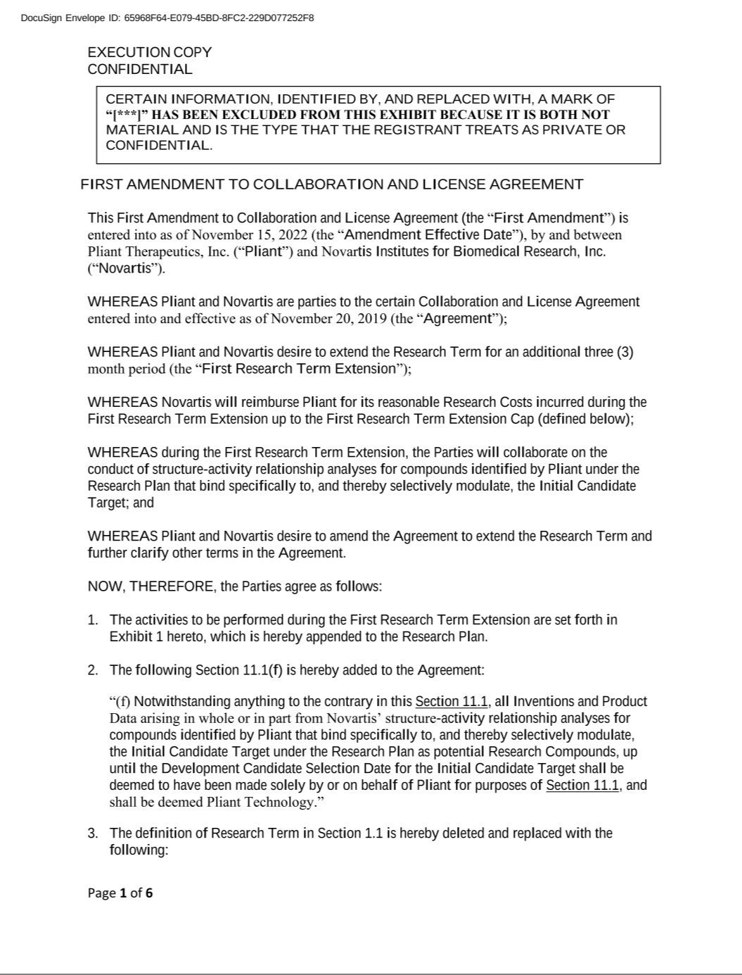



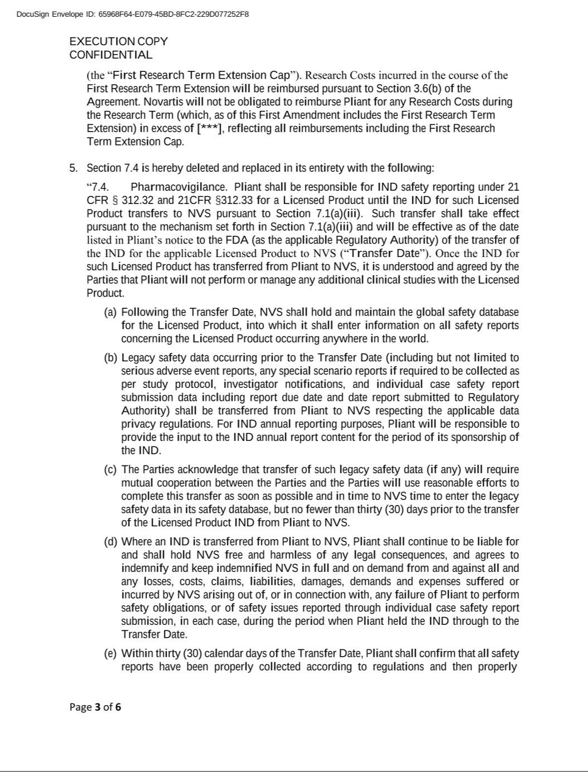

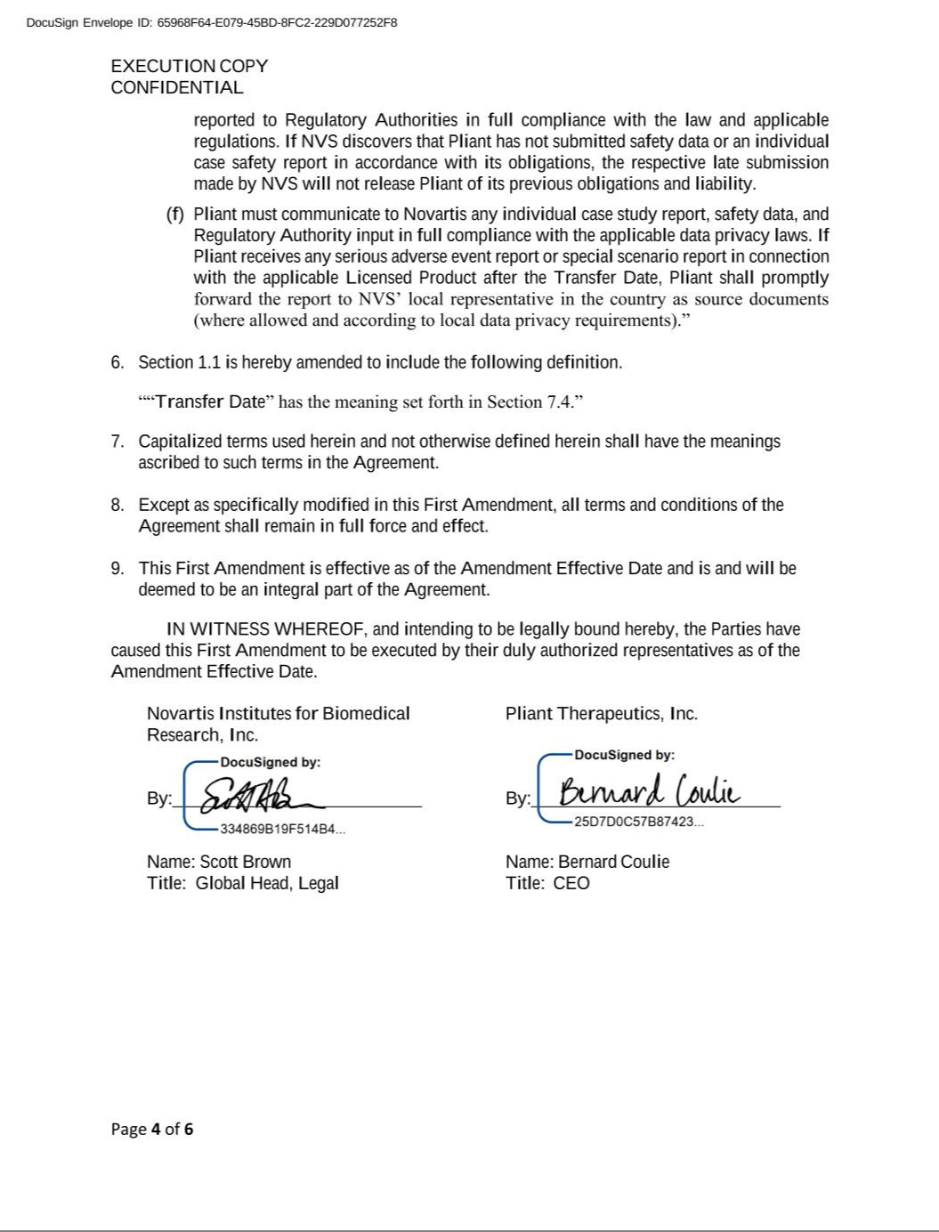



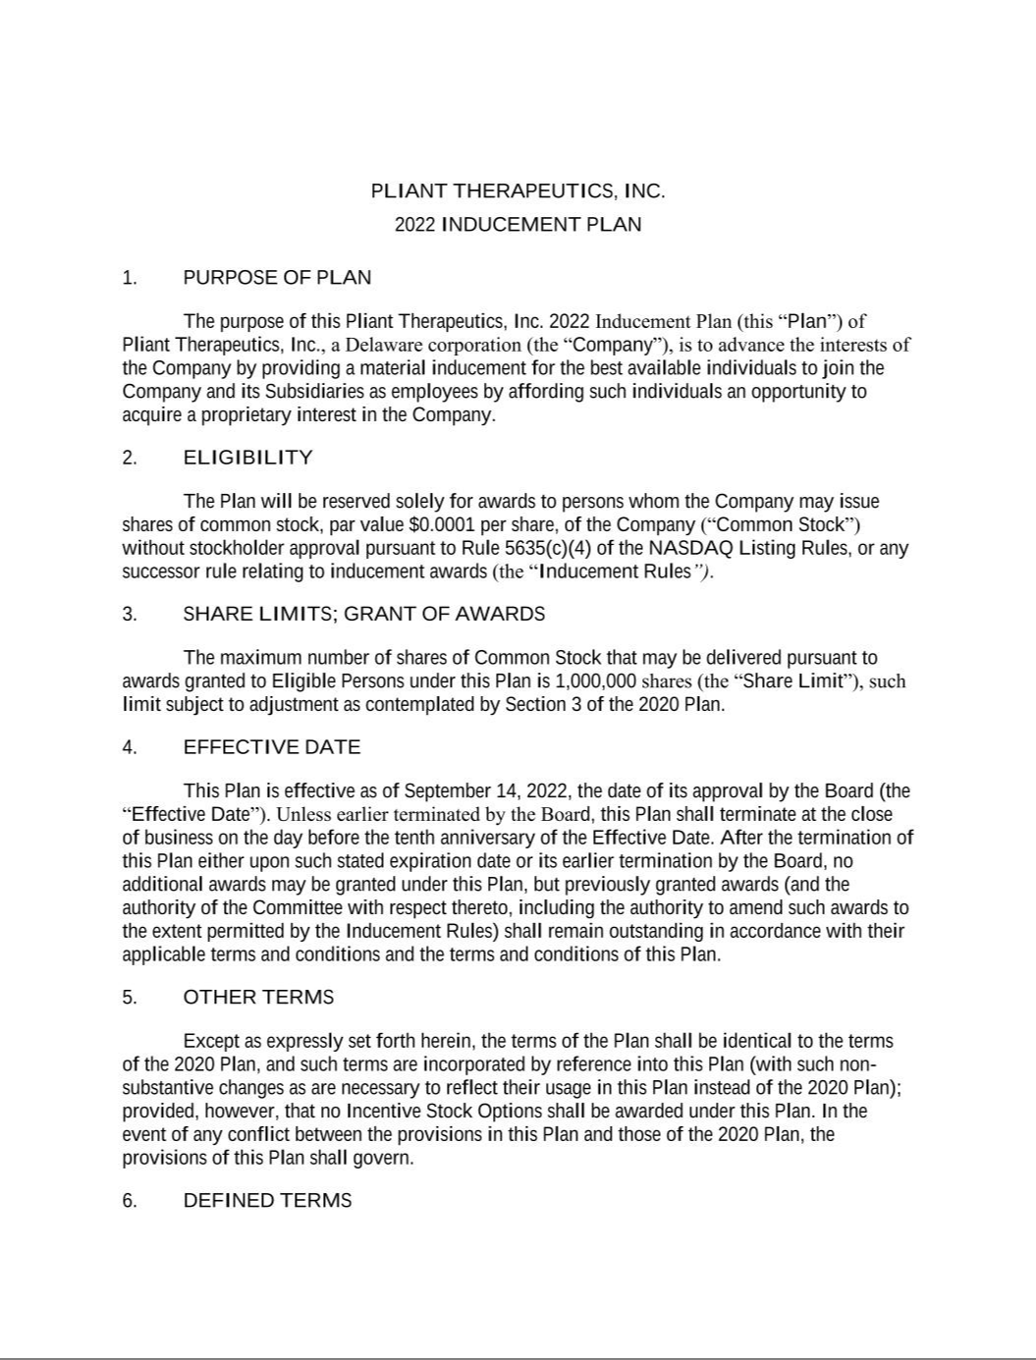



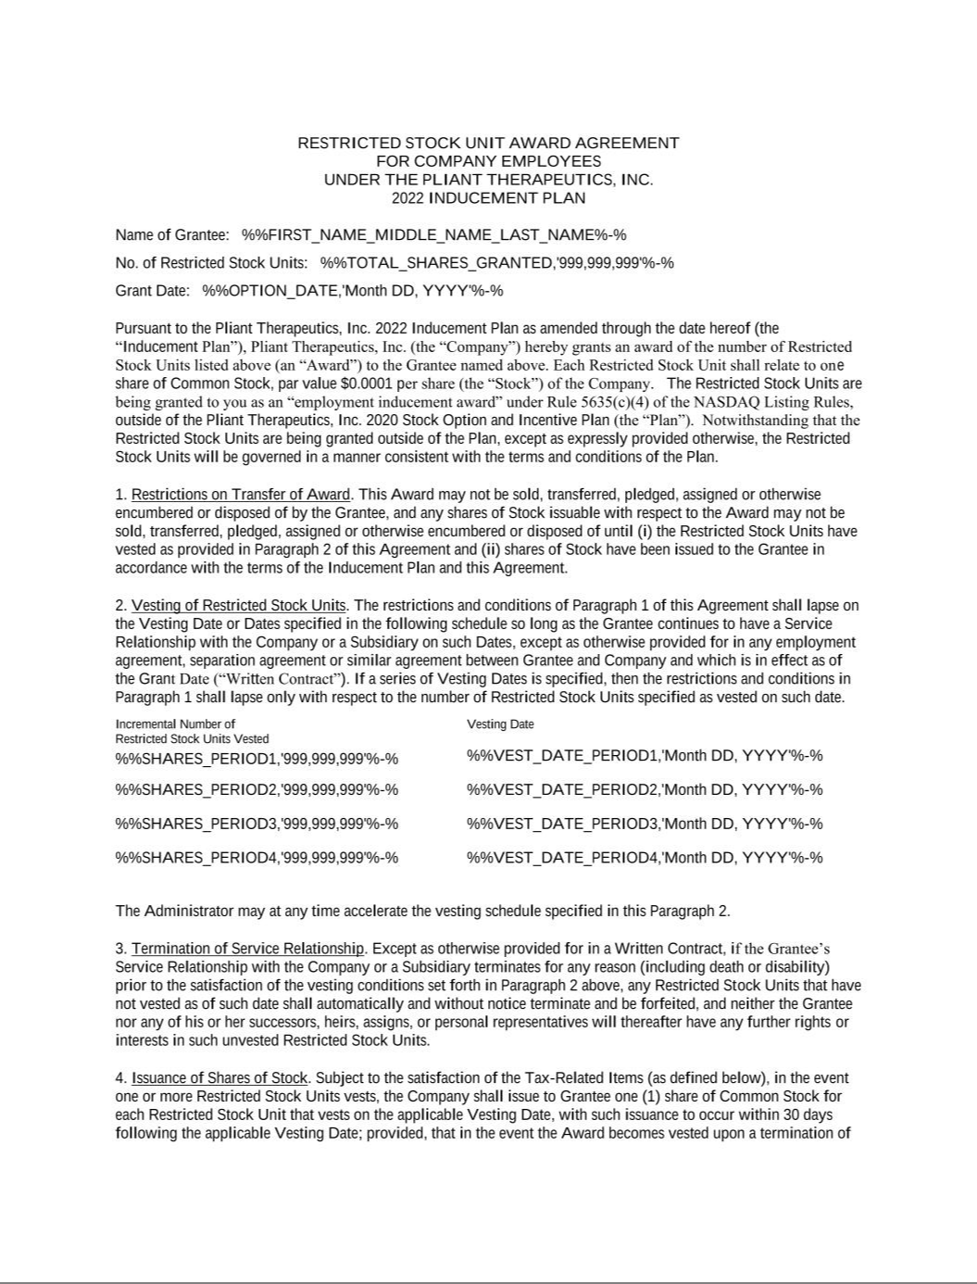

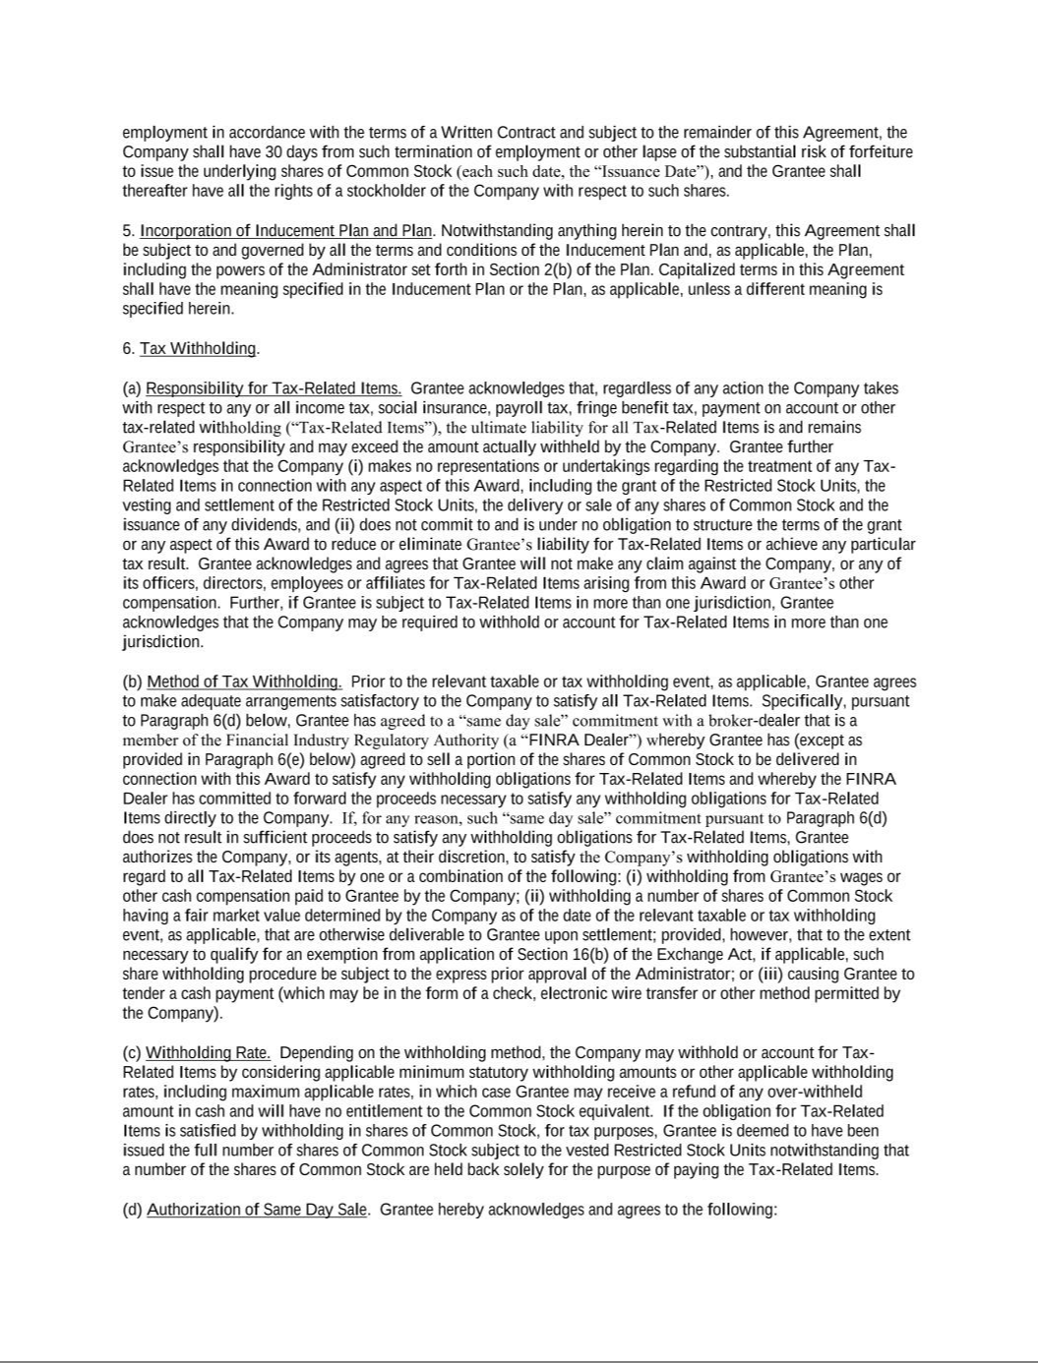

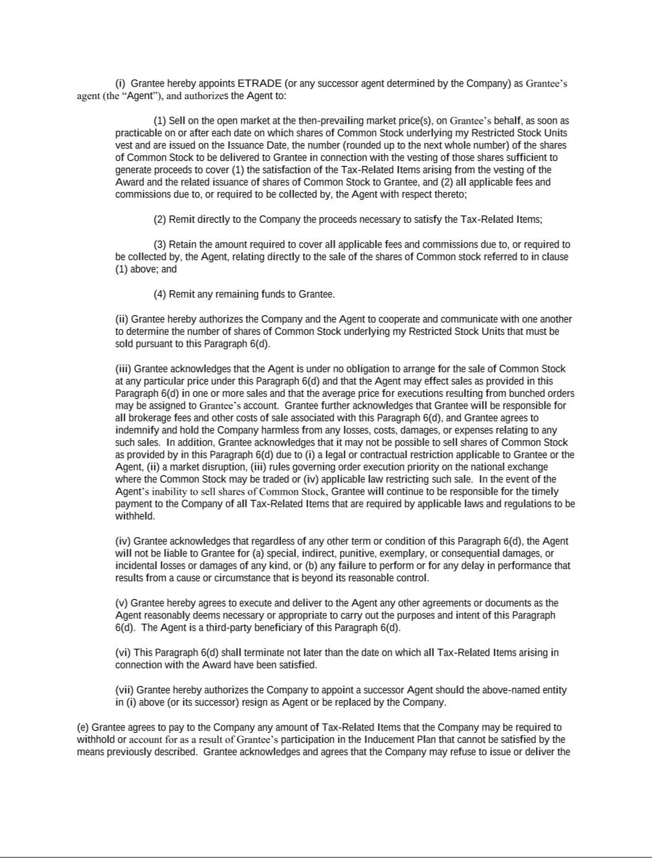

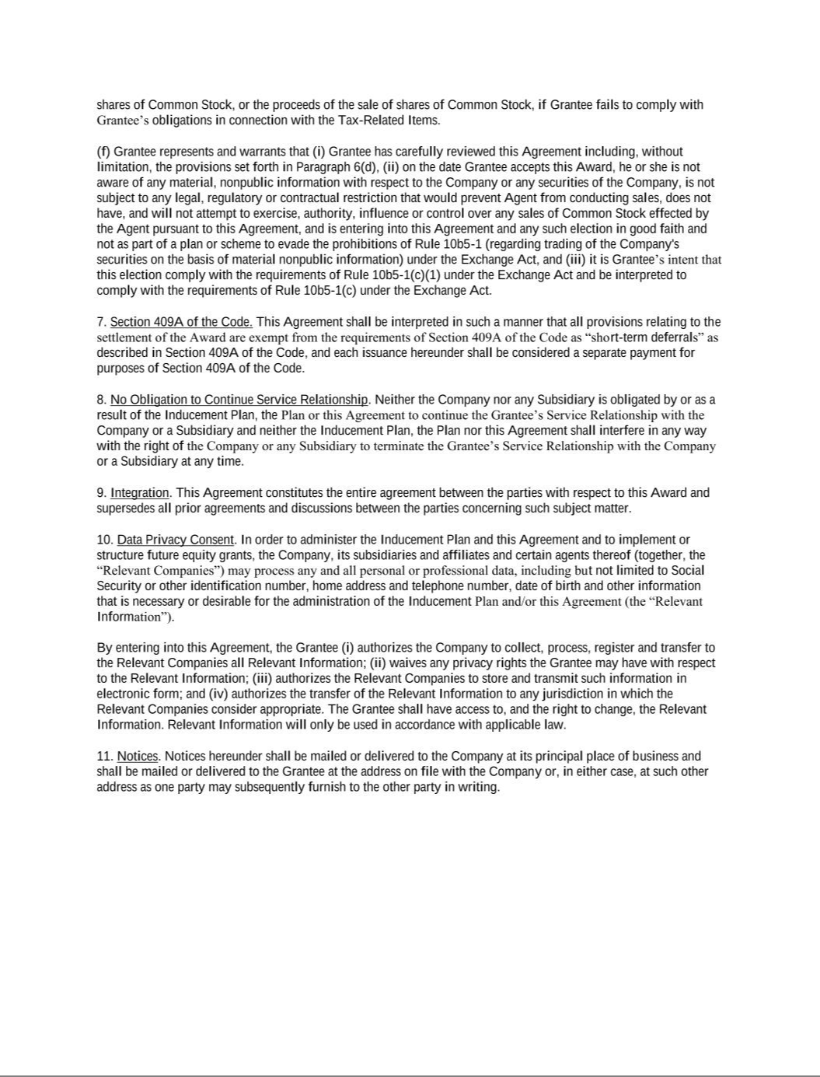

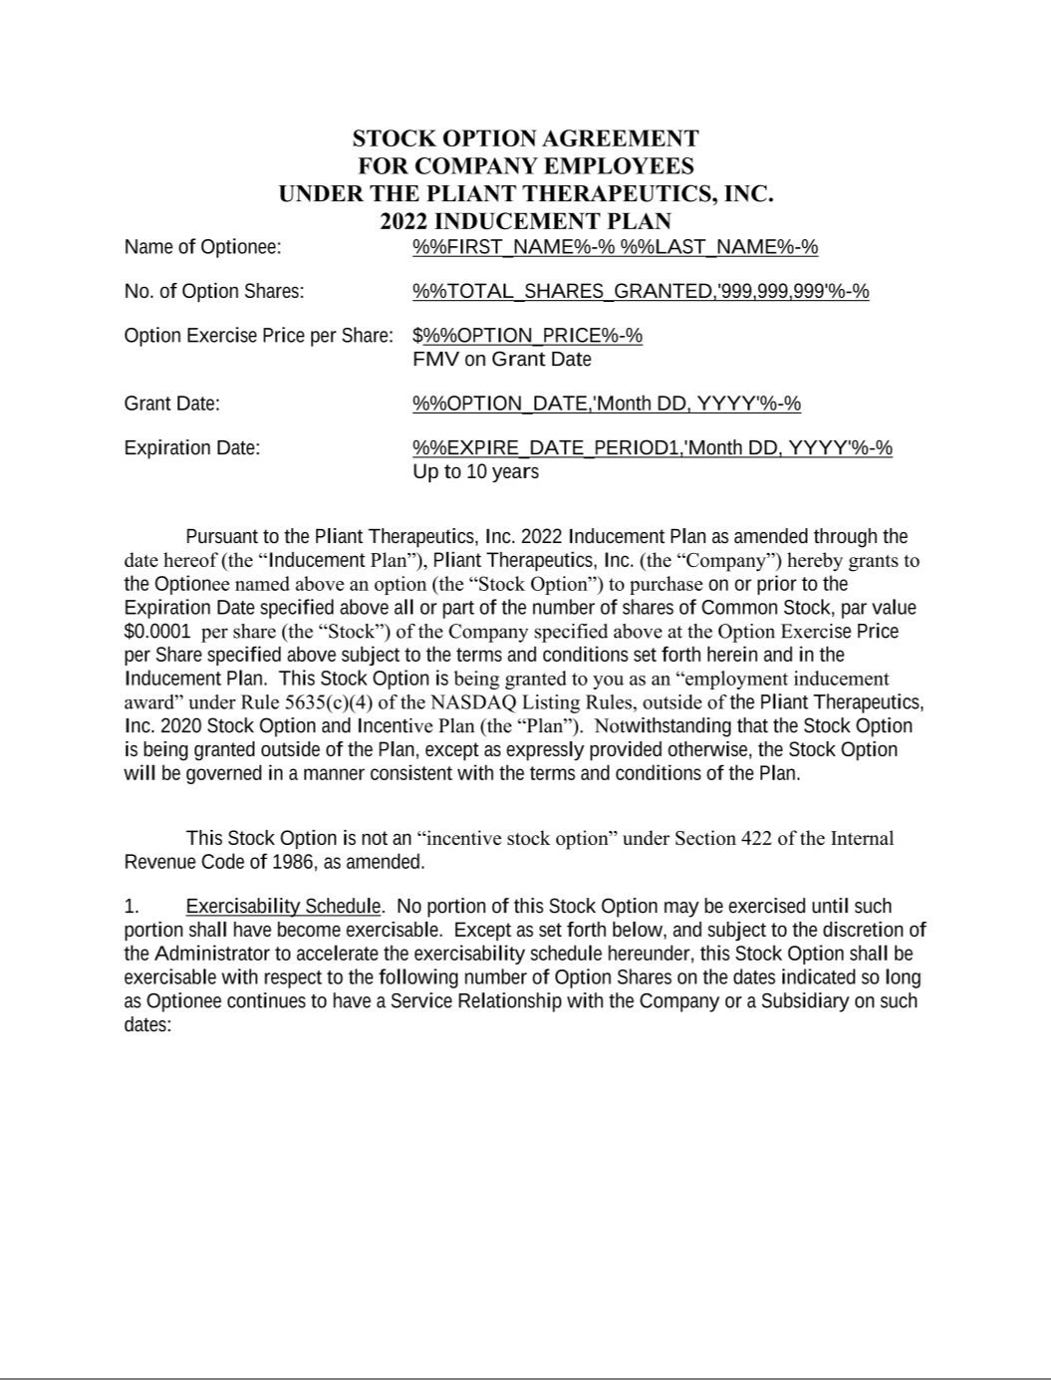

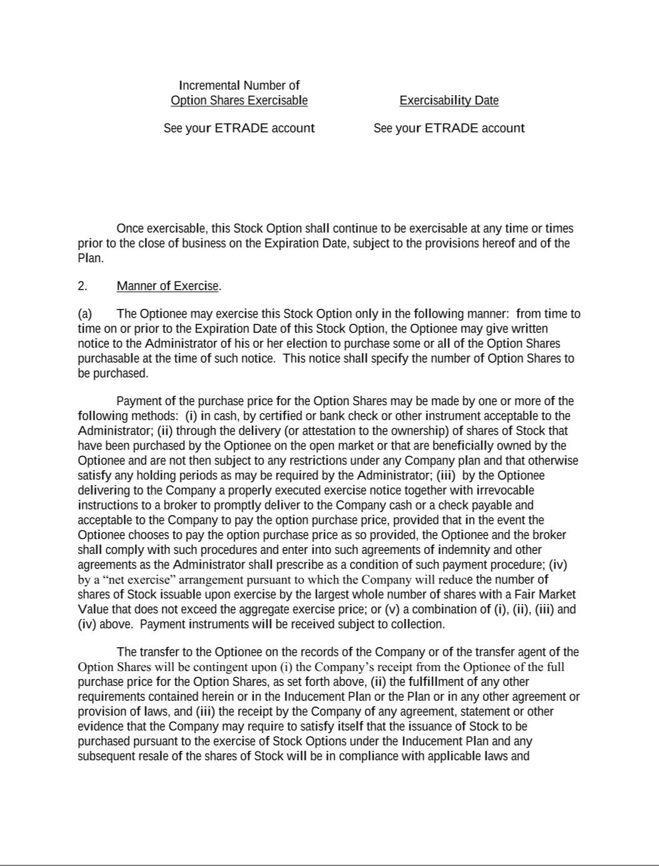

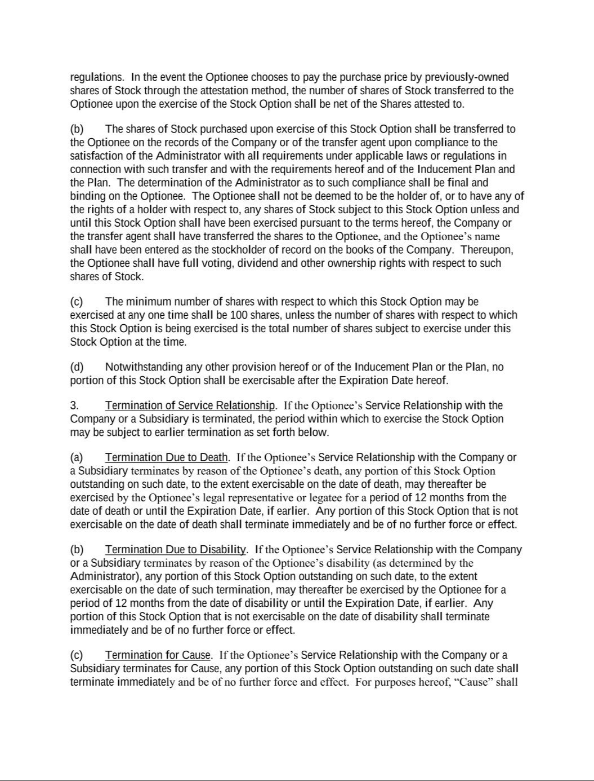

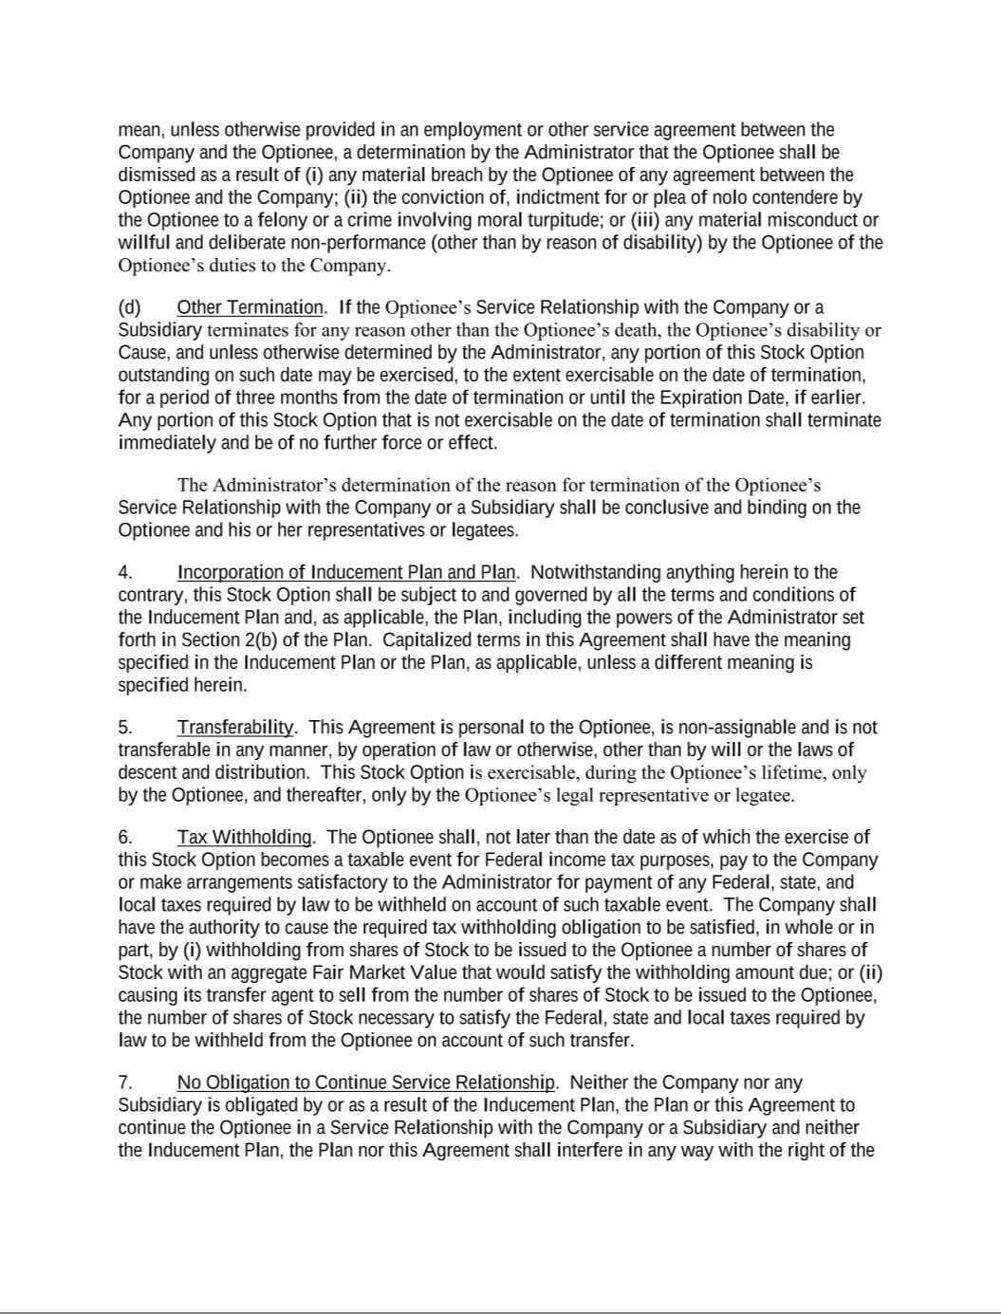

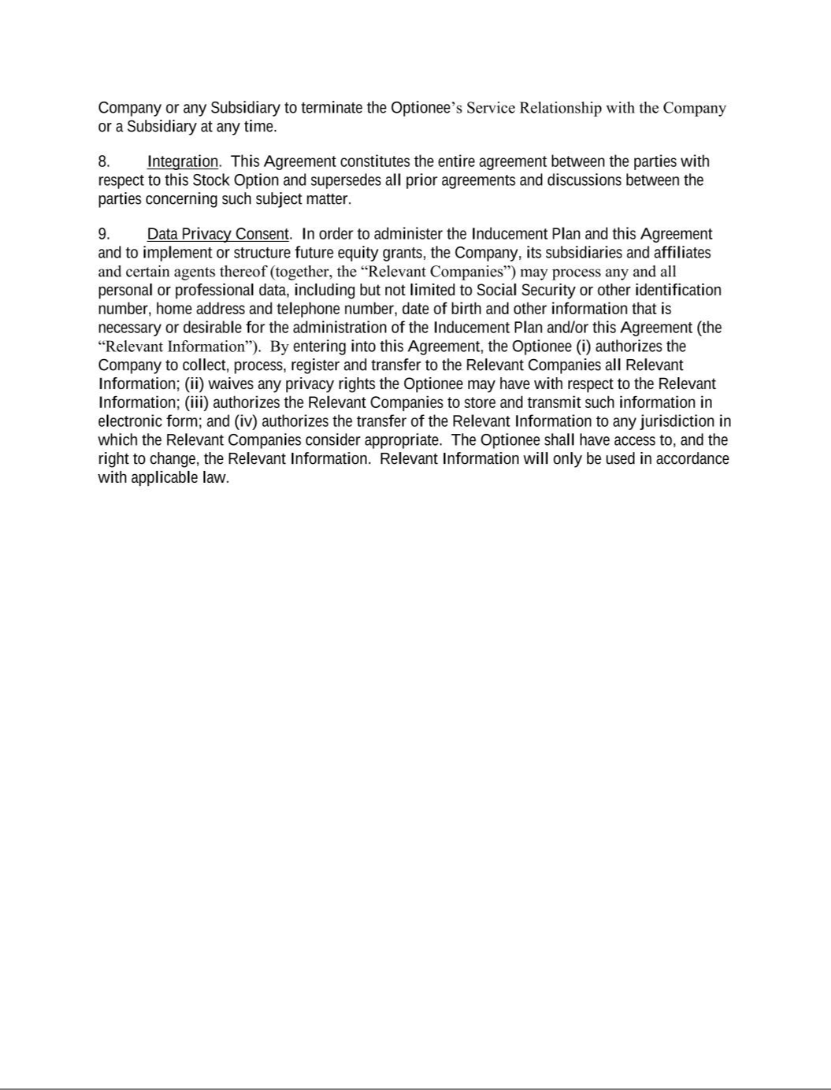

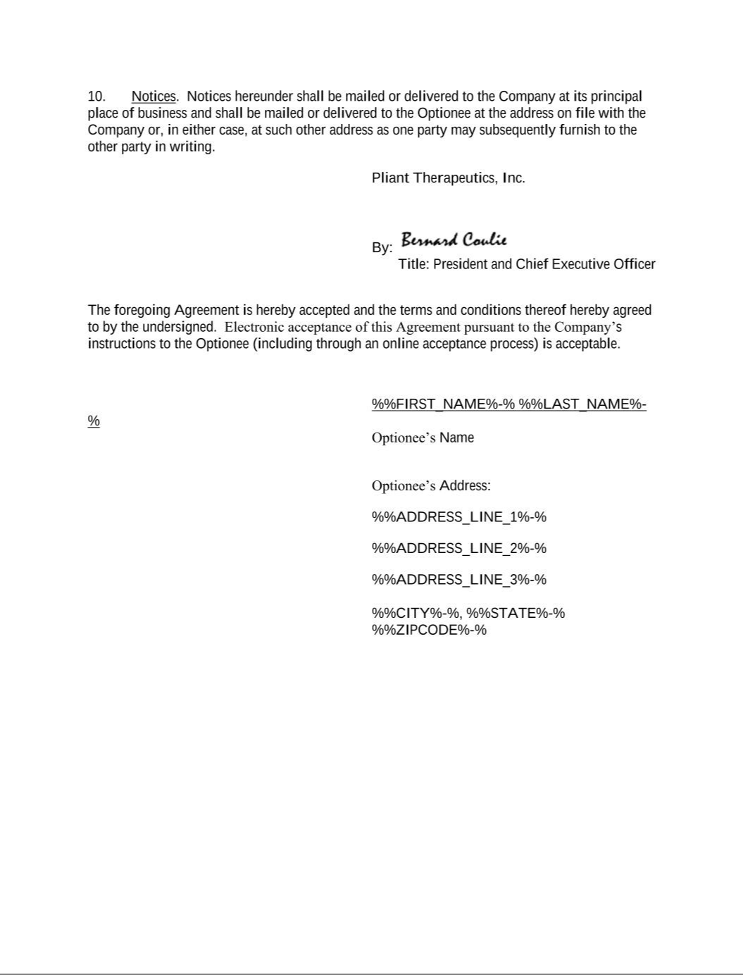

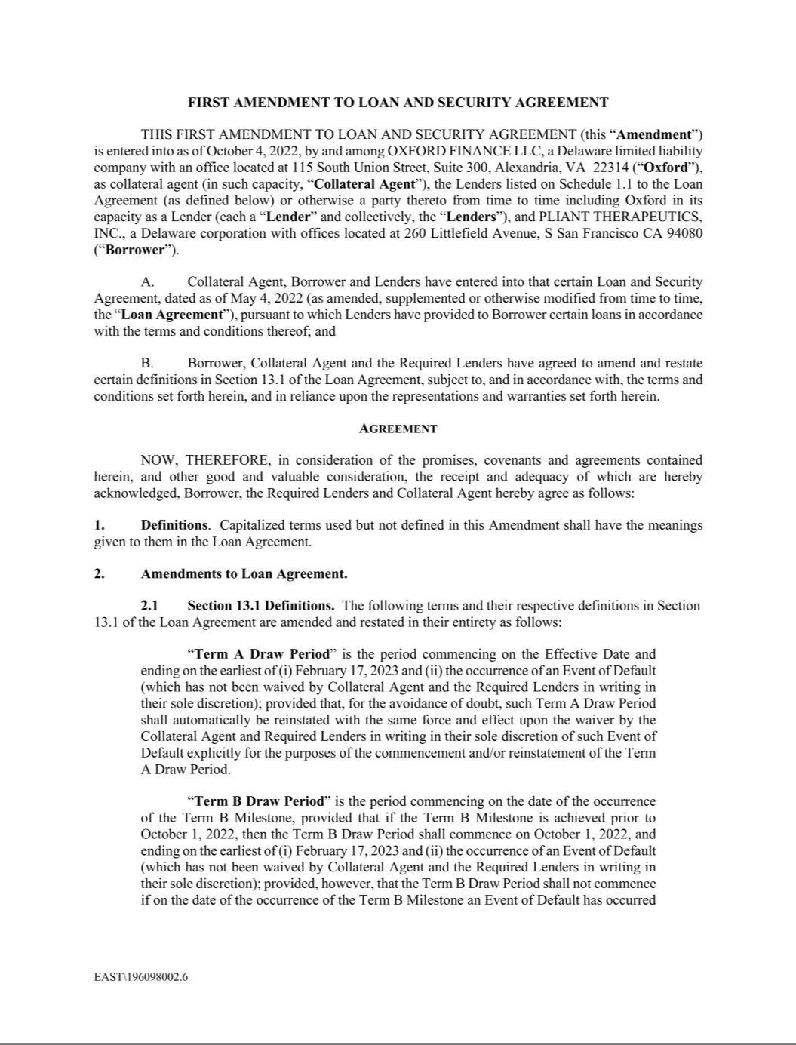

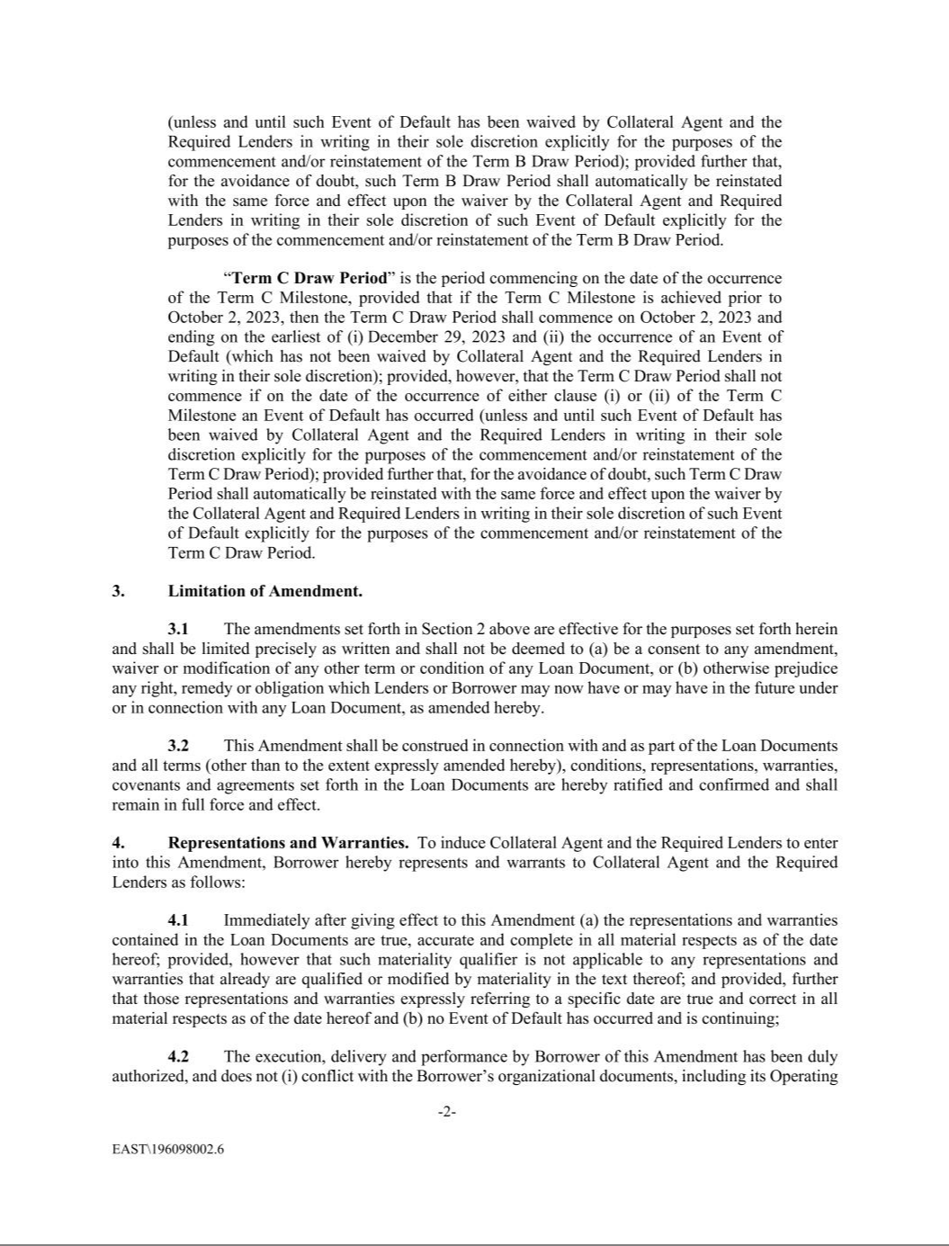

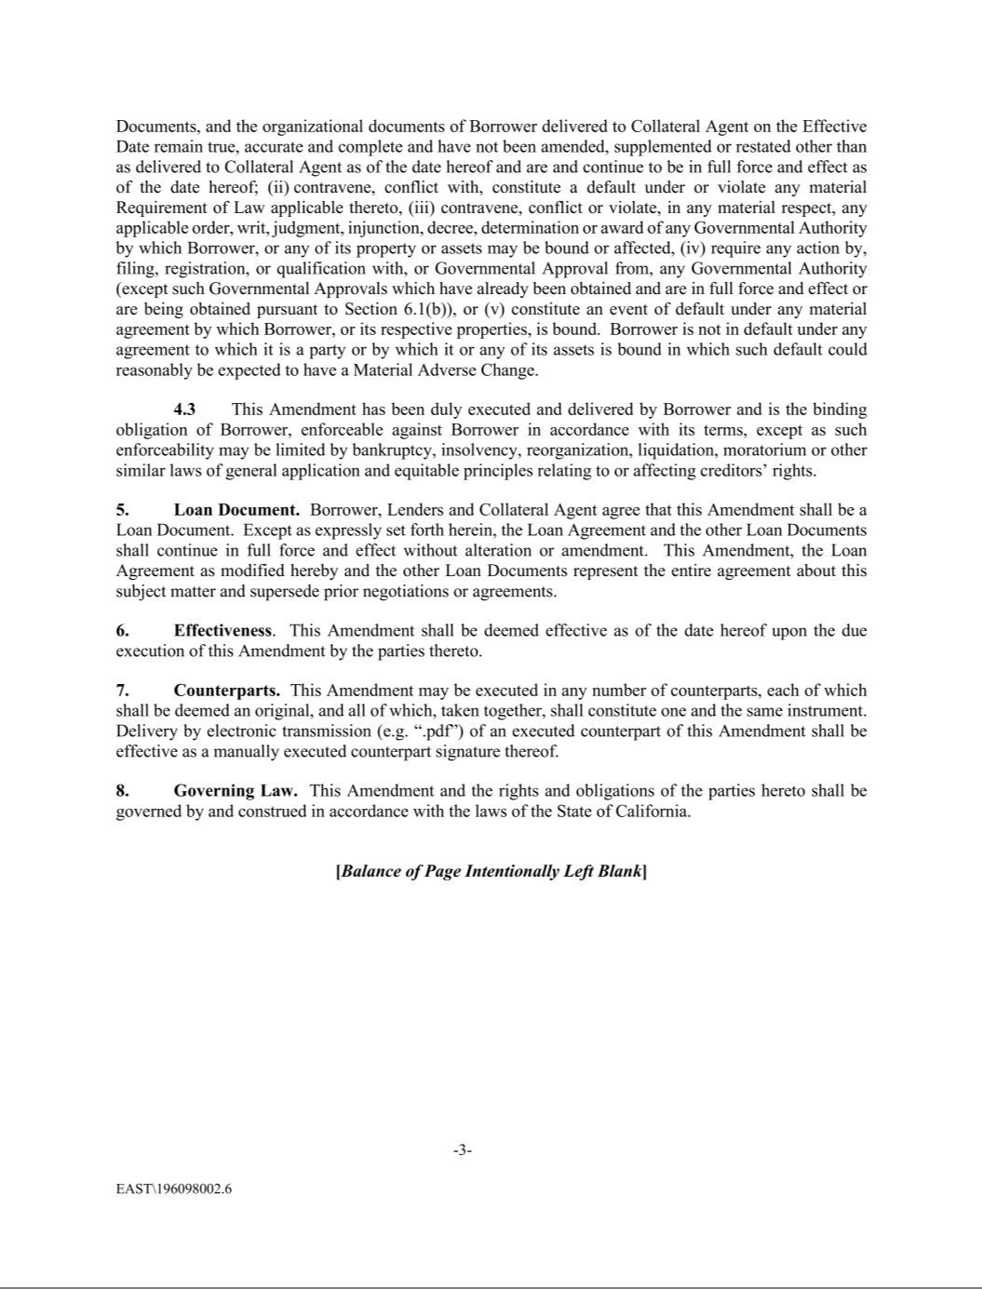

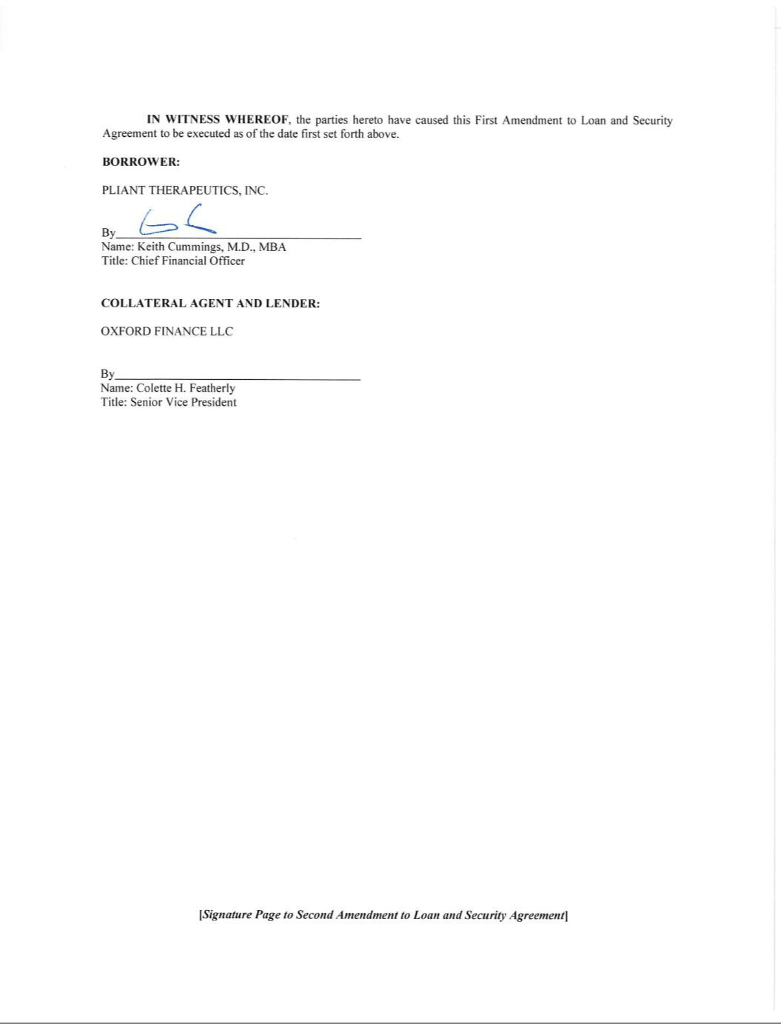

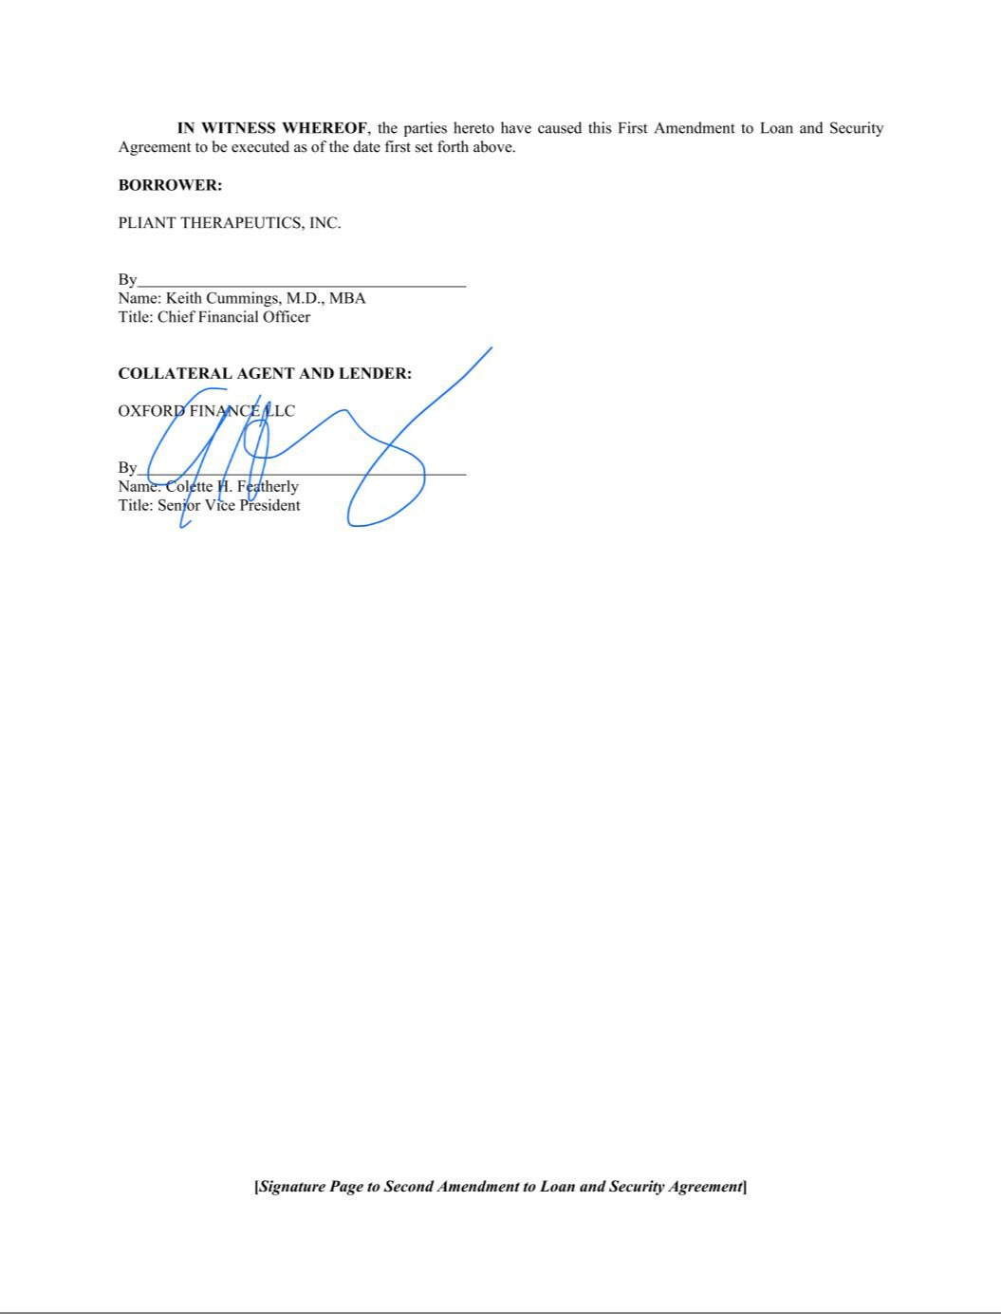

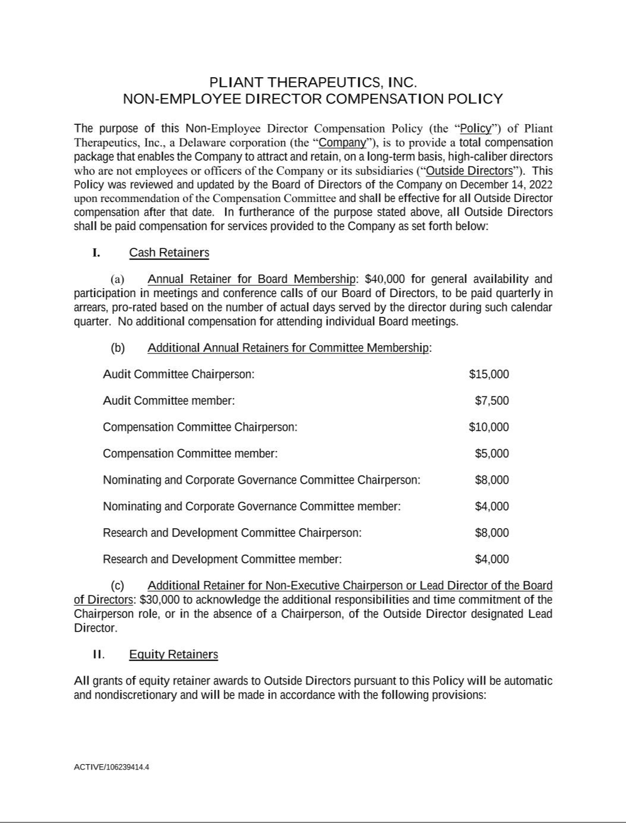

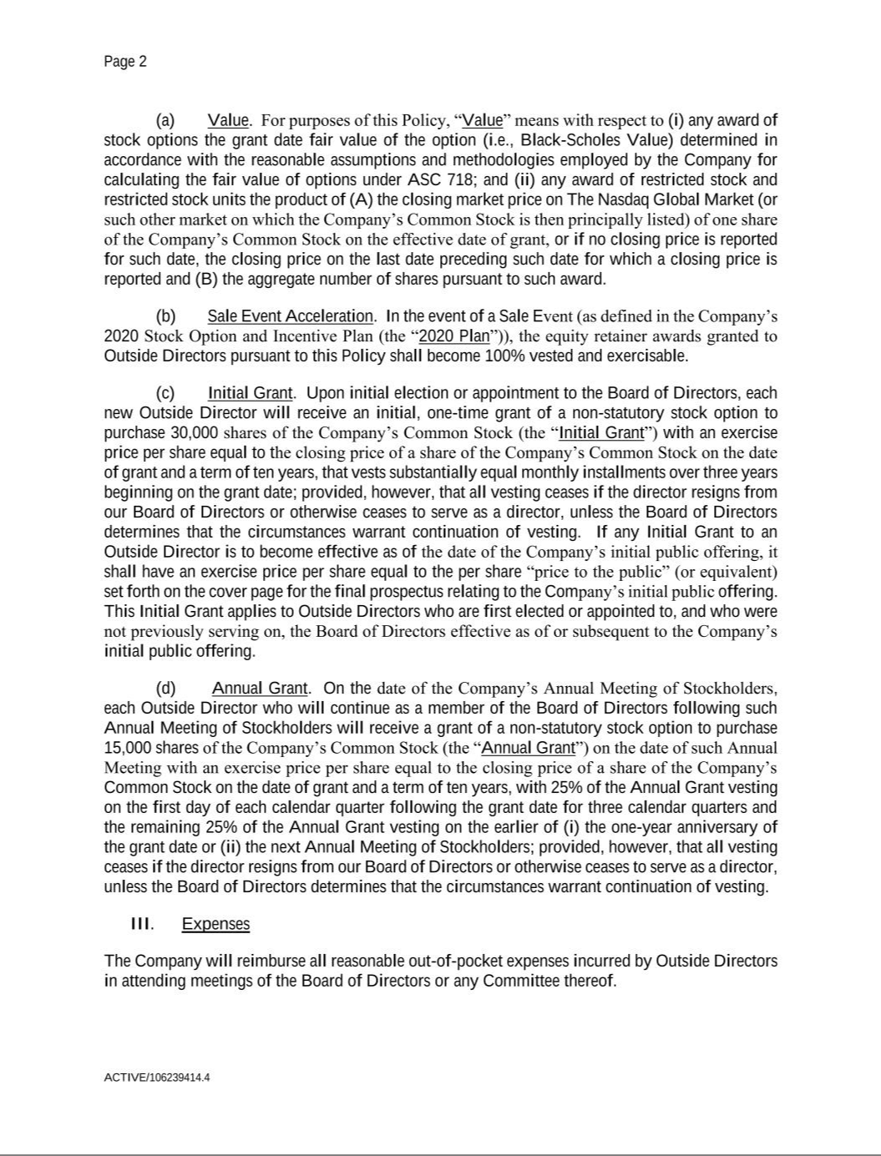

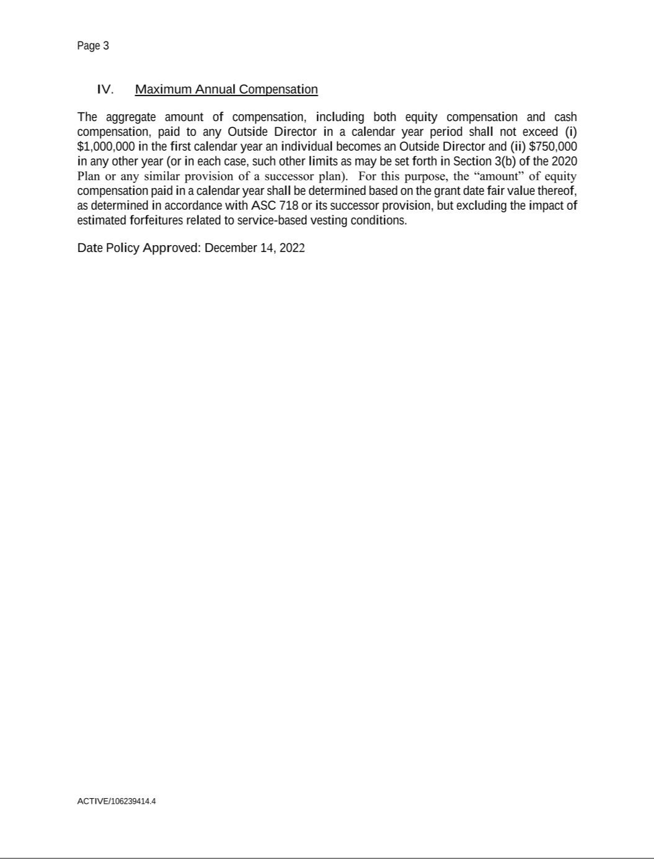

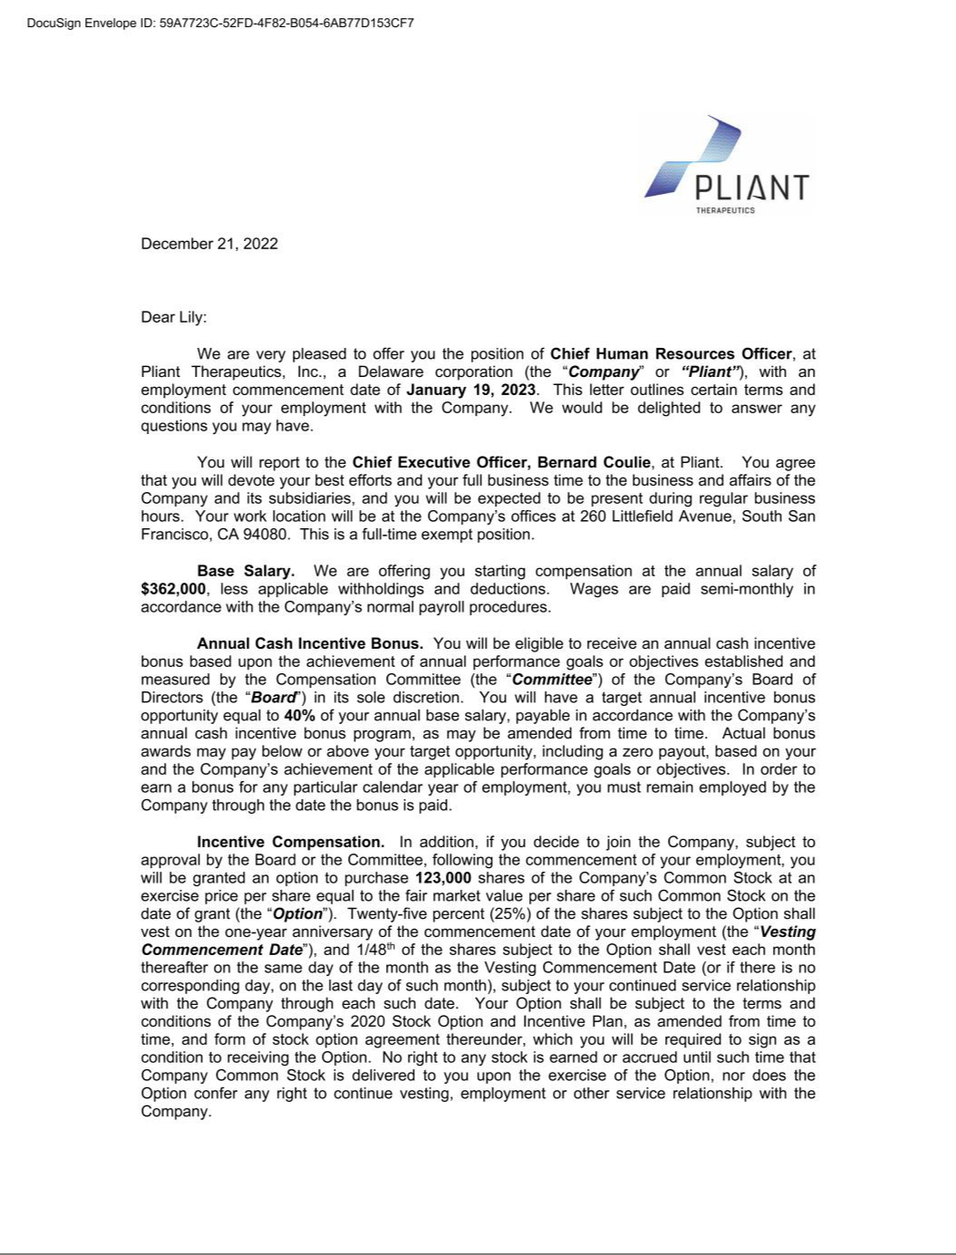

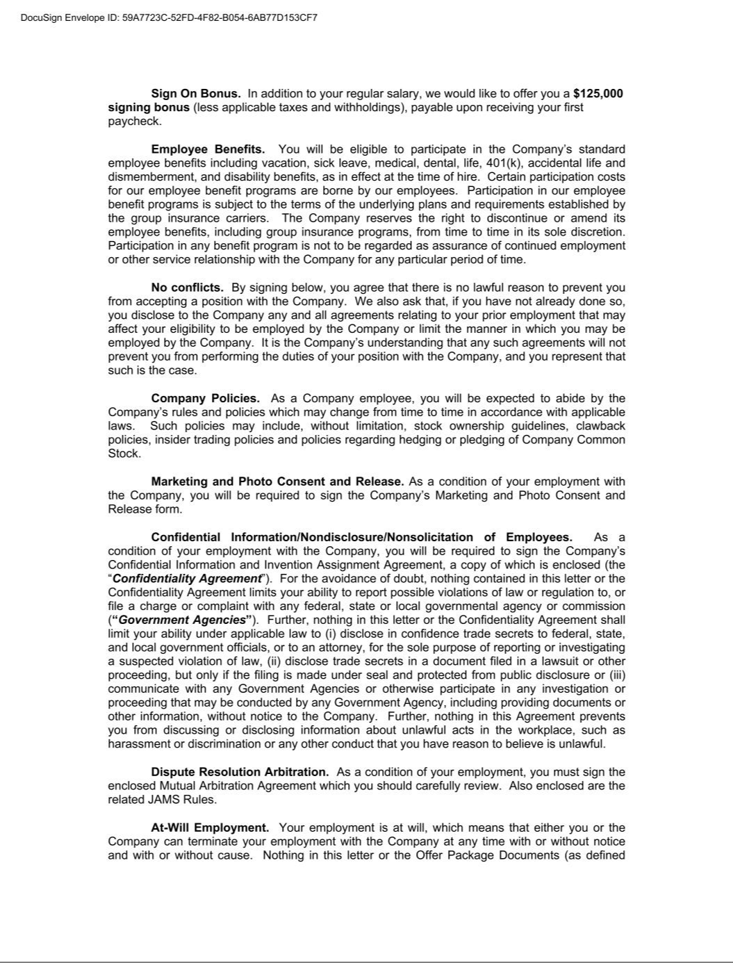

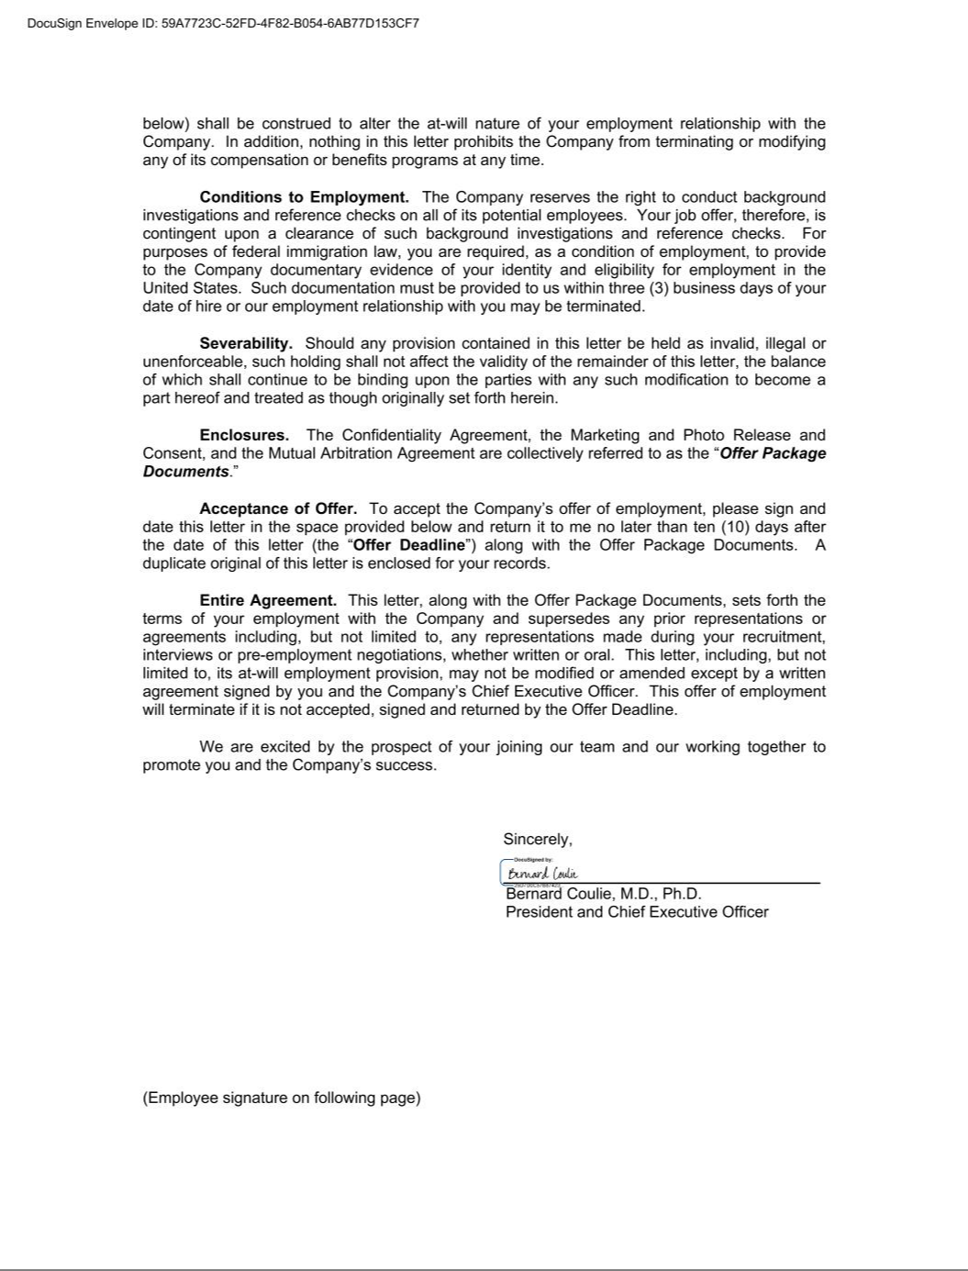





Exhibit 31.1

CERTIFICATION PURSUANT TO RULE 13a-14(a) OR 15d-14(a) OF

THE SECURITIES EXCHANGE ACT OF 1934,

AS ADOPTED PURSUANT TO SECTION 302 OF

THE SARBANES-OXLEY ACT OF 2002

I, Bernard Coulie, certify that:

- I have reviewed this Annual Report on Form 10-K of Pliant Therapeutics, Inc.;

- Based on my knowledge, this report does not contain any untrue statement of a material fact or omit to state a material fact necessary to make the statements made, in light of the circumstances under which such statements were made, not misleading with respect to the period covered by this report;

- Based on my knowledge, the financial statements, and other financial information included in this report, fairly present in all material respects the financial condition, results of operations and cash flows of the registrant as of, and for, the periods presented in this report;

- The registrant’s other certifying officer and I are responsible for establishing and maintaining disclosure controls and procedures (as defined in Exchange Act Rules 13a-15(e) and 15d-15(e)) and internal control over financial reporting (as defined in Exchange Act Rules 13a-15(f) and 15d-15(f)) for the registrant and have:

  - Designed such disclosure controls and procedures, or caused such disclosure controls and procedures to be designed under our supervision, to ensure that material information relating to the registrant, including its consolidated subsidiaries, is made known to us by others within those entities, particularly during the period in which this report is being prepared;

  - Designed such internal control over financial reporting, or caused such internal control over financial reporting to be designed under our supervision, to provide reasonable assurance regarding the reliability of financial reporting and the preparation of financial statements for external purposes in accordance with generally accepted accounting principles;

  - Evaluated the effectiveness of the registrant’s disclosure controls and procedures and presented in this report our conclusions about the effectiveness of the disclosure controls and procedures, as of the end of the period covered by this report based on such evaluation; and

  - Disclosed in this report any change in the registrant’s internal control over financial reporting that occurred during the registrant’s most recent fiscal quarter (the registrant’s fourth fiscal quarter in the case of an annual report) that has materially affected, or is reasonably likely to materially affect, the registrant’s internal control over financial reporting; and

- The registrant’s other certifying officer and I have disclosed, based on our most recent evaluation of internal control over financial reporting, to the registrant’s auditors and the audit committee of the registrant’s board of directors (or persons performing the equivalent functions)

  - All significant deficiencies and material weaknesses in the design or operation of internal control over financial reporting which are reasonably likely to adversely affect the registrant’s ability to record, process, summarize and report financial information; and

  - Any fraud, whether or not material, that involves management or other employees who have a significant role in the registrant’s internal control over financial reporting.

Date: March 9, 2023 By: /s/ Bernard Coulie

Bernard Coulie, M.D., Ph.D.

President and Chief Executive Officer

(Principal Executive Officer)

Exhibit 31.2

CERTIFICATION PURSUANT TO RULE 13a-14(a) OR 15d-14(a) OF

THE SECURITIES EXCHANGE ACT OF 1934,

AS ADOPTED PURSUANT TO SECTION 302 OF

THE SARBANES-OXLEY ACT OF 2002

I, Keith Cummings, certify that:

- I have reviewed this Annual Report on Form 10-K of Pliant Therapeutics, Inc.;

- Based on my knowledge, this report does not contain any untrue statement of a material fact or omit to state a material fact necessary to make the statements made, in light of the circumstances under which such statements were made, not misleading with respect to the period covered by this report;

- Based on my knowledge, the financial statements, and other financial information included in this report, fairly present in all material respects the financial condition, results of operations and cash flows of the registrant as of, and for, the periods presented in this report;

- The registrant’s other certifying officer and I are responsible for establishing and maintaining disclosure controls and procedures (as defined in Exchange Act Rules 13a-15(e) and 15d-15(e)) and internal control over financial reporting (as defined in Exchange Act Rules 13a-15(f) and 15d-15(f)) for the registrant and have:

  - Designed such disclosure controls and procedures, or caused such disclosure controls and procedures to be designed under our supervision, to ensure that material information relating to the registrant, including its consolidated subsidiaries, is made known to us by others within those entities, particularly during the period in which this report is being prepared;

  - Designed such internal control over financial reporting, or caused such internal control over financial reporting to be designed under our supervision, to provide reasonable assurance regarding the reliability of financial reporting and the preparation of financial statements for external purposes in accordance with generally accepted accounting principles;

  - Evaluated the effectiveness of the registrant’s disclosure controls and procedures and presented in this report our conclusions about the effectiveness of the disclosure controls and procedures, as of the end of the period covered by this report based on such evaluation; and

  - Disclosed in this report any change in the registrant’s internal control over financial reporting that occurred during the registrant’s most recent fiscal quarter (the registrant’s fourth fiscal quarter in the case of an annual report) that has materially affected, or is reasonably likely to materially affect, the registrant’s internal control over financial reporting; and

- The registrant’s other certifying officer and I have disclosed, based on our most recent evaluation of internal control over financial reporting, to the registrant’s auditors and the audit committee of the registrant’s board of directors (or persons performing the equivalent functions)

  - All significant deficiencies and material weaknesses in the design or operation of internal control over financial reporting which are reasonably likely to adversely affect the registrant’s ability to record, process, summarize and report financial information; and

  - Any fraud, whether or not material, that involves management or other employees who have a significant role in the registrant’s internal control over financial reporting.

Date: March 9, 2023 | /s/ Keith Cummings
 | Keith Cummings, M.D., MBA
 | Chief Financial Officer
 | (Principal Financial Officer)

Exhibit 32.1

CERTIFICATION PURSUANT TO

18 U.S.C. SECTION 1350, AS ADOPTED PURSUANT TO

SECTION 906 OF THE SARBANES-OXLEY ACT OF 2002

In connection with the Annual Report of Pliant Therapeutics, Inc. (the “Company”) on Form 10-K for the period ending December 31, 2022, as filed with the Securities and Exchange Commission on the date hereof (the “Report”), I certify, pursuant to 18 U.S.C. § 1350, as adopted pursuant to § 906 of the Sarbanes-Oxley Act of 2002, that:

- The Report fully complies with the requirements of section 13(a) or 15(d) of the Securities Exchange Act of 1934; and

- The information contained in the Report fairly presents, in all material respects, the financial condition and results of operations of the Company.

Date: March 9, 2023 /s/ Bernard Coulie

Bernard Coulie, M.D., Ph.D.

President and Chief Executive Officer

(Principal Executive Officer)

/s/ Keith Cummings

Keith Cummings, M.D., MBA

Chief Financial Officer

(Principal Financial Officer)

